

DM Habens

The Builder Ltd

Construction Phase Plan

Contract Name: | Bunting Gardens
Contract Address: | Bunting Gardens  Wecock Farm  Waterlooville
Postcode: | PO8 9UW
Date: | 17/12/2024

Contents
Introduction 5
1 Project details 5
1.1 Location 5
1.2 Scope of works 6
1.3 Details of project team 6
1.4 Programme 7
1.5 Existing records and plans 7
2 Management of the work 9
2.1 Management structure 10
2.2 Management responsibilities 10
2.3 Health & safety goals for the project 11
2.4 Clients project objectives 11
2.5 Arrangements for monitoring and review of health & safety performance 11
2.6 Regular liaison between contractors on site 12
2.7 Consultation with the workforce 12
2.8 Site safety information 12
2.9 Exchange of design Information and design changes 13
2.10 Selection and control of contractors 13
2.11 Site security 13
2.12 Site inductions and onsite training 14
2.13 Welfare facilities 14
2.14 First aid 15
2.15 Reporting and investigation of accidents and near misses 16
2.16 Risk assessments and safe systems of work 16
2.17 Site rules 17
2.18 Fire and emergency procedures 19
2.19 Location of nearest accident and emergency department 21
3 Arrangements for controlling significant site safety risks 25
3.1 Delivery and removal of materials to site 27
3.2 Services: water, gas, electricity 27
3.3 Adjacent land use 27
3.4 Impact on other neighbours 27
3.5 Delivery times / restrictions on working 27
3.6 Excavations 28
3.7 Temporary works 28
3.8 Working at height/preventing falls on site. 28
3.9 Controlling of lifting operations 29
3.10 Maintenance of plant and equipment 29
3.11 Traffic routes; segregation of vehicles and pedestrians 29
3.12 Storage of hazardous materials and work equipment 29
4 Arrangements for controlling significant site health risks 30
4.1 Asbestos 30
4.2 Manual handling 30
4.3 Use of hazardous substances 30
4.4 Reducing noise and vibration 30
4.5 Lone Working………………………………………………………………………………………………………………………….. .30
5 Arrangements for providing health and safety information 31
5.1 Responsibilities 31
5.2 Health & Safety File……………………………………………………………………………………………………………………31
6 APPENDICES 32

Appendix A – Site Rules
Appendix B – Fire Risk Assessment
Appendix C – Site Set Up Plan
Appendix D – Eco Map

Construction Phase Plan Revision Sheet
Revision Number | Date of Issue | Reason for Revision and Comments
1 | 03.10.2024 | DRAFT – Issued for review, amendment and comment.
2 | 17.12.2024 | Revision issued for review
3 | 31.5.2025 | Revised following comments from PCC
Author | Daniela Mihailov | Checked by | Alan Gruss
Date | 17.12.2024 | Date | 17/12/2024

Pre-Construction Information (PCI) Confirmation
Revision Number | Date of Issue |  | Reason
1 |  |  | I can confirm I have thoroughly read the Pre-Construction Information (PCI) document and have signed below in agreement that I have further developed the construction phase plan and uploaded this to Procore prior to commencement of the project.
Project Manager Signature |  | AGruss |  | Date | 17/12/2024

Introduction
This Construction Phase Plan has been produced to comply with the Construction Design and Management (CDM) Regulations 2015, Regulation 23 (1a) and is set out as appendix 3 in the Approved Code of Practice.
As the Principal Contractor we will:
- Address the health & Safety issues likely to be involved in the management of the construction phase.
- Plan, manage and monitor the construction phase, providing adequate resources and competent site management that is appropriate for the risks envisaged during the project.
- Provide contractors with the necessary information about the project that they need in order for them to carry out their work safely and without risk to health.
- Facilitate the co-ordination, co-operation and communication between contractors on the site.
- Provide information on any temporary works.

1 Project details

Location
Bunting Gardens, Wecock Farm, Waterlooville, PO8 9UW
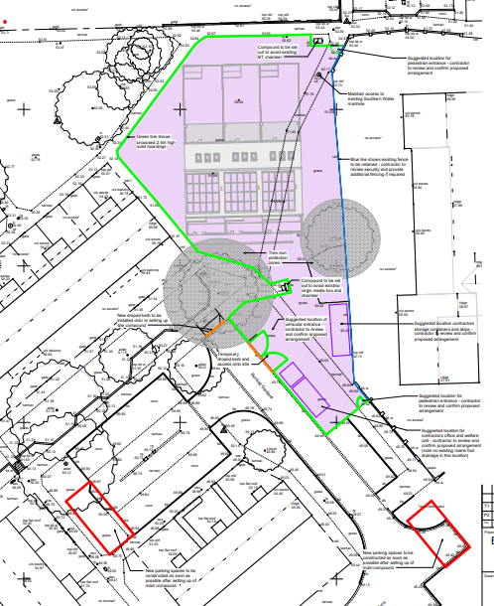

Scope of works
The works comprise of the construction of 3nr four-bedroom houses together with associated parking an external works.

Details of project team
Client: | Housing, Neighbourhood & Building Services
Address: | Portsmouth City Council  Civic Offices  Guildhall Square  Portsmouth  PO1 2AL
Tel: | 07507699572
Contact: | Patrick Leggett
E-mail:
Landscape Architect: | Design Group
Address: | Housing, Neighbourhood & Building Service  Portsmouth City Council  Civic Offices  Guildhall Square  Portsmouth  PO1 2AL
Tel: | 023 9283 4707
Contact: | Helen Bergin
E-mail:
Structural Engineer: | Design Group
Principal Designer: | Design Group
Address: | Housing, Neighbourhood & Building Service  Portsmouth City Council  Civic Offices  Guildhall Square  Portsmouth  PO1 2AL
Tel: | 02392841251
Contact: | Chris Greed
E-mail: | Chris.Greed@portsmouthcc.gov.uk
Drainage Engineer: | Baker &Associates
Address: | Wessex House  Upper Market Street  Eastleigh  SO50 9FD
Tel: | 02381290229
Contact: | Simon Baker
E-mail:
Mechanical Engineer: | Building Engineering Services Team
Address: | Housing, Neighbourhood & Building Service  Portsmouth City Council  Civic Offices  Guildhall Square  Portsmouth  PO1 2AL
Tel: | 07825 860013
Contact: | Abi Healy
E-mail:
Quantity Surveyor: | Housing, Neighbourhood & Building Service
Address: | Portsmouth City Council  Civic Offices  Guildhall Square  Portsmouth  PO1 2AL
Tel: | 023 9283 4735
Contact: | Jane Godden
Email:
Principal Contractor: | DM Habens The Builder Ltd
Address: | Unit B, 10 Rodney Road,  Southsea  Portsmouth  HAMPSHIRE  PO4 8SY
Tel: | 02392851153
Contact: | Rory Kennedy
E-mail: | rory@dmhabensltd.co.uk

Programme
Construction Start Date | 24th February 2025
Construction Programme | 44 weeks
Completion Date | 9th January 2026

Existing records and plans
The following documents are currently available and have been provided to DM Habens Ltd. These will be provided to the Site Manager in advance of the work:
- Specification
- Pre-Construction information
- Contract Data
- Site Plan & Drawings
- R&D Survey
- Traffic Management Plans
The following services are known to be present on site:
- Water
- BT
- Electric
- Virgin media
- Gas
- Foul and Surface water drainage
Any additional information will be added to the DM Habens Site Safety File, to ensure it is available to the Site Manager.

- Management of the work

2.1 Management structure

Sub-contractors
Operatives
Supervisors
HCS Safety Ltd
Safety Advisors
Admin
Quantity Surveyor
Contracts Manager
Site Manager
Directors

Management responsibilities

Description | Person(s) Responsible
Contracts Manager | Alan Gruss
Site Manager | Andrew Parsons
Produce Construction Phase Plan | Contracts Manager/H&S Advisor
Review and update CPP | Contracts Manager/H&S Advisor
Collate Health and Safety File information | Contracts Manager/H&S Advisor
Carry out and record excavation/scaffold/lifting equipment inspections | Site Manager
Carry out & record daily briefings | Site Supervisor
Contract Fire Safety Co-ordinator | Site Manager
Preparation and Review of Fire Safety Plan & Drawing | Site Manager
Fire Warden(s) | Site Manager

Health & safety goals for the project
The project team has set the following goals:
- To achieve, as far as is practicable, a site with zero harm.
- To ensure safe access and egress to and from the site.
- To protect pedestrians and adjacent occupiers from any risks associated with the site.
- To ensure all persons visiting the site have been given basic safety information on any hazards associated with the current phase of work.
- To ensure visitors are escorted around the site at all times.
- Ensure operatives act in a safe manner and where personal protective equipment appropriate to the task in hand.
- To investigate any accidents or incidents on site and take note of any recommendations coming from accident and incident investigations. The Contractor is required to be SSIP or CHAS registered and have obtained 'Principal Contractor' status within their work categories.
- To use (where required) professional support for assisting in the safety of the site.
- To provide regular toolbox talks throughout the project.
- Protection of the environment and compliance with environmental legislation.
- Principal Contractor will be expected to provide the Council’s CA with documented audit reports, dated at routine intervals not exceeding 4 weeks, to evidence and verify that the construction phase of the project is being planned, managed and monitored in a way which ensures that, as far as reasonably practicable, it is carried out without risks to health and safety of any person
These safety goals are monitored and discussed during site meetings and actions given to the appropriate personnel.

Clients project objectives
To implement the “General Principles of Prevention” during the design and construction and to ensure that due consideration is given to neighbouring properties which are to remain occupied throughout the period of the works.

Arrangements for monitoring and review of health & safety performance
Monitoring will be carried out daily by the Site Manager, who will maintain a constant presence on site. The Site Supervisor will carry out his own internal site checks on a daily and weekly basis. These will be further audited by our contract managers following site set up and a further audit completed during the construction phase by our independent Health and Safety Advisors who will prepare a report to senior management.

Inspections of any scaffolding, scaffold towers and plant & machinery are the responsibility of Site Supervisor, who will arrange for these to be carried out.

Subcontractors are expected to carry out their own individual monitoring of site works in addition to the above and their ability to do so is checked prior to awarding contracts with them.

Regular liaison between contractors on site
A positive health and safety culture have effective co-operation and communication at its heart. DM Habens Ltd has the following liaison procedures in place.
Site meetings | Site Manager and Trade Supervisors | Monthly
Early morning meetings | Site Manager and Trade Supervisors | Daily
Site Safety Induction | Site Manager with Operatives | Daily
Toolbox Talks | Delivered by Manager | Weekly
RA/MS briefings | Delivered by Manager | Before starting site works
Contractors working on the site will be expected to cooperate with the above table so that DM Habens Ltd can carry out the Principal Contractors duties effectively.

Consultation with the workforce
At the site induction it will be made clear that DM Habens Ltd want to actively engage with the workforce on the project for feedback on near misses, ideas to improve health and safety on the site, and to install a better attitude towards health & safety culture on the project. It is important that supervisors on the project convey all health and safety information to their team working on the site, and that they receive comments on the risk assessments and method statements that must be provided and explained to the workforce prior to the activity starting.

Site safety information
The following will be displayed in the site canteen on the site safety notice board.
- HSE Law Poster
- F10 Notification of Project
- Certificate of Employers Liability Insurance
- Details of actions to be taken in the event of a fire
- Details of the nearest A & E Department
- Details of First Aid arrangements for the site
- The Company Drug and Alcohol Policy
- Site Rules
- ISO Certification
- Traffic Management

Exchange of design Information and design changes
DM Habens Ltd will liaise regularly with the designers regarding design carried out during the construction phase, including any designs by a specialist contractor.
A drawing register will be compiled to control the issue of design information to relevant contractors and members of the project team. This will be monitored by the Site Manager.
Design meetings will be held pre-construction and during construction as necessary. These will be attended by the Designers and as required by the Client and Contractors.
Any changes to the initial design or additional design works which may include temporary works will be reviewed in regards to the health and safety aspects of the construction. The lead designer will be informed of any temporary works designs that may be required in order for the construction works to progress, so that this information can be communicated to other designers on the project.

Selection and control of contractors
DM Habens Ltd requires that all contractors are evaluated to Stage 1 Pre-Qualification Process prior to selection and as per Appendix 4 of the Construction (Design & Management) Regulations 2015. Where high risk activities are being undertaken the H&S Advisors will be notified by the contracts management team to provide assistance in the evaluation process. The Contracts Manager & Site Manager with assistance from the H&S Advisors will collectively review risk assessments and method statements (risk assessments and method statements) issued by sub-contractors prior to commencement on site. Additionally, the H&S Advisor will review all high-risk activities and ensure that safety systems of work are agreed prior to start.

Site security
The site security measures allowed for this project are as follows:
Boundary Fencing/Hoarding | Provided along site boundaries.
Site Gates | Vehicle / Pedestrian as marked on Traffic Manager Plans
Signing-In Procedures | All personnel and visitors to sign-in daily.
Provision of Gateman | All deliveries will be controlled by banksman.
Lockable Cabins | All temporary accommodation will be lockable.

Suitable boundary fencing and signage will be installed as soon as possible following site possession. Boundaries and signage will be checked regularly as part of the Site Manager’s daily checks. Should it become apparent that any breaches of security have occurred; the above provisions will be reviewed.

Site inductions and onsite training
Project specific site inductions and toolbox talks shall be carried out for all persons working on site. A site-specific induction will be produced as a presentation to operatives and will be delivered by the Site Manager prior to the individual being allowed to start work on site.
Visitors to site will receive a shorter induction if they are to be accompanied – otherwise the full site induction will be presented. Operatives will be provided with on-site training for specific activities as required.
Safety aspects of all operations will be delivered via toolbox talks by the either the Site Manager or the Site Supervisor. Face to face communication of safe working methods is considered to be a far more effective method of communication than the provision of documents.

Welfare facilities
Our provision for welfare will be 2x 20ft container cabin’s and 2x portaloos which will be located within the site hording, as shown in the site plan under the Appendixes.
Accommodation will include site office, canteen, drying room. The welfare facilities provided on this site will be shared by the subcontractors and will be located at the southern boundary. The welfare facilities provided by DM Habens Ltd for this project are as follows:
Maximum No. of persons on site | 25
No. and type of toilets | Chem Toilet x2 / 1x site office 1x canteen
No. of Mess Rooms | 1
No. of Drying Rooms | 1
Type of Water Supply | Mains cold water supply
Equipment for heating food | Microwave
Equipment for hot drinks | Kettle
Method of heating | Air blown heating system
Type of lighting | 12 Volt L.E.D. Lighting PIR
Housekeeping Arrangements | Labourer

Personal Protective Equipment
Risks, which cannot be removed, are dealt with by the provision of personal protective equipment. The need is identified by risk assessment. However, the following PPE is mandatory:
- Safety footwear.
- High visibility vest.
- ID Badges
- Hand Sanitiser
- Hard Hats

The following additional items of PPE may be needed in the course of the works:
- Eye protection.
- Safety Helmets.
- Ear defenders.
- Dust masks (FFP3).
- Gloves.
- Protective wet weather clothing.

The type selected will be suitable for the protection needed and conforms to the relevant standard. All PPE will be inspected weekly as part of the weekly site audit. All persons on site will be expected to treat the facilities with respect and report any defects to the Site Manager for correction immediately.

First aid
DM Habens Ltd will provide First Aid cover for all those working on and visiting the site.
The site First Aiders for the project are:
Name | Title
Andrew Parsons | Site Manager

The names of first aiders and location of first aid equipment will be identified and included on the Emergency Notice for the project that will be displayed on the project’s health and safety notice board. These persons will also be identified to all employees during their induction and first aiders will be identified by green cross stickers on helmets. A ‘First Aid’ green cross symbol will be shown on the site office door. The first aid requirements for this project are as follows:

No of first aid boxes and size: | 2 x 10 person
Location of first aid box: | Site Office

Reporting and investigation of accidents and near misses
In the event of an accident or incident on site, the priority will be to make the area safe and to ensure that any injuries are dealt with swiftly. Procedures outlined below that may follow such an incident are designed to enable DM Habens Ltd to determine the causes of the incident in order to be able to prevent a recurrence.
Following any accident/incident or near miss, the Site Manager will complete an incident report form. The purpose of this is to gather information as early as possible in order for the appropriate procedures to follow. Such procedures may include taking witness statements and photographs, calling in the Health and Safety Advisor or in the most serious cases, ensuring of the reporting the accident to the HSE under RIDDOR.
Records will be held securely & confidentially on the Company Incident Register/Database for Data Protection purposes. The requirement to report all incidents, method of recording and location of blank incident reporting sheets will be communicated to persons working on the project during the site induction.
Where any accident is reportable to the Health and Safety Executive the employer of the injured person will be responsible for ensuring it is reported, a copy of the F2508 will be filed (confidentially) on the site.
Where a contractor does not provide evidence of reporting to the Health and Safety Executive the project’s contracts management team will report it directly to the Health and Safety Executive on behalf of the contractor.
Investigations will be carried out and risk assessment reviews undertaken following the investigation.
Where lessons can be learnt Safety Alerts, Toolbox Talks, Information Sheets or other appropriate media will be used to communicate the information across the Company. Significant near misses will be treated in the same manner as an accident with appropriate investigations undertaken.

Risk assessments and safe systems of work
Risk Assessments will be provided for hazardous operations involved in the project. Method statements and permit to work systems will be introduced as applicable, and these will be mandatory for high-risk activities.
DM Habens Ltd expects risk assessments from Subcontractors to follow the format advised in the HSE guidance: “Steps to Risk Assessment” and will check risk assessments follow this procedure before allowing a subcontractor to start work.
Copies of all contractor’s risk assessments/method statements required are held in the Site Safety File. This will be updated as contractors are appointed through the lifetime of the project. The project’s contracts management team will ensure that all risk assessments and method statements have been briefed to all relevant personnel and keep records of briefings held on site.
Where contractors are used to undertake the works, the contracts management team will review the risk assessments and method statements (RAMS). Where the work is identified as high risk, additional support will be provided by the H&S Consultant. To allow the review to be carried out in sufficient time subcontractors will be expected to submit their documents two weeks prior to the commencement of works where appointment allows.
Contractors will not be allowed to work on this project until they have provided a relevant RAMS as appropriate and received a positive review back from the contract’s management team. A RAMS Review Form will be attached to the document reviewed.

Where required, a permit to work shall be issued by the Site Manager, the persons issuing and receiving the permit will sign it off and a copy of the permit will be held by both parties, when the work is complete the appointed person will check the work area before closing out the permit.

Permits for this project will include:
- Permit to carry out hot works.
- Permit to work at Height
- Permit to work on live electrics.

Site rules
- Report to the Site Manager on arrival at site and sign in.
- Read and work to your risk assessment/method statement – if you have any problems with the contents raise these with your supervisor immediately.
- Wear the minimum personal protective equipment at all times.
- Wear additional personnel protective equipment when it is deemed necessary for any specific undertaking or activity.
- Ensure plant and tools are secure when left unattended preventing unauthorised use.
- Do not use radios or personal music equipment on site.
- Do not consume food or drink on site other that in the canteen.
- Any operative suspected of being under the influence of drugs and/or alcohol will be told to leave site and their respective employer will be informed.
- Inform the Site Manager if you have been prescribed medicines or have a medical condition that may be relevant for the work that you carry out.
- Do not interfere or misuse anything provided in the interests of health and safety.
- If you require an adaptation to scaffolding, inform the Site Manager - do not attempt it yourself.
- If you see any hazardous situations, tell the Site Manager.
- Keep the site in a tidy condition – trips and slips cause the majority of site accidents.
- Store equipment in the designated areas only.
- Report all incidents, spills, near misses and accidents to the Site Manager.
- Ensure safe working practices are followed as detailed in individual risk assessments and method statements.
- Be familiar with the location of first aid equipment, fire extinguishers, fire exits and the site assembly point.
- Smoking is NOT permitted on site.
- All reversing vehicles must be marshalled until the vehicle is ready to be driven forward
- Deliveries using mechanical handling equipment such as skip deliver or HIAB lorry mounted cranes will be under the control of a banksman.
- No “Bombing” of materials on site.
Any personnel who breach Health & Safety site rules will be subjected to disciplinary procedures

Access for emergency vehicles | Main entrance
Fire assembly points | Entrance to site (see fire plan)
Names of fire wardens | Andrew Parsons
Types of extinguishers | All fire extinguishers may be used. If fire is caused due to electrical works please use CO2 extinguisher (black).
Location of extinguishers | Located at the site office during the initial phase of works. This will be assessed and additional extinguishers provided as work progresses.
Means of raising the alarm | Claxon located in the site office. Remote fire sirens will be located throughout the building. This will be reviewed as work progresses.
Flammable material storage areas | Dedicated Fuel Storage area.

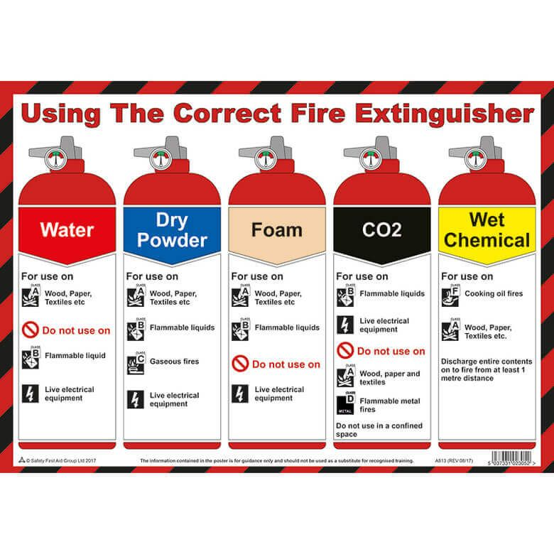

Fire and emergency procedures
The fire and emergency procedures shall be reviewed at regular intervals throughout the project’s duration or following any incident. Regular workplace fire inspections will be carried out by the Site Manager.
The Emergency Notice for this Project will be displayed on the site notice board. Details will be communicated to all personnel during their site induction. In the event of the fire alarm sounding, the Site Manager, will have ultimate responsibility for all contracting personnel on site. He will check all site personnel in line with the site register and ensure evacuation to the agreed muster point. In the event of a fire, the site manager will raise the alarm and will:

• Carry out onsite emergency response; i.e.: Use of fire extinguishers if fire is small.
• Summon emergency services
• Crowd management, including evacuation, where necessary to the muster point.
• Traffic management, including emergency vehicles
• Incident control
• Liaison with emergency services
• Provide first aid and medical assistance

Fire Risk Assessment is detailed in the appendix – APPENDIX B
Fire Plan
- If you discover smoke or a fire, unless it is of a very minor nature, do not try to extinguish it

- Alert your work mates by calling “FIRE” and leave the building in an orderly manner
- On hearing the “FIRE” call everyone must leave the building and assemble at:
SITE ENTRANCE
- The person discovering the fire must immediately alert the Supervisor, or DIAL 999 ask for the Fire Brigade, and give details of the:
Bunting Gardens
Wecock Farm
Waterlooville
PO8 9UW

Site Address:
AND
Your name
Exact location of the fire

- The Supervisor will check that everyone listed in the Attendance Register are at the assembly point.

- The names of any person listed in the Register but not at the assembly point will be reported to the Fire Brigade officer present, giving the location in which they are working

DO NOT RE-ENTER THE BUILDING FOR ANY REASON UNTIL INSTRUCTED THAT IT IS SAFE TO DO SO BY THE FIRE BRIGADE OFFICER

Location of nearest accident and emergency department

Important:
In the event of a serious accident, an ambulance must be called to transport the injured person to hospital. Please be aware that using private cars can be dangerous, particularly as there may be injuries that cannot be seen.

Fire Emergency | 999
Electricity Emergency | 0845 770 80 90
Gas Emergency | 0800 111 999
Water | 0845 920 0800
Health & Safety Executive | 0845 3450055

Using this link find the closest A&E –
https://www.nhs.uk/Service-Search/other-services/Accident%20and%20emergency%20services/LocationSearch/428

Name of Hospital | Queen Alexandra Hospital Emergency Room
Address | Hunter Road  Cosham  Portsmouth  Hampshire
Postcode | PO6 3LY
Telephone number | 02392286000
Distance in miles (on average) | 4.7 miles (13 min)

A map showing the route to the nearest A & E department follows:

Map to Nearest Hospital

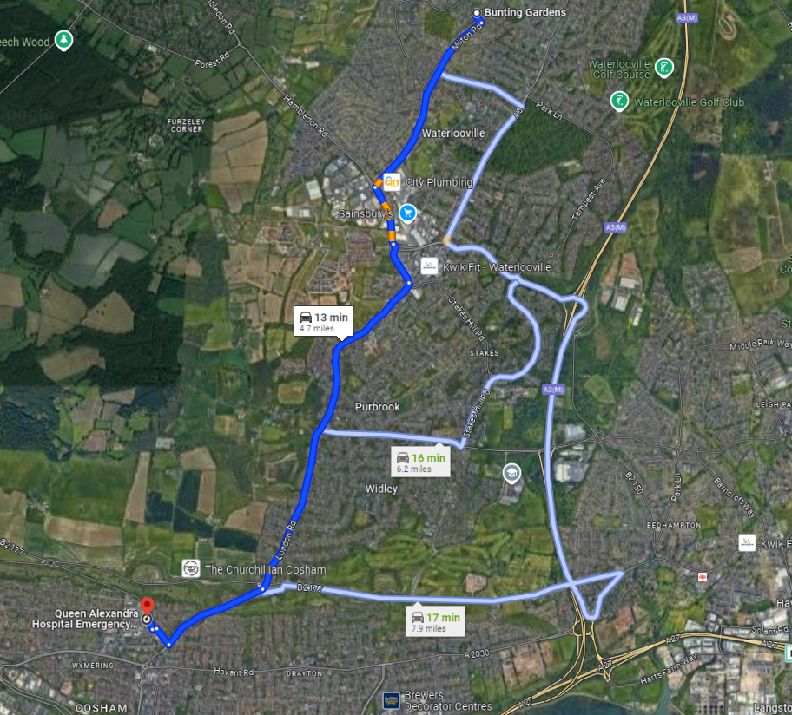

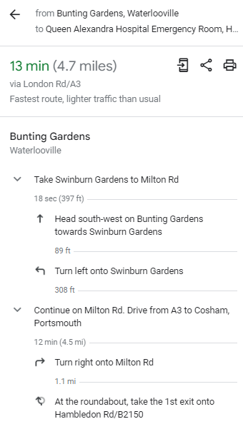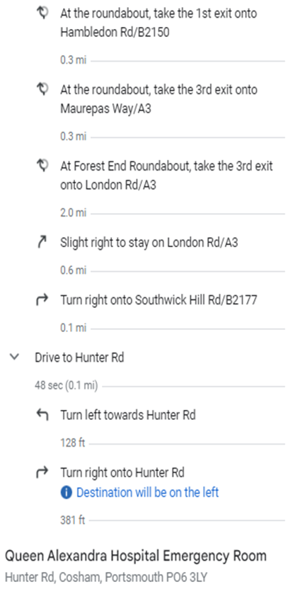

First Aid Plan

- Your nearest First Aider is the Supervisor
Andrew Parsons
07885518419

- Your nearest first Aid Box is in the Site office

- If any item in the First Aid Box needs replenishing, notify the Supervisor

- If you are taking medication, or for health reasons, you are unable to do your work safely notify the Supervisor

- In the event of an accident to yourself, or a colleague, report to the Supervisor, who will take the necessary action.

- If the Supervisor is unavailable, and further treatment in excess of first aid is required, ring the emergency services on 999

- Have the following information ready:

- The site address and your exact location
- Any local landmarks
- The type of accident
Bunting Gardens
Wecock Farm
Waterlooville
PO8 9UW
- The number, sex and age of casualties
- The suspected nature, and severity of injuries
- Any continuing hazard in the area

- The site address is

- All accidents must be reported to the Supervisor who will enter details in the Accident Register:

3 Arrangements for controlling significant site safety risks
The following significant risks are areas for DM Habens Ltd to be aware of. Suitable management arrangements will be put in place to control hazards and will be covered in the site-specific risk assessments and method statements for the works. A brief summary of likely actions is provided below.

 | Phase | Risk Description |  |  | Assess  ment | Control |  | Assess  ment |  |  | Future Action
1 | Construction |  | Site Access - Risk of road traffic accidents on highway (Bunting Gardens is a very narrow residential  street) | High |  |  | Alternative access routes were considered but no other suitable routes have been found. Site and access constraints are to be highlighted in tender documentation. |  | High | Contractor to prepare a method statement for managing deliveries and control of vehicles entering & leaving site. Contractor to ensure adequate temporary signage is  provided.
2 | Construction & Use |  | Contaminated Land - Health risks to site operatives and building users. | Medium |  |  | Desk top study and site investigations have been carried out. Site Investigations have identified the potential of asbestos to be present within the made ground. A watching brief is to be put in place to monitor the possible asbestos contamination. |  | Medium | Contractor to ensure that adequate safeguards are in place during construction and remain vigilant during excavations works for signs of further contaminants. Method statement must provide for notification and management  process of any material found.
3 | Construction |  | Buried Services - risk of electrocution, flooding, gas leaks, contamination, and loss of critical  services. | High |  |  | Record drawings provided by stats companies. Sub-surface scan carried out, and survey drawing to be included in tender documents. |  | Medium | Contractor to provide method statement for excavations near services. Contractor to CAT scan prior to all excavations and be vigilant during works.
4 | Construction |  | UXO - risk of explosion | Medium |  |  | Preliminary Unexploded Ordnance Threat Assessment carried out by specialist indicates that the site is in an area with a medium potential for wartime  bombs to be present. |  | Medium | Contractor to carry out further risk assessments and arrange for additional UXO investigations before and during groundworks if  required.
5 | Construction |  | Deep excavations. Risk of collapse. | High |  |  | Soil investigations carried out. Copy of report to be included in tender documents. |  | Medium | Contractor to provide strutting and planking to support excavations or batter sides of excavations as appropriate. Ensure all excavations are fenced and filled as soon as possible. Contractor to  provide a method statement prior to commencement of the works.

6 | Construction | Limited site access for crane - risk of injury during lifting and placing large or heavy elements. | High | Lightweight structural members specified wherever possible (eg. metal web floor joists)  Scheme design based on wide beam beam and block floor system for ground  floor to avoid the need for heavier 225mm deep beams. | Medium | Contractor to review access restrictions and ensure that suitable lifting equipment is used. Contractor to provide method statements for lifting large / heavy components.
7 | Construction | Risk of falls from height | High | Drawings clearly show that the design includes a three storey building. | High | Contractor to prepare method statements for working at height. Contractor to ensure that scaffolding is either TG20 Compliant Scaffolding or provide full design and calculations where the proposed scaffolding is outside of the scope of TG20 Compliant  Scaffolding.
8 | Maintenance | Window Cleaning - risk of falls | Medium | All opening windows are fully reversible for cleaning from the inside. | Low | Architect to provide statement for inclusion in H&S file.
9 | Maintenance | Cleaning Gutters - risk of falls | Medium | Gutters are oversized and have been designed for cleaning from the ground with high-reach vacuum system. | Low | Architect to provide statement for inclusion in H&S file.
10 | Construction | Groundworks on slopes in a confined site with wet soils etc. | Medium | Contractor offered opportunity to lay out site storage and materials movement within their site management plans | Low | Contractor to ensure suitable; machinery used on sloping levels, personnel management on and around any vehicles and materials, management and support around materials and ongoing works to  ensure safe working.
11 | Construction | Working near live cables | High | Isolate all circuits where practical | Medium | Contractor to ensure correct isolation and two men working for safety.
12 | Construction | Testing and commissioning. Live equipment tests giving  risk to electrocution. | High | Specification states that all electrical work to must be supervised by a qualified, registered NICEIC or ECA  supervising officer . | Medium | Contractor to follow correct test procedures as detailed and required by BS 7671. Using  certified test equipment only. Live  test to be undertaken when the  minimum number of persons are  on the site.  Only people who are qualified to  do Test and Inspection work are to  be allowed to carryout such work.  They must be registered as a  supervising officer with the NICEIC  or ECA and hold the correct City  and Guilds qualifications.

3.1 Delivery and removal of materials to site
All deliveries will be met by competent banksman when entering the site. Evacuation routes will be maintained at all times.
There will be a one-way system in place on the site and this will be detailed on the traffic management plan will be in place prior to the start of the works. All deliveries will be arranged so there is no build-up of delivery vehicles. Deliveries will be scheduled to coincide with work activities set out in the program following a ‘just in time’ process.
Deliveries or collections will be made between the hours of 9am – 2.30pm and 3.30pm – 5pm to avoid network peak periods.
All delivery vehicles that will be required to reverse on this site will be strictly controlled by a vehicle banksman. The turning area is as shown in the traffic management plan.
A delivery route map will be sent to all site visitors and delivery companies prior to delivering to site.

3.2 Services: water, gas, electricity
Existing service records and site survey will be obtained to establish details of services on site and around the boundary, if applicable. All services installed on the site will be recorded so that they can be protected against accidental damage. The location of services (existing and newly installed) will be marked on site where possible.

3.3 Adjacent land use
The adjacent land surrounding the Contractors site compound is all residential properties, public
footpaths and roads.

3.4 Impact on other neighbours
We will work within the time frames set out in the contract; a resident letter drop will be issued to local residents before the course of construction.
Noisy activities will be minimised where practicable.

3.5 Delivery times / restrictions on working
Deliveries or collections will be made between the hours of 9am – 2.30pm and 3.30pm – 5pm to avoid network peak periods. Permitted hours of working are:
- Monday to Friday 07.30am to 5pm
- No work is permitted outside these times due to planning restrictions.

Hauliers will be made aware of traffic restrictions around the site.
A Haulage area will be on site where deliveries can enter through the vehicle gates and off load materials, this will be manged by the site manager and banksman, as per 3.1 this is also notated on the site logistics plan.
The neighbouring properties will be contacted prior to the commencement of site activities and provided with the contact details of DM Habens The Builder Ltd staff to which they can raise any concerns regarding the works.
Clear signage will be displayed on the roads surrounding the site to warn of the presence of construction vehicles.

3.6 Excavations
All excavations will be undertaken within a permit to work system. A cable avoidance tool will be used by a competent person as part of the permit to work system. Work will be undertaken in accordance with HSG 47 “Avoiding Danger from Underground Services”.
Where a competent person deems it necessary to batter or shore an excavation, a record will be kept of regular inspections in accordance with regulation 22 of the Construction (Design and Management) Regulations 2015:

- at the start of the shift in which the work is to be carried out
- after any event likely to have affected the strength or stability of the excavation
- after any material unintentionally falls or is dislodged

All excavations will be adequately protected by physical barriers. No person shall enter the excavation without a suitable rescue plan being produced and discussed as part of the risk assessment briefing.

3.7 Temporary Works
Site Hording
Scaffolding
We will update and amend when needed through the construction

3.8 Working at height/preventing falls on site.
Work at height will be avoided where possible. Where access is required, collective protection must be considered (fixed guarding) or location of items from a fall risk area to ensure that the working zone is a place of safety. Where this cannot be achieved, then measures to mitigate consequences of a fall will be considered (Personal Protection).
Working at height will involve using ladders, podium steps, tower scaffold or mobile elevating work platforms. All work at height will be undertaken in accordance with the Work at Height Regulations 2005.

All scaffolding will be erected in accordance with the design or as per TG20:21 requirements. Scaffold will be inspected in accordance with section 12 of the Work at Height Regulations.

The following inspections will be carried out by a competent person.
- Before first use as part of the handover from the scaffolder.
- Every seven days if the scaffold has not been altered.
- After every adaption.
- After any incident that will affect the structural integrity of the scaffold.
- All scaffold inspection records will be kept on site until the end of the project and then in head office for a further three months. Forms will be kept with the site safety file.
- Scaffold towers will be erected by PASMA qualified individuals.
- Mobile Elevated Work Platforms will only be operated by IPAF qualified individuals.

3.9 Controlling of lifting operations
A Lift Plan to be prepared for all significant lifting operations and a trained, competent lifting operations coordinator to be appointed.
Only trained and competent banksman/ slingers will be permitted to bank the crane and sling loads.
Ensure test and thorough examination certificates are current and available and weekly inspections of the crane are carried out and recorded.

Lifting operations that do not require a Lifting Plan (such as standard lifts by forklift or excavator) will require a lifting checklist to be completed by the site team.

3.10 Maintenance of plant and equipment
All plant will be inspected prior to use by the operator. A weekly report sheet will be required from each Contractor for the plant that they have on site. Certificates for any plant requiring thorough lifting examination on site will be presented to the Site Management prior to its use.

Small tools will be 110v or battery powered. Electrical hand-held tools will undergo a Portable Appliance Test every 3 months.

3.11 Traffic routes; segregation of vehicles and pedestrians
The Traffic Management Plan details the following:
- Traffic routes / turning areas
- Parking
- Vehicular/pedestrian access/egress from site
- Segregation of vehicles/plant and pedestrians/operatives
- Material unloading areas

3.12 Storage of hazardous materials and work equipment
Contractors will be made aware of their responsibilities and any such materials will be suitably stored in areas where they will not affect others or the environment. The arrangements for storage of such items will be detailed in the risk assessments/method statements provided by subcontractors.

Storage of diesel on site will be within a double bunded container. The bunding must have the capacity to hold 110 percent of the capacity of the container. Spill kits will be located next to each site next to the diesel storage.

Waste management

All waste will be segregated into separate skips, general waste, clean hardcore, soil’s plasterboard etc the skips will all have signage in place

All waste removed from site will be recorded where a document will be produced from the waste disposal company.

Arrangements for Controlling Significant Site Health Risks

4.1 Asbestos

As this is a new build project, an asbestos survey is not required. However, during the excavation phase, a trained and competent banksman will be present for all excavation activities. The banksman will hold asbestos awareness training and be capable of identifying any suspected asbestos-containing materials (ACMs) that may be uncovered unexpectedly. If such materials are identified, work will immediately cease, and appropriate measures will be taken to assess and manage the situation in compliance with health and safety regulations.

4.2 Manual Handling
Manual handling will be reduced as far as is reasonably practicable by the use of mechanical means.
Where possible the manual handling risk will be reduced through the use of trolleys and pallet trucks. Sub-contractors will be required to consider the risk of manual handling tasks through their risk assessments and method statements.

4.3 Use of hazardous substances
COSHH assessments will be produced by the employers of those affected for hazardous materials used during the construction phase. COSHH assessments will be presented and explained to operatives.

4.4 Reducing noise and vibration
Noisy activities will be minimised where practicable. Suitable PPE will be worn. The standard required will be identified within the risk assessment and will be communicated to the operatives. Where necessary hearing protection zones will be established and clear signage posted to indicate their boundaries.
Records will be kept by individual employers of exposure to vibration. DM Habens Ltd will expect Subcontract employers to comply with their duties under the Control of Vibration Regulations 2005.

4.5 Lone Working
On rare occasions site managers/supervisors may be required to be on site alone. The need for lone work will be avoided were reasonably practicable. If such occasions are to occur the site management team will be required to adhere to the following procedures:
- No use of heavy plant or machinery whilst alone on site.
- Not undertake high risk manual handling tasks
- Have access to a mobile phone at all times.
- Be required to contact the company office upon leaving site.
- Office representatives to be made fully aware of the location of site-based staff and the lone working procedures.

Arrangements for providing Health and Safety information

5.1 Responsibilities
- DM Habens Ltd Technical Department in liaison with their safety consultant will be responsible for compiling the health & safety information during and at the end of the project.
- During the construction phase of the project the health & safety information will be located and managed at DM Habens Ltd Head Office.
- On completion of the construction works the health & safety file will be submitted to the Client in both electronic and hardcopy format.

5.2The Health and Safety File
DM Habens Ltd shall provide sufficient information for the Health and Safety File as required by the Construction (Design and Management) Regulations 2015. The Health and Safety File shall be prepared by DM Habens Ltd for review by the Principal Designer based upon the following. Summary text shall be provided by the Principal Designer. Key Health and Safety File information shall include the following:
- A brief description of the work carried out
- Any hazards that have not been eliminated through the design and construction process, and how they have been addressed (e.g., surveys or other information concerning asbestos or contaminated land)
- Key structural principles (e.g., bracing, sources of substantial stored energy – including pre- or post-tensioned members) and safe working loads for floors and roofs
- Hazardous materials used (e.g., hazardous substances, lead paints and special coatings that should not be burnt off)
- Information regarding removal or dismantling of plant and equipment (e.g., any special arrangements for lifting such equipment)
- Health and safety information about equipment provided for cleaning or maintaining the structure
- The nature, location and markings of significant services, including underground cables; gas supply equipment; fire-fighting services etc.
- Information and as-built drawings of the building, its plant and equipment (e.g., the means of safe access to and from service voids and fire doors)

The Health and Safety File shall be prepared in parallel with and, when appropriate, co-ordinated with DM Habens Ltd completion handover documentation. All the information provided by DM Habens Ltd for the Health and Safety File shall be provided electronically. Portsmouth City Council has a document Pro Forma that will be issued to the Contracts Manager. A draft copy of the file shall be provided a minimum of two weeks prior to practical completion for review. The final version shall be in place before practical completion is granted.

6 APPENDICES
- APPENDIX A - Site Rules
- APPENDIX B - Fire Risk Assessment
- APPENDIX C - Site Location Plan
- APPENDIX D – Eco Map

APPENDIX A
Site Rules

Site Rules
- Report to the Site Manager on arrival at site and sign in.
- Attend the site induction and act on what is said.
- Read and work to your risk assessment/method statement – if you have any problems with the contents raise these with your supervisor immediately.
- Wear the minimum personal protective equipment at all times.
- Wear additional personnel protective equipment when it is deemed necessary for any specific undertaking or activity.
- Ensure plant and tools are secure when left unattended preventing unauthorised use.
- Do not use radios or personal music equipment on site.
- Do not consume food or drink on site other that in the canteen.
- Any operative suspected of being under the influence of drugs and/or alcohol will be told to leave site and their respective employer will be informed.
- Inform the Site Manager if you have been prescribed medicines or have a medical condition that may be relevant for the work that you carry out.
- Do not interfere or misuse anything provided in the interests of health and safety.
- If you require an adaptation to scaffolding, inform the Site Manager - do not attempt it yourself.
- If you see any hazardous situations, tell the Site Manager.
- Keep the site in a tidy condition – trips and slips cause the majority of site accidents.
- Store equipment in the designated areas only.
- Report all incidents, spills, near misses and accidents to the Site Manager.
- Ensure safe working practices are followed as detailed in individual risk assessments and method statements.
- Be familiar with the location of First Aid Equipment, Fire Extinguishers, Fire Exits and the Site Assembly Point.
- Smoking is NOT permitted on site.
- All reversing vehicles must be marshalled until the vehicle is ready to be driven forward
- Deliveries using mechanical handling equipment such as skip deliver or HIAB lorry mounted cranes will be under the control of a banksman.
- No “Bombing” of materials on site.

Any personnel who breach Health & Safety site rules will be subjected to disciplinary procedures

APPENDIX B
FIRE ASSESSMENT

Hazard № | Hazard Description | Existing Controls | Risk Rating  L R S |  |  | Additional Controls Required  (To be enforced and monitored by Site Manager) | Residual  Risk Rating  L R S
1 | Smoking | None | 3 | 5 | 15 | Smoking is NOT permitted on site | 1 | 5 | 5
2 | Arson | Security fencing consisting of hoarding / “Heras” fencing and use of existing boundary fencing. | 2 | 5 | 10 | All skips to be lockable.  Security lighting to be considered.  Heras fencing to site compound. | 1 | 5 | 5
3 | Waste | Good housekeeping required to reduce waste build up within the building. | 3 | 5 | 15 | All waste to be stored in lockable skips segregated from the building and will be stored within the site compound. | 1 | 5 | 5
4 | Electricity | None | 2 | 5 | 10 | All electrical connections to be made by qualified personnel, certification to be supplied.  All 110v supply to site to be fitted by qualified personnel, certification to be supplied.  All 110v equipment used on site to be PAT tested as per HSE guidance.  240v appliances only allowed within office / welfare area i.e. microwave, printers, chargers etc. | 1 | 5 | 5
5 | Hot works | Permit to work system in operation. | 3 | 5 | 15 | Consider with designers all possibilities for the building out of hot works.  Limit hot works to a controlled area away from buildings where possible.  Ensure checks are made an hour after works have been completed. | 1 | 5 | 5
6 | Emergency response | Appointed Fire Safety Co-ordinator | 2 | 5 | 10 | The local fire service to be contacted by the Site Manager to inform them of our presence and the address and contact details. | 2 | 4 | 8
7 | Safe Storage of Materials including flammables and LPG | Storage to be kept 15m away from all buildings. | 3 | 5 | 15 | Any containers or drums must be kept more than 6 m away any wall or boundary fence. | 1 | 5 | 5
Risk Assessment Matrix

 | Severity (S) | Fatal | Major | Minor | Trivial | No Injury
Likelihood (L) | Score | 5 | 4 | 3 | 2 | 1
Likely (1:10) | 5 | 25 | 20 | 15 | 10 | 5
Probable (1:100) | 4 | 20 | 16 | 12 | 8 | 4
Possible (1:1000) | 3 | 15 | 12 | 6 | 6 | 3
Remote (1:10,000) | 2 | 10 | 8 | 6 | 4 | 2
Improbable (1:100,000) | 1 | 5 | 4 | 3 | 2 | 1

APPENDIX C
Site Location Plan
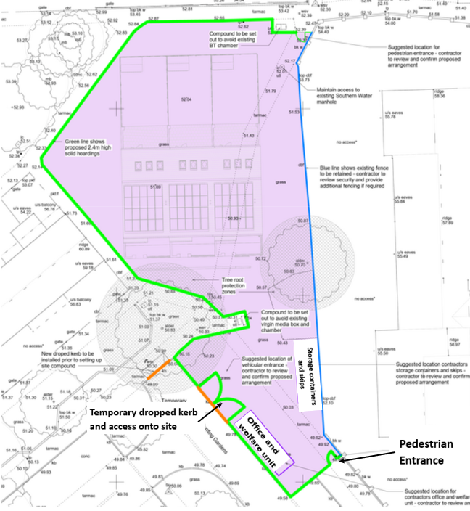

APPENDIX D
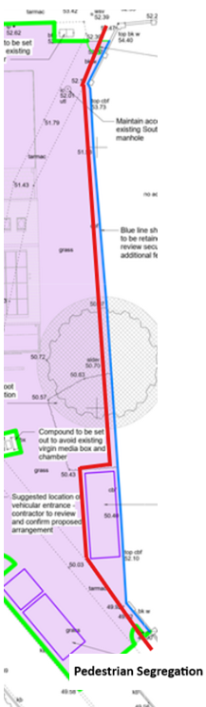
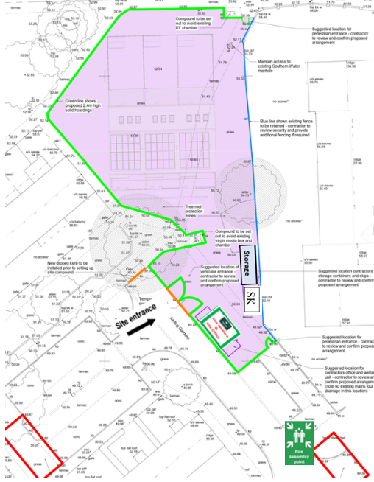
Eco Map

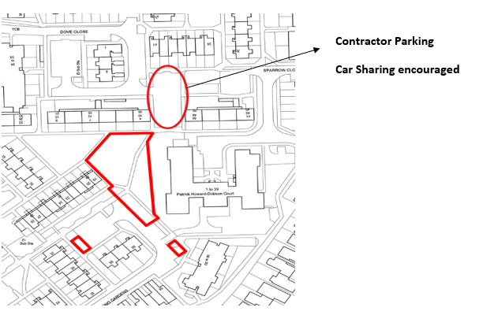
Eco – Map Contents List
