Flood risk assessment
Property:
Swan House
Bath Road
Emsworth
PO10 7ES

Proposal
Raise height of existing flood wall by 330mm

Version: 2

Date: 19/07/24

BACKGROUND
The site is identified as being in a Flood Zone 3 and this development is believed to satisfy the policy CS15 and the proposals are in line with the Coastal [defence] Strategy.

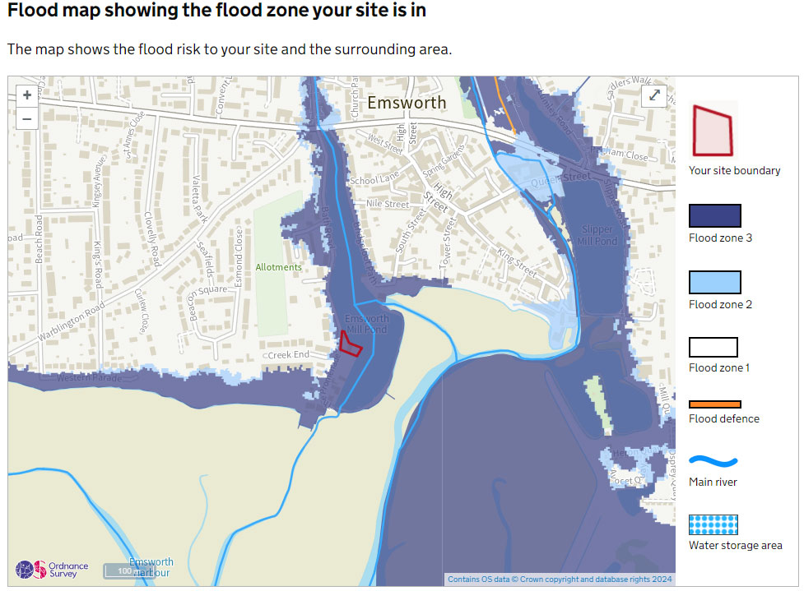

According to policy CS15 Flood and Coastal Erosion Risk, development will be permitted where
- site-specific flood risk assessment demonstrates that the development will be safe, including the access, without increasing flood risk elsewhere, and, where possible, will reduce flood risk overall.
- The scheme incorporates flood protection, flood resilience and resistance measures appropriate to the character and biodiversity of the area and the specific requirements of the site.
- Appropriate flood warning and evacuation plans are in place.
The residual flood risk is managed on this site by the existence of a flood warning and evacuation plan for the property.

It is understood that in the high risk / functional flood plan areas of flood zone 3, water-compatible
development, such as flood defence infrastructure is acceptable under the NPPF and related guidance and will not result in a loss of floodplain storage, impede water flows and will not increase flood risk elsewhere. Local policy DM25 provides support for development for flood risk management in Emsworth. As this proposal will increase flood defence at this particular property, it is consistent with DM25.

It should be noted that in 2016 the Environment Agency (EA) raised no objection to raising the flood wall at this property, and considering the NPPF requirements it confirmed that the works would not increase risk of flooding in the surrounding area. Also in the past the Coastal partnership has confirmed no objection.

REASONS FOR THE PROPOSAL

On Tuesday 9th April there was a very high tide and many of the applicant’s neighbours flooded to some degree. The applicants were lucky and due to the flood wall that was built in 2016 and extended in 2016, they did not flood although it was very close and within 75mm of the top of their wall.

The applicant would now like to raise the flood wall around their property, to protect them against flooding in the future due to extra high tides, by 330mm to match the height of the low wall which bounds their property to the West side, along Bath Road.

The applicant believes this would enhance the look of the property whilst giving them the added flood protection they would like to achieve.

PROPOSAL

The proposal is to raise the existing flood wall that backs onto the Mill Pond by 330mm via a mixture of rendered concrete block (to match the existing) and a glass flood wall sat between aluminium support polsts. Please see the submitted proposed site plan and proposed elevations for details of which areas are glass and rendered concrete block.

The glass flood wall will be supplied and installed by MM Engineering who are specialist flood defence Engineers. Qingdao Mingyu Industry Co., Ltd. Are the suppliers of the glass and have been chosen by MM Engineering as they have a good relationship with them and they provided the glass panels for the Belfast flood alleviation scheme they are involved with.

We will be using closed cell EPDM scrim backed seals, a 25mm x 25.5mm seal will be used between the bottom glass edge and the substrate and 2 x 20mm scrim backed EPDM seals will run vertically on the wet and dry side within each post channel with the glass panel sandwiched in between. There is a specific tolerance added between the glass and posts to allow the glass panel to essentially float within the opening to allow for any construction tolerances and expansion and contraction in the material.

About MM Engineering –
MMEngineering in Port Talbot are a specialist defence engineering company that survey, design, manufacture and install high quality and bespoke flood defence solutions across the UK and export internationally. To date they have provided flood defence solutions on multiple schemes across the UK with the largest glazing projects being the Belfast flood alleviation scheme, Hawick flood alleviation scheme, Hessle foreshore and they have upcoming projects starting in Bewdley and Aberaeron this year.

METHOD STATEMENT
Swan House – Bath Road, Emsworth

Introduction
This Method Statement covers the operations required to safely carry out raising the existing boundary wall to Swan House, Emsworth.

Construction Team
The building work will be carried out by Nutbourne Construction who built the extension to the flood wall in 2016, as well as building the garage and porch extension at the same time. The glass wall has been designed and will be installed by MMEngineering who have extensive experience in this area. Both teams have experience in similar projects and fully understand the sensitivity and beauty of the surrounding area.

Method of Works
The works to the existing retaining wall to the Mill Pond will not require any heavy plant or any
machinery for the construction, nor will any heavy plant or any machinery enter the Mill Pond. All the work will be done by hand. The only machinery required is a concrete mixer to enable a total of c 240 concrete blocks to be laid. Glass panels will be inserted into the aluminium supports by hand using suction devices.

Timing of the Works
The works on site will be weekdays between 8am and 5pm.

Road Access
The property is accessed off Bath Road. Bath Road will remain accessible to vehicles and pedestrians at all times. All materials will be stored on site at all times.

Tree on Site
There is a Weeping Willow to the North East of the site. A detailed survey has been undertaken by Encompass Surveys that has established the exact location of this tree. The Willow at its closest to the boundary is 2.7m. The wall repair around the tree will not be taken below ground level, therefore the roots will not be damaged.

CONCLUSION
A recent identified flood risk on 10th July by MMEngineering identified the need to increase the existing flood wall height to protect the property. The proposed increase in height of the flood wall using rendered concrete blocks and a low glass flood wall will be supplied and installed by a specialist in their field.

In summary this work considerably reduces the very real flood risk to this property due to climate change and it is intended to carry the work out prior to winter 2024.

