GENERAL RISKS & CONTROLS
Classification (state the category of danger)
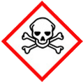 | ☐ |  |  | Serious Health Hazard/Toxic |  |  |  | 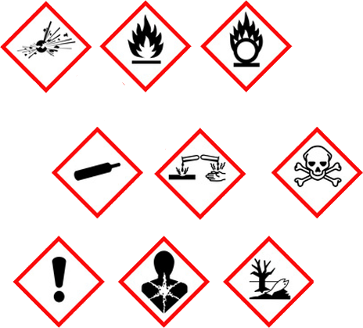 |  | ☐ |  | Oxidising |  |  | 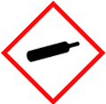 |  |  | ☐ |  |  | Gas Under Pressure
 | ☒ |  |  | Health Hazard/ Harmful/Irritant |  |  |  |  |  | ☒ |  | Flammable |  |  |  |  |  | ☒ |  |  | Acute Toxicity/ Carcinogen
 | ☐ |  |  | Corrosive |  |  |  |  |  | ☐ |  | Explosive |  |  |  |  |  | ☒ |  |  | Dangerous for the Environment
Hazard Type
☒ |  |  | ☐ |  |  | ☐ |  |  | ☐ |  |  |  | ☐ |  |  | ☐ |  |  |  | ☐ |  |  | ☐
Gas |  |  | Water |  |  | Mist |  |  | Fume |  |  |  | Dust |  |  | Liquid |  |  |  | Solid |  |  | Other
Route of Exposure
☒ |  | ☒ |  |  |  |  | ☒ |  |  |  | ☒ |  |  | ☐
Inhalation |  | Skin |  |  |  |  | Eyes |  |  |  | Ingestion |  |  | Other (state)
Workplace Exposure Limits (WELs) please indicate n/a where not applicable |  |  |  |  |  |  |  |  |  |  |  |  |  |  |  |  | 68mg Derived No Effect Level
Storage & Handling |  |  |  |  |  |  |  |  |  |  |  |  | Hazard Symptoms
- Store in cool, well ventilated area. Do NOT remove warning labels.  - Keep container tightly closed / Open slowly in order to control possible pressure release.  - Empty drums should be drained and safely stored away from full drums before disposal.  - Store on bund 110% capacity of container, and impermeable ground. Keep stored away from possible impact.  - Store away from sources of heat and ignition.  - Use mechanical aids when moving/handling full, and empty drums. |  |  |  |  |  |  |  |  |  |  |  |  | - Flammable liquid and vapour.  - May be fatal if swallowed and enters airways.  - Causes skin irritation. Causes eye irritation  - May cause damage to liver, kidneys and nervous system by repeated and prolonged inhalation.Toxic to aquatic life with long lasting effects.  - Harmful if ingested.  - Gases and vapours may contribute to a flammable atmosphere.
Controls |  |  |  |  |  |  |  |  |  |  |  |  | Remedial Actions
- Keep away from heat, sparks, open flames, welding and hot surfaces  - Do not siphon by mouth  - Wear PPE to prevent skin and eye contact with liquid.  - Avoid breathing vapours or mists. Do not eat, drink or smoke when using this product.  - Keep in bund container 110% capacity of container, on impermeable ground.  - Wash hands or liquid-contacted skin thoroughly after handling  - Use only outdoors or in a well-ventilated area. |  |  |  |  |  |  |  |  |  |  |  |  | - Eliminate all ignition sources.  - Stop leak if you are able to without risk.  - Prevent entry into waterways, sewers, basement, and confined spaces.  - Absorb or cover with dry earth, sand, or other non-combustible material.  - Use clean non-spark tools to collect absorbed materials.
Disposal
Hazardous Waste?  ☒ |  |  |  |  | Skip  ☐ |  |  |  |  |  |  |  | Other ☒  - Dispose of waste or residues in accordance with local authority.  - Recycle packaging where applicable.  - Do NOT burn substance.
Return to Depot  ☒ |  |  |  |  | Return to Supplier  ☐
FIRST AID   |  |  |  |  |  |  |  |  |  |  |  |  | FIRE FIGHTING  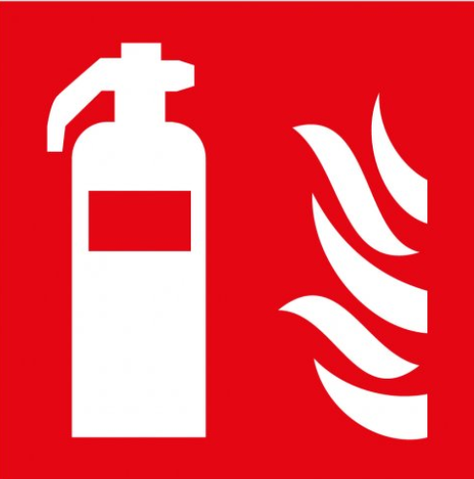
- Dry wipe exposed skin and cleanse with waterless hand cleaner, follow by washing with soapy water.  - If respiratory irritation, dizziness, nausea, or unconsciousness occurs, seek medical advice. |  |  |  |  | - Flush thoroughly with water. If irritation occurs seek medical assistance.  - Seek immediate medical attention. Do NOT induce vomiting.  - Remove victim from further exposure. |  |  |  |  |  |  |  | WATER  ☒ |  | FOAM  ☒ |  | POWDER  ☒ |  |  |  |  | CO2  ☒ |  | CHEMICAL  ☐
PRECAUTIONS:
Do NOT use solid water Jet, use mist spray. Avoid residual water run-off into drains.
SITE SPECIFIC CONTROLS
Work Activities Being Undertaken
Fuelling of Plant & Equipment on site
Exposure
Number of Persons |  |  |  | Frequency |  |  |  |  | Duration |  |  |  |  | Any specific training requirements?
5-10 |  |  |  | Daily |  |  |  |  | 30 mins |  |  |  |  | ☐
Personal Protective Equipment (PPE) Control Measures
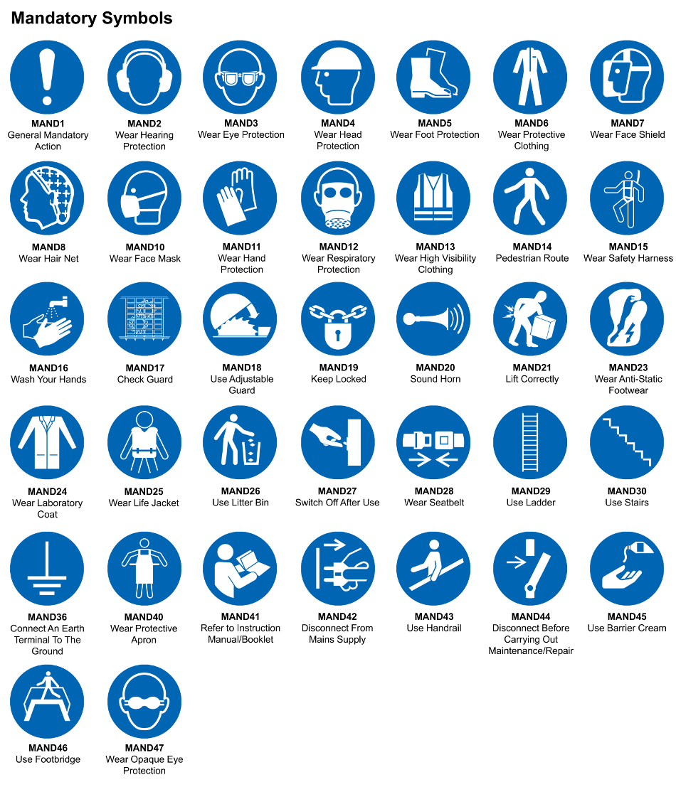
☒ | ☐ |  | ☐ |  | ☐ |  |  | ☐ |  | ☐ |  | ☒ |  |  | ☐ |  | ☐
Eye Protection | Ear Protection |  | Hard Hat |  | Footwear |  |  | Overalls |  | Visor |  | Gloves |  |  | Face Mask |  | Respirator
Storage Requirements
LOCKED CAGE |  | BUNDED CONTAINER |  |  |  |  | PROTECTION  FROM WEATHER |  |  |  | COSHH STORAGE ROOM |  |  |  |  | SEALED CONTAINER
☐ |  | ☒ |  |  |  |  | ☐ |  |  |  | ☐ |  |  |  |  | ☐
Waste Management
SEGREGATED STORAGE |  |  |  |  |  | SEALED CONTAINERS |  |  |  |  |  |  | WASTE CARRIER DISPOSAL / RECYCLING LICENCE
☐ |  |  |  |  |  | ☒ |  |  |  |  |  |  | ☐
Risk Rating Following Control Measures
LOW |  |  |  |  |  | MEDIUM |  |  |  |  |  |  | HIGH
☒ |  |  |  |  |  | ☐ |  |  |  |  |  |  | ☐

Site Specific RA Prepared by: | Si King | Position: | Contracts Director
Site Specific RA Prepared by: | Si King | Review Date: | 27/09/2023

