

Construction Environmental Management Plan

Bunting Gardens

Contract Name: | Bunting Gardens
Contract Address: | Bunting Gardens, Waterlooville,
Postcode: | PO8 9UW
Date: | 17/12/24

CEMP Plan

Site Name: Ref No:
4550
Bunting Gardens
Contents
- Introduction .
- Legal and Regulatory Requirements
- Environmental Management Roles and Responsibilities
- Environmental Risk Management
- Emergency Spill Response Plan
- Training and Awareness

7 Monitoring, Reporting, and Review………………………………………………………….

8 Appendences ………………………………………………………………………………….
CEMP Plan

Site Name: Ref No:
4550
Bunting Gardens

Construction Environmental Management Plan
 | Date of Issue | Reason for Revision and Comments
1 | 12/02/24
2
Author | Alan Gruss
Date | 12/12/2024

 | Issue 1 Revision 1 | December 2024 | Page 3 of 8

CEMP Plan

Site Name: Ref No:
4550
Bunting Gardens

1 Introduction

Purpose: | The objective of the CEMP is to mitigate environmental risks during construction.
Scope: | The works comprise of the construction of 3nr four- bedroom houses together with associated parking and external works.  Date for Commencement of the Works: July 2024 Date for Completion: March 2025
Project Details: | The site is surrounded by residential properties including council owned masionettes, and  former council owned houses, most of which are now privately owned. To the east of the site is  Patrick Howard Dobson Court sheltered housing. The main site access will be by the way of Bunting Gardens via Swinburn Gardens. Bunting  Gardens and Swinburn Gardens are very narrow residential streets with kerb side parking, and tight junctions

Legal and Regulatory Requirements
- A Summary of relevant environmental legislation and guidelines.
- Specific permits and licenses required for the construction activities.

 | Issue 1 Revision 1 | December 2024 | Page 4 of 8

CEMP Plan
Site Name: Ref No:
4550
Bunting Gardens

- Environmental Management Roles and Responsibilities
- Outline the roles of personnel responsible for environmental management, including Site Manager, Environmental Officer, and subcontractors.
- Reducing, water, energy and material consumption
- Turning off non required electrical tools and lighting
- Minimizing waster through practices like recycling
- Define lines of communication for reporting environmental incidents.

Environmental Risk Management
  - Management of Overland Runoff
    - Objective: Minimize sedimentation, and pollution from surface water runoff.

Measures: Use permeable materials for roadways, walkways etc. allowing rainwater to filtrate into the ground instead of running off
      - Regularly monitor heavy rainfall rainwater runoff from the site

Monitoring:
      - Conduct weekly inspections and after heavy rainfall.

Storage and Handling of Hazardous Materials
    - Objective: Prevent spills, leaks, and contamination of soil and water resources.

Measures:
      - Store hazardous materials in designated areas with secondary containment.
      - Keep Material Safety Data Sheets (MSDS) available for all hazardous substances on site.
      - Label all hazardous material containers clearly.
      - Limit storage to the quantities required for immediate use.
      - Develop and implement spill response procedures.

Monitoring:
      - Weekly inspection of storage areas for leaks or damage.
      - Inventory checks to ensure proper storage practices.

Management of Chemicals and Hydrocarbons
    - Objective: Prevent environmental harm from chemical and hydrocarbon use and storage.

Measures:
      - Store fuel and lubricants in double-skinned tanks or with secondary containment.
      - Use drip trays during refuelling or maintenance of machinery.
      - Train staff on safe handling and emergency spill response.
      - Maintain spill kits at easily accessible locations.

Monitoring:
      - Regular checks for leaks or spills.
      - Ensure proper disposal of chemical and hydrocarbon waste through licensed contractors.

 | Issue 1 Revision 1 | December 2024 | Page 5 of 8

CEMP Plan

Site Name: Ref No:
4550
Bunting Gardens

Temporary Drainage Infrastructure
    - Objective: Ensure effective management of stormwater to prevent waterlogging and pollution.

Measures:
      - Permeable materials to be installed such as concrete, tarmac, type 1 limestone the benefit in this is to prevent waterlogging

Monitoring:
      - Measure sediment levels in storm water run off, to make sure the effectiveness of the permeable material is adequate
      - Maintain logs of drainage system performance

Emergency Spill Response Plan
- Spill Response Procedure:
  - Stop the source of the spill immediately if safe.
  - Contain the spill using spill kits, sandbags, or other materials.
  - Clean up and dispose of contaminated materials safely.

Contact Information:
  - Emergency contacts, including environmental authorities and waste disposal services.

Training and Awareness
- Objective: Ensure all personnel understand their environmental responsibilities.

Measures:
  - Conduct induction training covering key environmental risks and CEMP procedures.

Monitoring, Reporting, and Review
- Monitoring:
  - Frequency and methods for inspecting environmental controls (e.g., visual inspections, testing).

Reporting:
  - Record-keeping for all inspections, incidents, and corrective actions.
  - Submission of periodic reports to relevant authorities.

Review:
  - Schedule regular reviews of the CEMP to incorporate lessons learned or regulatory changes.

Appendices
 | Issue 1 Revision 1 | December 2024 | Page 6 of 8

CEMP Plan

Site Name: Ref No:
4550
Bunting Gardens

- Site Map
  - Site Layout

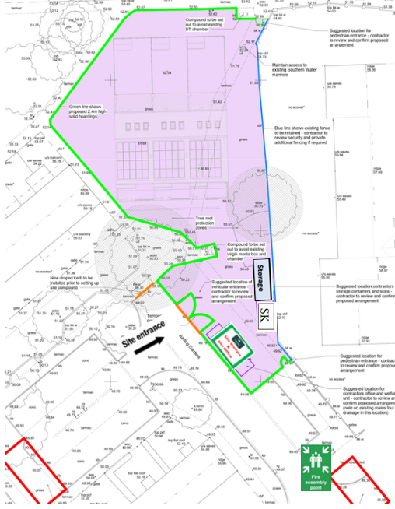

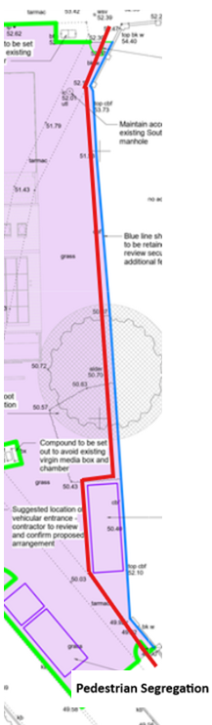

 | Issue 1 Revision 1 | December 2024 | Page 7 of 8

CEMP Plan

Site Name: Ref No:
4550
Bunting Gardens

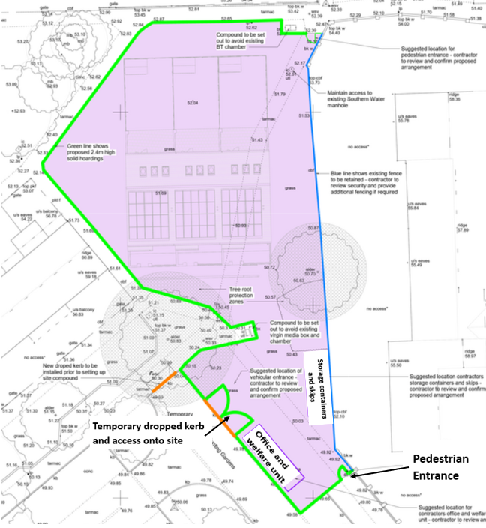

 | Issue 1 Revision 1 | December 2024 | Page 8 of 8

