DESIGN & ACCESS STATEMENT
FLOOD RISK STATEMENT
BIO DIVERSITY ASSESSMENT

In Support of Design for

Proposed two storey side extension, single storey rear extension
with external alterations including replacement flat roof to existing
rear conservatory.

At

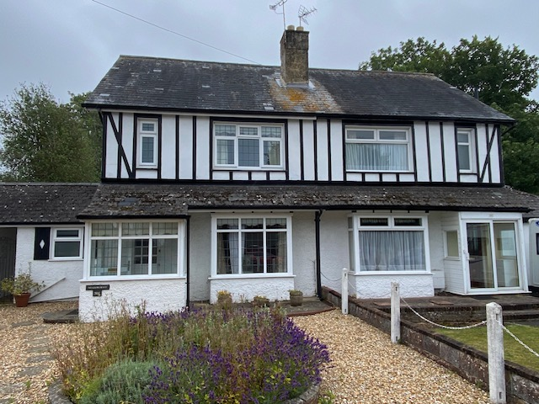
204 Park Avenue
Waterlooville
PO7 5EZ

For

Mr & Mrs H Harding

By

BH Architecture Ltd
Heath Cottage
Newlands Lane
Waterlooville
PO7 5SQ

On

30th September 2024

- LOCATION
The site is located to the northern end of Park Avenue close to its junction with Stakes Road. This area is mostly residential with a mixture of dwelling types including detached, semi-detached houses and bungalows, some of which have off road car parking.

The local shops and amenities are a short distance away in Purbrook with larger shopping facilities in Waterlooville available within a short car journey.

The location has very good road connections to adjacent M27, A3, A27 to the surrounding areas. This particular house is semi-detached, constructed approx. 1900’s, masonry construction, situated on a very large plot backing onto Alameda Way to the east. There is a blanket TPO area towards the eastern part of the site located a considerable distance away from the property. Within this area are a number of protected trees, it has not been regularly maintained for a number of years.

- SITE USE
The semi-detached dwelling is utilised as a family dwelling, accommodation includes three bedrooms, family bathroom, living room, kitchen, shower room, dining room and a conservatory. The house benefits from a driveway with off road car parking for two vehicles, a single attached garage together with a rear access, front garden, a large rear garden mostly laid to grass and a large patio area, see photograph below.

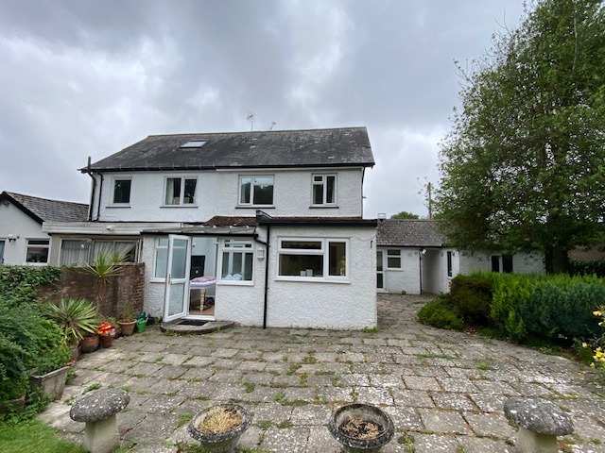

- PLANNING MATTERS
We have carried out a planning search on your website via Public Access and this property has had various applications to carry out works to trees within the TPO blanket area, the earliest in 2007, the latest in 2024. There are no planning applications concerning construction activities.

- FLOOD RISK
We have carried out a search on The Environmental Agency website and discovered this property has a very low risk from flooding from Rivers and Sea (less than 0.1% risk per year) and a medium risk from flooding from surface water (between 1 – 3.3% risk per year).

We can confirm these proposals will not put any more persons at risk in this property as there will be no increase in occupancy, floor levels of the proposed ground floor extensions will match the existing.

- PROPOSALS / BIO DIVERSITY
Our clients have recently purchased the property, it has been ‘uncared’ for a number of years and is in need of general refurbishment. As part of these works our clients wish to enlarge the property to a four-bedroom dwelling. This will be created by a two-storey side extension to enable a master bedroom suite to be created at first floor level.

As part of this process the existing holly tree (T1) to the rear garden will need to be removed. We understand there is no TPO on this specimen, see photograph below. There is no evidence of roosting birds, cracks, splits, cavities and we conclude its removal will not affect the bio-diversity on this site.

Please note the proposals are some considerable distance away from the blanket TPO area to the east of the site.

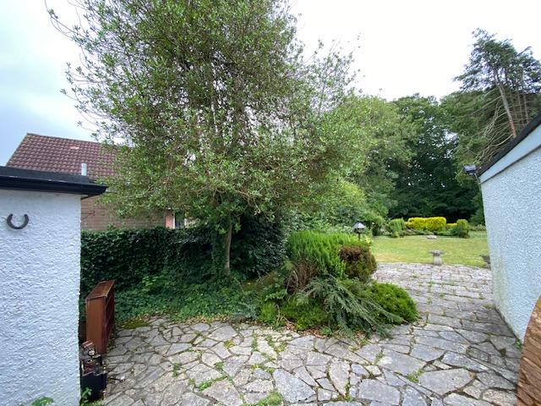
The current ground floor rooms need to be adjusted and enlarged to suit today’s modern living standards; this will be complimented by a single storey rear extension. The current glazed roof to the conservatory will be removed and replaced with a flat roof as detailed, an open plan concept will be employed for the rooms facing the rear garden.

A large set of bi-folding doors to be fitted to allow access into the beautiful garden to create an inside / outside environment on better summer days.

- DESIGN
Our proposals are two-fold, firstly to provide more habitable accommodation, secondly to improve the ground floor layout in terms of enhanced design and circulation.

Our design involves the construction of a two-storey side extension, dimensions approx. 3.8m width x 6.3m depth, this will create a master bedroom suite on the first floor and an enlarged kitchen / dining room to the ground floor. The accommodation to the ground will be improved by a single storey rear extension, 3.8m width x 4.35m depth as detailed.

The two-storey extension will be set back to be subservient from the main elevation to allow the architectural appearance of the pair of semi-detached dwellings to be maintained when viewed from the public highway.

Internal accommodation to provide an open plan kitchen / dining room, this to be achieved by removing a section of the existing cavity wall to create a pleasing internal environment. To enable access into the garden large bi-folding doors are to be inserted as detailed.

Other internal improvements include the creation of a much-needed store area off the attached single garage. As the direct access from the front to the rear of the house is being lost a double door will be inserted in the rear wall of the garage to allow access into the garden for larger equipment via the garage.

As part of the scheme the current glazed roof to the conservatory will be removed and replaced with a new flat roof which will marry into the current / proposed single storey rear extension. To enable further natural daylight to enter the back of the house a roof lantern will be inserted as per the drawings. The scheme is completed by providing a utility room utilising part of the existing kitchen which will allow the washing machine / dryer to be hidden from view.

Externally the two-storey extension will be of masonry construction, K render finish, colour to client choice, Eternit or similar man-made roofing tiles, colour to match the main roof. As part of this process the timber faming to the street elevation will be removed and a similar K render finish employed to create a unified appearance.

The single storey rear extension will be of masonry construction, K render finish, a flat roof will be employed to marry into the current / proposed flat roof to the conservatory as detailed. All windows and doors to be white pvc to match the existing dwelling.

- CAR PARKING & ACCESS
The current vehicular and pedestrian access arrangements including the car parking provision will remain unaffected by these proposals.

- CONCLUSION
The proposals, in our professional opinion, will not affect the amenities of the adjacent neighbours. The materials will match the existing in all aspects, there will be no overlooking to adjacent properties, the design is appropriate in terms of its design, appearance, scale and will complement the existing house. It will enable the dwelling to be upgraded to suit today’s modern living standards.

We respectfully request Havant Borough Council to support these proposals.

