

Traffic Management Plan

Bunting Gardens

Contract Name: | Bunting Gardens
Contract Address: | Bunting Gardens, Waterlooville, Hampshire,
Postcode: | PO8 9UW
Date: | 17/12/24

Traffic Control Plan
Site Name: Ref No:
4550
Bunting Gardens
Contents
- Project Details 4
- Site Factors (Risk Assessment) 5
- Procedural Factors (Risk Assessment) 6
- Special Provisions 7
- Pedestrian Protection 7
- APPENDICES 8
Appendix A – Site Layout

 | Issue 1 Revision 2 | December 2024 | Page 2 of 10

Traffic Control Plan
Site Name: Ref No:
4550
Bunting Gardens

Traffic Plan Revision Sheet
Revision Number | Date of Issue | Reason for Revision and Comments
1 | 12/12/24 | Draft
2
Author | Alan Gruss
Date | 12/12/2024

 | Issue 1 Revision 2 | December 2024 | Page 3 of 10

Traffic Control Plan
Site Name: Ref No:
4550
Bunting Gardens

- Project Details

Plan Date | 12/12/2024
Latest Revision | 12/0122024
Site Name | Bunting Gardens
Plan Developed By | Rory Kennedy
Site Address | See Front Page
Project Manager | Rory Kennedy
Main Contractor | DM Habens The Builder Ltd
Site Agent | Andrew Parsons
Project Start Date | 24/02/2024
Project Completion Date | 09/01/2026

 | Issue 1 Revision 2 | December 2024 | Page 4 of 13

Traffic Control Plan
Site Name: Ref No:
4550
Bunting Gardens

- Site Factors (Risk Assessment)

Road Alignment | Merge with main traffic and follow existing road signs
Road Type | Single Carriage Way
Driver Sight Distances | Good visibility
Approaches | Enter Swinburn road via Milton road turn right into Bunting gardens follow the road around to the left where the DM Habens site will be located deliveries and plant to enter via the vehicle access gates.
Regulated Speed | 20 mph
Reduced Speed Limit | 20 mph
Surrounding Land Use | Residential use buildings
Weather Conditions | To be reviewed daily
Site Hazards | Other road users

 | Issue 1 Revision 2 | December 2024 | Page 5 of 10

Traffic Control Plan
Site Name: Ref No:
4550
Bunting Gardens

- Procedural Factors (Risk Assessment)

Traffic Activity | Public footpath and Road users
Work On/Off Roadway | Off Roadway.
Site Access/Egress | Site access via Bunting Gardens, driving to the site itself the road is both ways with vehicles. Larger vehicles to have banksmen to manage traffic within Bunting Gardens the unlikely event that any dirt or debris is left on the public footpath, our manager or operative will wet the area and sweep away disposing of the waste into our skip.  No vehicles will be permitted to block any parked vehicles Parking is shown on the CPP. Contractor’s parking will be accessed via Dove close to the North of the site.
Hours of Work | Normal working hours will be 0730 – 1700hrs the noisy work hours will be from 08:30-1700 for 5 days a week in accordance with working time regulations.
Skip & Storage Location | With in the site hoarding location
Traffic Restrictions | NA
Construction Equipment | NA

Traffic Activity | Deliveries
Work On/Off Roadway | Off Roadway. Deliveries into site compound.
Site Access/Egress | Site access via Bunting Gardens, driving to the site itself the road is both ways with vehicles. Larger vehicles to have banksmen to manage traffic within Bunting Gardens the unlikely event that any dirt or debris is left on the public footpath, our manager or operative will wet the area and sweep away disposing of the waste into our skip.  No vehicles will be permitted to block any parked vehicles Parking is shown on the CPP. Contractor’s parking will be accessed via Dove close to the North of the site.  Deliveries will be scheduled to coincide with work activities set out in the program following a ‘just in time’ process.
Hours of Work | Normal working hours will be 0730 – 1700hrs the noisy work hours will be from 08:30-1700 for 5 days a week in accordance with working time regulations.
Skip & Storage Location | With in the site hoarding location
Traffic Restrictions | NA
Construction Equipment | NA

 | Issue 1 Revision 2 | December 2024 | Page 6 of 10

Traffic Control Plan
Site Name: Ref No:
4550
Bunting Gardens

- Special Provisions

Traffic Control Persons | TBS
Off-Hours Traffic Control | N/A
Means of Communication | TMP copy communicated to site agent, Contract Administrator. Record retained in site office.
Signage | Site manager to manager traffic routes

- Pedestrian Protection
The following actions have been taken to ensure pedestrian protection during the construction phase

Road – Site Access | - All delivers to use call ahead procedure  - Deliveries within permitted times ONLY  - Banksmen present with all deliveries and plant movements  - Banksmen present during site ingress and egress  - Road into compound to be used.
Work Area | Access for contractors from the north pedestrian gate to walk along a segregated walkway using crowd barriers. This is to the southern area of the compound where the site office and welfare area is.
Compound + Skip area | - Banksmen present during unloading/loading

 | Issue 1 Revision 2 | December 2024 | Page 7 of 10

Traffic Control Plan

Site Name: Ref No:
4550
Bunting Gardens

- APPENDICES

  - Site Layout

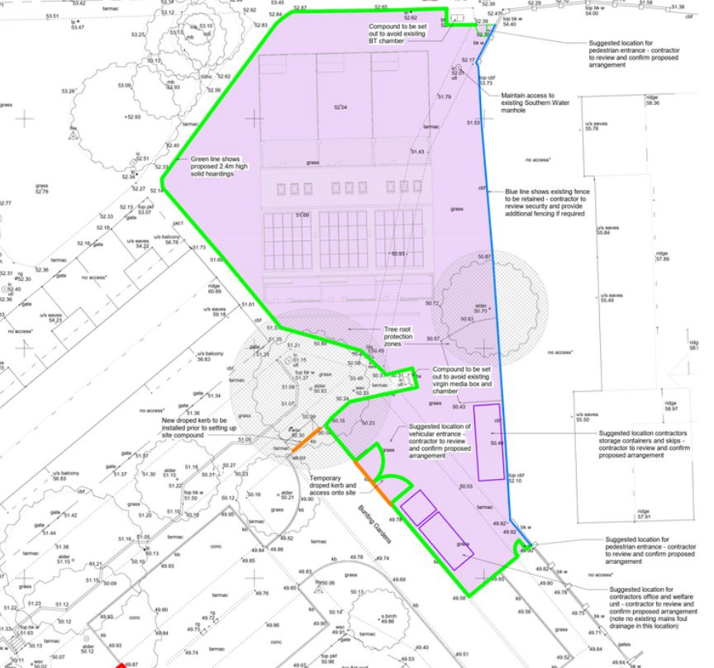

Vehicular Entrance

 | Issue 1 Revision 2 | December 2024 | Page 8 of 10

Traffic Control Plan
Site Name: Ref No:
4550
Bunting Gardens
APPENDIX A

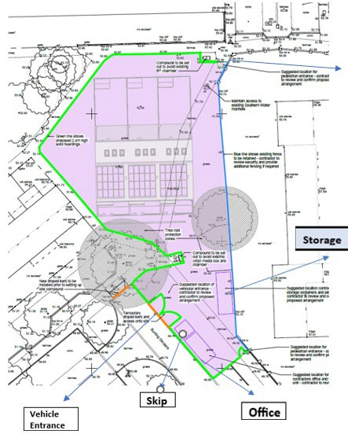
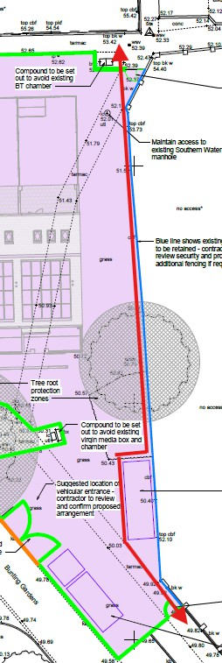
Deliveries and plant parking area.
Segregated Pedestrian Walkway

 | Issue 1 Revision 2 | December 2024 | Page 9 of 10

Traffic Control Plan
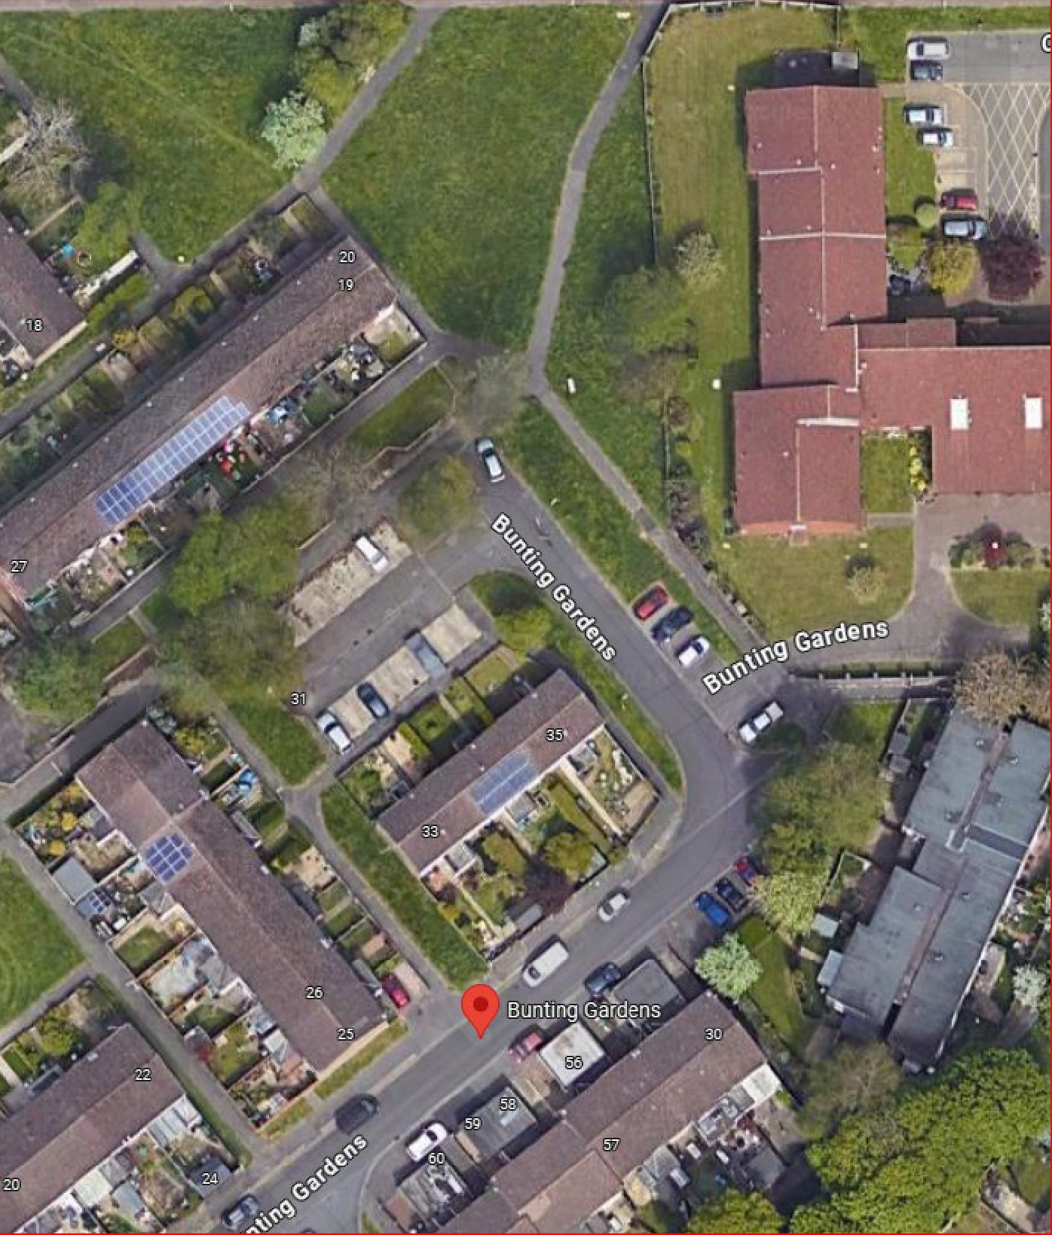
Site Name: Ref No:
4550
Bunting Gardens
Turning Area for vehicular deliveries.
Most direct route to Bunting Gardens building site. Via Milton road into Swinburn Gardens, turn right into Bunting Gardens.

Contractor Parking

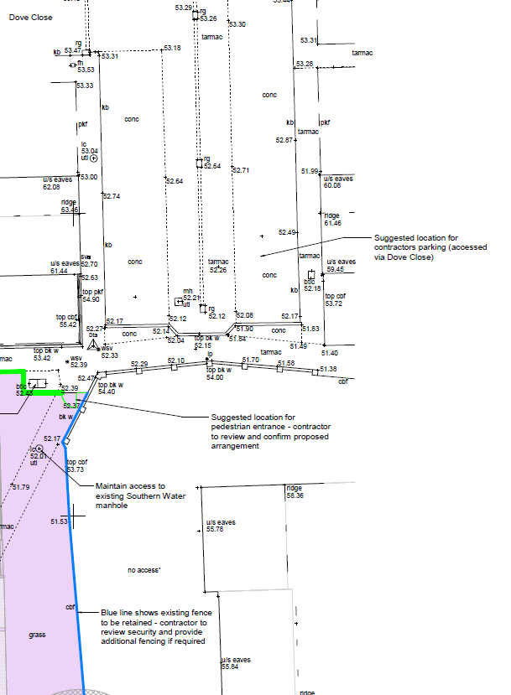

Contractor Parking Only

 | Issue 1 Revision 2 | December 2024 | Page 10 of 10

