GCL 2501H / top-hung / heritage conservation
The ideal choice for heritage, conservation and historical properties.
The Heritage Conservation Roof Window is designed in line with the aesthetics of historical buildings. The window is slim and elegant and sits flush to the slates of the roof, beautifully blending into the roofing material and conserving the historical heritage of the building. It is suitable for roofs made with slate of plain tiles up to 14 mm. The elegant white internal finish is an ideal fit for modern interiors.
The window has been created in collaboration with Architects and Conservation Officers to enhance modern living while maintaining the original character of the building with one of the most destinct traits being the vertical glazing bar in in the middle of the window's pane. The window is historical in appearance but has all the modern day benefits of a VELUX roof window allowing you to bring natural daylight and fresh air into the room. The window has been tested and tried vigorously to ensure optimal durability and a long lifespan.
The authentic top-hung design of the window allows for efficient ventilation in the room. The window opens up to 15 cm using the original hand-winder placed at the bottom of the sash.
• Sleek, slim-fit profile in line with historical aesthetics
• Authentic top-hung design
• Manual operation with original hand-winder
• Crafted glass-to-glass edge technology for a clean appearance
• Central, vertical glazing bar for authenticity
• Bright white internal finish for modern interiors
• Toughened, safety laminated double glazing
• Flashing kit developed for slate and plain tile roofs ensuring easy installation
• Suitable for roof pitches 20-65° and for plain tiles and slates up to 14 mm thick
• For profiled roofing materials you can use the VELUX GGL H conservation roof window
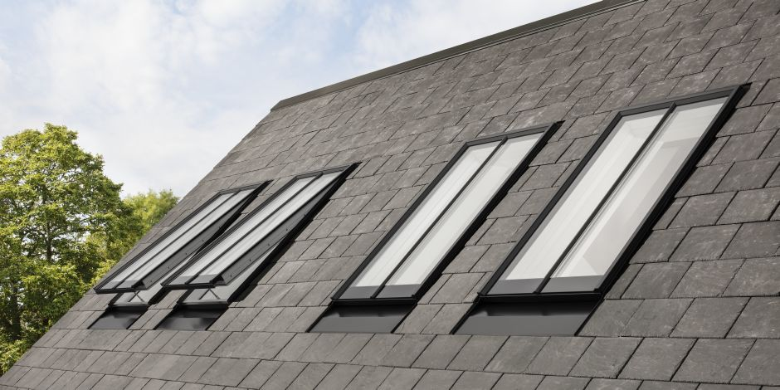
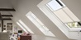

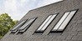
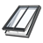

Glazing : | Double glazed
Internal Finish : | White painted
Select a suitable size (W x H) 55 x 98 cm (CC04)66 x 140 cm (FC08)78 x 118 cm (MC06)55 x 118 cm (CC06)66 x 118 cm (FC06)94 x 140 cm (PC08)114 x 140 cm (SC08)114 x 160 cm (SC10)78 x 140 cm (MC08)
Buy this window now
This is my product id
GCL CC04 2501H

