Workshop to rear of
7-9 South Street,
Havant
PO9 1BU

PHASE 1 BAT SURVEY

September 2023

Dr.Jonty Denton (Chartered Ecologist) FRES FLS MCIEEM CECol


Prepared by
Dr. Jonty Denton Bsc (Hons) D(Phil) FRES, FLS, MCIEEM, (Chartered Ecologist)
31 Thorn Lane, Four Marks, Hampshire, GU34 5BX
Phone: (01420) 565647 mobile: 07935594093

SUMMARY
This report constitutes a site survey carried out on the 21st September 2023 and further assessment of the potential impacts arising from the proposed re-development of the workshop to rear of 7-9 South St., Havant, PO9 1BU.
The structure has negligible potential for bats with no enclosed voids and a permanently illuminated interior. Therefore, a phase 2 emergence survey is not recommended.

INTRODUCTION
Site Setting and Description
The property is a workshop to the east of South St., in Havant town centre to the rear of numbers 7-9. The setting is urban with no trees within. The nearest woodland is 230m to the east. The habitats in the area are suitable for bats especially common and soprano pipistrelles.
METHODS
Datasearch

Background Data Search
According to the DEFRA MagicMap website https://magic.defra.gov.uk/MagicMap.aspx no licenses have been issued for properties within 1km of the workshop.
Phase 1 Bat Survey Methods
Details of the survey methods are given below;-
The workshop was investigated externally to identify potential bat access/egress locations and roosting areas such as gaps or holes in roof tiles, fascias and soffits and to record direct evidence of bat presence such as droppings and urine staining. This was followed by a detailed investigation of all accessible internal spaces to record evidence of bat roosting activity such as droppings, feeding remains, live animals, corpses, urine staining and fur staining. The building was assessed as to its suitability for supporting roosting bats. The survey conformed to current Bat Conservation Trust guidelines (Bat Conservation, (2012) Bat surveys for professional ecologists: Good practice guidelines 3rd edition).
The details of the assessment criteria used to determine the ecological value of on-site attributes is outlined below. During the Phase 1 survey the assessment criteria are based on the potential for the site to support the species considered. However, in many cases Phase 2 surveys will be required to confirm presence /absence of any bat species and hence the importance of a population at the site, therefore the assessment of value should be considered a provisional.
Where possible, a provisional assessment of potential will be made although this may well require Phase 2 surveys to confirm status.
High Potential- High potential buildings are those that have features highly suitable for use by roosting bats, including gaps around soffits, hanging tiles, extensive roof spaces etc. High potential buildings are often, but not always, buildings of more historic construction. Further Phase 2 surveys will be required to confirm the presence/absence of bats.
Medium Potential- Medium potential buildings have a moderate number of features that may be utilised by bats for roosting, these may include loose fascias, roof spaces etc. Further Phase 2 surveys are likely to be required to confirm the presence/absence of bats.
Low Potential- Low potential buildings are those that provide limited bat roosting potential although some features that may be utilised by bats may be present. Further Phase 2 surveys are likely to be required to confirm the presence/absence of bats.
No/Negligible Potential – These are buildings that are extremely unlikely to support roosting bats due to the absence of suitable features. Further Phase 2 surveys are unlikely to be required for buildings with negligible potential.
Phase 1 Survey Equipment
During the Phase 1 survey the surveyor was equipped with 10x42 binoculars and a high-powered 1 million candlepower Clulite torch.
RESULTS
Phase 1 Bat Survey Results
Building Assessments
The building is a single storey engineering workshop built of plain brick with an open metal framed roof faced with corrugated cement sheets with numerous clear plastic skylight sheets with a small flat roof section over the apex faced with planking covered in felting (see figure 1-4). There are no enclosed voids, and the roof is unlined.
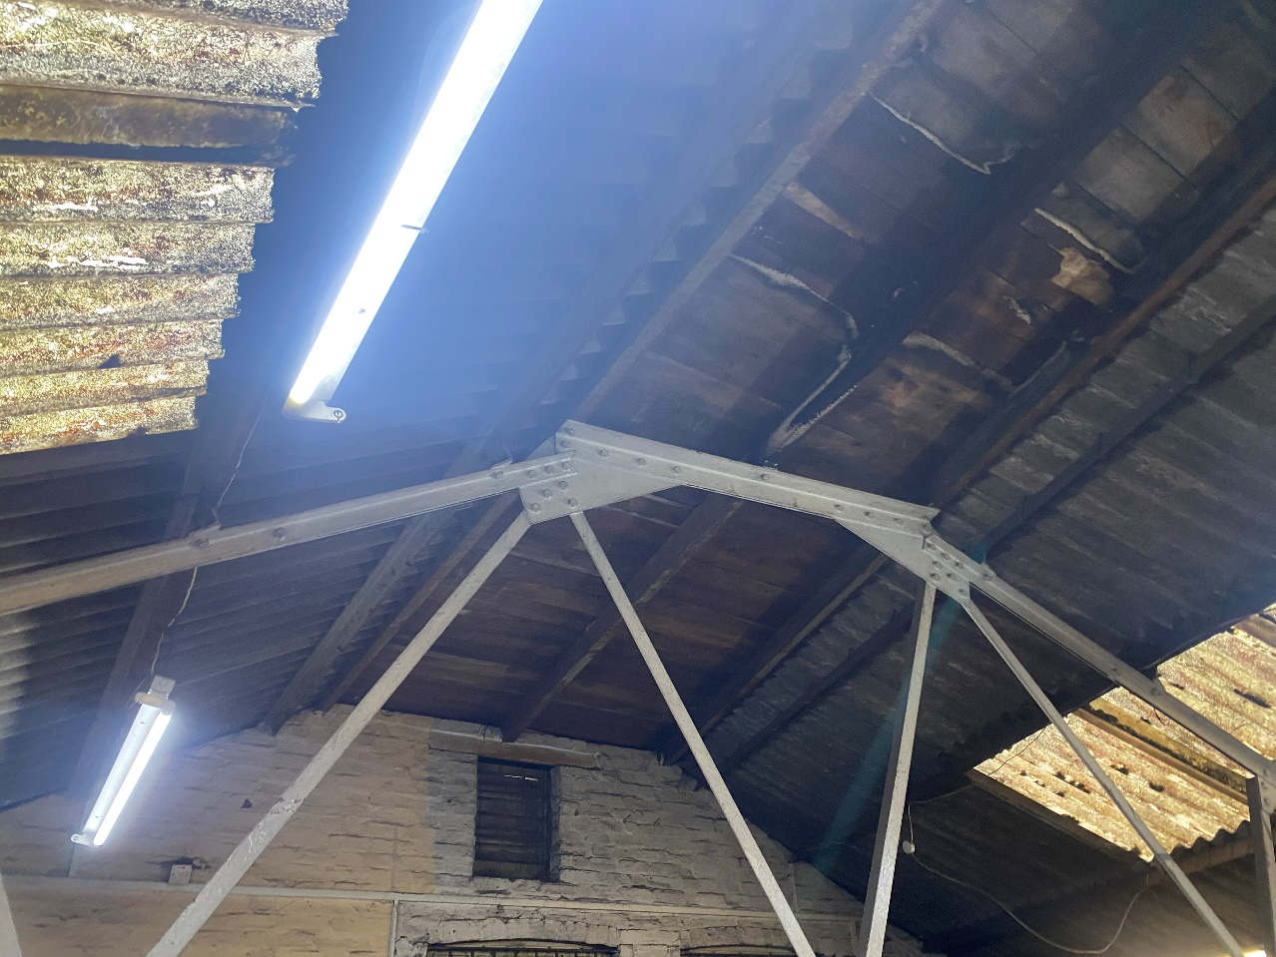
Figure 1. Interior of roof looking west
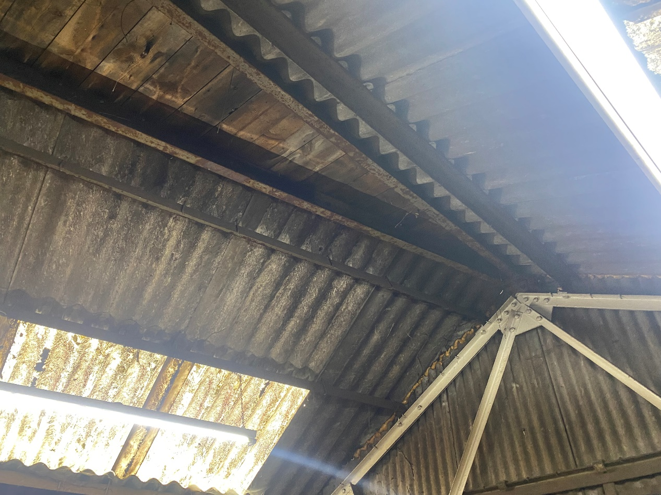
Figure 2. Interior of roof looking east
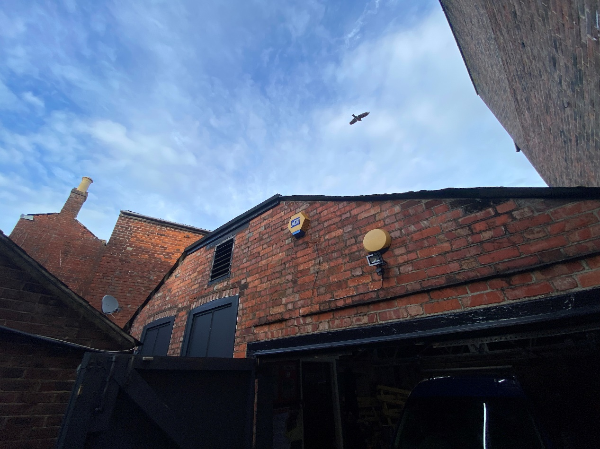
Figure 3. Western elevation looking northeast
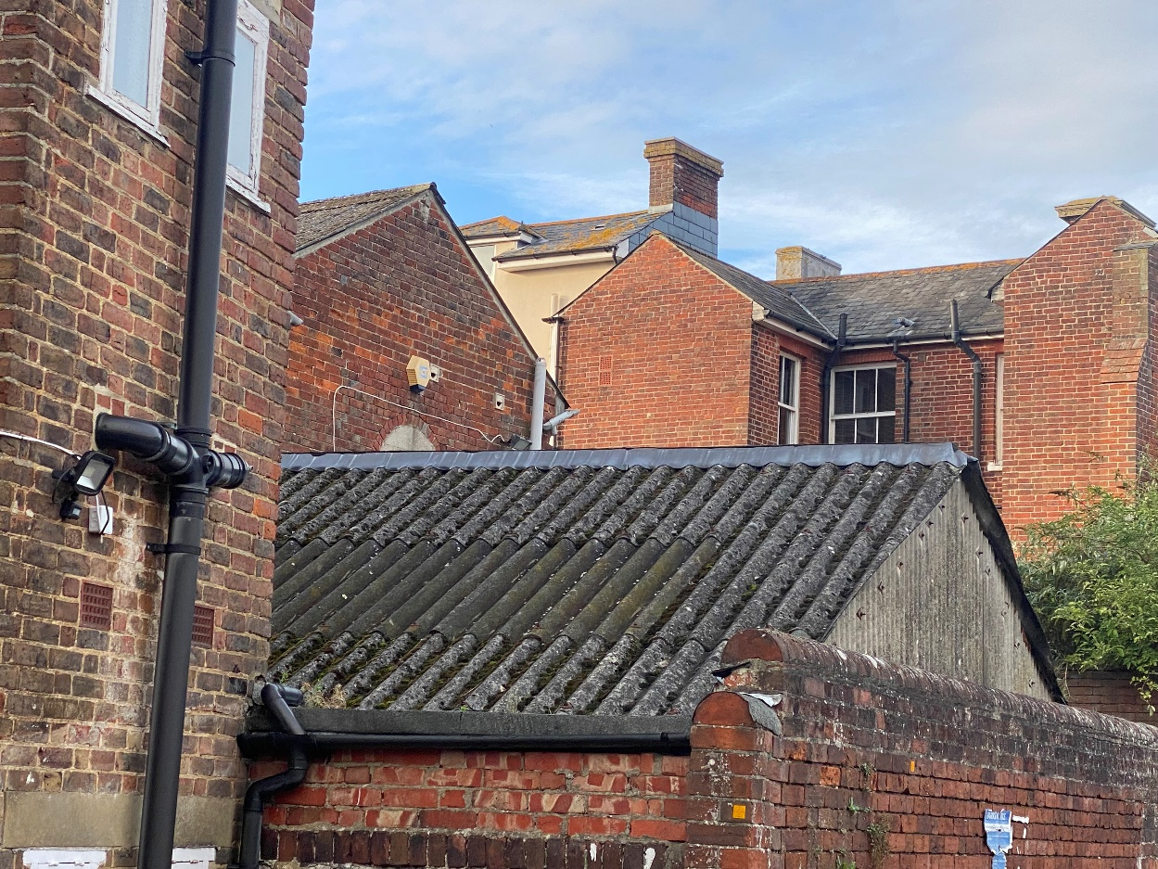
Figure 4. Southern and eastern elevations looking north

EVALUATION, IMPACTS AND RECOMMENDATIONS
The building has negligible potential for bats and a phase 2 bat survey is not recommended.

REFERENCES
Collins, J. (ed.) (2016) Bat Surveys for Professional Ecologists: Good Practice Guidelines (3rd Edition). The Bat Conservation Trust, London.
Mitchell-Jones, A.J. (2004) Bat Mitigation Guidelines. English Nature, Peterborough.
Reason, P.F. and Wray, S. (2023). UK Bat Mitigation Guidelines: a guide to impact assessment, mitigation and compensation for developments affecting bats. Chartered Institute of Ecology and Environmental Management, Ampfield.
INTERNET RESOURCES
Google Maps: www.maps.google.co.uk
Magic Interactive Map: www.magic.gov.uk

