GENERAL RISKS & CONTROLS
Classification (state the category of danger)
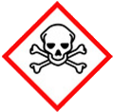 | ☐ |  |  | Serious Health Hazard/Toxic |  |  |  | 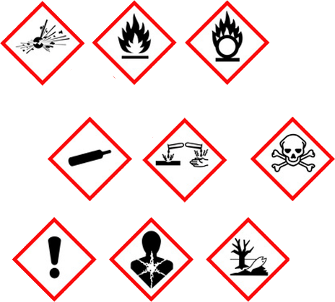 |  | ☐ |  | Oxidising |  |  | 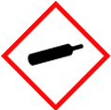 |  |  | ☐ |  |  | Gas Under Pressure
 | ☒ |  |  | Health Hazard/ Harmful/Irritant |  |  |  |  |  | ☒ |  | Flammable |  |  |  |  |  | ☒ |  |  | Acute Toxicity/ Carcinogen
 | ☐ |  |  | Corrosive |  |  |  |  |  | ☐ |  | Explosive |  |  |  |  |  | ☐ |  |  | Dangerous for the Environment
Hazard Type
☐ |  |  | ☐ |  |  | ☐ |  |  | ☐ |  |  |  | ☐ |  |  | ☒ |  |  |  | ☐ |  |  | ☐
Gas |  |  | Water |  |  | Mist |  |  | Fume |  |  |  | Dust |  |  | Liquid |  |  |  | Solid |  |  | Other
Route of Exposure
☐ |  | ☒ |  |  |  |  | ☒ |  |  |  | ☒ |  |  | ☐
Inhalation |  | Skin |  |  |  |  | Eyes |  |  |  | Ingestion |  |  | Other (state)
Workplace Exposure Limits (WELs) please indicate n/a where not applicable |  |  |  |  |  |  |  |  |  |  |  |  |  |  |  |  | N/A
Storage & Handling |  |  |  |  |  |  |  |  |  |  |  |  | Hazard Symptoms
- Store in cool, well ventilated area, out of direct sunlight, and away from heat and ignition sources.  - Keep container tightly closed / Wash hands thoroughly after handling.  - Empty drums should be drained and safely stored away from full drums before disposal with labels intact.  - Keep on bund, on impermeable ground.  - Store away from possible impact.  - Use mechanical aids when handling full and empty drums. |  |  |  |  |  |  |  |  |  |  |  |  | - Ingestion may cause gastrointestinal irritation and diarrhoea, or death  - Used engine oil may contain hazardous components which have the potential to cause cancer.  - Prolonged or repeated contact with skin could lead to irritation and/or dermatitis.  - Contact with eyes may cause irritation.  - Inhalation may cause respiratory tract irritation.  - Toxic to aquatic life with long lasting effects.  - Spills create a slippery surface.
Controls |  |  |  |  |  |  |  |  |  |  |  |  | Remedial Actions
- Do NOT siphon by mouth. Do NOT eat drink or smoke.  - Wear appropriate PPE to prevent contact.  - Wear protective overalls were necessary. Avoid prolonged contact and handle with care to prevent splash.  - Wear appropriate eye protection. Avoid contact with the eyes.  - Use outside in a well-ventilated area.  - Prevent entry into the environment, drains, sewers, water courses.  - Clear up any spillages using available spill kit absorbent material. |  |  |  |  |  |  |  |  |  |  |  |  | - Soak up with inert absorbent material.  - Remove contaminated absorbent material for remediation or disposal in accordance with local authority.  - If spilled on water, contain using a boom, and collect by skimming or absorption.
Disposal
Hazardous Waste?  ☒ |  |  |  |  | Skip  ☐ |  |  |  |  |  |  |  | Other ☒  - Place used and contaminated materials in suitable containers.  - Dispose using licensed waste disposal company.  - Do NOT pressurise, cut, weld, braze, solder, drill, grind, heat.
Return to Depot  ☐ |  |  |  |  | Return to Supplier  ☐
FIRST AID   |  |  |  |  |  |  |  |  |  |  |  |  | FIRE FIGHTING  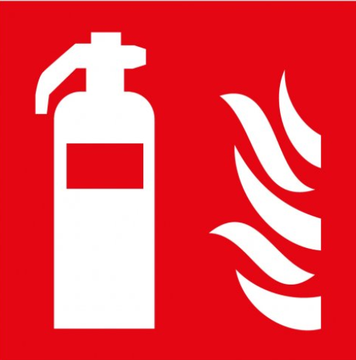
- If inhaled, remove to fresh air. If symptoms appear, get medical attention.  - Wash skin as soon as possible with soap water.  - Change contaminated clothing immediately and launder before re-use. Get medical attention if irritation persist. |  |  |  |  | - Wash out eyes immediately with water, remove any contact lenses. If irritation persists seek medical advice.  - Do not induce vomiting, unless instructed to by medical persons.  - Seek medical attention if internal irritation symptoms occur. |  |  |  |  |  |  |  | WATER  ☐ |  | FOAM  ☒ |  | POWDER  ☒ |  |  |  |  | CO2  ☒ |  | CHEMICAL  ☐
 |  |  |  |  |  |  |  |  |  |  |  |  | PRECAUTIONS:
SITE SPECIFIC CONTROLS (TO BE COMPLETED ON SITE)
Work Activities Being Undertaken
Exposure
Number of Persons |  |  |  | Frequency |  |  |  |  | Duration |  |  |  |  | Any specific training requirements?
 |  |  |  |  |  |  |  |  |  |  |  |  |  | ☐
Personal Protective Equipment (PPE) Control Measures
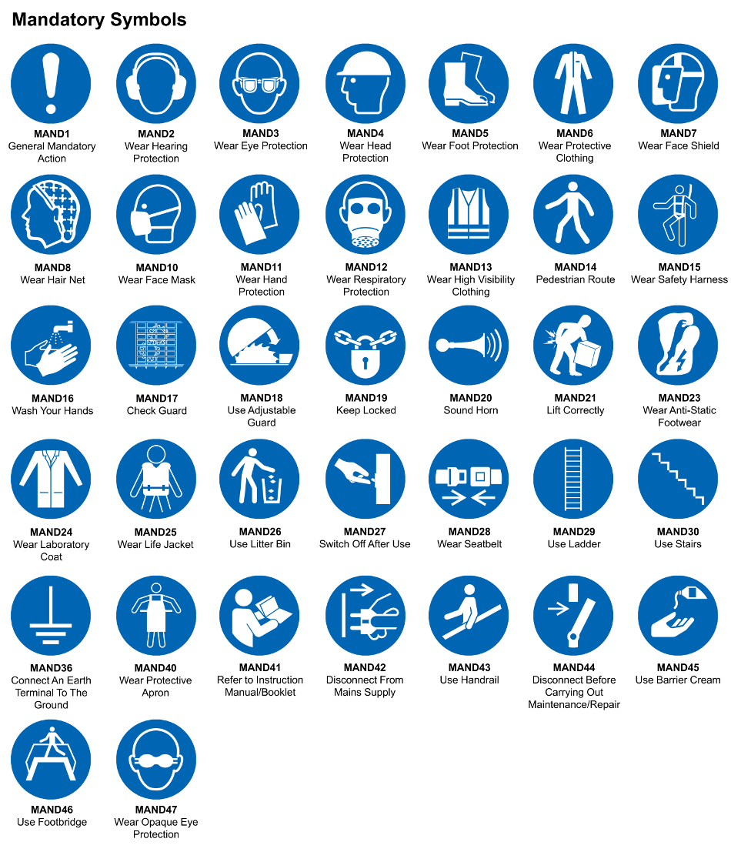
☐ | ☐ |  | ☐ |  | ☐ |  |  | ☐ |  | ☐ |  | ☐ |  |  | ☐ |  | ☐
Eye Protection | Ear Protection |  | Hard Hat |  | Footwear |  |  | Overalls |  | Visor |  | Gloves |  |  | Face Mask |  | Respirator
Storage Requirements
LOCKED CAGE |  | BUNDED CONTAINER |  |  |  |  | PROTECTION  FROM WEATHER |  |  |  | COSHH STORAGE ROOM |  |  |  |  | SEALED CONTAINER
☐ |  | ☐ |  |  |  |  | ☐ |  |  |  | ☐ |  |  |  |  | ☐
Waste Management
SEGREGATED STORAGE |  |  |  |  |  | SEALED CONTAINERS |  |  |  |  |  |  | WASTE CARRIER DISPOSAL / RECYCLING LICENCE
☐ |  |  |  |  |  | ☒ |  |  |  |  |  |  | ☐
Risk Rating Following Control Measures
LOW |  |  |  |  |  | MEDIUM |  |  |  |  |  |  | HIGH
☐ |  |  |  |  |  | ☐ |  |  |  |  |  |  | ☒

Site Specific RA Prepared by: | Si King | Position: | Contracts Director
Site Specific RA Prepared by: | Si King | Review Date: | 27/09/2023

