Further information as requested by Hampshire County Council Highways.
December 12th 2024.
Please accept this document which sets out the additional information required.
Existing Closure of the Hayling Billy:
The northern section of the Hayling Billy Trail is currently closed to allow works to take place upgrading the route. This closure runs from the Hayling Halt Car Park in the south at grid reference SU 71727 02972 (WhatThreeWords: https://w3w.co/renamed.running.attic) to the point adjoining the Havant Road in the north at grid reference SU 71959 03904 (WhatThreeWords: https://w3w.co/glee.cuddled.deduced). The closure started on October 21st 2024 and will remain in place until February 1st 2025.
Working with the Hampshire County Council Countryside Project Team delivering the Hayling Billy Upgrade, the shingle island restoration works have been planned to take place fully within the closure period and have no impact on the trail being upgraded. Their purpose will enhance the trail by ensuring the designated coastal birds that the public enjoy along the trails route is able to continue to thrive.
After a site visit with the Hampshire County Council Project Manager and appointed contractor, the reduced amount of shingle needed was bought onto site at the West Hyaling LNR in mid November 2024 at the same time as a larger amount of stone was being bought in for use in the Hayling Billy Upgrade project. This was undertaken by the Hants CC appointed contractor in order for it to take place before surfacing works on the Billy Trail and remove any chance of impact. As a result, no further shingle deliveries are required and the surfacing works have subsequently been largely completed. The contractors are carrying out further works as part of the Billy Trail upgrade and this will be taking place up until February with them remaining on site until then. The shingle island restoration works will take place in January.
Compound and parking:
The existing work compound is a single unit and herris fencing, located at the junction between the Billy Trail and West Hayling LNR at gid reference SU 71675 03360 (WhatThreeWords: https://w3w.co/pleasing.noted.stub). Parking will be two site vehicles in the compound whilst the Hayling Billy remains closed. The existing space allows plentiful room for the turning of the vehicles in use. Please see following photo, taken by the contractor today (December 12th 2024) which shows the set up and turning space available (with moveable Herris fencing if required).
Deliveries:
The remaining restoration specific deliveries consist of the use of a drop side van with trailer on day 1 to deliver the pontoon modules, and then collection on the final day.

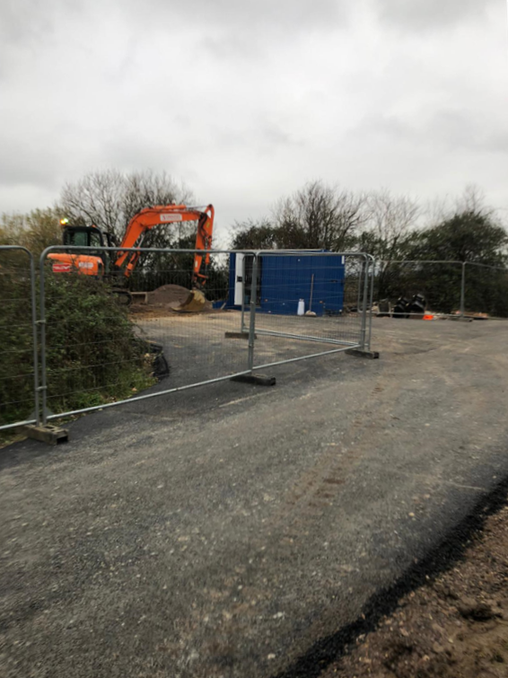
Photo 1: The compound area.
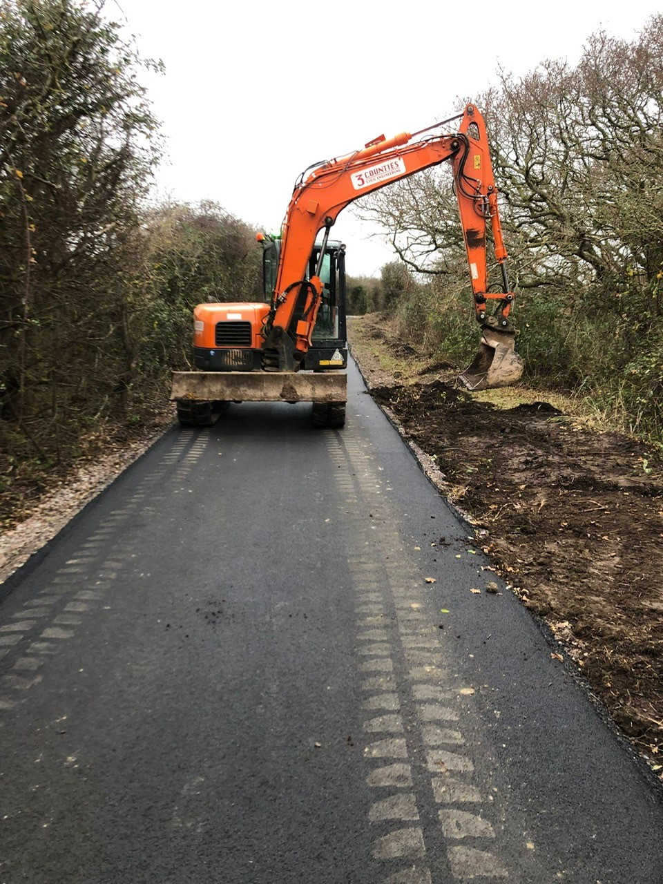
Photo 2: Works taking place as part of the Billy Trail upgrade giving an example of the trail post surfacing equipment in use.

