GENERAL RISKS & CONTROLS
Classification (state the category of danger)
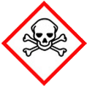 | ☒ |  |  | Serious Health Hazard/Toxic |  |  |  | 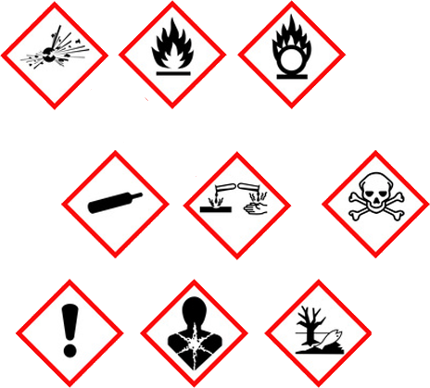 |  | ☐ |  | Oxidising |  |  | 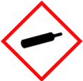 |  |  | ☐ |  |  | Gas Under Pressure
 | ☒ |  |  | Health Hazard/ Harmful/Irritant |  |  |  |  |  | ☐ |  | Flammable |  |  |  |  |  | ☒ |  |  | Acute Toxicity/ Carcinogen
 | ☐ |  |  | Corrosive |  |  |  |  |  | ☐ |  | Explosive |  |  |  |  |  | ☐ |  |  | Dangerous for the Environment
Hazard Type
☐ |  |  | ☐ |  |  | ☐ |  |  | ☐ |  |  |  | ☒ |  |  | ☐ |  |  |  | ☐ |  |  | ☐
Gas |  |  | Water |  |  | Mist |  |  | Fume |  |  |  | Dust |  |  | Liquid |  |  |  | Solid |  |  | Other
Route of Exposure
☒ |  | ☒ |  |  |  |  | ☒ |  |  |  | ☐ |  |  | ☐
Inhalation |  | Skin |  |  |  |  | Eyes |  |  |  | Ingestion |  |  | Other (state)
Workplace Exposure Limits (WELs) please indicate n/a where not applicable |  |  |  |  |  |  |  |  |  |  |  |  |  |  |  |  | 10mg  8 hours
Storage & Handling |  |  |  |  |  |  |  |  |  |  |  |  | Hazard Symptoms
- Ensure spoil heaps are frequently doused with water suppression.  - Hot weather will increase the build-up of dust.  - Windy conditions will kick up settles dust into the atmosphere. |  |  |  |  |  |  |  |  |  |  |  |  | - Cutting/breaking hard cement may eject fragments at high speed that could cause injury.  - Cutting/breaking will disperse dust into the atmosphere.  - Breathing in airborne dust over a prolonged period of time will increase the risk of silicosis and lung cancer  - Dust settling on surfaces may make them become slippery.
Controls |  |  |  |  |  |  |  |  |  |  |  |  | - Remedial Actions
- Ensure cutting/breaking equipment are fitting with adequate protection, and suitable PPE is warn to protect against projectiles.  - Ensure good ventilation in confined areas, and use dust suppression methods such water dampening.  - Ensure adequate RPE is warn when dust is likely to occur.  - Ensure surfaces including roads, are appropriately maintained to ensure the build-up of surface dust does not affect users. |  |  |  |  |  |  |  |  |  |  |  |  | - Stop the process creating the dust.  - Avoid breathing in dust, wear dust mask/respirator as per your face fit test certificate and googles.  - Ensure sufficient ventilation.  - Used dust suppression methods.  - Vacuum, or wet mod dust once settled.  - Use dust monitoring devises to ensure the atmosphere is at a suitable level.
Disposal
Hazardous Waste?  ☐ |  |  |  |  | Skip  ☒ |  |  |  |  |  |  |  | Other ☒  - Residual dust collected by a vacuum or from sweeping can be taken with the crushed concrete.  - Do NOT pour down drains, sewers, watercourses.  - Waste should be disposed in accordance with local and national waste disposal regulation.
Return to Depot  ☐ |  |  |  |  | Return to Supplier  ☐
FIRST AID   |  |  |  |  |  |  |  |  |  |  |  |  | FIRE FIGHTING  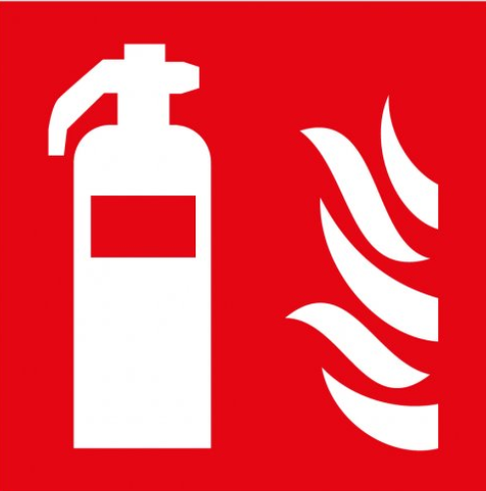
- Remove to fresh air, and seek medical attention if required.  - Remove contaminated cloths.  - Wash skin thoroughly with warm soap water. If irritation continues, seek medical advice. |  |  |  |  | - Remove contact lenses, flush with clean water for 10 minutes, seek medical attention if irritation continues.  - If accidently swallowed, remove from exposure and seek medical advice. |  |  |  |  |  |  |  | WATER  ☒ |  | FOAM  ☒ |  | POWDER  ☒ |  |  |  |  | CO2  ☒ |  | CHEMICAL  ☒
 |  |  |  |  |  |  |  |  |  |  |  |  | Is not flammable – Will not facilities combustion with other materials.
SITE SPECIFIC CONTROLS (TO BE COMPLETED ON SITE)
Work Activities Being Undertaken
Exposure
Number of Persons |  |  |  | Frequency |  |  |  |  | Duration |  |  |  |  | Any specific training requirements?
5 -10 |  |  |  | Daily |  |  |  |  | 8 Hours |  |  |  |  | ☐
Personal Protective Equipment (PPE) Control Measures
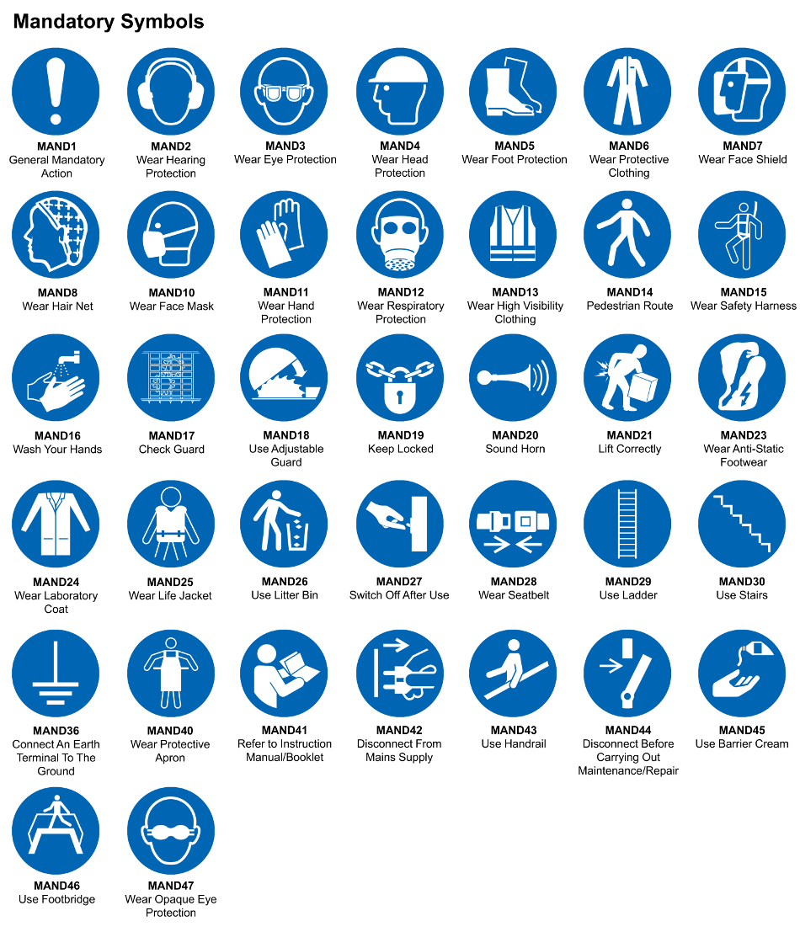
☒ | ☐ |  | ☒ |  | ☒ |  |  | ☐ |  | ☐ |  | ☒ |  |  | ☒ |  | ☐
Eye Protection | Ear Protection |  | Hard Hat |  | Footwear |  |  | Overalls |  | Visor |  | Gloves |  |  | Face Mask |  | Respirator
Storage Requirements
LOCKED CAGE |  | BUNDED CONTAINER |  |  |  |  | PROTECTION  FROM WEATHER |  |  |  | COSHH STORAGE ROOM |  |  |  |  | SEALED CONTAINER
☐ |  | ☐ |  |  |  |  | ☒ |  |  |  | ☐ |  |  |  |  | ☐
Waste Management
SEGREGATED STORAGE |  |  |  |  |  | SEALED CONTAINERS |  |  |  |  |  |  | WASTE CARRIER DISPOSAL / RECYCLING LICENCE
☒ |  |  |  |  |  | ☒ |  |  |  |  |  |  | ☐
Risk Rating Following Control Measures
LOW |  |  |  |  |  | MEDIUM |  |  |  |  |  |  | HIGH
☒ |  |  |  |  |  | ☐ |  |  |  |  |  |  | ☒

Site Specific RA Prepared by: | Si King | Position: | Contracts Director
Site Specific RA Prepared by: | Si King | Review Date: | 27/09/2023

