Design and Access Statement and Heritage statement for 72 Havant road Hayling Island

This proposal is for the replacement of the windows in the application property, it currently has dark wood windows and for ease of maintenance the applicant would like to replace with high quality Aluminium composite black windows. Tyoe as per the picture below
Whilst these are more modern, we believe the black finish is in keeping with the surrounding building and does not damage the buildings relationship with the near by heritage assets. It should be noted that the current windows do not match the heritage asset property (number 70 Havant Road) which has white painted windows (see site views A116 and A117)

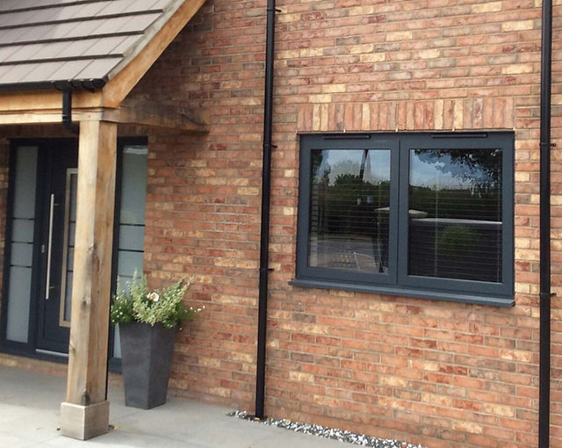

Heritage Statement

The applicant appreciates the building is next to listed buildings and notes the listings (details provided below.) We also note that the property shares few if any architectural features with the listed buildings and its existing windows do not match in style or colour with the listed buildings.
The use of black aluminium windows is common in many older style buildings as shown in the examples below.
We believe this change is likely to be more sympathetic to the listed buildings and is more in keeping with the style of the application property

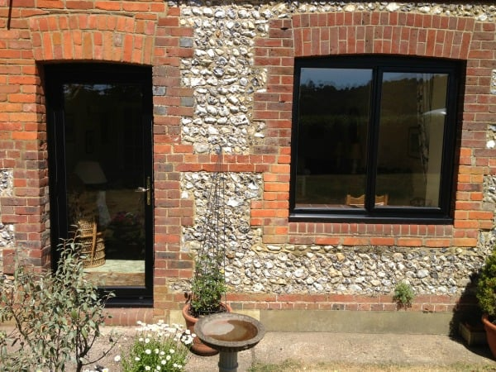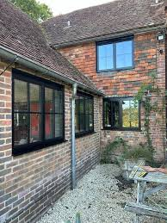

Cotterell Farmhouse History

70 Havant Road, Stoke, Hayling Island PO11 0LH known as Cottrell Farmhouse is a Grade 2 listed building . Listed in 1976 it has the English Heritage Reference Building ID of 135364.
The House is listed as a late 18th century brick building with tiled roof
The listing refers to the front elevation

‘Symmetrical front (west) of 2 storeys 2 windows Brick walling in blue headers with red flush dressings eaves fascia, rubbed arches(openings narrowed), vertical bands and quoins (projecting ) first floor band, cill height plinth. Early 19th century sashes canopy on brackets above a plain doorway’
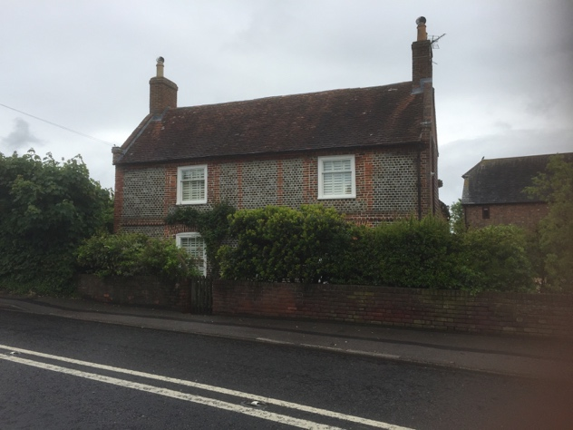

The Granary History

The Granary to the rear of Cotterell farmhouse (no 70 Havant Road) is now in the garden of no 72 Havant road.
The Granary is a grade 2 listed building from the early 19th century
Listed in 1988 with the English heritage building ID 135547
The listing refers to
‘Timber framed granary clad in weatherboard with half hipped roof now covered in asbestos sheeting on mushroom shaped saddle stones. Square building 3x3bays. Entrance by boarded door interior retains grain bin. Included for group value
This Building will be retained in its original position and thus will not be affected by the proposal
