GENERAL RISKS & CONTROLS
Classification (state the category of danger)
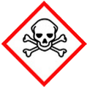 | ☐ |  |  | Serious Health Hazard/Toxic |  |  |  | 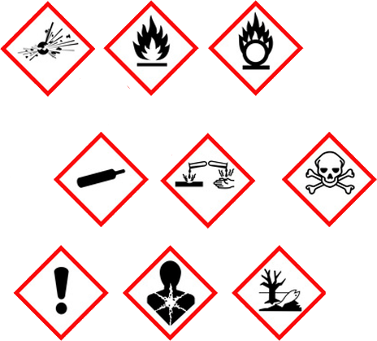 |  | ☒ |  | Oxidising |  |  | 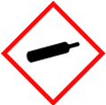 |  |  | ☒ |  |  | Gas Under Pressure
 | ☐ |  |  | Health Hazard/ Harmful/Irritant |  |  |  |  |  | ☒ |  | Flammable |  |  |  |  |  | ☐ |  |  | Acute Toxicity/ Carcinogen
 | ☐ |  |  | Corrosive |  |  |  |  |  | ☐ |  | Explosive |  |  |  |  |  | ☐ |  |  | Dangerous for the Environment
Hazard Type
☒ |  |  | ☐ |  |  | ☐ |  |  | ☐ |  |  |  | ☐ |  |  | ☐ |  |  |  | ☐ |  |  | ☐
Gas |  |  | Water |  |  | Mist |  |  | Fume |  |  |  | Dust |  |  | Liquid |  |  |  | Solid |  |  | Other
Route of Exposure
☒ |  | ☒ |  |  |  |  | ☒ |  |  |  | ☐ |  |  | ☐
Inhalation |  | Skin |  |  |  |  | Eyes |  |  |  | Ingestion |  |  | Other (state)
Workplace Exposure Limits (WELs) please indicate n/a where not applicable |  |  |  |  |  |  |  |  |  |  |  |  |  |  |  |  | N/A
Storage & Handling |  |  |  |  |  |  |  |  |  |  |  |  | Hazard Symptoms
- Store cylinders secured up right to prevent falling, in a locked cage, and protect from damage from impact.  - Store separate from flammable gasses and materials, do NOT remove labels, and ensure adequate signage.  - Keep in a cool, well ventilated area, NO Smoking.  - Do NOT allow water or grease to contaminate the cylinder or valve.  - Ensure storage area is suitably signed and firefighting equipment located close to by.  - Transport using mechanical aids such as trollies. |  |  |  |  |  |  |  |  |  |  |  |  | - Contact with combustible material may cause a fire. Will vigorously accelerate combustion.  - Oxygen enrichment creates a highly explosive atmosphere. Oxygen enrichment is considered above 22% (20.8-21% normal atmosphere)  - Oxygen enriched atmospheric pressure for more than a few hours may cause nasal stuffiness, cough, sore throat, chest pain and breathing difficulties.  - Breathing pure oxygen under pressure may cause lung damage and also central nervous system effects.  - High pressure release causing puncture injuries.  - Oxidizing.  - Cylinders are heavy, especially when full.
Controls |  |  |  |  |  |  |  |  |  |  |  |  | Remedial Actions
- Keep cylinders away from sources of ignition - No smoking when in use or near storage areas. Unsure system is purged before use.  - Ensure permit to work systems are in place to you this substance.  - Keep cylinders outside when in use to ensure good natural ventilation. Do NOT use in confined spaces. Wear appropriate RPE were necessary.  - General training in the safe use, handling, disposal and storage, instruction in the use of control measures. Awareness of damage to cylinders and valves. Awareness of potential reactions with other substances.  - Wear safety footwear and gloves when moving and handling cylinders, ensure transport on site is carried out using trolleys. Do NOT drag or roll cylinders. |  |  |  |  |  |  |  |  |  |  |  |  | - Evacuate the area, and eliminate sources of ignition.  - Stop release if safe to do so.  - Ensure adequate ventilation.  - Prevent from entering sewers, basements, work pits, or any place where accumulation can be dangerous.  - Conduct monitoring to ensure the atmosphere is back to normal.
Disposal
Hazardous Waste?  ☐ |  |  |  |  | Skip  ☐ |  |  |  |  |  |  |  | Other ☒  - Vent to atmosphere in well ventilated area if safe to do so.  - Do not discharge if the accumulation could become dangerous.  - Contact supplier if further guidance if required.
Return to Depot  ☒ |  |  |  |  | Return to Supplier  ☒
FIRST AID   |  |  |  |  |  |  |  |  |  |  |  |  | FIRE FIGHTING  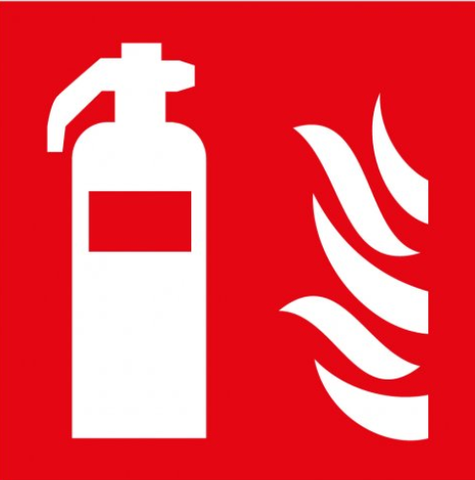
- Remove victim from contaminated area, keep warm. If discomfort continues, seek medical attention.  - Avoid high pressure release resulting in direct contact that may pierce the skin. Seek medical attention. |  |  |  |  | - Avoid high pressure release resulting in direct eye contact will cause damage. Seek medical attention.  - Ingestion is not considered a potential route of access. |  |  |  |  |  |  |  | WATER  ☒ |  | FOAM  ☒ |  | POWDER  ☒ |  |  |  |  | CO2  ☒ |  | CHEMICAL  ☒
 |  |  |  |  |  |  |  |  |  |  |  |  | PRECAUTIONS: Use media best suited to surrounding materials. Oxygen will vigorously accelerate combustion
SITE SPECIFIC CONTROLS (TO BE COMPLETED ON SITE)
Work Activities Being Undertaken
Hot works
Exposure
Number of Persons |  |  |  | Frequency |  |  |  |  | Duration |  |  |  |  | Any specific training requirements?
10 |  |  |  | Daily |  |  |  |  | 8 hours |  |  |  |  | ☒
Personal Protective Equipment (PPE) Control Measures
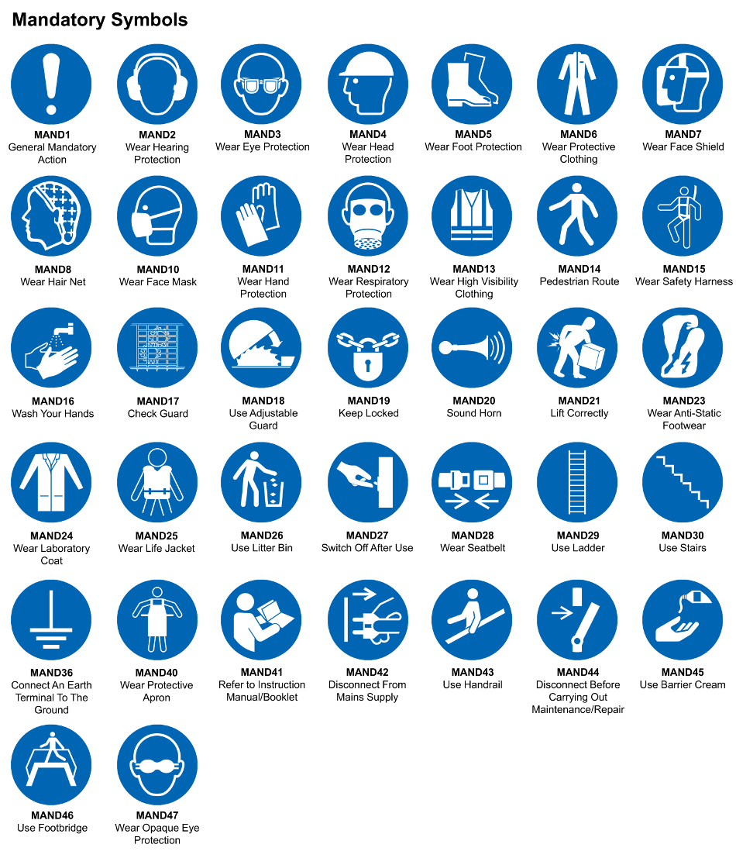
☒ | ☐ |  | ☒ |  | ☒ |  |  | ☒ |  | ☒ |  | ☒ |  |  | ☒ |  | ☒
Eye Protection | Ear Protection |  | Hard Hat |  | Footwear |  |  | Overalls |  | Visor |  | Gloves |  |  | Face Mask |  | Respirator
Storage Requirements
LOCKED CAGE |  | BUNDED CONTAINER |  |  |  |  | PROTECTION  FROM WEATHER |  |  |  | COSHH STORAGE ROOM |  |  |  |  | SEALED CONTAINER
☒ |  | ☐ |  |  |  |  | ☐ |  |  |  | ☒ |  |  |  |  | ☐
Waste Management
SEGREGATED STORAGE |  |  |  |  |  | SEALED CONTAINERS |  |  |  |  |  |  | WASTE CARRIER DISPOSAL / RECYCLING LICENCE
☒ |  |  |  |  |  | ☒ |  |  |  |  |  |  | ☐
Risk Rating Following Control Measures
LOW |  |  |  |  |  | MEDIUM |  |  |  |  |  |  | HIGH
☐ |  |  |  |  |  | ☒ |  |  |  |  |  |  | ☐

Site Specific RA Prepared by: | Si King | Position: | Contracts Director
Site Specific RA Prepared by: | Si King | Review Date: | 27/09/2023

