GENERAL RISKS & CONTROLS
Classification (state the category of danger)
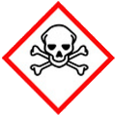 | ☐ |  |  | Serious Health Hazard/Toxic |  |  |  | 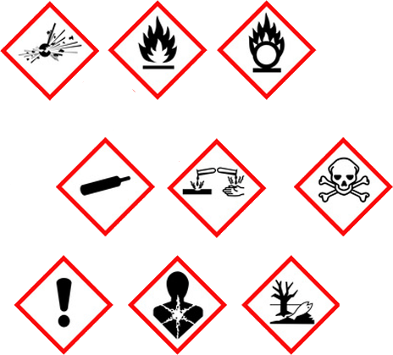 |  | ☒ |  | Oxidising |  |  | 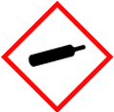 |  |  | ☐ |  |  | Gas Under Pressure
 | ☐ |  |  | Health Hazard/ Harmful/Irritant |  |  |  |  |  | ☐ |  | Flammable |  |  |  |  |  | ☐ |  |  | Acute Toxicity/ Carcinogen
 | ☐ |  |  | Corrosive |  |  |  |  |  | ☐ |  | Explosive |  |  |  |  |  | ☒ |  |  | Dangerous for the Environment
Hazard Type
☐ |  |  | ☐ |  |  | ☐ |  |  | ☐ |  |  |  | ☐ |  |  | ☒ |  |  |  | ☐ |  |  | ☐
Gas |  |  | Water |  |  | Mist |  |  | Fume |  |  |  | Dust |  |  | Liquid |  |  |  | Solid |  |  | Other
Route of Exposure
☒ |  | ☒ |  |  |  |  | ☒ |  |  |  | ☒ |  |  | ☐
Inhalation |  | Skin |  |  |  |  | Eyes |  |  |  | Ingestion |  |  | Other (state)
Workplace Exposure Limits (WELs) please indicate n/a where not applicable |  |  |  |  |  |  |  |  |  |  |  |  |  |  |  |  | NONE IDENTIFIED.
Storage & Handling |  |  |  |  |  |  |  |  |  |  |  |  | Hazard Symptoms
- Store in locked COSHH store until required.  - Store in cool well ventilated area, with container tightly closed.  - Keep away from fire and heat sources. Avoid strong oxidising agents.  - Do NOT remove labels, avoid subsoil penetration. |  |  |  |  |  |  |  |  |  |  |  |  | - May cause slight eye irritation.  - May cause stomach pains, and diarrhoea.  - Fire causes formation of toxic fumes.  - Prolonged inhalation may cause dizziness, nausea, and headaches.  - Spilling paint may cause permanent colour change/damage to materials.  - May cause irritation to skin with repeated and prolonged exposure.
Controls |  |  |  |  |  |  |  |  |  |  |  |  | Remedial Actions
- Avoid contact with eyes. Wear eye protection if splashing is likely.  - Do NOT eat, drink, smoke when using. Wash hands after use.  - Store/use away from fire and heat sources. Do NOT burn or incinerate empty or full containers.  - Use in well ventilated area. If necessary wear appropriate RPE.  - Ensure spill kit is available, and splash controls are implemented such as covering of surfaces with protective sheeting  - Wear impermeable gloves, and overalls if necessary. |  |  |  |  |  |  |  |  |  |  |  |  | - - Stop spillage immediately if safe to do so.  - - Ensure adequate ventilation.  - - Do NOT allow release into drains, sewers, or water courses.  - - Absorb with absorbent material.  - - If spilt into water, contain using a boom, and remove by skimming and absorbent material.  - - Wash contaminated area thoroughly after spillage.
Disposal
Hazardous Waste?  ☐ |  |  |  |  | Skip  ☒ |  |  |  |  |  |  |  | Other ☒  - Dispose of using licensed waste disposal site in accordance with local authority.  - Recycle packaging where applicable.  - Do NOT burn or incinerate.
Return to Depot  ☐ |  |  |  |  | Return to Supplier  ☐
FIRST AID   |  |  |  |  |  |  |  |  |  |  |  |  | FIRE FIGHTING  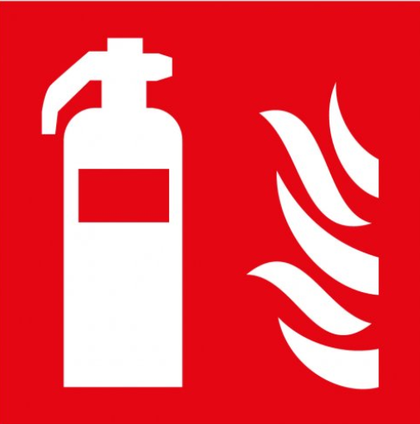
- Remove person from source of exposure. Keep at rest. If discomfort continues seek medical attention.  - Remove contaminated cloths. Wash skin thoroughly with water. If irritation occurs, seek medical attention. |  |  |  |  | - Remove any contact lenses and flush eyes with water, continue for 15 minutes.  - Seek medical attention if irritation occurs.  - - Rinse mouth with water, do NOT induce vomiting, and seek medical attention if any discomfort occurs. |  |  |  |  |  |  |  | WATER  ☒ |  | FOAM  ☒ |  | POWDER  ☒ |  |  |  |  | CO2  ☒ |  | CHEMICAL  ☒
PRECAUTIONS:
Use media best suited to surrounding materials. Fire causes formation of toxic fumes.
SITE SPECIFIC CONTROLS (TO BE COMPLETED ON SITE)
Work Activities Being Undertaken
Filling plant on site
Exposure
Number of Persons |  |  |  | Frequency |  |  |  |  | Duration |  |  |  |  | Any specific training requirements?
5 -10 |  |  |  | Daily |  |  |  |  | 8 hours |  |  |  |  | ☒
Personal Protective Equipment (PPE) Control Measures
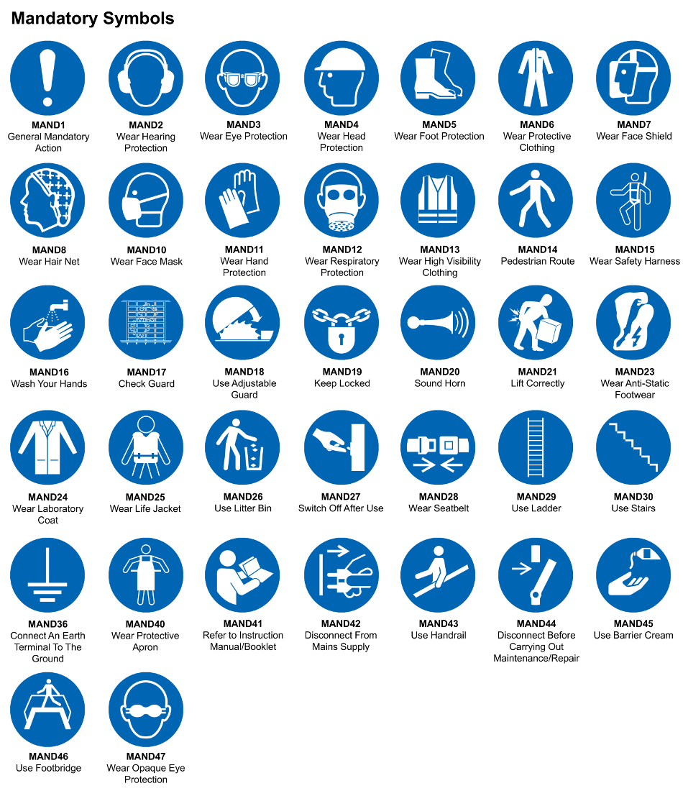
☒ | ☐ |  | ☒ |  | ☒ |  |  | ☐ |  | ☐ |  | ☒ |  |  | ☐ |  | ☐
Eye Protection | Ear Protection |  | Hard Hat |  | Footwear |  |  | Overalls |  | Visor |  | Gloves |  |  | Face Mask |  | Respirator
Storage Requirements
LOCKED CAGE |  | BUNDED CONTAINER |  |  |  |  | PROTECTION  FROM WEATHER |  |  |  | COSHH STORAGE ROOM |  |  |  |  | SEALED CONTAINER
☐ |  | ☐ |  |  |  |  | ☐ |  |  |  | ☒ |  |  |  |  | ☐
Waste Management
SEGREGATED STORAGE |  |  |  |  |  | SEALED CONTAINERS |  |  |  |  |  |  | WASTE CARRIER DISPOSAL / RECYCLING LICENCE
☐ |  |  |  |  |  | ☒ |  |  |  |  |  |  | ☐
Risk Rating Following Control Measures
LOW |  |  |  |  |  | MEDIUM |  |  |  |  |  |  | HIGH
☒ |  |  |  |  |  | ☐ |  |  |  |  |  |  | ☐

Site Specific RA Prepared by: | Si King | Position: | Contracts Director
Site Specific RA Prepared by: | Si King | Review Date: | 27/09/2023

