GENERAL RISKS & CONTROLS
Classification (state the category of danger)
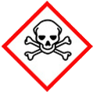 | ☐ |  |  | Serious Health Hazard/Toxic |  |  |  | 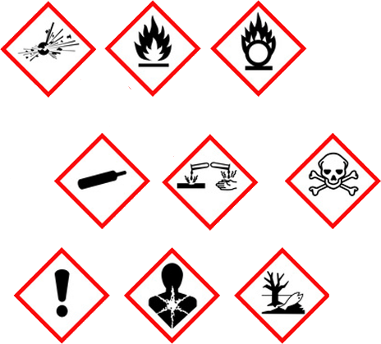 |  | ☐ |  | Oxidising |  |  | 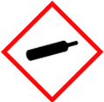 |  |  | ☒ |  |  | Gas Under Pressure
 | ☒ |  |  | Health Hazard/ Harmful/Irritant |  |  |  |  |  | ☒ |  | Flammable |  |  |  |  |  | ☐ |  |  | Acute Toxicity/ Carcinogen
 | ☐ |  |  | Corrosive |  |  |  |  |  | ☒ |  | Explosive |  |  |  |  |  | ☐ |  |  | Dangerous for the Environment
Hazard Type
☐ |  |  | ☐ |  |  | ☐ |  |  | ☐ |  |  |  | ☐ |  |  | ☒ |  |  |  | ☐ |  |  | ☐
Gas |  |  | Water |  |  | Mist |  |  | Fume |  |  |  | Dust |  |  | Liquid |  |  |  | Solid |  |  | Other
Route of Exposure
☒ |  | ☒ |  |  |  |  | ☒ |  |  |  | ☐ |  |  | ☐
Inhalation |  | Skin |  |  |  |  | Eyes |  |  |  | Ingestion |  |  | Other (state)
Workplace Exposure Limits (WELs) please indicate n/a where not applicable |  |  |  |  |  |  |  |  |  |  |  |  |  |  |  |  | 150ppm/474mg3  8 hours
Storage & Handling |  |  |  |  |  |  |  |  |  |  |  |  | Hazard Symptoms
- Secure cylinders upright to prevent them from falling.  - Store separate from oxidant cylinders stored 10meters away, and away from ignition sources. No smoking.  - Keep in a cool well ventilated area, in a locked cage.  - Store at least 1meter away from buildings. Ensure adequate signage is in place with firefighting equipment.  - Not compatible with Oxidising agents. Protect against potential impact and puncture.  - Do NOT drag cylinders when handling, always keep in upright position. |  |  |  |  |  |  |  |  |  |  |  |  | - Inhalation of vapour can cause irritation to nose and throat, headaches, nausea and vomiting.  - May cause frostbite/cold burns when in contact with skin.  - Cylinders are heavy, especially when full.  - Substance is heavier then air and will collect at low levels. Substance may travel on declining surfaces and contaminate remote areas.  - Extremely flammable liquefied gas.  - Risk of explosion, accidental release through damaged cylinders or valve.
Controls |  |  |  |  |  |  |  |  |  |  |  |  | Remedial Actions
- Store cylinders outside when not in use to ensure good natural ventilation. Wear appropriate RPE.  - Use flame retardant overalls and suitable gloves to prevent frostbite and burns from contact with liquid.  - Wear safety footwear and gloves when handling cylinders. Transport on site using trolleys, reduce unnecessary handling were possible.  - Avoid storage and use close to excavation, drains, basements, and confined spaces where substance may accumulate.  - Ensure hot works permit to work system is in place.  - Keep cylinders away from sources of ignition - No smoking when in use or near storage areas. Ensure flashback arrestors are fitted.  - Suitable fire extinguishers to be available i.e water, powder.  - General training in the safe use, handling, to be able to identify damage and faults. Do NOT drag roll cylinder when handling. |  |  |  |  |  |  |  |  |  |  |  |  | - Evacuate the area including drains, basements, and excavations.  - Eliminate all sources of ignition if safe to do so.  - Stop the leak if safe to do so.  - Allow for good ventilation. Ensure RPE is worn.  - Absorb spill using absorbent material. And store in sealed container  - - If leaking gas flame cannot be extinguished, allow to burn.
Disposal
Hazardous Waste?  ☐ |  |  |  |  | Skip  ☐ |  |  |  |  |  |  |  | - Do not release when risk of forming an explosive atmosphere.  - Waste gas should be flared in a safe place through a suitable burner with flash back arrestors.  - Return back to supplier otherwise treat as hazardous waste.  - Do NOT burn, incinerate, or crush cylinders.
Return to Depot  ☐ |  |  |  |  | Return to Supplier  ☐
FIRST AID   |  |  |  |  |  |  |  |  |  |  |  |  | FIRE FIGHTING  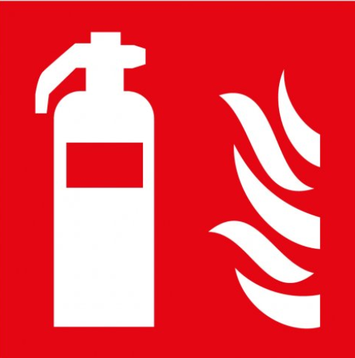
- Remove victim from to uncontaminated area. Keep warm and rested.  - If breathing is stopped, trained person to apply artificial respiration and call doctor.  - Remove contaminated clothes. Rinse skin with warm soap water. Apply moisturising dressing.  - If irritation continues seek medical advice. |  |  |  |  | - Remove contact lenses, and flush eyes with water. Repeat for 15 minutes.  - If discomfort continues seek medical attention.  - Ingestion is not considered a potential route of exposure. But if occurs, seek medical attention. |  |  |  |  |  |  |  | WATER  ☒ |  | FOAM  ☐ |  | POWDER  ☒ |  |  |  |  | CO2  ☐ |  | CHEMICAL  ☐
PRECAUTIONS:

Exposure to fire may cause cylinder to erupt or explode. Do NOT use water jet, use spray/mist. Do NOT extinguish a leaking gas flame unless necessary.
SITE SPECIFIC CONTROLS (TO BE COMPLETED ON SITE)
Work Activities Being Undertaken
Number of Persons |  |  |  | Frequency |  |  |  |  | Duration |  |  |  |  | Any specific training requirements?
 |  |  |  |  |  |  |  |  |  |  |  |  |  | ☐
Personal Protective Equipment (PPE) Control Measures
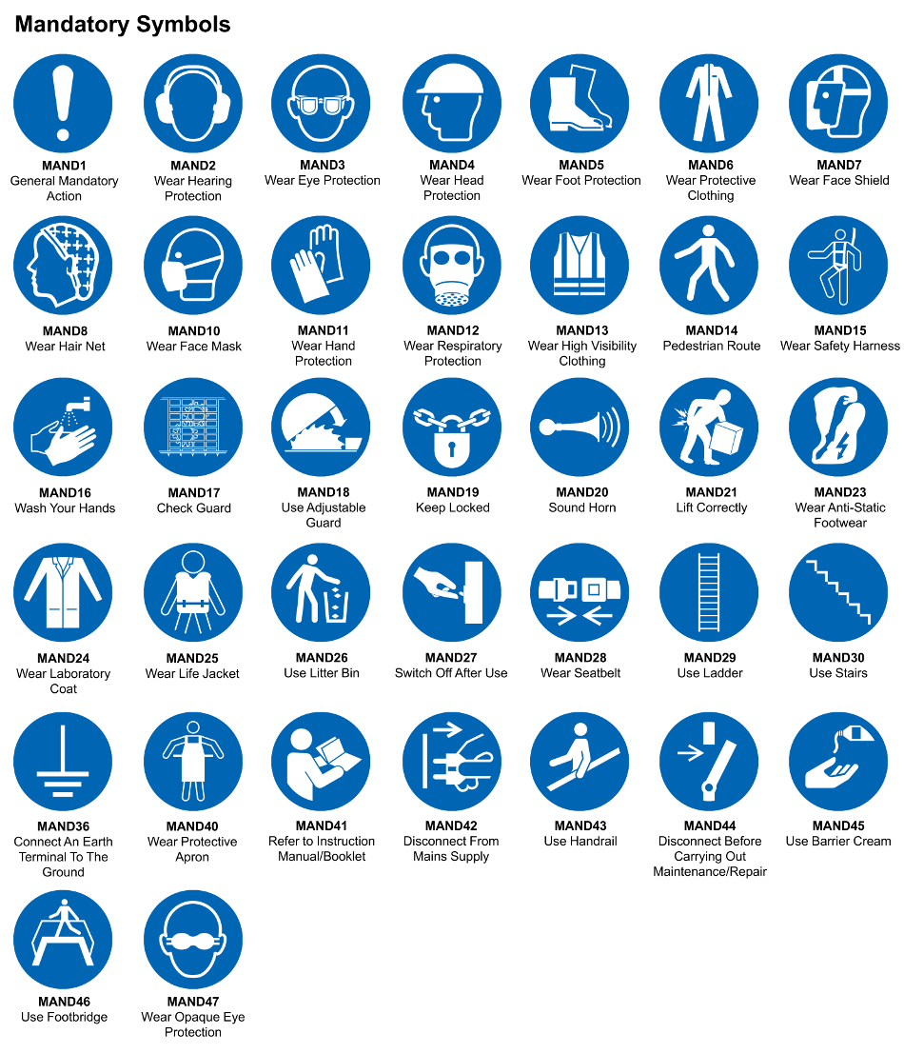
☒ | ☐ |  | ☒ |  | ☒ |  |  | ☐ |  | ☐ |  | ☒ |  |  | ☐ |  | ☐
Eye Protection | Ear Protection |  | Hard Hat |  | Footwear |  |  | Overalls |  | Visor |  | Gloves |  |  | Face Mask |  | Respirator
Storage Requirements
LOCKED CAGE |  | BUNDED CONTAINER |  |  |  |  | PROTECTION  FROM WEATHER |  |  |  | COSHH STORAGE ROOM |  |  |  |  | SEALED CONTAINER
☐ |  | ☐ |  |  |  |  | ☐ |  |  |  | ☐ |  |  |  |  | ☐
Waste Management
SEGREGATED STORAGE |  |  |  |  |  | SEALED CONTAINERS |  |  |  |  |  |  | WASTE CARRIER DISPOSAL / RECYCLING LICENCE
☐ |  |  |  |  |  | ☒ |  |  |  |  |  |  | ☐
Risk Rating Following Control Measures
LOW |  |  |  |  |  | MEDIUM |  |  |  |  |  |  | HIGH
☐ |  |  |  |  |  | ☒ |  |  |  |  |  |  | ☒

Site Specific RA Prepared by: | Si King | Position: | Contracts Director
Site Specific RA Prepared by: | Si King | Review Date: | 28/09/2023

