DESIGN, ACCESS & HERITAGE STATEMENT
Swan House, Bath Road, Emsworth, PO10 7ES

Proposal – Increase in height of existing flood wall.

DESCRIPTION OF THE SITE
Swan House is a detached dwelling located towards the southern end of Bath Road, Emsworth. The site is located on the east side of Bath Road, directly adjacent to the Mill Pond and comprises Swan House and a recently constructed timber clad garage. To the south of the site is a car park serving the Sailing Club. To the west of the site there are two detached dwellings separated by a distance of 12 metres respectively and 26m from the existing garage.

Swan House is set back from the front of the plot with mature landscaping as well as a gravelled area to the front that provides parking for 2 cars as well as a drive to the detached garage. To the rear of the plot the site is grassed with mature landscaping on all sides. There is a mature Judas tree to the west of the dwelling and a mature willow tree to in the north-east corner.

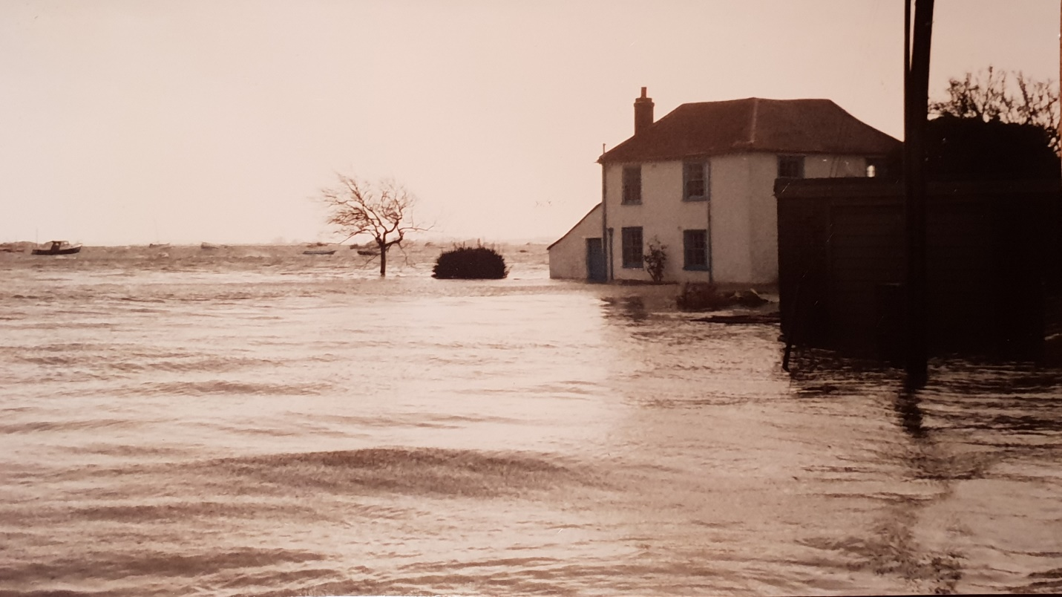

Photo of Swan House taken in the mid 1970s before any flood walls were installed.

BACKGROUND
The Applicants moved to Swan House, 66 Bath Road in February 2017, and were fully aware that the property had flooded in the past. From records provided by a local resident, it seems likely that this flooding occurred around 8 times since 1950. A GPS survey carried out by Sumo Services identified the levels around the property suggesting that the entrance level should be raised and the flood wall should be extended on all sides of the property. These works were completed in 2017 and flood barriers were purchased to seal the two access gates.

It should be noted that Swan House last flooded on 14th February 2014, when at 23:15 the sea height measured by Cambermet was 5.92 metres, it caused extensive damage.

On 9th April at 00:30 the tidal height was measured at 5.95 metres, which was the highest ever recorded in Emsworth. It is very likely that this will be exceeded in the coming years.
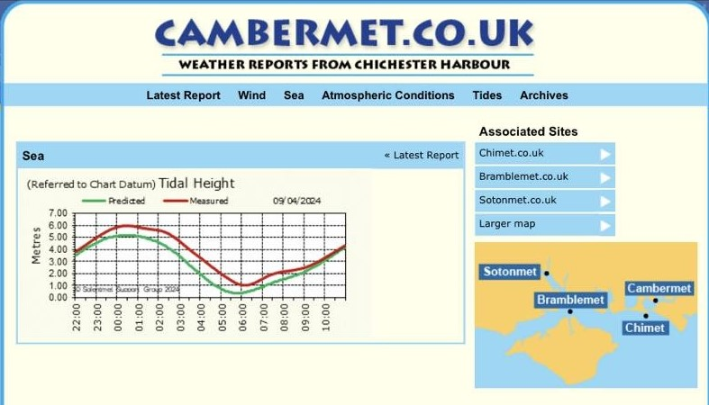
On 9th April the sea breached Emsworth promenade which was entirely covered by the sea to an approximate depth of 0.35 metres. The Emsworth Mill pond water level rose within 15 minutes by 1.9 metres.

The water level at this time was within 0.075 metres / 75mm / 3 inches of the top of the flood wall surrounding Swan House. If it had breached this flood wall the house would have flooded to a depth of 0.65 metres or over 2 feet.

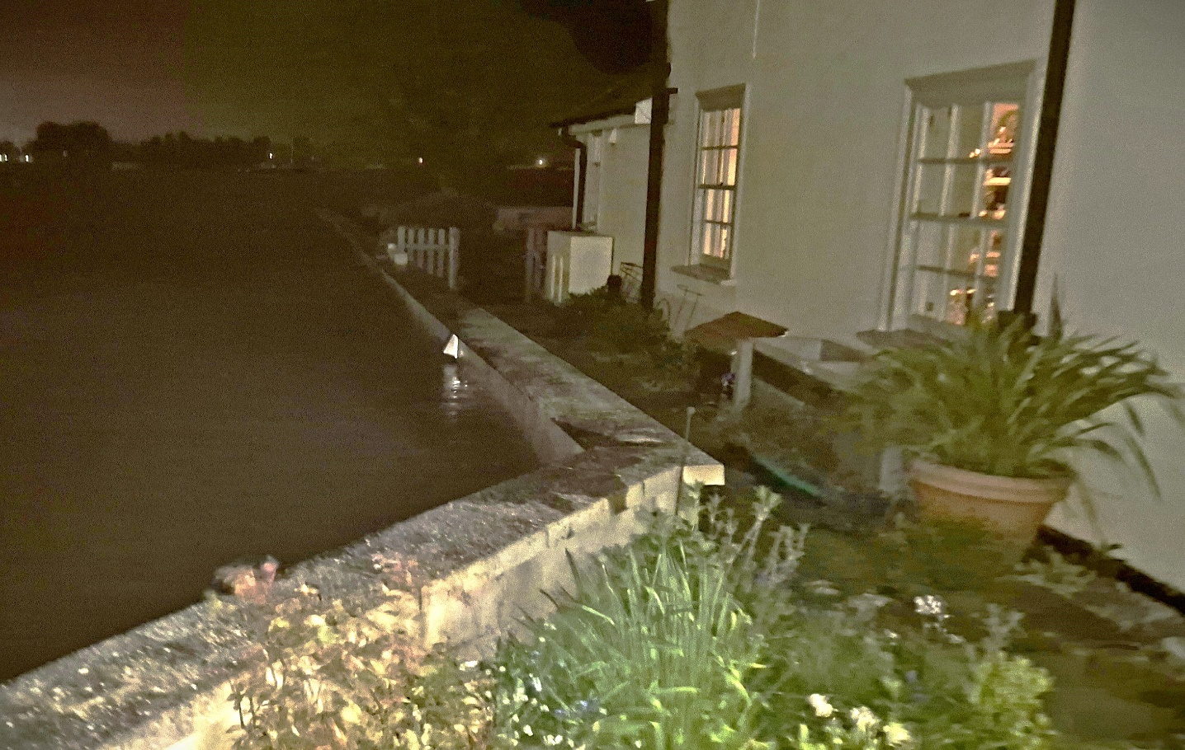
View of high water at Swan House after it had subsided by 100mm

What the applicant is asking for is to be able to protect themselves from future sea level rises such that they can remain living at Swan House in Emsworth.

They fully accept the responsibility which comes with living in what could be considered a high profile house and which can be viewed by so many people from around Emsworth and they do wish to limit as far as possible any adverse additions to any part of the property.

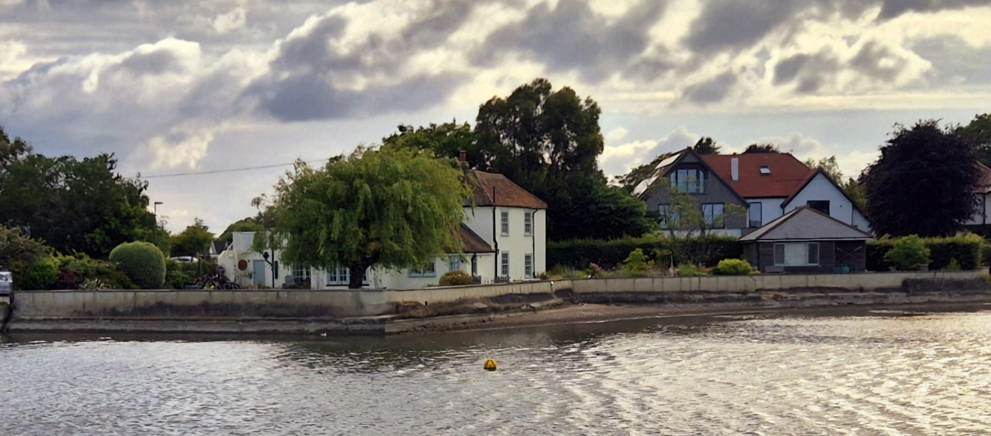
View of Swan House showing the existing flood wall
The picture above shows the existing flood wall clearly and it can be seen that the wall itself has blended quite well into the surroundings. Ideally the applicant would prefer not to have to raise this wall but clearly that is not an option.

PROPOSAL
This application is to raise the height of the existing boundary flood wall by a total of 330mm via a mixture of glass and rendered blockwork to match the existing flood wall.

The proposed site plan and elevations submitted with this application indicate the sections of the wall that are proposed to be rendered blockwork and the sections that will be glass panels.

The majority of the rendered blockwork increase is to the North of the site near the existing garage, with the glass sections concentrated where there are views from the property. The proposed glass sections are constructed in non-reflective glass in between aluminium supports anodised in a grey colour to blend with the existing wall. The proposed glass is Low Iron, Anti-Glare Glass with SGP Interlayers 3Ply – 12mm/1.5mm/12mm. The glass will be angled at 3° to further reduce any glare. The manufacturers drawings accompany this application.

Below is an example of what the proposed glass flood wall would look like.
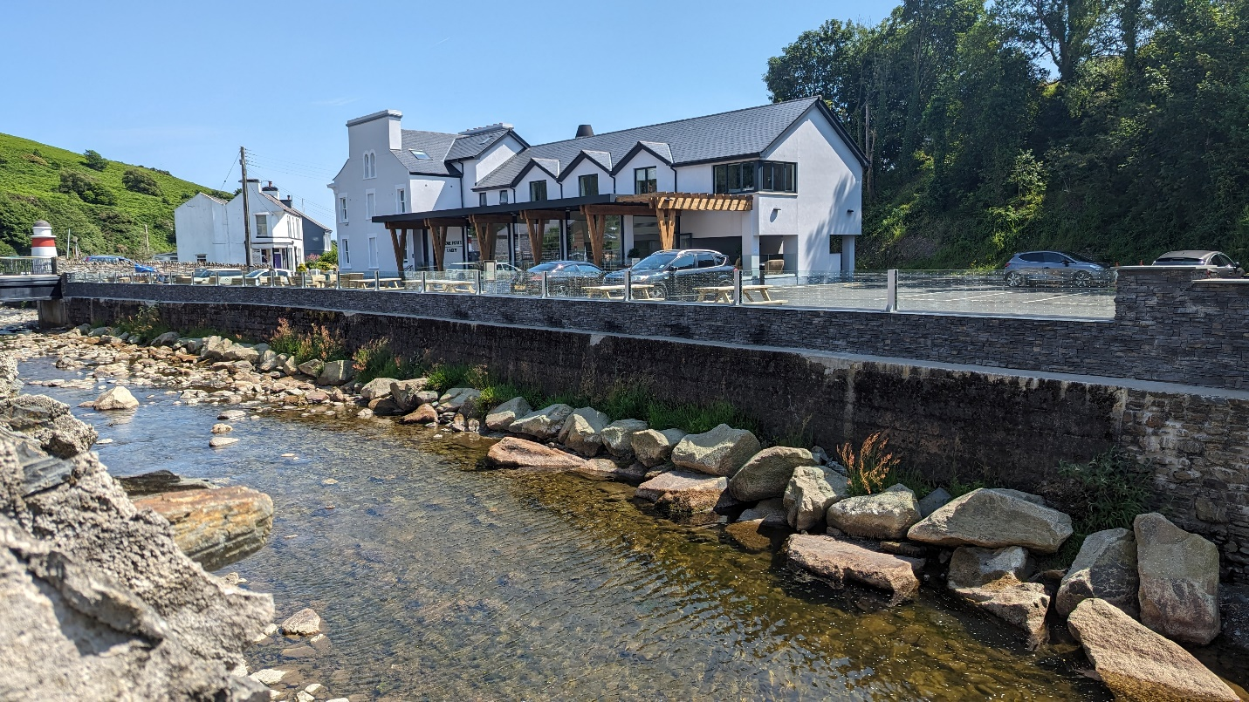

The below advice from the Chichester Harbour Conservancy on the proposed materials is acknowledged but it was felt that using a glass flood wall would be more flood resilient than the suggested timber. The latter also has a considerably shorter life and would be more visible.

PRE-APPLICATION ADVICE

The following advice was received from the planning department and heritage team.

Chichester Harbour Conservancy
It is not quite clear from the plans submitted whether the proposed addition to the boundary
wall would be 600mm in total (i.e. concrete with glass above along its whole length) or 300mm
increase in height (either concrete or glass but not both). It is also difficult to make an
informed assessment without proposed elevations showing the appearance of the proposed
higher wall.

The existing concrete wall is quite a prominent feature within the wider Chichester Harbour
National Landscape and Emsworth Conservation Area at present, and any increase in height
will therefore be noticeable as viewed from Bath Road, Bridgefoot Path, The Promenade, and
will also be visible at a distance from the wider Harbour (the Emsworth Channel).

There is no objection in principle to the proposed raising of the height of the wall, but it will
need to be done sensitively given the exposed location of the property within the Chichester
Harbour AONB / National Landscape and the Emsworth Conservation Area, and we would
query whether natural timber may be more sympathetic to the area than concrete. We would
also wish to ensure that any glass used is of the non-reflective variety, to avoid excessive
reflective impacts which would draw attention to the wall and detract from the natural beauty
of the surroundings.

Further, we would be likely to ask for suitable conditions on any permission granted to ensure
that the timing of the works avoids the overwintering bird period (1st October to 31st March)
and that the construction methods avoid any pollution entering the Mill Pond or wider Harbour.

Environment Agency
Having reviewed your proposal we are providing you with a preliminary opinion, which outlines
the key environmental issues within our remit and provides guidance on any actions you need
to undertake. It may provide hyperlinks to where you can obtain further information and advice
to support your planning application. We offer one free preliminary opinion per site, per
applicant /developer.

The Environmental Constraints identified on the site include:
- Flood Zone 2
- Flood Zone 3
- Principle aquifer
- Within 8m of a main river

Based on the information currently available, the development raises some environmental
concerns that you will need to address as part of your planning application. Further work will
be needed to show how these issues can be satisfactorily addressed to ensure no
environmental impacts.

Due to the presence of the above on site, we would expect a Flood Risk Assessment (FRA) to
be submitted with any planning application. A checklist of what should be included in an FRA
can be found here –

https://www.gov.uk/guidance/flood-risk-and-coastal-change?msclkid=cb0aae57c21211ecb70d
e763271b8fbb#Site-Specific-Flood-Risk-Assessment-checklist-section.

The FRA will need to incorporate flood data that can be obtained from us. There is no charge
for the provision of this data, but due to a current backlog of enquiries we would strongly
recommend that the applicant requests the data as soon as possible. Enquiries can take up to
12 weeks at the current time. We recommend requesting 'Product 4' flood data and this can
be requested by emailing SSDEnquiries@environment-agency.gov.uk. Please include a
location plan with the request.

Any proposed works or structures, in, under, over or within 8 metres of the main river or 16
metres of a defence will require a permit from us under the Environmental Permitting
(England and Wales) Regulations 2016. Further guidance about such permits can be found
here - https://www.gov.uk/guidance/flood-risk-activities-environmental-permits.

Coastal Team
The proposals to raise the existing flood wall to mitigate against future tidal flood risk are in
alignment with the recommendations set out in the overarching North Solent Shoreline
Management Plan to 'Hold the Line' (maintain or upgrade the existing standard of protection
provided by defences) for this frontage (Policy Unit 5a16 - Emsworth Yacht Haven to
Maisemore Gardens) for the next 100 years.

Please note that works to flood defence structures require a Flood Risk Activity Permit
(FRAP) to be obtained from the Environment Agency (EA) prior to any works commencing,
more information on these and details of how to apply can be found here:

https://www.gov.uk/guidance/flood-risk-activities-environmental-permits. Any questions on this
process can be directed to the EA here: enquiries@environment-agency.gov.uk.
A Marine License from the Marine Management Organisation may also be required, more
information on this and how to apply can be found here:
https://www.gov.uk/guidance/do-i-need-a-marine-licence#activities-that-may-need-a-marine-lic
ence

In 2021, Natural England published a Condition Review of Chichester Harbour sites: intertidal,
subtidal and bird features (NERR090), which declared Chichester Harbour to be in
"unfavourable declining condition". As a result of this, additional scrutiny is being placed on
development within the Harbour, including works to privately-owned defences. We therefore
recommend consulting with Natural England, and potentially also Chichester Harbour
Conservancy, to ensure the suitability of these proposals prior to any works taking place.

Conservation Officer
Legislative and Policy Context
When assessing the proposal, the following legislation and policy context is taken in consideration.
- Section 72 of the Planning (Listed Buildings and Conservation Areas) Act 1990 requires planning authorities, when considering whether to grant planning permission for development which affects a Conservation Area, to have special regard to the desirability of preserving or enhancing the character and appearance of that area.
- NPPF (December 2023) – Chapter 16
- Local Plan Policies: CS11, CS16, DM20
- Emsworth Neighbourhood Plan

The Emsworth Neighbourhood Plan has now been adopted and has relevant policies which are applicable to this application:

Policy H1 – Design and Heritage
Policy H2 – Locally Listed Buildings

Assessment:

A plan has been provided with the submission, along with a photo example of an existing glass flood wall. It is unclear from the plan if the proposal involves a 300mm increase to the wall and then a further 300mm containing the glass section, or just 300mm increase comprising the glass section – please can this be clarified?

Overall, in principle the raising of the flood wall is supported however, this would be subject to finalised design details including a detailed plan of the flood wall including elevations and material details (style of glazing (i.e. non-reflective or reflective)

The proposal would be highly visible with the conservation area and as such, the high-quality execution of any design is crucial. Any forthcoming application will also need to be accompanied by a Hertiage Statement, in line with the advice laid out in Policy DM20 which covers the following:
1. Describe the significance of the asset and its setting, using appropriate expertise and where necessary original survey, at a level of detail proportionate to its significance and sufficient to understand the potential impact of the proposal.

2. Sets out the impact of the development on the heritage assets and mitigation that is proportionate to the impact and the significance of the heritage asset, including where possible positive opportunities to conserve and enjoy heritage assets.

NB – For this proposal, the ‘heritage asset’ is the Emsworth Conservation Area.

In light of this if you have any further questions, please feel free to get in touch.

Please note that the above comments are the opinion of individual Planning Officers and are
in no way binding upon the Council when determining any future applications for planning
permission and nor will they prejudice the outcome of any applications submitted.

IMPACT ON THE EMSWORTH CONSERVATION AREA

The proposed increase in height of the flood wall will have a minimal impact on the Conservation area as the parts raised in rendered concrete block will match the existing flood wall in terms of design and colour. The additional sections raised in glass will be non-reflective as requested above.

IMPACT ON THE CHICHESTER HARBOUR AONB

The proposed wall increase would be visible from the Mill Pond to the east of the site and from the east and north east when walking along the promenade. The position of the host property would screen the views from the south east.

The boundary wall is approximately 100m from The Promenade so the small increase of 330mm is unlikely to be noticeable.

IMPACT ON LISTED BUILDINGS

A search on the Historic England Listed building register highlighted 1 listed building close to the application site which is shown below

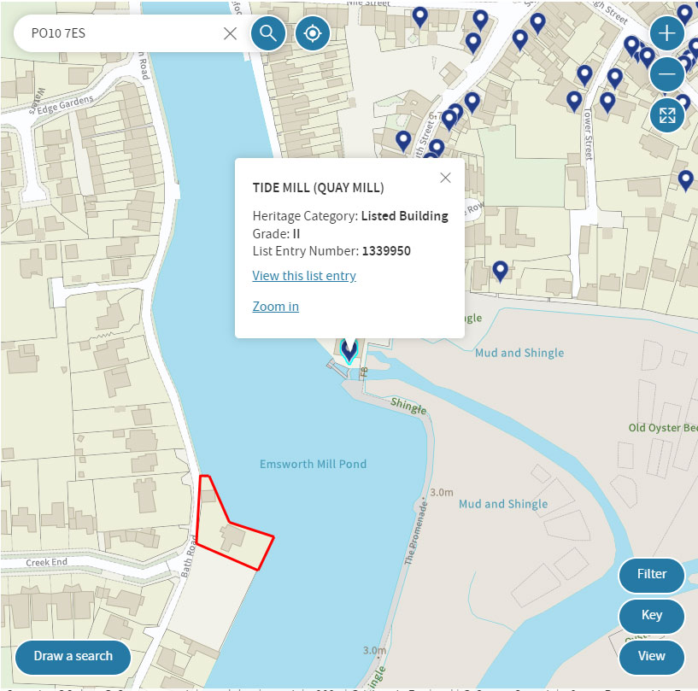

There are views of the listed building, Tide Mill, from the application site but this will remain uninterrupted due to the use of glass in the increased height for the majority of the raised flood wall.

There are no views of Tide Mill from the entrance to Emsworth Sailing club car park through the proposed flood wall due to the positioning of the existing property and existing boundary treatments.

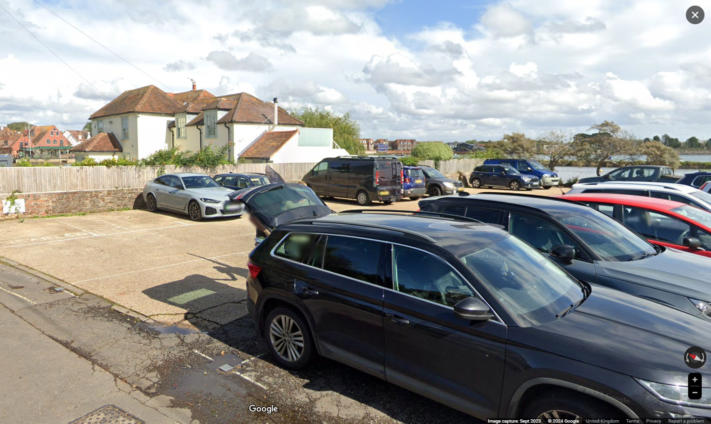

Google StreetView image taken from the Emsworth Sailing Club car park entrance towards Tide Mill. Swan House can be seen at the top left of the above image.

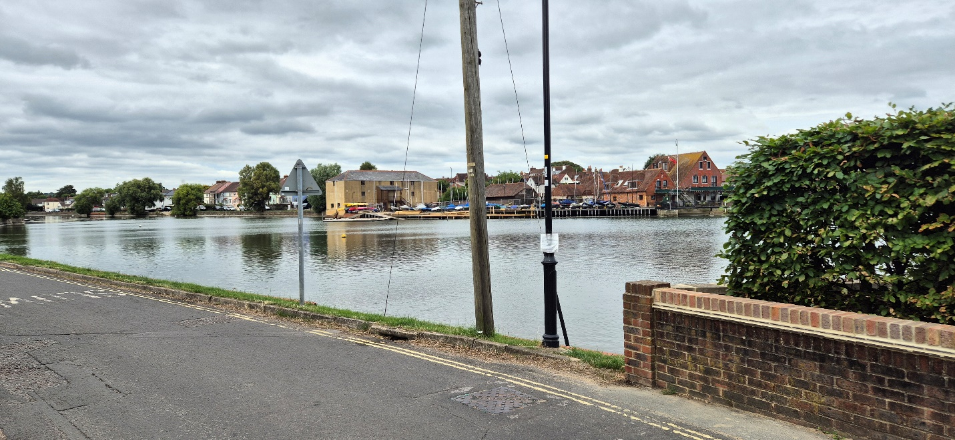

Photo taken from the North corner of the application site showing Tide Mill in the background. The increase in the boundary wall height of 330mm won’t impact the views of the listed building.

