GENERAL RISKS & CONTROLS
Classification (state the category of danger)
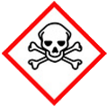 | ☐ |  |  | Serious Health Hazard/Toxic |  |  |  | 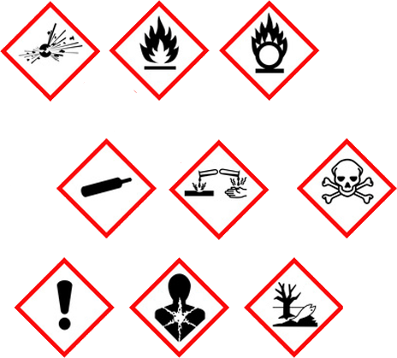 |  | ☐ |  | Oxidising |  |  | 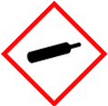 |  |  | ☐ |  |  | Gas Under Pressure
 | ☒ |  |  | Health Hazard/ Harmful/Irritant |  |  |  |  |  | ☐ |  | Flammable |  |  |  |  |  | ☐ |  |  | Acute Toxicity/ Carcinogen
 | ☐ |  |  | Corrosive |  |  |  |  |  | ☐ |  | Explosive |  |  |  |  |  | ☒ |  |  | Dangerous for the Environment
Hazard Type
☐ |  |  | ☐ |  |  | ☐ |  |  | ☐ |  |  |  | ☐ |  |  | ☒ |  |  |  | ☐ |  |  | ☐
Gas |  |  | Water |  |  | Mist |  |  | Fume |  |  |  | Dust |  |  | Liquid |  |  |  | Solid |  |  | Other
Route of Exposure
☒ |  | ☒ |  |  |  |  | ☒ |  |  |  | ☐ |  |  | ☐
Inhalation |  | Skin |  |  |  |  | Eyes |  |  |  | Ingestion |  |  | Other (state)
Workplace Exposure Limits (WELs) please indicate n/a where not applicable |  |  |  |  |  |  |  |  |  |  |  |  |  |  |  |  | 5mg/m3  TWA
Storage & Handling |  |  |  |  |  |  |  |  |  |  |  |  | Hazard Symptoms
- Store in cool, well ventilated area, in original container on an impermeable floor and away from acids.  - Avoid sources of ignition and heat sources, and ingress of water.  - Do NOT remove labels.  - Ensure container is protected from impact.  - Avoid strong oxidising agents, and strong acids.  - Ensure container does not have residual grease on outside of container when lifting or handling. |  |  |  |  |  |  |  |  |  |  |  |  | - In combustion emits toxic fumes.  - Release into the environment causes damage to aquatic organisms.  - Container may be slippery due to residual grease left on the container.  - Creates slippery surface.  - Ingesting substance can cause diarrhoea and stomach pains.  - Extended exposure to skin can cause irritation and dermatitis.  - Contact with the eyes will cause irritation.
Controls |  |  |  |  |  |  |  |  |  |  |  |  | Remedial Actions
- Avoid leaving the substance close to sources of extreme temperature, oxidising agents, and strong acids.  - Store on impermeable ground. Use bund to ensure leaks to not contaminate the ground.  - Ensure container is adequately free from grease before lifting/handling. Use gloves with suitable grip, and mechanical aids were necessary.  - Clean up procedure if spilt: Absorb into dry earth or sand and dispose of waste accordingly.  - Do NOT eat, drink, smoke, when using. Maintain high level of hygiene.  - Wear impermeable protective gloves when handling.  - Wear protective eye wear. |  |  |  |  |  |  |  |  |  |  |  |  | - Stop the spill if safe to do so.  - Prevent entry into drains, sewers, and watercourses.  - Soak up with absorbent material.  - If spilt into water, contain by a boom, then collect by skimming or absorption.  - Clean the contaminated area, surface will be slippery.
Disposal
Hazardous Waste?  ☐ |  |  |  |  | Skip  ☒ |  |  |  |  |  |  |  | Other ☒  - Place used/contaminated materials in suitable containers.  - Do NOT burn or incinerate empty or full containers.  - Dispose of controlled waste using licenced waste disposal company.
Return to Depot  ☐ |  |  |  |  | Return to Supplier  ☐
- FIRST AID  -  |  |  |  |  |  |  |  |  |  |  |  |  | FIRE FIGHTING  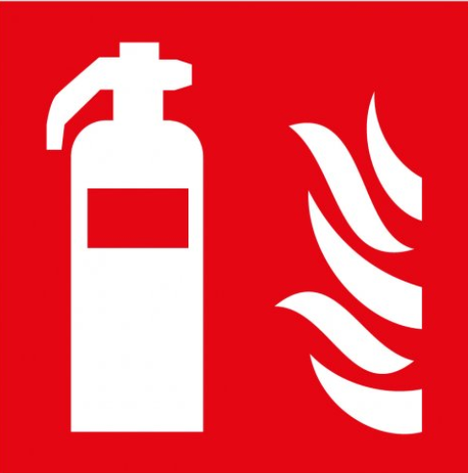
- No applicable. May exert toxic fumes when exposed to acids and combustion. In the event seek medical attention  - Remove contaminated cloths and wash with warm soap water immediately.  - Seek medical attention if irritation continues. |  |  |  |  | - Remove contact lenses and flush eye immediately with water. Seek medical attention if discomfort continues.  - Wash mouth out with water. Do not induce vomiting. Seek medical attention if discomfort continues. |  |  |  |  |  |  |  | WATER  ☒ |  | FOAM  ☒ |  | POWDER  ☒ |  |  |  |  | CO2  ☒ |  | CHEMICAL  ☒
PRECAUTIONS:
Combustion emits toxic fumes. Use media best suited for surroundings.
SITE SPECIFIC CONTROLS (TO BE COMPLETED ON SITE)
Work Activities Being Undertaken
Fuelling of Plant & Equipment on site
Exposure
Number of Persons |  |  |  | Frequency |  |  |  |  | Duration |  |  |  |  | Any specific training requirements?
5-10 |  |  |  | Daily |  |  |  |  | 30 mins |  |  |  |  | ☐
Personal Protective Equipment (PPE) Control Measures
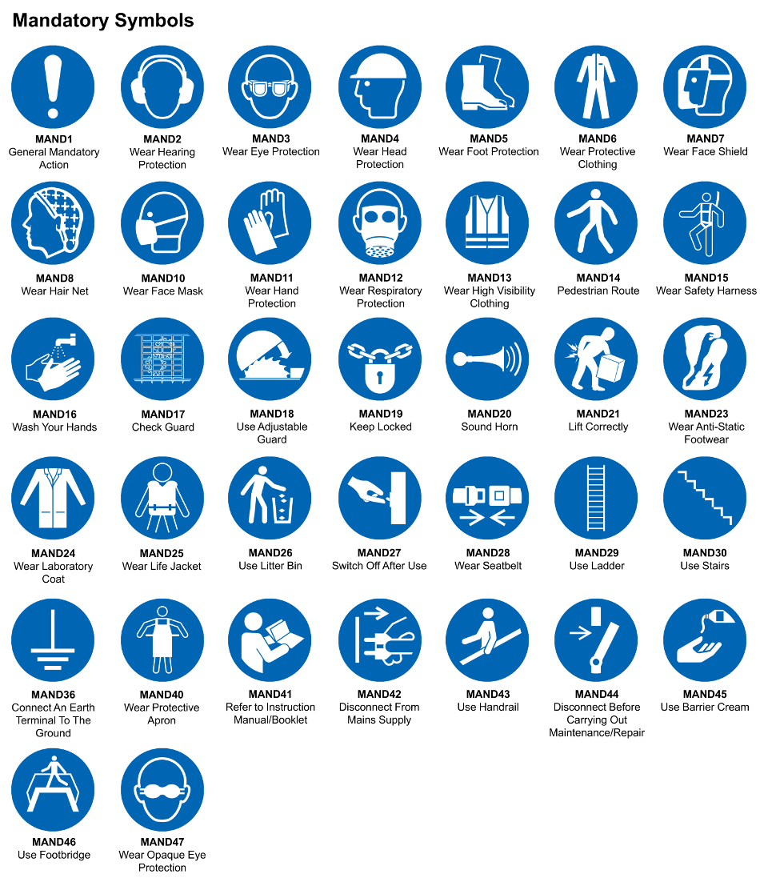
☐ | ☐ |  | ☐ |  | ☐ |  |  | ☐ |  | ☐ |  | ☐ |  |  | ☐ |  | ☐
Eye Protection | Ear Protection |  | Hard Hat |  | Footwear |  |  | Overalls |  | Visor |  | Gloves |  |  | Face Mask |  | Respirator
Storage Requirements
LOCKED CAGE |  | BUNDED CONTAINER |  |  |  |  | PROTECTION  FROM WEATHER |  |  |  | COSHH STORAGE ROOM |  |  |  |  | SEALED CONTAINER
☐ |  | ☐ |  |  |  |  | ☐ |  |  |  | ☐ |  |  |  |  | ☐
Waste Management
SEGREGATED STORAGE |  |  |  |  |  | SEALED CONTAINERS |  |  |  |  |  |  | WASTE CARRIER DISPOSAL / RECYCLING LICENCE
☐ |  |  |  |  |  | ☒ |  |  |  |  |  |  | ☐
Risk Rating Following Control Measures
LOW |  |  |  |  |  | MEDIUM |  |  |  |  |  |  | HIGH
☐ |  |  |  |  |  | ☐ |  |  |  |  |  |  | ☐

Site Specific RA Prepared by: | Si King | Position: | Contracts Director
Site Specific RA Prepared by: | Si King | Review Date: | 27/09/2023

