GENERAL RISKS & CONTROLS
Classification (state the category of danger)
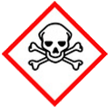 | ☐ |  |  | Serious Health Hazard/Toxic |  |  |  | 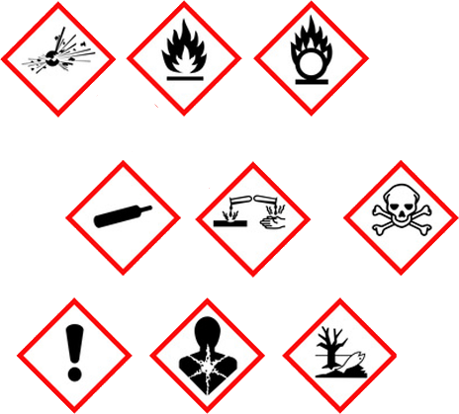 |  | ☐ |  | Oxidising |  |  | 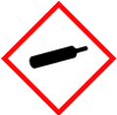 |  |  | ☐ |  |  | Gas Under Pressure
 | ☒ |  |  | Health Hazard/ Harmful/Irritant |  |  |  |  |  | ☐ |  | Flammable |  |  |  |  |  | ☐ |  |  | Acute Toxicity/ Carcinogen
 | ☐ |  |  | Corrosive |  |  |  |  |  | ☐ |  | Explosive |  |  |  |  |  | ☒ |  |  | Dangerous for the Environment
Hazard Type
☐ |  |  | ☐ |  |  | ☐ |  |  | ☐ |  |  |  | ☐ |  |  | ☒ |  |  |  | ☐ |  |  | ☐
Gas |  |  | Water |  |  | Mist |  |  | Fume |  |  |  | Dust |  |  | Liquid |  |  |  | Solid |  |  | Other
Route of Exposure
☒ |  | ☒ |  |  |  |  | ☒ |  |  |  | ☒ |  |  | ☐
Inhalation |  | Skin |  |  |  |  | Eyes |  |  |  | Ingestion |  |  | Other (state)
Workplace Exposure Limits (WELs) please indicate n/a where not applicable |  |  |  |  |  |  |  |  |  |  |  |  |  |  |  |  | 10mg/15mins
Storage & Handling |  |  |  |  |  |  |  |  |  |  |  |  | Hazard Symptoms
- Keep substance in original container tightly closed.  - Avoid sources of heat and ignition, and ingress of water.  - A bund area is required (110% percent capacity of container.)  - Keep on impermeable ground.  - Do NOT remove labels.  - Protect against impact and puncture. |  |  |  |  |  |  |  |  |  |  |  |  | - Substance may cause slight skin irritation.  - May cause slight eye irritation.  - Ingestion may cause gastrointestinal irritation, nausea, vomiting and diarrhoea.  - Harmful to aquatic organisms.  - Barrels are heavy even when empty.  - Inheritably combustible.
Controls |  |  |  |  |  |  |  |  |  |  |  |  | Remedial Actions
- Wear impermeable gloves, and overalls where necessary.  - Avoid contact with the eyes. Use eye protection.  - Do NOT siphon by mouth. Do NOT eat, drink smoke when using, and wash hands after use.  - Store on bund, on impermeable grounds. Keep spill kit close by.  - Use mechanical aids, and manual handling techniques when handling. Do NOT drag, roll, or push drums.  - Keep away from open flames, heat, hot surfaces, and other sources of ignition. |  |  |  |  |  |  |  |  |  |  |  |  | - Stop the spill if safe to do so.  - Prevent entry into drains, sewers, and watercourses.  - Soak up with absorbent material.  - If spilt into water, contain by a boom, then collect by skimming or  - absorption.  - Clean the contaminated area, surface will be slippery.  - Notify Environmental agency if spill contaminates water.
Disposal
Hazardous Waste?  ☐ |  |  |  |  | Skip  ☒ |  |  |  |  |  |  |  | - Place used/contaminated materials in suitable containers. - Dispose of controlled waste in accordance with Duty of Care Regs (Environmental Protection Act 1990-Section34) Using a licenced waste disposal company. - Do NOT burn or incinerate drums. Other ☐
Return to Depot  ☐ |  |  |  |  | Return to Supplier  ☐
FIRST AID   |  |  |  |  |  |  |  |  |  |  |  |  | FIRE FIGHTING  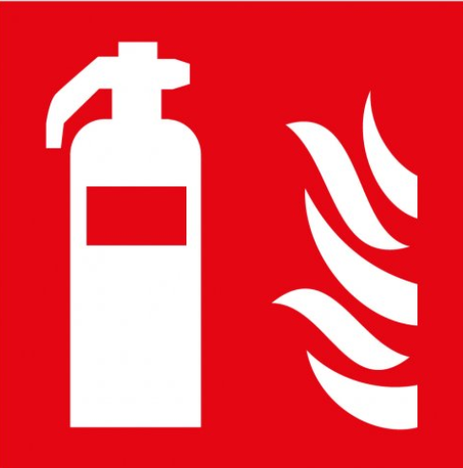
Remove to fresh air. If effects persist, seek medical attention.  Wash thoroughly with warm soap water. Seek medical attention if irritation occurs. |  |  |  |  | Remove contact lenses, and flush with water. If irritation continues get medical attention.  Rinse mouth with water. Do NOT induce vomiting, unless instructed by a medical professional. |  |  |  |  |  |  |  | WATER  ☒ |  | FOAM  ☒ |  | POWDER  ☒ |  |  |  |  | CO2  ☐ |  | CHEMICAL  ☐
 |  |  |  |  |  |  |  |  |  |  |  |  | PRECAUTIONS:
SITE SPECIFIC CONTROLS (TO BE COMPLETED ON SITE)
Work Activities Being Undertaken
Fuelling of Plant & Equipment on site
Exposure
Number of Persons |  |  |  | Frequency |  |  |  |  | Duration |  |  |  |  | Any specific training requirements?
5-10 |  |  |  | Daily |  |  |  |  | 30 mins |  |  |  |  | ☐
Personal Protective Equipment (PPE) Control Measures
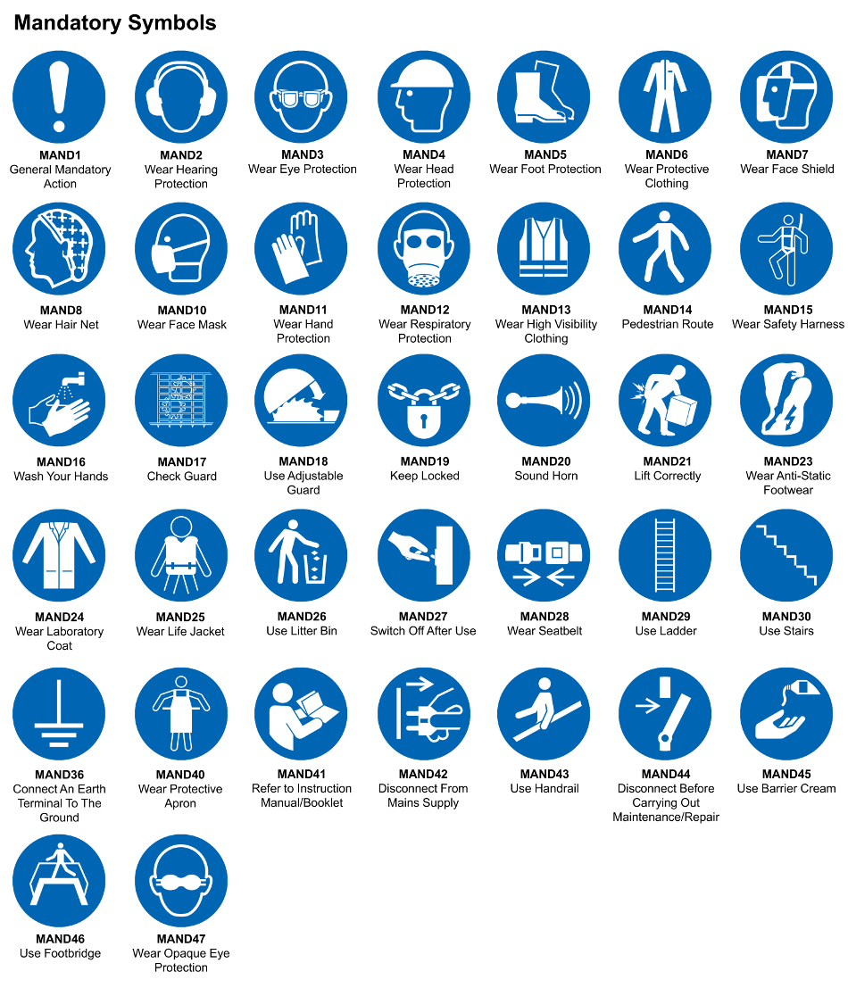
☐ | ☐ |  | ☐ |  | ☐ |  |  | ☐ |  | ☐ |  | ☐ |  |  | ☐ |  | ☐
Eye Protection | Ear Protection |  | Hard Hat |  | Footwear |  |  | Overalls |  | Visor |  | Gloves |  |  | Face Mask |  | Respirator
Storage Requirements
LOCKED CAGE |  | BUNDED CONTAINER |  |  |  |  | PROTECTION  FROM WEATHER |  |  |  | COSHH STORAGE ROOM |  |  |  |  | SEALED CONTAINER
☐ |  | ☐ |  |  |  |  | ☐ |  |  |  | ☐ |  |  |  |  | ☐
Waste Management
SEGREGATED STORAGE |  |  |  |  |  | SEALED CONTAINERS |  |  |  |  |  |  | WASTE CARRIER DISPOSAL / RECYCLING LICENCE
☐ |  |  |  |  |  | ☒ |  |  |  |  |  |  | ☐
Risk Rating Following Control Measures
LOW |  |  |  |  |  | MEDIUM |  |  |  |  |  |  | HIGH
☐ |  |  |  |  |  | ☒ |  |  |  |  |  |  | ☐

Site Specific RA Prepared by: | Si King | Position: | Contracts Director
Site Specific RA Prepared by: | Si King | Review Date: | 28/09/2023

