GENERAL RISKS & CONTROLS
Classification (state the category of danger)
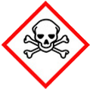 | ☐ |  |  | Serious Health Hazard/Toxic |  |  |  | 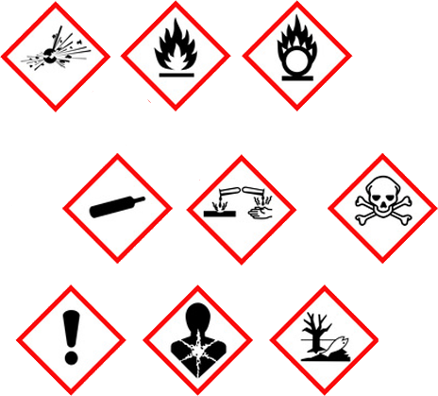 |  | ☐ |  | Oxidising |  |  | 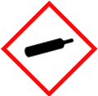 |  |  | ☐ |  |  | Gas Under Pressure
 | ☐ |  |  | Health Hazard/ Harmful/Irritant |  |  |  |  |  | ☐ |  | Flammable |  |  |  |  |  | ☐ |  |  | Acute Toxicity/ Carcinogen
 | ☐ |  |  | Corrosive |  |  |  |  |  | ☐ |  | Explosive |  |  |  |  |  | ☒ |  |  | Dangerous for the Environment
Hazard Type
☐ |  |  | ☐ |  |  | ☐ |  |  | ☐ |  |  |  | ☒ |  |  | ☐ |  |  |  | ☒ |  |  | ☐
Gas |  |  | Water |  |  | Mist |  |  | Fume |  |  |  | Dust |  |  | Liquid |  |  |  | Solid |  |  | Other
Route of Exposure
☒ |  | ☒ |  |  |  |  | ☒ |  |  |  | ☒ |  |  | ☐
Inhalation |  | Skin |  |  |  |  | Eyes |  |  |  | Ingestion |  |  | Other (state)
Workplace Exposure Limits (WELs) please indicate n/a where not applicable |  |  |  |  |  |  |  |  |  |  |  |  |  |  |  |  | 10mg /8 hour
Storage & Handling |  |  |  |  |  |  |  |  |  |  |  |  | Hazard Symptoms
- Store on stable pallets on even ground  - Ensure plaster boards do not fall, or can be blown over. Protect against the weather, prevent the ingress of moisture.  - Ensure substance is laid flat.  - Use mechanical aids when handling, substance may come in awkward sizes. |  |  |  |  |  |  |  |  |  |  |  |  | - May irritate the respiratory system, skin and eyes. Plasters may produce an alkaline solution on contact with body moisture or when mixed with water.  - Plasterboard can NOT take the weight of any person.  - Avoid mechanical cutting equipment. Cutting material causes dust to eject into the atmosphere.  - Heavy in large quantities, and awkward to handle.
Controls |  |  |  |  |  |  |  |  |  |  |  |  | Remedial Actions
- Wear overalls to prevent contact with skin. Ensure good ventilation of working area.  - Wear protective gloves to avoid prolonged or repeated contact. Exclude unauthorised persons from the area.  - General training in the safe use, handling, disposal and storage, instruction in the use of control measures.  - Remove as a whole wherever possible. Wet down prior and during removal to reduce levels of dust. Hand cut were possible. If dust cannot be sufficiently controlled when cutting or breaking use appropriate RPE and isolate the working area.  - When handling large quantities, ensure mechanical aids are implemented, and manual handling techniques are used. |  |  |  |  |  |  |  |  |  |  |  |  | - Stop the process creating the release.  - Dampen down the area, and allow for ventilation.  - Dry sweep/vacuum large amounts using adequate RPE.  - Wet mop and rinse contaminated area for residual dust.  - Conduct monitoring to ensure dust is back to an acceptable level
Disposal
Hazardous Waste?  ☐ |  |  |  |  | Skip  ☒ |  |  |  |  |  |  |  | Other ☒  - Fully recyclable classified as EWC 17 08 02.  - Store waste separate from all other waste.
Return to Depot  ☐ |  |  |  |  | Return to Supplier  ☐
FIRST AID   |  |  |  |  |  |  |  |  |  |  |  |  | FIRE FIGHTING  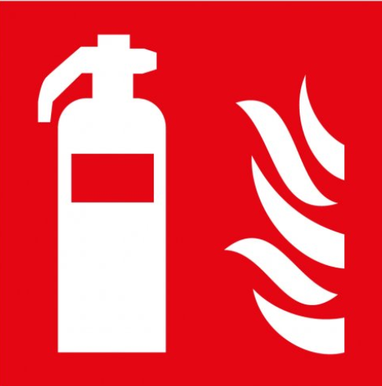
- Remove casualty to fresh air, and keep warm and at rest. If irritation occurs, seek medical advice.  - Wash skin with plenty of warm soap water. Apply moisturising lotion. If irritation occurs, seek medical advice. |  |  |  |  | - Remove any contact lenses, flush eyes with water. Repeat for 15mins. Seek medical attention if irritation occurs.  - Do NOT induce vomiting. Rinse mouth with clean water. Seek medical attention if irritation occurs. |  |  |  |  |  |  |  | WATER  ☒ |  | FOAM  ☒ |  | POWDER  ☒ |  |  |  |  | CO2  ☒ |  | CHEMICAL  ☒
 |  |  |  |  |  |  |  |  |  |  |  |  | PRECAUTIONS: NOT a fire hazard, packaging may burn.
SITE SPECIFIC CONTROLS (TO BE COMPLETED ON SITE)
Work Activities Being Undertaken
Exposure
Number of Persons |  |  |  | Frequency |  |  |  |  | Duration |  |  |  |  | Any specific training requirements?
5 -10 |  |  |  | Daily |  |  |  |  | 8 hours |  |  |  |  | ☐
Personal Protective Equipment (PPE) Control Measures
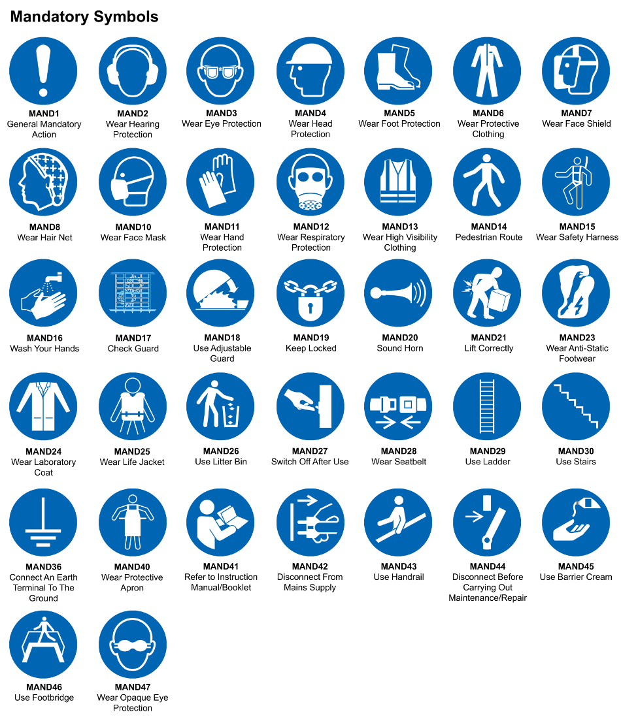
☒ | ☐ |  | ☒ |  | ☒ |  |  | ☐ |  | ☐ |  | ☒ |  |  | ☒ |  | ☐
Eye Protection | Ear Protection |  | Hard Hat |  | Footwear |  |  | Overalls |  | Visor |  | Gloves |  |  | Face Mask |  | Respirator
Storage Requirements
LOCKED CAGE |  | BUNDED CONTAINER |  |  |  |  | PROTECTION  FROM WEATHER |  |  |  | COSHH STORAGE ROOM |  |  |  |  | SEALED CONTAINER
☐ |  | ☐ |  |  |  |  | ☒ |  |  |  | ☐ |  |  |  |  | ☐
Waste Management
SEGREGATED STORAGE |  |  |  |  |  | SEALED CONTAINERS |  |  |  |  |  |  | WASTE CARRIER DISPOSAL / RECYCLING LICENCE
☐ |  |  |  |  |  | ☒ |  |  |  |  |  |  | ☒
Risk Rating Following Control Measures
LOW |  |  |  |  |  | MEDIUM |  |  |  |  |  |  | HIGH
☐ |  |  |  |  |  | ☐ |  |  |  |  |  |  | ☐

Site Specific RA Prepared by: | Si King | Position: | Contracts Director
Site Specific RA Prepared by: | Si King | Review Date: | 28/09/2023

