Flood Risk Assessment for:

1 THE PARCHMENT, HAVANT, HAMPSHIRE, PO9 1HD

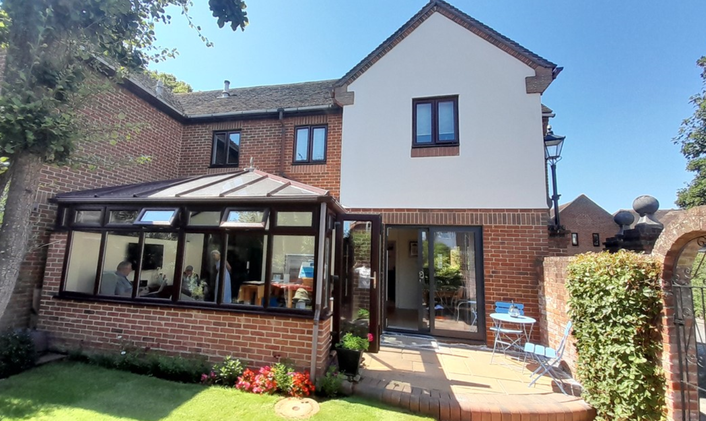

This FRA Statement has been prepared by Anglian Home Improvements in support of the Planning Application, for the replacement of existing conservatory roof with solid panel roof with tinted toughened glass sections. The application site is situated within flood zone flood zone 3, an area with a high probability of flooding.
Please be advised that we are just replacing the existing roof, there will be no base works involved.
