GENERAL RISKS & CONTROLS
Classification (state the category of danger)
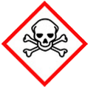 | ☐ |  |  | Serious Health Hazard/Toxic |  |  |  | 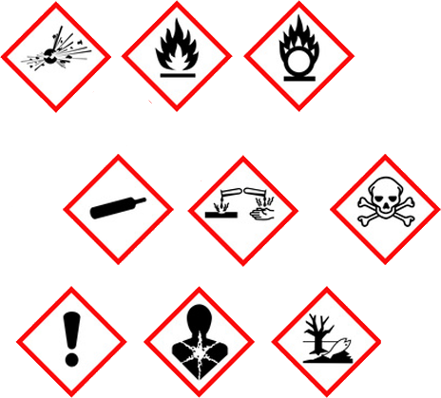 |  | ☐ |  | Oxidising |  |  |  |  | 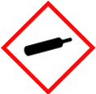 |  |  |  | ☐ |  |  | Gas Under Pressure
 | ☒ |  |  | Health Hazard/ Harmful/Irritant |  |  |  |  |  | ☐ |  | Flammable |  |  |  |  |  |  |  |  | ☐ |  |  | Acute Toxicity/ Carcinogen
 | ☒ |  |  | Corrosive |  |  |  |  |  | ☐ |  | Explosive |  |  |  |  |  |  |  |  | ☒ |  |  | Dangerous for the Environment
Hazard Type
☐ |  |  | ☐ |  |  | ☐ |  |  | ☐ |  |  |  |  | ☐ |  |  |  | ☒ |  |  |  |  | ☐ |  |  | ☐
Gas |  |  | Water |  |  | Mist |  |  | Fume |  |  |  |  | Dust |  |  |  | Liquid |  |  |  |  | Solid |  |  | Other
Route of Exposure
☒ |  | ☒ |  |  |  |  | ☒ |  |  |  | ☒ |  |  |  | ☐
Inhalation |  | Skin |  |  |  |  | Eyes |  |  |  | Ingestion |  |  |  | Other (state)
Workplace Exposure Limits (WELs) please indicate n/a where not applicable |  |  |  |  |  |  |  |  |  |  |  |  |  |  |  |  |  |  |  | 2mg/15mins
Storage & Handling |  |  |  |  |  |  |  |  |  |  |  |  |  | Hazard Symptoms
- Keep in original.  - Keep container tightly closed.  - Keep in locked COSHH store in a cool, well ventilated area away from food and water.  - Store separate from acids.  - Avoid possible impact and puncture.  - Store away from sources of heat and ignition. |  |  |  |  |  |  |  |  |  |  |  |  |  | - Will severely irritate eyes.  - Contact with the skin may cause burns.  - Respiration may cause irritation.  - May cause burning on ingestion.  - Fire/burning can create toxic gasses.  - Surfaces may become slippery.
Controls |  |  |  |  |  |  |  |  |  |  |  |  |  | Remedial Actions
- Wear appropriate eye protection, avoid contact with the eyes.  - Wear impermeable gloves, and overalls were necessary.  - Ensure usage is in a well ventilated area. Wear RPE if required.  - Do NOT eat, drink or smoke when using. Wash hands thoroughly after use.  - Use/store away from potential sources of heat and ignition. Only store amount required. Do NOT over stock.  - Do NOT decant into other containers.  - General information and training on usage, storing, handling, controls, and disposal before using product. |  |  |  |  |  |  |  |  |  |  |  |  |  | - Stop the spillage if safe to do so.  - Prevent entry into drains, sewers, and watercourses.  - Use absorbent material to absorb the spill.  - Small spillages can be flushed away with water.  - Clean area with water thoroughly. Area may become slippery
Disposal
Hazardous Waste?  ☐ |  |  |  |  | Skip  ☒ |  |  |  |  |  |  |  | - Do not pore into drains or water courses.  - Dispose in accordance with local authority requirements. Recycle if practicable.  - Do NOT burn or incinerate container.
Return to Depot  ☐ |  |  |  |  | Return to Supplier  ☐
FIRST AID   |  |  |  |  |  |  |  |  |  |  |  |  |  | FIRE FIGHTING  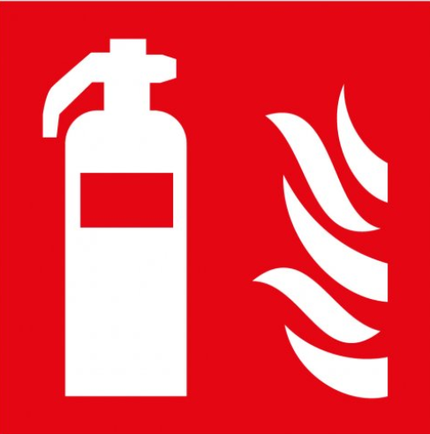
- Remove victim immediately from souse of exposure. Seek medical advice if irritation continues.  - Remove contaminated cloths, and wash skin thoroughly with warm soap water. - Use suitable lotion to moisturise skin. Get medical advice with irritation continues. |  |  |  |  | - Remove contact lenses. Flush eyes with water, get medical attention if irritation persists.  - Rinse mouth thoroughly, Drink plenty of water. Seek medical attention immediately if irritation occurs. |  |  |  |  |  |  |  | WATER  ☒ |  |  | FOAM  ☒ |  |  | POWDER  ☒ |  |  |  |  |  | CO2  ☐ |  | CHEMICAL  ☐
 |  |  |  |  |  |  |  |  |  |  |  |  | PRECAUTIONS: NOT flammable. Fire causes formation of toxic gasses. Prevent water runoff into water sources.
SITE SPECIFIC CONTROLS (TO BE COMPLETED ON SITE)
Work Activities Being Undertaken
Exposure
Number of Persons |  |  |  | Frequency |  |  |  |  | Duration |  |  |  |  | Any specific training requirements?
5 -10 |  |  |  | Daily |  |  |  |  | 8 Hours |  |  |  |  | ☐
Personal Protective Equipment (PPE) Control Measures
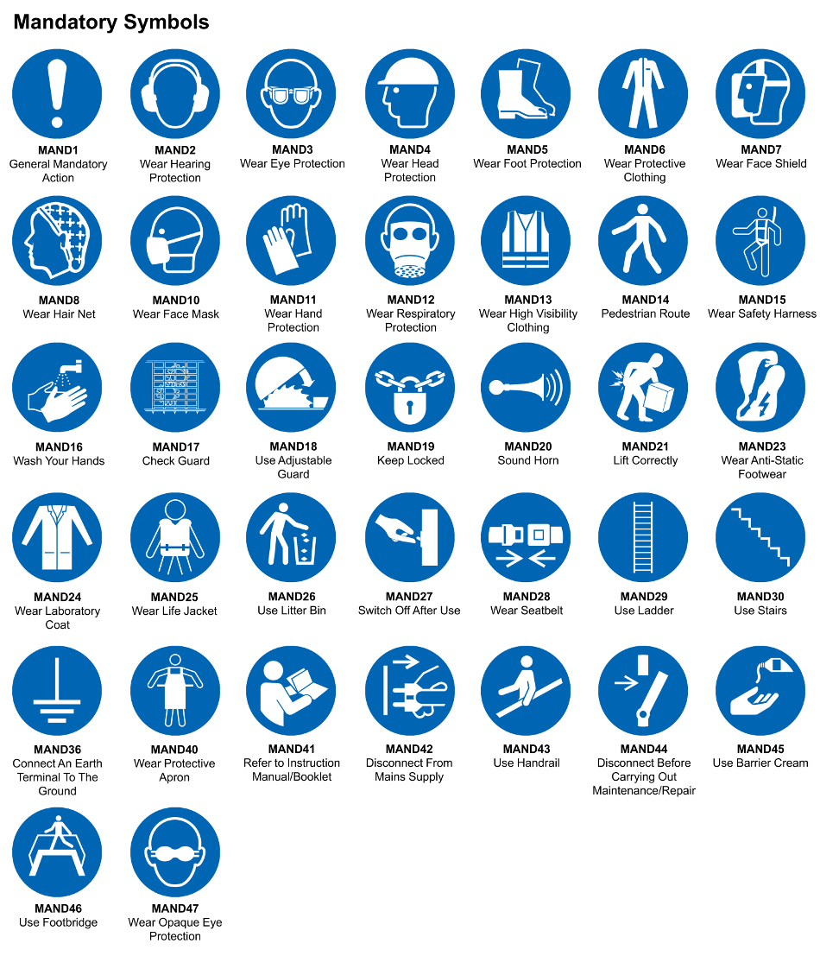
☒ | ☐ |  | ☒ |  | ☒ |  |  | ☐ |  | ☐ |  | ☒ |  |  | ☒ |  | ☐
Eye Protection | Ear Protection |  | Hard Hat |  | Footwear |  |  | Overalls |  | Visor |  | Gloves |  |  | Face Mask |  | Respirator
Storage Requirements
LOCKED CAGE |  | BUNDED CONTAINER |  |  |  |  | PROTECTION  FROM WEATHER |  |  |  | COSHH STORAGE ROOM |  |  |  |  | SEALED CONTAINER
☐ |  | ☐ |  |  |  |  | ☐ |  |  |  | ☒ |  |  |  |  | ☐
Waste Management
SEGREGATED STORAGE |  |  |  |  |  | SEALED CONTAINERS |  |  |  |  |  |  | WASTE CARRIER DISPOSAL / RECYCLING LICENCE
☐ |  |  |  |  |  | ☒ |  |  |  |  |  |  | ☐
Risk Rating Following Control Measures
LOW |  |  |  |  |  | MEDIUM |  |  |  |  |  |  | HIGH
☐ |  |  |  |  |  | ☒ |  |  |  |  |  |  | ☐

Site Specific RA Prepared by: | Si King | Position: | Contracts Director
Site Specific RA Prepared by: | Si King | Review Date: | 28/09/2023

