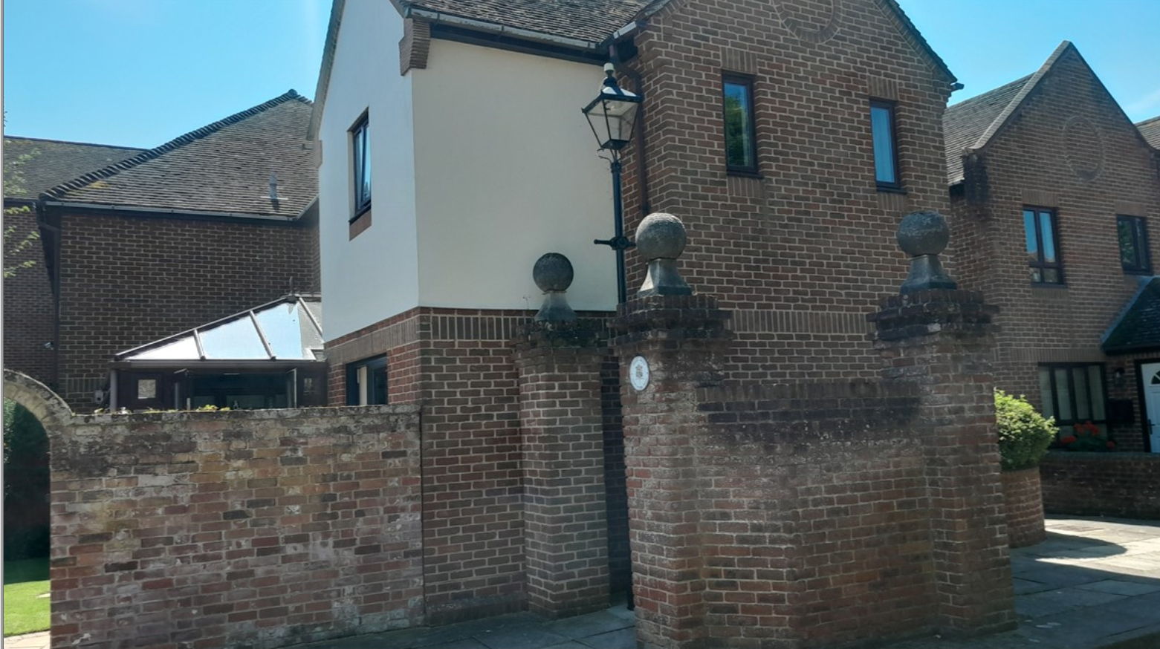

Heritage Statement - 1 THE PARCHMENT, HAVANT, HAMPSHIRE, PO9 1HD
Replacement Conservatory Roof to solid panel roof with tinted toughened glass roof sections.
To the north of Havant lies Leigh Park, and beyond that Staunton country park, to the east is Emsworth and to the west lies Bedhampton and Portsdown hill. The old centre of the town is on a crossroad configuration with the four streets being named North Street, East Street, South Street and west street With St Faith's church at the crossing. At least one axis, although evidence suggests both, is a known roman road.
There are several natural springs in the area, including one near the southwest of the Church on West Street at the end of Homewell this used to be the home of the premier parchment making factory in Southern England which closed in 1936, it is said that the Magna carta and the treaty of Versailles was written on Havant parchment.
In 1086 Havant was a village with a population of approximately 100. In 1200 monks of Winchester Cathedral were granted the right to hold a market at Havant. In 1760 much of the town was destroyed by fire, leaving only the church and the adjacent 16th and 17th Century cottages unscathed. The cottages were later known collectively as the Old House at home public house which claims that the two main beams were recovered from the Spanish Armada and the last bear post. 1 the parchment is an end of terrace property in a small development. It is proposed to replace the conservatory roof to the rear of the property.
Due to the location of the property the conservatory will be visible from the road, the build will not impact on any of the amenities of neighbouring sites, nor will it affect the current level of sunlight or daylight enjoyed by neighbouring properties. The existing access to the property will not be disrupted or disturbed. It will not be necessary to disturb any shrubs or bushes of consequence surrounding the property.
Other matters
The property is not a listed building but is within the confines of a Conservation Area. It is not in an area of outstanding natural beauty and is not in the national park.
