GENERAL RISKS & CONTROLS
Classification (state the category of danger)
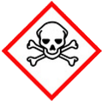 | ☐ |  |  | Serious Health Hazard/Toxic |  |  |  | 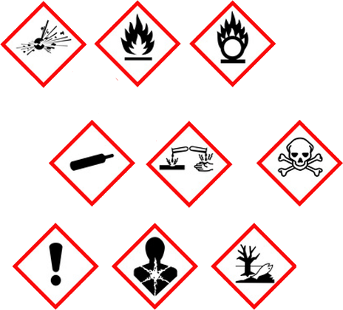 |  | ☐ |  | Oxidising |  |  | 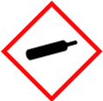 |  |  | ☐ |  |  | Gas Under Pressure
 | ☒ |  |  | Health Hazard/ Harmful/Irritant |  |  |  |  |  | ☒ |  | Flammable |  |  |  |  |  | ☐ |  |  | Acute Toxicity/ Carcinogen
 | ☐ |  |  | Corrosive |  |  |  |  |  | ☒ |  | Explosive |  |  |  |  |  | ☒ |  |  | Dangerous for the Environment
Hazard Type
☐ |  |  | ☐ |  |  | ☐ |  |  | ☐ |  |  |  | ☐ |  |  | ☒ |  |  |  | ☐ |  |  | ☐
Gas |  |  | Water |  |  | Mist |  |  | Fume |  |  |  | Dust |  |  | Liquid |  |  |  | Solid |  |  | Other
Route of Exposure
☒ |  | ☒ |  |  |  |  | ☒ |  |  |  | ☒ |  |  | ☐
Inhalation |  | Skin |  |  |  |  | Eyes |  |  |  | Ingestion |  |  | Other (state)
Workplace Exposure Limits (WELs) please indicate n/a where not applicable |  |  |  |  |  |  |  |  |  |  |  |  |  |  |  |  | 574mg/150ppm  15 minutes
Storage & Handling |  |  |  |  |  |  |  |  |  |  |  |  | Hazard Symptoms
- Store in segregated, and approved area stood upright. Empty containers stored separately.  - Keep bund 110% capacity of container, on impermeable grounds, in cool and well-ventilated area.  - Keep minimal amount of substance on site, store and use amount as its needed.  - Do not remove warning labels. Keep tightly closed.  - Keep away from sources of ignition, no smoking. Store away from possible sources of impact.  - Establish designated storage and refuelling area.  - Keep spill kits, and firefighting equipment stored close by. |  |  |  |  |  |  |  |  |  |  |  |  | - Extremely flammable.  - Toxic to aquatic organisms.  - Fumes are heavier then air and will collect at low levels. Fumes may travel on declining surfaces and contaminate remote areas.  - Exposure to high levels of the vapour can cause irritation to eyes and mucous membranes, drowsiness leading to loss of consciousness.  - Ingestion of small amounts may cause nausea, diarrhoea; larger amounts may cause irritation, drowsiness and vomiting.  - Prolonged or repeated exposure may lead to short-term irritation, defatting of the skin and dermatitis.  - Contact with the eyes is likely to cause short-term irritation with redness and stinging.
Controls |  |  |  |  |  |  |  |  |  |  |  |  | Remedial Actions
- Keep bund and on impermeable grounds.  - Avoid storage and use close to excavation, drains, basements, and confined spaces where fumes may accumulate. General training on specific hazards associated with substance.  - Do NOT Use close to ignition sources.  - Do NOT siphon by mouth. Wash hands after use. Do NOT eat, drink, smoke when using.  - Wear impermeable gloves. Avoid contact with the skin. Wear protective overalls were necessary.  - Wear appropriate eye protection. |  |  |  |  |  |  |  |  |  |  |  |  | - Eliminate all sources of ignition.  - Ensure spill is absorbed with inert material.  - Dispose of/replace contaminated clothing.  - Do NOT allow entry into the environment.  - Keep all contaminated materials safely stored until disposal.
Disposal
Hazardous Waste?  ☒ |  |  |  |  | Skip  ☒ |  |  |  |  |  |  |  | Other ☒  - Dispose via an authorised person/Licensed disposal contractor in accordance to local regulations.  - Empty containers may contains residual substances, never weld, solder, braze, grind or heat.
Return to Depot  ☐ |  |  |  |  | Return to Supplier  ☐
FIRST AID   |  |  |  |  |  |  |  |  |  |  |  |  | FIRE FIGHTING  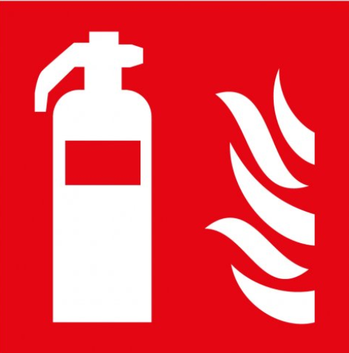
- If exposure causes drowsiness, headache, blurred vision, or irritation of the eyes, nose or throat, remove immediately to fresh air, keep patient warm and at rest. If symptoms persist, obtain medical advice.  - Wash skin thoroughly with warm soap water and remove heavily contaminated clothing to be washed.  - Seek medical advice if skin becomes red, swollen, or painful. |  |  |  |  | - In case of eye contact, rinse immediately with water. Get medical attention if irritation continues.  - If swallowed, do not induce vomiting. Never give anything by mouth to an unconscious person.  - Aspiration hazard if swallowed, can enter lungs and cause damage, seek medical attention. |  |  |  |  |  |  |  | WATER  ☒ |  | FOAM  ☒ |  | POWDER  ☒ |  |  |  |  | CO2  ☒ |  | CHEMICAL  ☐
PRECAUTIONS:
Do NOT use solid water Jet, use mist spray. Avoid residual water run-off into drains.
SITE SPECIFIC CONTROLS (TO BE COMPLETED ON SITE)
Work Activities Being Undertaken
Generators
Exposure
Number of Persons |  |  |  | Frequency |  |  |  |  | Duration |  |  |  |  | Any specific training requirements?
5 -10 |  |  |  | Daily |  |  |  |  | 8 hours |  |  |  |  | ☐
Personal Protective Equipment (PPE) Control Measures
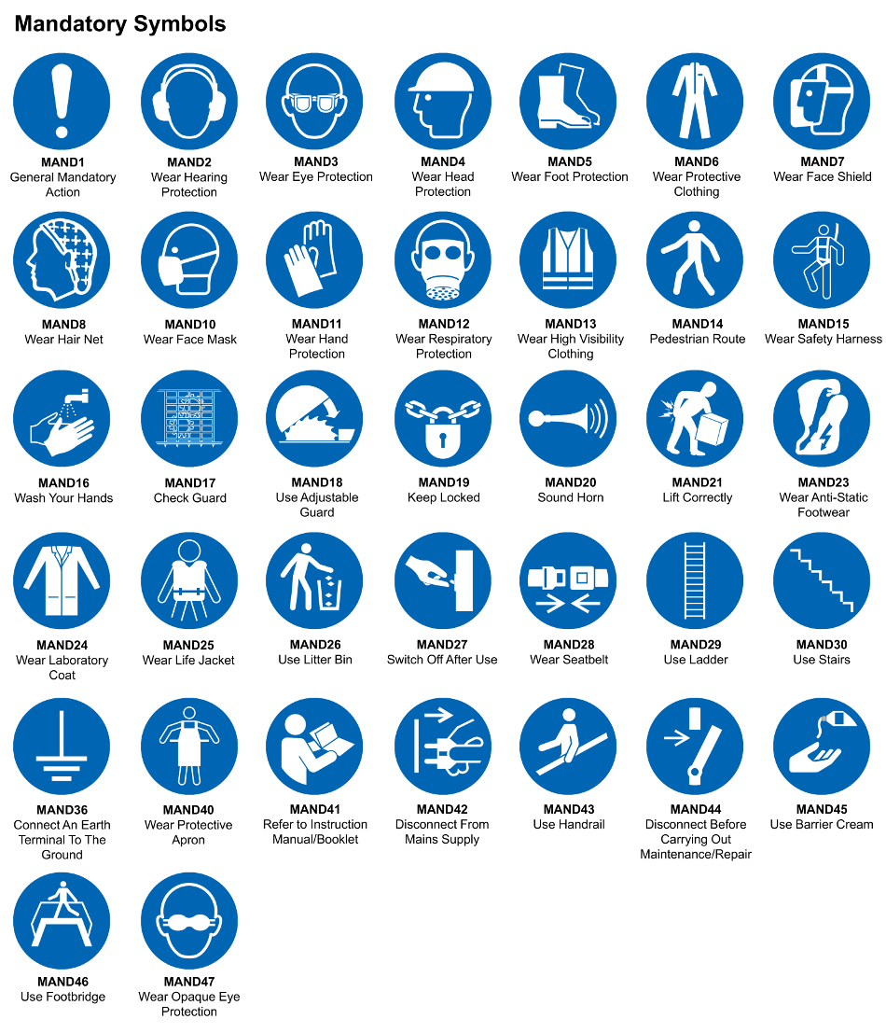
☒ | ☐ |  | ☒ |  | ☒ |  |  | ☐ |  | ☐ |  | ☒ |  |  | ☐ |  | ☐
Eye Protection | Ear Protection |  | Hard Hat |  | Footwear |  |  | Overalls |  | Visor |  | Gloves |  |  | Face Mask |  | Respirator
Storage Requirements
LOCKED CAGE |  | BUNDED CONTAINER |  |  |  |  | PROTECTION  FROM WEATHER |  |  |  | COSHH STORAGE ROOM |  |  |  |  | SEALED CONTAINER
☐ |  | ☒ |  |  |  |  | ☐ |  |  |  | ☐ |  |  |  |  | ☐
Waste Management
SEGREGATED STORAGE |  |  |  |  |  | SEALED CONTAINERS |  |  |  |  |  |  | WASTE CARRIER DISPOSAL / RECYCLING LICENCE
☐ |  |  |  |  |  | ☒ |  |  |  |  |  |  | ☐
Risk Rating Following Control Measures
LOW |  |  |  |  |  | MEDIUM |  |  |  |  |  |  | HIGH
☐ |  |  |  |  |  | ☒ |  |  |  |  |  |  | ☒

Site Specific RA Prepared by: | Si King | Position: | Contracts Director
Site Specific RA Prepared by: | Si King | Review Date: | 28/09/2023

