GENERAL RISKS & CONTROLS
Classification (state the category of danger)
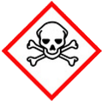 | ☐ |  |  | Serious Health Hazard/Toxic |  |  |  | 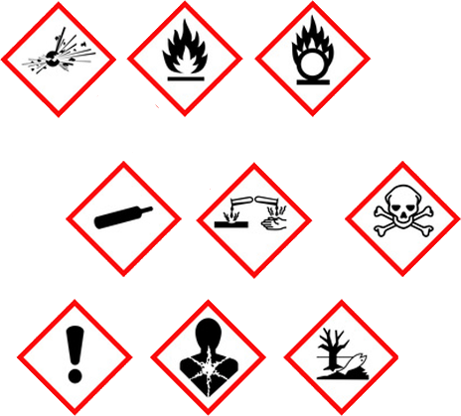 |  | ☐ |  | Oxidising |  |  | 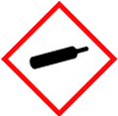 |  |  | ☐ |  |  | Gas Under Pressure
 | ☒ |  |  | Health Hazard/ Harmful/Irritant |  |  |  |  |  | ☒ |  | Flammable |  |  |  |  |  | ☐ |  |  | Acute Toxicity/ Carcinogen
 | ☐ |  |  | Corrosive |  |  |  |  |  | ☐ |  | Explosive |  |  |  |  |  | ☐ |  |  | Dangerous for the Environment
Hazard Type
☐ |  |  | ☐ |  |  | ☐ |  |  | ☐ |  |  |  | ☐ |  |  | ☒ |  |  |  | ☐ |  |  | ☐
Gas |  |  | Water |  |  | Mist |  |  | Fume |  |  |  | Dust |  |  | Liquid |  |  |  | Solid |  |  | Other
Route of Exposure
☒ |  | ☒ |  |  |  |  | ☒ |  |  |  | ☒ |  |  | ☐
Inhalation |  | Skin |  |  |  |  | Eyes |  |  |  | Ingestion |  |  | Other (state)
Workplace Exposure Limits (WELs) please indicate n/a where not applicable |  |  |  |  |  |  |  |  |  |  |  |  |  |  |  |  | 750ppm/1060mg 15mins
Storage & Handling |  |  |  |  |  |  |  |  |  |  |  |  | Hazard Symptoms
- Store in original packaging.  - Keep away from heat and sources of ignition.  - General training in the safe use, handling, disposal and storage.  - Store in locked COSHH store out of direct sunlight.  - Avoid potential impact and puncture. |  |  |  |  |  |  |  |  |  |  |  |  | - Extremely flammable.  - Container is under pressure.  - Harmful by inhalation and if swallowed.  - Will defat skin and prolonged contact may produce dermatitis.  - Irritant to eyes.  - Limited evidence of a carcinogenic (causing cancer) effect.
Controls |  |  |  |  |  |  |  |  |  |  |  |  | Remedial Actions
- Use away from heat and ignition sources.  - Do not pierce/puncture or incinerate even when container is empty.  - Ensure good ventilation and avoid use in confined spaces. Do NOT eat, drink, smoke while using. Wash hands after use.  - Ensure impermeable gloves are worn, wear overalls were necessary.  - Wear appropriate eye protection.  - Avoid prolonged contact with the substance. |  |  |  |  |  |  |  |  |  |  |  |  | - Stop the spill if safe to do so.  - Clear any spillages using any available spill kit with absorbent  - material.  - Eliminate all sources of ignition.  - Ensure adequate ventilation  Do not allow entry into environment.
Disposal
Hazardous Waste?  ☒ |  |  |  |  | Skip  ☐ |  |  |  |  |  |  |  | Other ☒  Ensure that container is empty and dispose of according local authority regulations.  Do not pierce or incinerate even when container is empty.  Separate waste container for aerosol cans.
Return to Depot  ☐ |  |  |  |  | Return to Supplier  ☐
FIRST AID   |  |  |  |  |  |  |  |  |  |  |  |  | FIRE FIGHTING  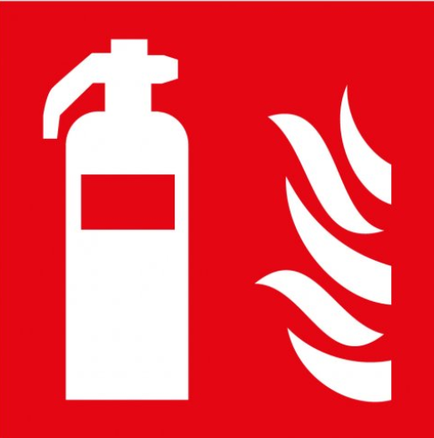
Move exposed person to fresh air. Seek medical attention is discomfort continues.  Promptly wash contaminated skin with soap or mild detergent and water. - Remove clothing is soaked through ad wash as above. |  |  |  |  | Remove clothing is soaked through ad wash as above.  - Immediately flush eyes with waste while lifting the eye lid. Continue procedure for 15 minutes before seeking medical attention.  - Rinse mouth thoroughly. Do not induce vomiting. Seek medical attention if irritation persist. |  |  |  |  |  |  |  | WATER  ☐ |  | FOAM  ☒ |  | POWDER  ☒ |  |  |  |  | CO2  ☒ |  | CHEMICAL  ☐
PRECAUTIONS:

May explode in fire, May flash back. Forms explosive atmosphere. Do NOT use water jet, only spray/mist.
SITE SPECIFIC CONTROLS (TO BE COMPLETED ON SITE)
Work Activities Being Undertaken
Exposure
Number of Persons |  |  |  | Frequency |  |  |  |  | Duration |  |  |  |  | Any specific training requirements?
5 -10 |  |  |  | Daily |  |  |  |  | 8 Hiuyrs |  |  |  |  | ☐
Personal Protective Equipment (PPE) Control Measures
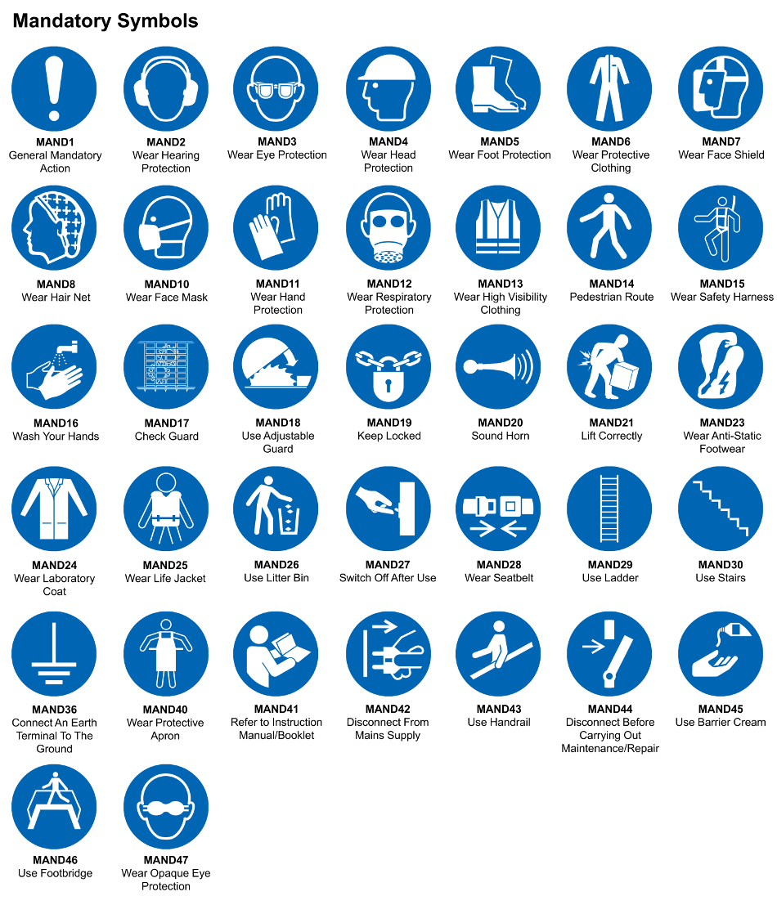
☒ | ☐ |  | ☒ |  | ☒ |  |  | ☐ |  | ☐ |  | ☒ |  |  | ☐ |  | ☐
Eye Protection | Ear Protection |  | Hard Hat |  | Footwear |  |  | Overalls |  | Visor |  | Gloves |  |  | Face Mask |  | Respirator
Storage Requirements
LOCKED CAGE |  | BUNDED CONTAINER |  |  |  |  | PROTECTION  FROM WEATHER |  |  |  | COSHH STORAGE ROOM |  |  |  |  | SEALED CONTAINER
☐ |  | ☐ |  |  |  |  | ☐ |  |  |  | ☒ |  |  |  |  | ☐
Waste Management
SEGREGATED STORAGE |  |  |  |  |  | SEALED CONTAINERS |  |  |  |  |  |  | WASTE CARRIER DISPOSAL / RECYCLING LICENCE
☐ |  |  |  |  |  | ☒ |  |  |  |  |  |  | ☐
Risk Rating Following Control Measures
LOW |  |  |  |  |  | MEDIUM |  |  |  |  |  |  | HIGH
☒ |  |  |  |  |  | ☐ |  |  |  |  |  |  | ☐

Site Specific RA Prepared by: | Si King | Position: | Contracts Director
Site Specific RA Prepared by: | Si King | Review Date: | 28/09/2023

