GENERAL RISKS & CONTROLS
Classification (state the category of danger)
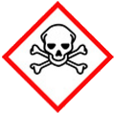 | ☐ |  |  | Serious Health Hazard/Toxic |  |  |  | 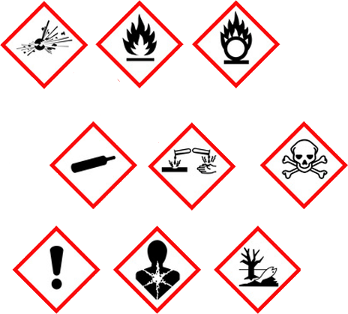 |  | ☐ |  | Oxidising |  |  | 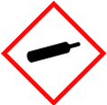 |  |  | ☐ |  |  | Gas Under Pressure
 | ☒ |  |  | Health Hazard/ Harmful/Irritant |  |  |  |  |  | ☐ |  | Flammable |  |  |  |  |  | ☐ |  |  | Acute Toxicity/ Carcinogen
 | ☒ |  |  | Corrosive |  |  |  |  |  | ☐ |  | Explosive |  |  |  |  |  | ☒ |  |  | Dangerous for the Environment
Hazard Type
☐ |  |  | ☐ |  |  | ☐ |  |  | ☐ |  |  |  | ☒ |  |  | ☐ |  |  |  | ☐ |  |  | ☐
Gas |  |  | Water |  |  | Mist |  |  | Fume |  |  |  | Dust |  |  | Liquid |  |  |  | Solid |  |  | Other
Route of Exposure
☒ |  | ☒ |  |  |  |  | ☒ |  |  |  | ☒ |  |  | ☐
Inhalation |  | Skin |  |  |  |  | Eyes |  |  |  | Ingestion |  |  | Other (state)
Workplace Exposure Limits (WELs) please indicate n/a where not applicable |  |  |  |  |  |  |  |  |  |  |  |  |  |  |  |  | 10mg/ 8 hours
Storage & Handling |  |  |  |  |  |  |  |  |  |  |  |  | Hazard Symptoms
- Keep shielded from weather, and humid environments.  - Store away from objects that may puncture the packaging.  - Cautions should be taken when manual handling due to weight of packaged substance. Use of mechanical aids is advised when dealing with large quantities.  - Store away from aluminium powder as when mixed with wet cement hydrogen is produced.  - Keep bulk supplies in shrink wrapped packaging were possible to prevent residual dust being released. |  |  |  |  |  |  |  |  |  |  |  |  | - Cement may have an irritating effect on moist skin due to  transpiration or humidity.  - Prolonged contact with wet cement may cause serious chemical burns, and can develop without pain being felt.  - Eye contact with cement, wet or dry, may cause serious and potentially irreversible injuries.  - Frequent inhalation of large quantities of cement dust over a longer period increases the risk of developing lung disease.  - Nerve endings may be damaged prior to skin burning, hence burning may occur without pain being felt at the time.
Controls |  |  |  |  |  |  |  |  |  |  |  |  | Remedial Actions
- Wear impermeable protective clothing to ensure that cement or any cement/water mix does NOT come in contact with the skin.  - Ensure that wet concrete does NOT enter the boots and that people do NOT kneel on wet concrete. Wear impermeable gloves.  - Wherever there is a risk of cement powder or cement/water mixtures entering the eye, wear dust proof goggles. Do not eat, drink, or smoke when using. Wash hands thoroughly after use.  - Ensure good ventilation or ensure suitable RPE is worn.  - When laying concrete, impermeable gloves, boots, and trousers will be necessary. General awareness talks on delayed effects. |  |  |  |  |  |  |  |  |  |  |  |  | - Do NOT wash cement down sewers, drains, watercourses.  - Recover the spillage in a dry state if possible.  - Use clean-up methods that do NOT cause airborne dispersion. Use wet mop/vacuum.  - Collect wet cement and place in container.  - Ensure all cement has hardened before disposal.
Disposal
Hazardous Waste?  ☐ |  |  |  |  | Skip  ☒ |  |  |  |  |  |  |  | Other ☒  Do NOT use after use by date.  Do NOT flush into sewers, drains, watercourses.  Dispose or recycle according to local authority
Return to Depot  ☐ |  |  |  |  | Return to Supplier  ☐
FIRST AID   |  |  |  |  |  |  |  |  |  |  |  |  | FIRE FIGHTING  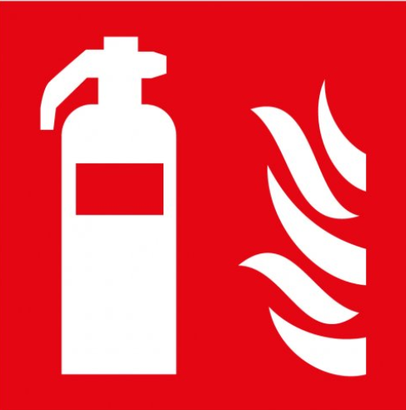
Move person to fresh air. If discomfort persist, seek medical attention.  Remove any contaminated cloths. Wash off with plenty of water, seek medical attention if irritation continues. |  |  |  |  | Do NOT rub eyes. Remove any contact lenses and flush with water. (Use isotonic water if able to.) - Seek medical attention if irritation continues.  If ingested do NOT induce vomiting. Wash out mouth with plenty of water, seek medical advice if irritation persists. |  |  |  |  |  |  |  | WATER  ☒ |  | FOAM  ☒ |  | POWDER  ☒ |  |  |  |  | CO2  ☒ |  | CHEMICAL  ☒
PRECAUTIONS

Use extinguishing method best suited for surrounding materials.
SITE SPECIFIC CONTROLS (TO BE COMPLETED ON SITE)
Work Activities Being Undertaken
Exposure
Number of Persons |  |  |  | Frequency |  |  |  |  | Duration |  |  |  |  | Any specific training requirements?
5 -10 |  |  |  | Daily |  |  |  |  | 8 Hours |  |  |  |  | ☐
Personal Protective Equipment (PPE) Control Measures
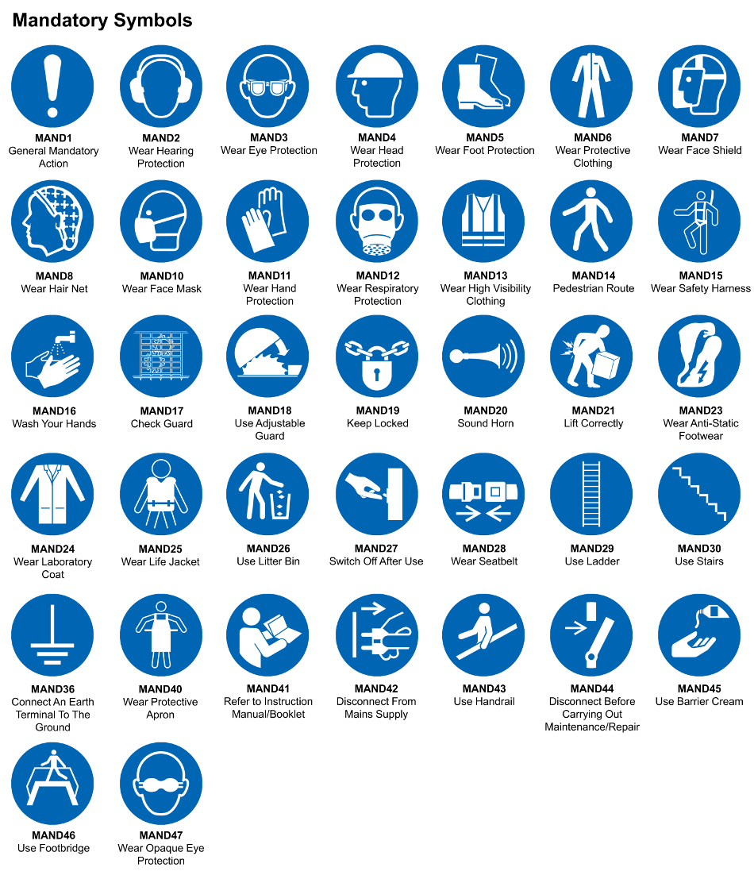
☒ | ☐ |  | ☒ |  | ☒ |  |  | ☐ |  | ☐ |  | ☒ |  |  | ☒ |  | ☐
Eye Protection | Ear Protection |  | Hard Hat |  | Footwear |  |  | Overalls |  | Visor |  | Gloves |  |  | Face Mask |  | Respirator
Storage Requirements
LOCKED CAGE |  | BUNDED CONTAINER |  |  |  |  | PROTECTION  FROM WEATHER |  |  |  | COSHH STORAGE ROOM |  |  |  |  | SEALED CONTAINER
☐ |  | ☐ |  |  |  |  | ☐ |  |  |  | ☐ |  |  |  |  | ☐
Waste Management
SEGREGATED STORAGE |  |  |  |  |  | SEALED CONTAINERS |  |  |  |  |  |  | WASTE CARRIER DISPOSAL / RECYCLING LICENCE
☒ |  |  |  |  |  | ☒ |  |  |  |  |  |  | ☐
Risk Rating Following Control Measures
LOW |  |  |  |  |  | MEDIUM |  |  |  |  |  |  | HIGH
☒ |  |  |  |  |  | ☐ |  |  |  |  |  |  | ☐

Site Specific RA Prepared by: | Si King | Position: | Contracts Director
Site Specific RA Prepared by: | Si King | Review Date: | 28/09/2023

