GENERAL RISKS & CONTROLS
Classification (state the category of danger)
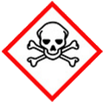 | ☐ |  |  | Serious Health Hazard/Toxic |  |  |  | 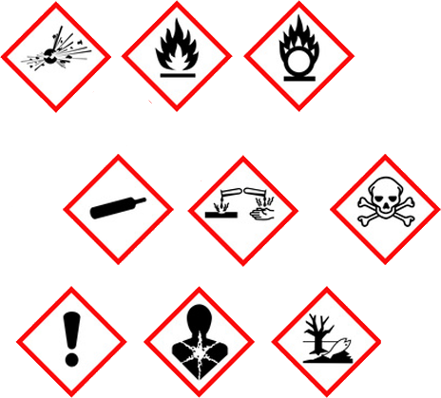 |  | ☐ |  | Oxidising |  |  | 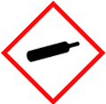 |  |  | ☐ |  |  | Gas Under Pressure
 | ☒ |  |  | Health Hazard/ Harmful/Irritant |  |  |  |  |  | ☒ |  | Flammable |  |  |  |  |  | ☒ |  |  | Acute Toxicity/ Carcinogen
 | ☐ |  |  | Corrosive |  |  |  |  |  | ☐ |  | Explosive |  |  |  |  |  | ☒ |  |  | Dangerous for the Environment
Hazard Type
☐ |  |  | ☐ |  |  | ☐ |  |  | ☐ |  |  |  | ☐ |  |  | ☐ |  |  |  | ☐ |  |  | ☒
Gas |  |  | Water |  |  | Mist |  |  | Fume |  |  |  | Dust |  |  | Liquid |  |  |  | Solid |  |  | Other
Route of Exposure
☒ |  | ☒ |  |  |  |  | ☒ |  |  |  | ☒ |  |  | ☐
Inhalation |  | Skin |  |  |  |  | Eyes |  |  |  | Ingestion |  |  | Other (state)
Workplace Exposure Limits (WELs) please indicate n/a where not applicable |  |  |  |  |  |  |  |  |  |  |  |  |  |  |  |  | 25ppm  8 hour
Storage & Handling |  |  |  |  |  |  |  |  |  |  |  |  | Hazard Symptoms
- Do not remove safety labels.  - Keep in locked COSHH store and well ventilated away from direct sunlight sources of heat and ignition.  - Store away from oxidising agents, and strong alkaline, and acidic materials.  - Protect against possible impact and puncture. |  |  |  |  |  |  |  |  |  |  |  |  | - Extremely flammable. Risk of container explosion.  - May cause irritation if ingested.  - Repeated exposure to skin may cause skin dryness or cracking.  - Vapours may cause headache fatigue, dizziness and nausea.  - Irritant to eyes.  - Wet paint may make surfaces temporarily slippery.
Controls |  |  |  |  |  |  |  |  |  |  |  |  | Remedial Actions
- Do NOT store or use close to heat or ignition sources. Do NOT smoke when using.  - Do NOT eat, drink, smoke when using, wash hands after use.  - Wear impermeable gloves, and overalls were necessary.  - Use in well ventilated area, or use appropriate RPE if required. Avoid use in confined spaces.  - Avoid contact with eyes, use eye protection.  - General training in the safe use, handling, disposal and storage, instruction in the use of control measures. |  |  |  |  |  |  |  |  |  |  |  |  | - Eliminate all ignition sources.  - Stop the leak if safe to do so.  - Prevent entry into drains, sewers, and watercourses.  - Absorb spill using absorbent material.  - Store contaminated materials in sealed container.  - Wash contaminated area thoroughly with detergent.
Disposal
Hazardous Waste?  ☒ |  |  |  |  | Skip  ☐ |  |  |  |  |  |  |  | Other ☒  - Do NOT pore into drains/allow access into water courses.  - Dispose in accordance with the regulations made under the Control of Pollution Act.  - Do NOT burn or incinerate empty or full containers.
Return to Depot  ☐ |  |  |  |  | Return to Supplier  ☐
FIRST AID   |  |  |  |  |  |  |  |  |  |  |  |  | FIRE FIGHTING  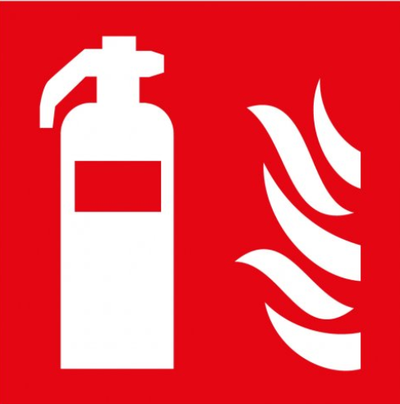
- Remove to fresh air, and keep warm and at rest. If breathing is irregular, or stopped, seek medical attention, or administer artificial respiration from a trained person.  - Remove contaminated clothing, and wash skin with warm soap water. |  |  |  |  | - Remove contact lenses and rinse eyes immediately. Get medical attention if irritation persists.  - If swallowed, seek medical advice immediately and show container label. Do not induce vomiting. |  |  |  |  |  |  |  | WATER  ☒ |  | FOAM  ☒ |  | POWDER  ☒ |  |  |  |  | CO2  ☒ |  | CHEMICAL  ☐
PRECAUTIONS:
Do NOT use solid water Jet, use mist spray. Avoid residual water run-off into drains.
SITE SPECIFIC CONTROLS (TO BE COMPLETED ON SITE)
Work Activities Being Undertaken
Exposure
Number of Persons |  |  |  | Frequency |  |  |  |  | Duration |  |  |  |  | Any specific training requirements?
5 -10 |  |  |  | Daily |  |  |  |  | 8 Hours |  |  |  |  | ☐
Personal Protective Equipment (PPE) Control Measures
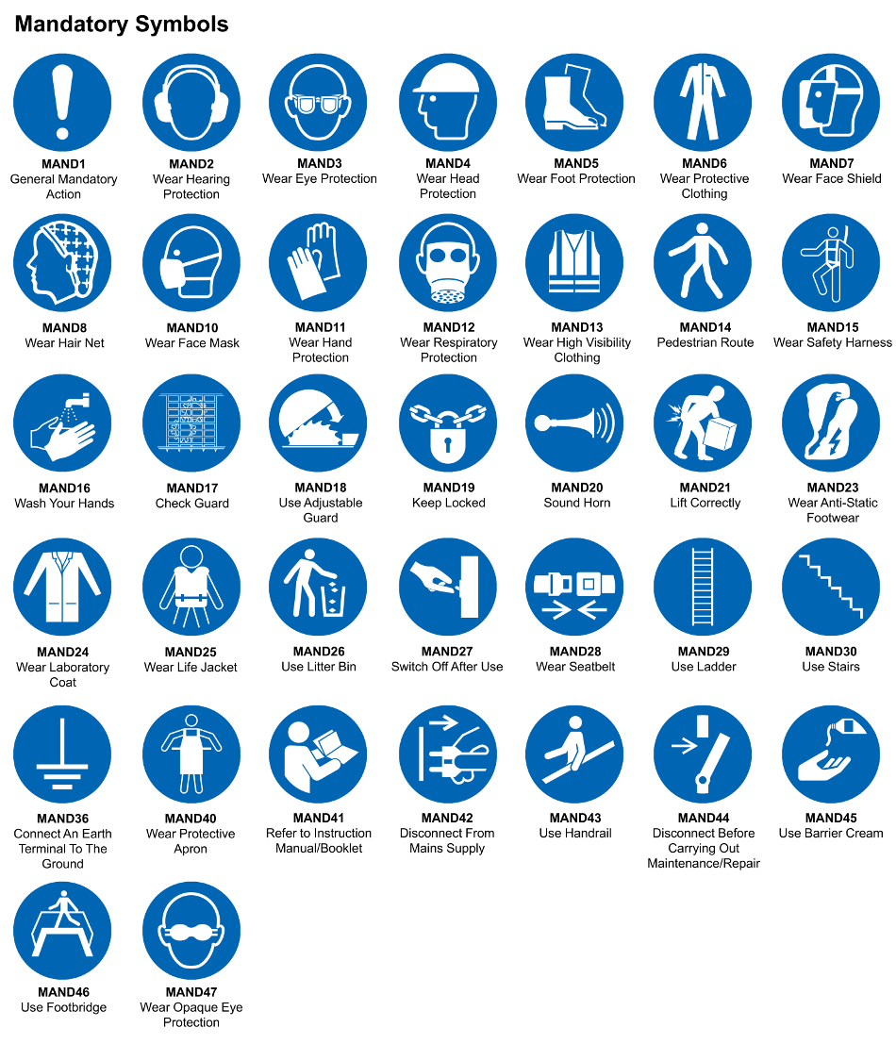
☒ | ☐ |  | ☒ |  | ☒ |  |  | ☐ |  | ☐ |  | ☒ |  |  | ☐ |  | ☐
Eye Protection | Ear Protection |  | Hard Hat |  | Footwear |  |  | Overalls |  | Visor |  | Gloves |  |  | Face Mask |  | Respirator
Storage Requirements
LOCKED CAGE |  | BUNDED CONTAINER |  |  |  |  | PROTECTION  FROM WEATHER |  |  |  | COSHH STORAGE ROOM |  |  |  |  | SEALED CONTAINER
☐ |  | ☐ |  |  |  |  | ☐ |  |  |  | ☒ |  |  |  |  | ☐
Waste Management
SEGREGATED STORAGE |  |  |  |  |  | SEALED CONTAINERS |  |  |  |  |  |  | WASTE CARRIER DISPOSAL / RECYCLING LICENCE
☐ |  |  |  |  |  | ☒ |  |  |  |  |  |  | ☐
Risk Rating Following Control Measures
LOW |  |  |  |  |  | MEDIUM |  |  |  |  |  |  | HIGH
☒ |  |  |  |  |  | ☒ |  |  |  |  |  |  | ☐

Site Specific RA Prepared by: | Si King | Position: | Contracts Director
Site Specific RA Prepared by: | Si King | Review Date: | 27/09/2023

