APP/24/00017 - Laburnums, St Peters Road, Hayling Island, PO11 0RT
Planning History
- 18285/5 – Reconstruction of part of stables – permit 23/03/1979
Conditions
- The stables/loose boxes shall be used only to accommodate the applicant’s own horses and shall not be used for any commerical riding, breeding or training purposes.
4. The area shown on plan as exercise paddock shall not be occupied by horses for more than two hours on any day.
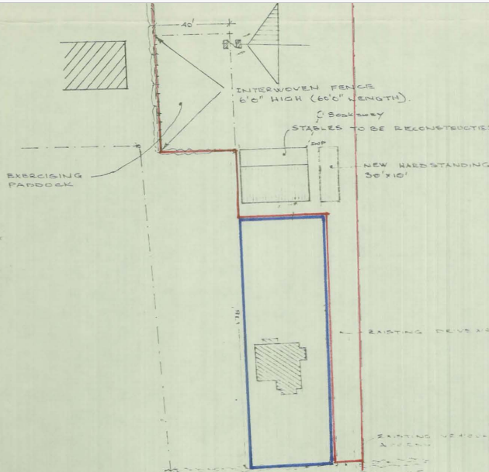

- 18285/8 – 10 loose boxes to replace 5 existing and 5 new stables – permit 03/01/85 (not implemented)
Conditions
- The stables/loose boxes shall be used only to accommodate the applicant’s own horses and shall not be used for any commerical riding, breeding or training purposes.
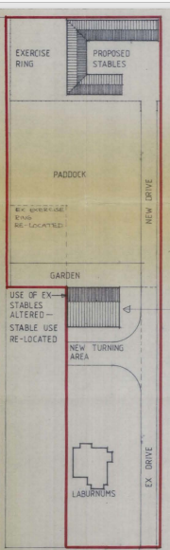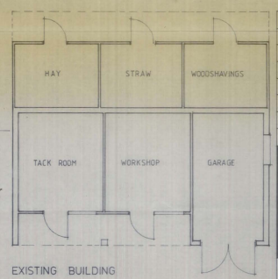

3. 18285/9 – Alterations to existing building including creation of workshop and garages and extensions to west and south including provision of storage accommodation – permit 17/12/86
Conditions
4. The existing and proposed buildings the subject of this permission shall not at any time be used for the storage of manure.
5. The buildings the subject of this permission shall be used only for purposes incidental to the enjoyment of the dwelling house as such shall not be used for any business, commercial or industrial purposes whatsoever.

4. 89/52498/1 – Amendment to 18285/0 to incorporate changes to roof and elevations of approved outbuilding – permit 29/06/89.
Conditions
- Notwithstanding the provisions of any General Development Order the building the subject of this permission shall only be used for the purposes specified on the approved plan and for no other purpose (including the stabling of horses or storage of manure) except as may be agreed in writing with the Local Planning Authority. Reason: To preserve the amenities of adjacent residential properties.

- The building the subject of this permission shall be used purposes incidental to the enjoyment of the dwelling house as shall not be used for any business, commercial or industrial whatsoever. Reason I In the interests of the amenity of the area

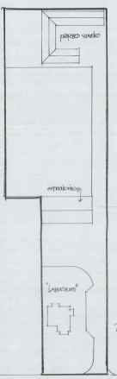
5. Certificate of Lawful use for use of outbuilding for purposes not incidental to the enjoyment of the dwellinghouse. Granted 09/07/04.
6. 05/52498/005 – 2 storey extensions to south and east elevations, porch to west elevation. Existing access to St Peters Road altered, change of use of existing outbuilding to ancillary garage/workshop for dwellinghouse – permit 16/12/05
Taken from Officer Report – para 1.2 - The paddock at the rear is not part of the application but shown as within the applicant’s ownership.
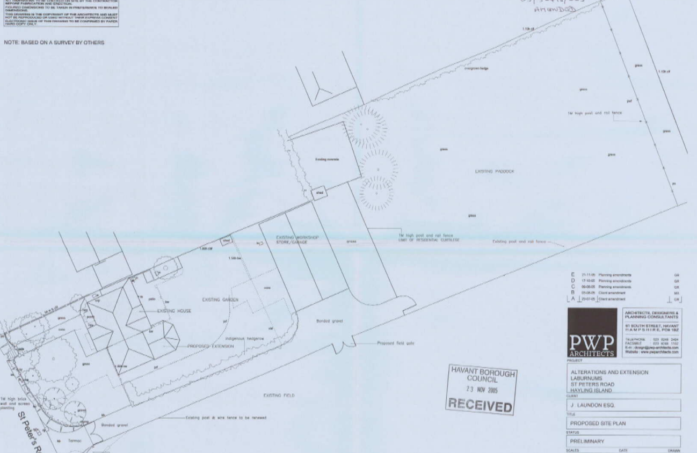
Para 3.1 – the use and modification of the exiting outbuilding to the rear to provide garaging, storage and workshops ancillary to Laburnums as a dwelling.
the use of a 6.8m deep area of land to the rear of the outbuilding as part of the residential curtilage of Laburnums; such area to be fenced by a 1m high post and rail fence from the adjacent paddock area.
Outbuilding reassociation with Laburnums.
7.13 It is therefore considered that the revised proposals for the extended residential curtilage of Laburnums including the alteration of the access arrangements and the reassociation of the outbuilding with Laburnums are acceptable.
Conditions
5. The outbuilding shall be used purposes incidental to the enjoyment of the dwelling house as shall not be used for any business, commercial or industrial whatsoever. Reason I In the interests of the amenity of the area

6. APP/20/00425 – Garage conversion to residential annex for use of main dwelling – permit 28 July 2020
Conditions
3. The accommodation hereby permitted shall be occupied solely for purposes ancillary to the occupation and enjoyment of the existing dwelling and shall not be used as a separate unit of accommodation whatsoever.
Reason: Separate accommodation would lack adequate amenity/garden space resulting in an unsatisfactory form of development which would not accord with Policy CS16 of the Havant Borough Local Plan (Core Strategy) 2011 and the National Planning Policy Framework. It would also generate the need for mitigation of the in-combination impact of new dwellings on designated habitats which is subject to the provisions of Policy DM24 of the Havant Borough Local Plan (Allocations) 2014, Policy CS11 of the Havant Borough Local Plan (Core Strategy) 2011, the Habitat Regulations and the National Planning Policy Framework
