Photograph of proposed patio.
23 Shaftesbury Avenue,
Waterlooville,
Hampshire.
PO7 5HW.

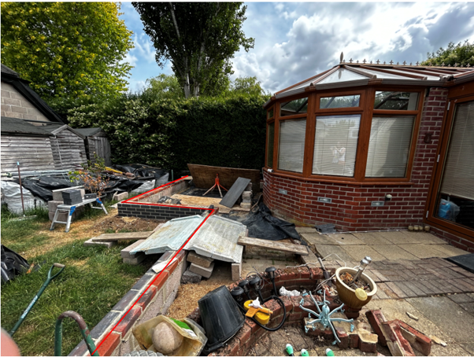
Taken during the site visit on 27th. July 2023 by Katie Howard.

C.H Planning & Sales
112 Stubbington Lane,
Fareham,
Hants. PO14 2PE
Tel: 01329-661877
OS Licence: 100050691

Not to scale

