Flood Risk assessment for replacement dwelling at 197 Southwood Road Hayling Island PO119PZ

Background.
The proposed site is a on the southeast corner of Hayling island and is in a flood risk zone 3 as per the map below

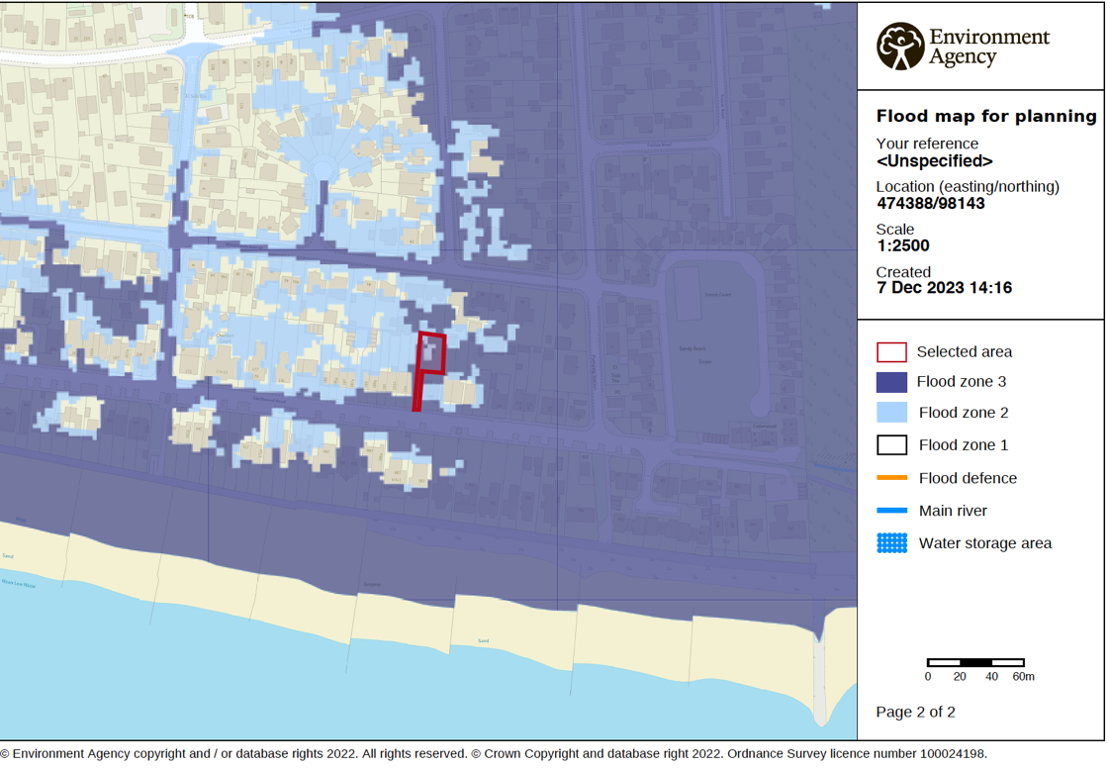

The site is currently occupied by a dated three bedroomed chalet bungalow with masonry walls, timber suspended floors, a pitched tiled roof and a first-floor bedroom area in the roof.

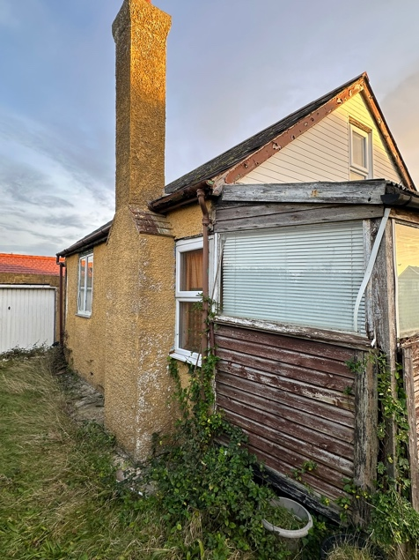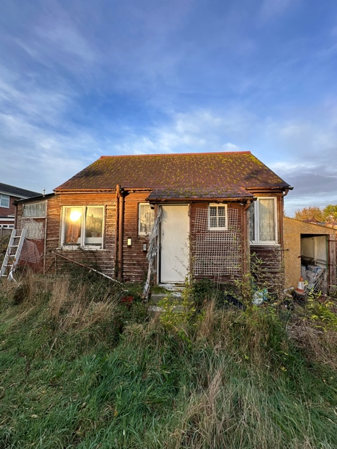
Proposal
The proposal is to demolish the existing 3 bed property and replace it with another three bedroomed property. As below

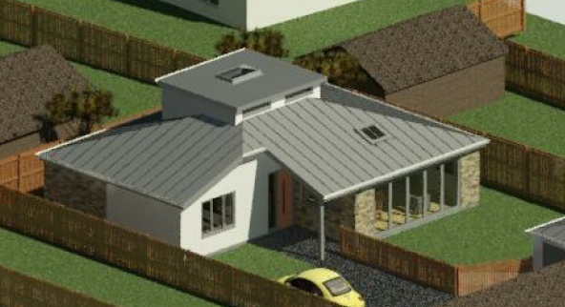

It is important to state that no increased occupancy is proposed however significant improvements in terms of the building flood resilience are proposed and thus any risk to life is only reduced by the betterment achieved by the proposal

Flood resilience measures
The new building has floor levels set higher throughout than the current highest point of the existing building, whilst improving flood resilience within the design of the building structure and layout.
These improvements include
- Suspended concrete floors with damp proof membranes taken 600mm up ground floor walls
- Wiring at ceiling level coming down to sockets and switches raised to current disability specifications. (Minimum 450mm)
- A first-floor refuge area with compliant stair access and a rooflight to access the flat roof above in emergencies only.
- All doors, skirting, Architrave at ground floor level to be solid wood painted in waterproof paint
- Permeable materials used for all drive and access areas
- Soakaways created for all surface water drainage

Conclusions
Due to new dwelling retaining the same level of occupancy of the existing dwelling and having features which provide much better resilience to flooding and protection to life, this proposal can only be seen as betterment in terms of flood risk, and we would therefore ask for environment agency support for this proposal.

