Current Privacy Screening
Construction: Wood
Current total height from ground: 2.3 metres
Current total height from surface of decking: 1.86 metres
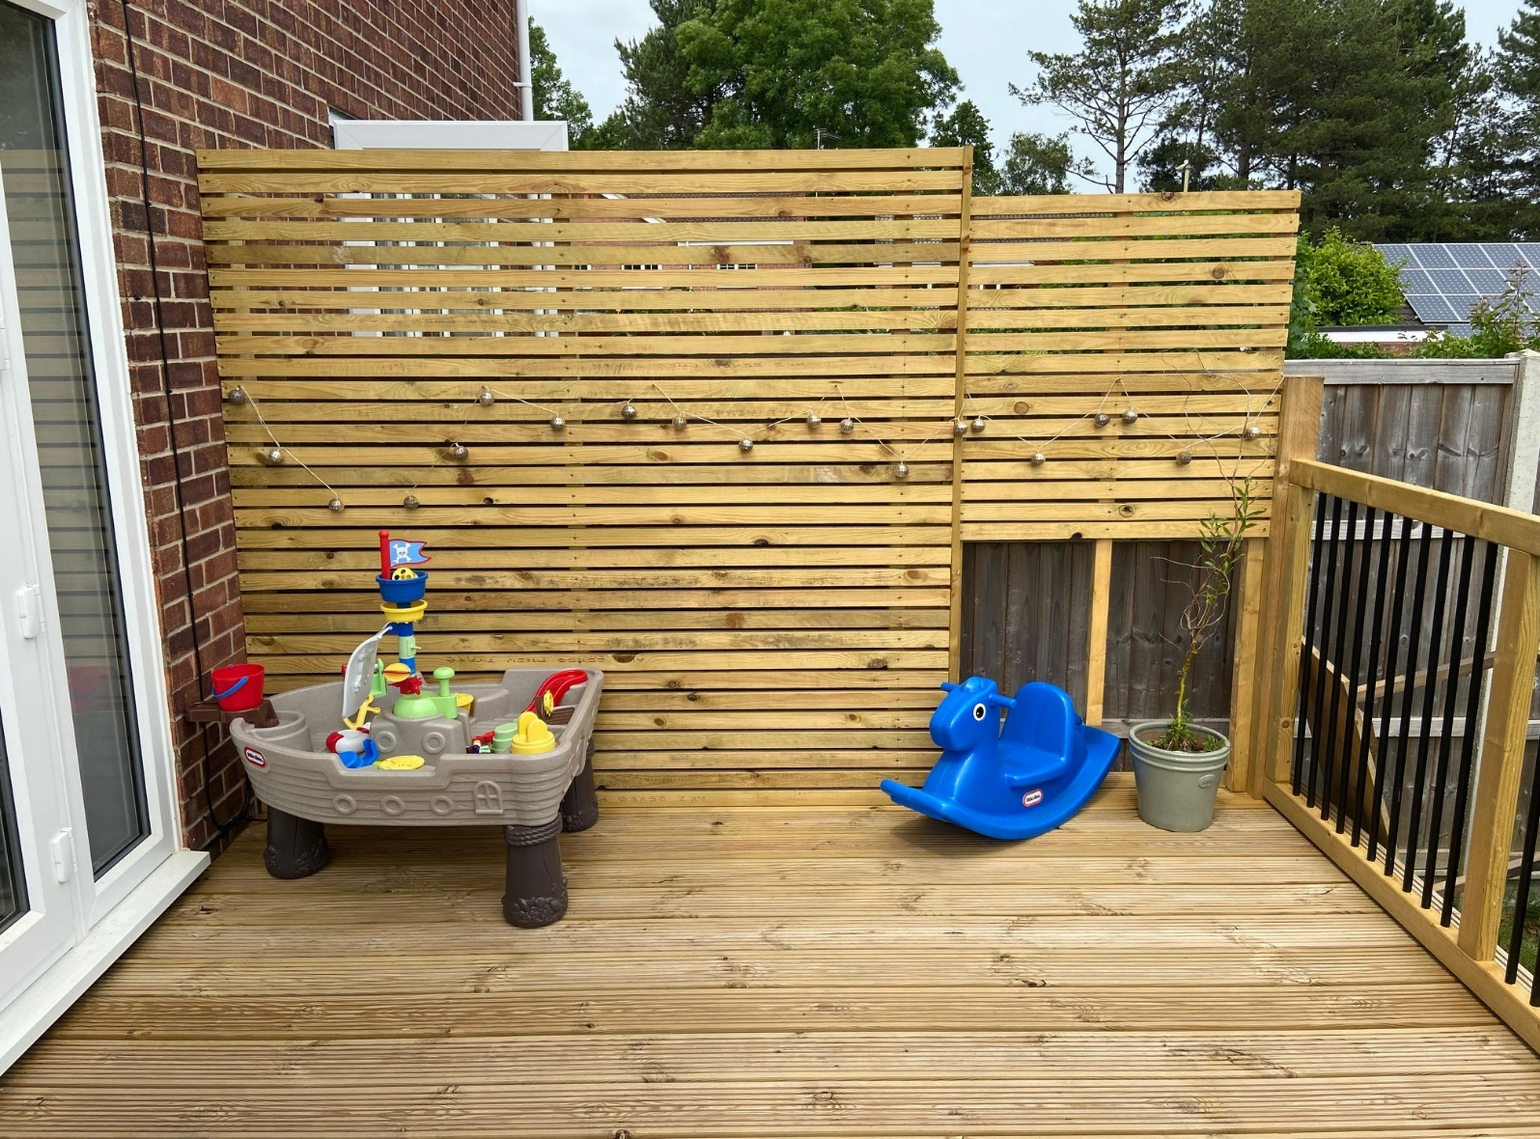
Total screen length from house wall: 2.92 metres
Length 2.9m
Height From Deck 1.86m
Total Height From Ground 2.3m

Proposed Privacy Screening Following Email Dated 03/11/23 From Josephine Lacey
Proposed total height from ground 2.14m (2140mm)
Proposed total height from surface of decking: 1.7m (1700mm)
Proposal to remove gaps between battens to create a solid screen from fence level and above.
Please see drawing (fig.1) for more details.

