
AIRTIGHT & NOISECHECK LIMITED
The Old Laundry, Bridge Street, Southwick, Hampshire, PO17 6DZ
Phone: 034 5066 6966 email: info@airtightnoisecheck.co.uk

BS4142: 2014 (+A1: 2019) TESTING REPORT FOR

TASTE OF INDIA
45 HIGH STREET
EMSWORTH
HAMPSHIRE
PO10 7AL

SITE ADDRESS:

TASTE OF INDIA
45 HIGH STREET
EMSWORTH
HAMPSHIRE
PO10 7AL

ISSUE DATE: 17TH MAY 2023


Acoustic Engineer: Test Date: 10th – 11th May 2023
Michael Vine

AIRTIGHT & NOISECHECK BUILDING ACOUSTIC TESTING

Contents

- Customer Name.….………………………..…………….3
- Site Address.…………………………………….…………3
- Equipment Used………….……………….….…….……3
- Measurement Procedure.….……………….…...…..3
- Executive Summary..........................................4
- Objective……….……………………………………….....….5
- Calibration……………..…………………………….….…….5
- Site Layout & Microphone Positions…..………….5
- Hours of Operation...........................................5
- Description of Testing……………..….………………….6
- Plant Data & BGN Levels………………………………...6
- Results Table…….……….……………….……….……..6&7
- Results Conclusion…………………………….……….......8
- Google Earth.......................................................9
- Acoustic Definitions............................................10
- Site Plan…………………………………………………………..11
- Raw Data…………………………………………………….12-16

AIRTIGHT & NOISECHECK LIMITED ACOUSTICS TESTING

Customer Name: Test Date: 10th – 11th May 2023
Taste of India
45 High Street
Emsworth
Hampshire
PO10 7AL

Site Address:
Taste of India
45 High Street
Emsworth
Hampshire
PO10 7AL

Acoustic Engineer:
Mr. Michael Vine

Equipment used:

Norsonic Environmental Analyser 121 – Serial No 29809 Calibration due July 2024

Norsonic 140 precision sound analyser – serial number 1407126 Calibration due February 2024

Measurement Microphone (Gras 40AF) – Serial No 51465, - Calibration due July 2024 & Nor 1225 – serial number 305215 – Calibration due February 2024

Acoustic Calibrator - (Type 1251) – Serial No 31652, Calibration due March 2024

Measurement Procedure:

The external ambient noise levels were measured for a period of 24hours between Wednesday 10th & Thursday 11th May 2023 in one microphone location to ascertain the current background noise levels close to the residential boundary. In addition to the above, sample measurements were taken at the plant location to the rear of the building. These levels were measured to indicate the current noise emissions in this location. There is numerous other plant located in the immediate area which is the dominant noise source and each of these were measured as part of this assessment.

All of the units were functioning as usual during the measurement period so both the background noise (BGN) and rating levels of the plant were measured.

The purpose of this report is to ascertain if the newly installed extraction system (replacement not a new unit completely) will have an adverse impact on the residential dwellings located at the upper floors above the restaurant.

The extraction unit is located on the flat roof at the rear of the restaurant, at a distance of 7m from the residential window. The chiller unit for the neighbouring restaurant tis located circa 11m from the window and the extraction system for the neighbouring restaurant is located 9m from the residential window.

AIRTIGHT & NOISECHECK ACOUSTIC TESTING

Executive Summary:

Airtight & Noisecheck Ltd were instructed by Taste of India restaurant to undertake a noise assessment at 45 High Street, Emsworth to establish if the proposed replacement extraction system will have an adverse impact on the residential dwellings located at the upper floors of the building. The system replaces the former extraction system and is in the same location as the previous system.

The plant comprises of the fan/motor (encased with silencers) and a cylindrical duct currently all located on the rear flat roof of the building. There are other units also in operation at the site location, with all 3 units listed in the table below.

Unit | Location/Distance | Operation | Audible | Dominant
Extraction system for 45 High Street | Flat roof – 7m from window | Continuous (1430-2300hrs) | No | No
Chiller Unit for 47 High Street | Flat Roof – 11m from window | Intermittent – 24hours | Yes | Yes – night time
Extraction system for 47 High Street | Flat roof – 9m from window | Continuous (1430-2230hrs) | Yes | Yes

The above is a table with the plant that is apparent at the site, the neighbouring plant is clearly audible above the replacement plant for 45 High Street and the dominant noise on site. The noise associated with the replacement extraction system is only faintly audible at the façade when no other plant is in operation and not audible at all when the other plant is in operation. The plant serving 45 High Street is only ever on when the neighbouring extraction system is running so it is not audible at all, and the chiller unit runs intermittently 24hour a day so this is clearly audible throughout the night time period. The noise levels associated with the above plant is shown later in the report. The plant has been compared to the requirements of BS4142: 2014 (+A1: 2019) for the day time and night time period.

BS4142: 2014 states that:

1- A difference of around +10dB or more is likely to be an indication of a significant adverse impact, depending on the context.

2- A difference of around +5dB is likely to be an indication of an adverse impact, depending on the context.

3- The lower the rating level is relative to the measured background sound level, the less likely it is that the specific source will have an adverse impact or a significant adverse impact. Where the rating level does not exceed the background sound level this is an indication of the specific sound source having a low impact, depending on the context.

Based on the measured levels on site, the noise associated with the plant is inaudible at the residential façade when the neighbouring plant is in operation, and the calculations also indicate that the rating level is below the lowest LA90 value measured so it will not have an adverse impact on the residential dwellings. The plant has been fitted with silencers and is not audible at the residential façade when other plant is running and therefore no further mitigation measures are required to ensure the requirements of BS4142: 2014 (+A1: 2019) are achieved.

All plant were measured directly on site and the rating levels shown in this report. Furthermore, calculations have also been included to show the rating levels of certain plant elements at the residential window. The chiller units runs intermittently throughout the night time period and the plant for 45 High Street is replacing an existing system, and also only runs at the same time as the neighbouring extraction system. So, it is very rare that only this plant is running on its own.

AIRTIGHT & NOISECHECK LIMITED ACOUSTICS TESTING

1 Objective:

1.1 The objective of the acoustic procedure is to measure the current background noise levels associated with the current site, to determine if the plant replacement will have an adverse impact on the existing dwellings located in close proximity, circa 7m away. The building is situated within a terrace of mixed-use buildings, and the majority have their own plant (the dominant noise source being the plant associated with No 47 High Street) the residential dwellings are located at upper floor levels and face the flat roof area. The plant is located to the rear of the building with all units to be situated on the rear flat roof.

2 Calibration:

2.1 The measurement microphone was calibrated both before and after the testing procedure and no drift was recorded.

3 Site Layout & Microphone Position:

3.1 The site (45 High Street, Emsworth) is a terraced building located in the centre of Emsworth. The building is located immediately to the South of the High Street and East of South Street. The immediate area is mixed use with ground floor commercial units and residential above. The dominant noise source is road traffic using the local road network.

3.2 There is another restaurant located immediately to the North of the site (No 47 High Street) along with other commercial properties located to the South.

3.3 The plant serving 45 High Street is already located on the rear flat roof of the building and has been in this location for many years. The extraction system was replaced and upgraded recently and that is the reason for this assessment, so in fact the BGN before would have incorporated the old extraction system, along with other extraction systems located in the immediate vicinity. There are 2 x no units serving No 47 also located on the flat roof which are the dominant noise sources apparent, measurements were also taken for these units as part of this assessment.

4 Microphone Location:

4.1 For the background noise levels, the microphone was positioned close to the rear façade of the building as this was the closest façade apparent. Further spot measurements were taken at the existing plant location to achieve exact rating levels for the plant.

4.2 Hours of Operation:

The restaurant is open between 1730 -2330hrs every day but closed on Tuesday. The extraction system is usually switched on circa 1530hrs and switched off at 2300hrs, this is in line with the extraction system for No 47 and the chiller units serving No 47 is on intermittently 24hours a day. No 47 High Street is open between 1700-2330hrs Sunday to Thursday & 1700-0000hrs on Friday and Saturday, so this extraction system will always be in operation for longer periods than that at 45 High Street.

AIRTIGHT & NOISECHECK LIMITED ACOUSTICS TESTING

6 Description of Testing/Results:

6.1 All plant is currently installed on the flat roof and has been for many years (both sets of plant). It is located circa 7m from the rear façade and close to existing plant already serving other units (other units are located 9 – 11m away from the same window). The rating level for the roof top unit is 46-48dBA at 1m. The measured noise levels of the chiller unit serving the neighbouring unit is 48dBA at 4m and is intermittent, and the rating level for the extraction system serving the neighbouring unit is 54dBA at the residential window (9m) and this was the dominant noise source.

6.2 The chiller unit is clearly audible at the window and it can be seen that the chiller comes on circa every 15minutes throughout the day time and night time period and this is leading to increased BGN levels during this period, so this will actually lead to higher noise levels throughout the night time period.

LAeq 1hour value – day time | LA90 1hour value – day time | LAeq 15min value – Night time | LA90 15minute value – night time
44dBA | 36dBA | 39dBA | 30dBA

6.3 It can be seen that the lowest LA90 15min value during the night time period between 2300-0030hrs (the times when the plant will be switched off) was 30dBA, with the day time value being 36dBA. Please Note – the LA90 values increase to 33dBA form 0430hrs (plant off) and in excess of 36dBA from 0500hrs so these are more representative values. Also, the chiller unit is operational every 15mins or so throughout the night time period for approximately 2minutes, with LA90 values increasing to between 42-44dBA throughout the night time period, once again leading to indicate the noise associated with the replacement extraction system should not lead to an adverse impact.

6.4 BS4142: 2014 states that:

1- A difference of around +10dB or more is likely to be an indication of a significant adverse impact, depending on the context.

2- A difference of around +5dB is likely to be an indication of an adverse impact, depending on the context.

3- The lower the rating level is relative to the measured background sound level, the less likely it is that the specific source will have an adverse impact or a significant adverse impact. Where the rating level does not exceed the background sound level this is an indication of the specific sound source having a low impact, depending on the context.

6.5 The noise levels associated with all plant were measured on site with the plant being switched on and off for reference values to be taken. The background noise levels were measured for a 24hour period to encapsulate the night time period. The table below shows the rating levels of the other plant apparent on the roof top (all values taken at the residential window)

Plant Unit | Location | LAeq Value
Neighbouring extraction system | 9m | 54dBA
Chiller Unit | 11m | 46-48dBA
Both extraction systems in operation | 7-9m | 53.7dBA

6.6 It can be seen that the replacement extraction system does not increase the noise levels at the residential window when the other extraction system is in operation. The rating level (calculation) of the replacement unit is shown on the following page, but it is not audible at the façade when other plant is in operation. It will not be in operation during times when the neighbouring unit is not in operation.

AIRTIGHT & NOISECHECK LIMITED ACOUSTICS TESTING
Rating Levels – with other plant in operation:
Results |  | Commentary
Ambient Sound Level | Sound Pressure Level = 48dBA @1m | Measured source level (no AFC)
Residual Sound Level | 54dBA | Measured at receptor – LAeq during opening hours – with neighbouring plant in operation
Specific Sound Level | 48dB
Acoustic Feature Correction | None | Continuous and not audible
Reductions due to distance | -17dB to levels for distance | L2 – L1 -20log (r2/r1) 1m to 7m
Rating Level | 31dBA | Plant level at façade
Background Sound level | 52dBA | Measured on site – with plant on
Excess of rating over background | (31-52) = -21dB
Assessment indicates no adverse impact at receptor – inaudible at façade
The above table indicates the level of the replacement plant when the other plant is in operation. This will be the case all of the time as the neighbouring plant is always on at the same time.

Day Time – replacement Plant only:
Results |  | Commentary
Ambient Sound Level | Sound Pressure Level = 48dBA | Plant measured at 1m
Residual Sound Level | 44dBA | Measured at receptor
Specific Sound Level | 46dBA
Acoustic Feature Correction | 0 | Continuous
Reductions due to distance | -17dB to levels for distance | L2 – L1 -20log (r2/r1) 1m to 7m
Rating Level | 29dBA | Plant level at façade
Background Sound level | 36dBA | Measured on site
Excess of rating over background | (29-36) = -7dB
Assessment indicates no adverse impact at receptor – inaudible at façade

Night Time – replacement Plant only:
Results |  | Commentary
Ambient Sound Level | Sound Pressure Level = 48dBA | Plant measured at 1m
Residual Sound Level | 39dBA | Measured at receptor
Specific Sound Level | 47dBA
Acoustic Feature Correction | 0 | Continuous
Reductions due to distance | -17dB to levels for distance | L2 – L1 -20log (r2/r1) 1m to 7m
Rating Level | 30dBA | Plant level at façade
Background Sound level | 30dBA | Measured on site
Excess of rating over background | (30-30) = 0dB
Assessment indicates no adverse impact at receptor – inaudible at façade
The plant was not noticeable at the façade but even if a +3dB AFC was applied it would only be +3dB above the LA90 and still not lead to an adverse impact.
AIRTIGHT & NOISECHECK LIMITED ACOUSTICS TESTING

7 Results Conclusion:

7.1 The results table indicate that the replacement plant will not lead to an adverse impact during the day time or night time period for the residential dwellings. The plant will not be audible at the residential façade as it is located circa 7m away and not audible if the neighbouring plant is in operation. Even in isolation, it should not lead to an adverse impact. The dwellings are exposed to noise levels comprising of road traffic noise and other commercial uses. The installation of the plant will be negligible at the residential façade.

7.2 The other noise sources apparent at the residential façade were road traffic (circa 46dBA), the intermittent chiller unit (46dBA and on every 15mins during the night time), neighbouring plant (54dBA – rising to circa 60-63dBA depending on capacity within restaurant). So, the noise associated with the replacement plant will not lead to an adverse impact and is not a dominant noise source. This is clear to see during a site visit with the noise source sin operation.

7.3 The plant is purely a replacement system and had replaced a previous system, that would have emitted higher noise levels. The new unit is mounted on anti-vibration feet and has had an acoustic silencer fitted to the motor to reduce the noise output even more.

7.4 It is also clear to see from the data that the neighbouring plant is dominant and depending on the number of people using the restaurant (it is much larger than the site in question) the fan noise will increase due to the fan being turned up to cope with the number if people. In addition to this, the chiller is on throughout the night time period, intermittently and it comes on every 15mins or so, and again, this is clearly seen in the measured BGN levels.

7.5 It is also clear to see that the site is exposed to LA90 noise levels in excess of 33dBA from 0430hrs and 36dBA from 0515hrs, further illustrating that the calculated rating levels of the plant will not leas to an adverse impact for the residential dwellings located at upper floors.

AIRTIGHT & NOISECHECK LIMITED ACOUSTICS TESTING

8 Google Earth Image:

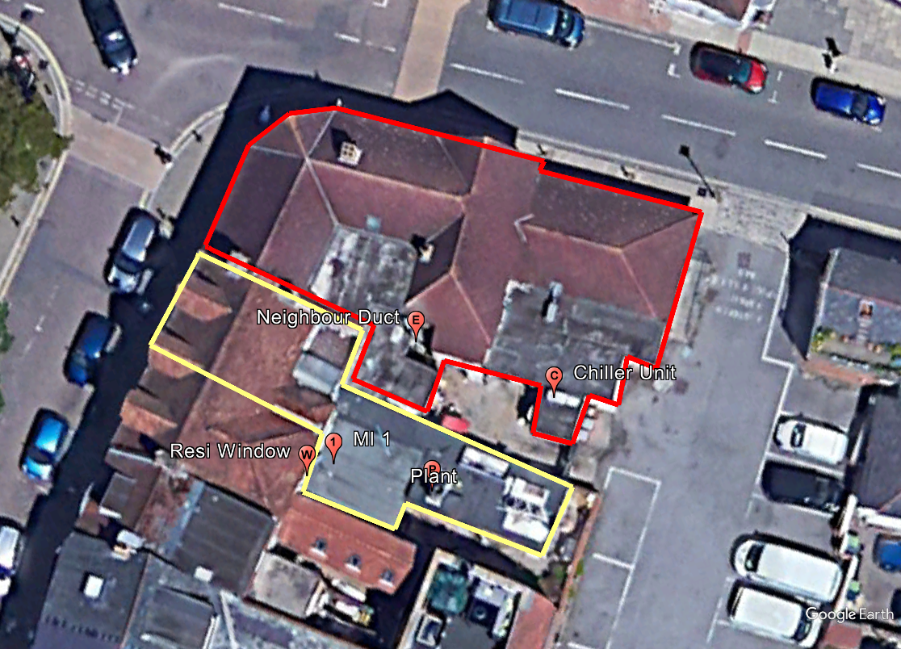

AIRTIGHT & NOISECHECK LIMITED ACOUSTICS TESTING

APPENDIX

Continuous equivalent noise level, LAeq — The steady noise level (usually in dBA) which, over the period of time under consideration, contains the same amount of sound energy as the time varying noise.

LAmax - The maximum value that the A-weighted sound pressure level reaches during a measurement period.

dB (A) — The A-weighted sound pressure level.

Decibel (dB) — A unit used for many acoustic qualities to indicate the level of sound with respect to a reference level.

A-weighting — A frequency weighting that relates to the response of the human ear.

Background noise level — Prevailing noise level in a specified environment measured in the absence of the noise being studied.

Habitable Room – A room used for sleeping or recreation/relaxation.

LA90 - The A-weighted noise level exceeded for 90% of the measurement duration.

British Standards & associated documents:

Code of Practice: BS8233: 2014 - Sound Insulation and noise reduction for buildings.

BS4142: Methods for rating and assessing industrial and commercial sound.

L2 = L1 – 20log(r2/r1) – Point source equation

10log (duration of event/duration of reference period)

AIRTIGHT & NOISECHECK LIMITED ACOUSTICS TESTING

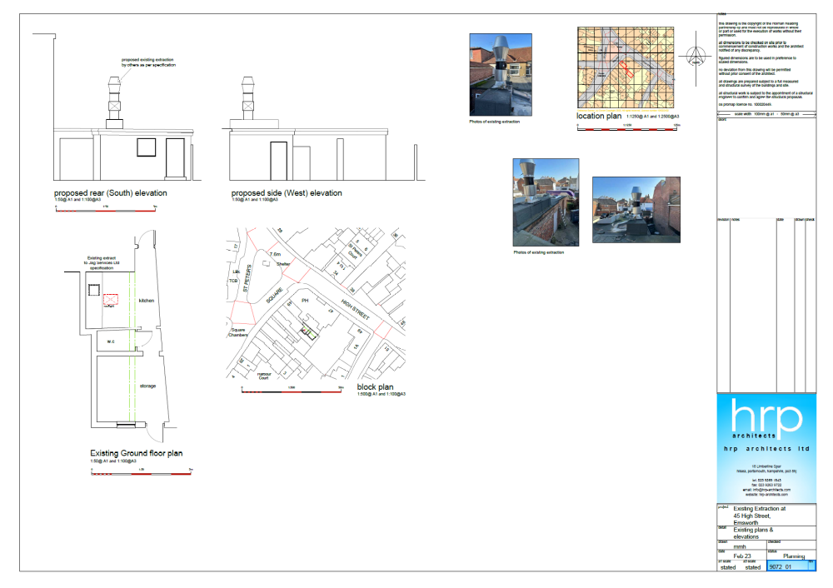

Raw Data – Measured at Site – 1hour data.

Time: | LAeq | LA90
(2023-05-10 13:00:00.390) | 44.9 | 37
(2023-05-10 14:00:00.390) | 47.2 | 36.4
(2023-05-10 15:00:00.390) | 51.5 | 49.2
(2023-05-10 16:00:00.390) | 53.4 | 49.9
(2023-05-10 17:00:00.390) | 58.5 | 50.6
(2023-05-10 18:00:00.390) | 58.5 | 54.2
(2023-05-10 19:00:00.390) | 60.1 | 53.7
(2023-05-10 20:00:00.390) | 54.1 | 52.6
(2023-05-10 21:00:00.390) | 60.8 | 52.8
(2023-05-10 22:00:00.390) | 57.7 | 51.6
(2023-05-10 23:00:00.390) | 43.5 | 30.7
(2023-05-11 00:00:00.390) | 39.5 | 29.6
(2023-05-11 01:00:00.390) | 37.7 | 26.9
(2023-05-11 02:00:00.390) | 36.1 | 26
(2023-05-11 03:00:00.390) | 35.6 | 25.3
(2023-05-11 04:00:00.390) | 41.1 | 28.2
(2023-05-11 05:00:00.390) | 42.3 | 34
(2023-05-11 06:00:00.390) | 43.1 | 37.8
(2023-05-11 07:00:00.390) | 44 | 36
(2023-05-11 08:00:00.390) | 46.7 | 36.6
(2023-05-11 09:00:00.390) | 44.3 | 36.4
(2023-05-11 10:00:00.390) | 47.7 | 37.1
(2023-05-11 11:00:00.390) | 45.3 | 38.1
(2023-05-11 12:00:00.390) | 48.3 | 42.8

Time: | LAeq | LA90
(2023-05-10 13:00:00.390) | 44.3 | 36.2
(2023-05-10 13:15:00.390) | 44.5 | 37.8
(2023-05-10 13:30:00.390) | 43.6 | 36.1
(2023-05-10 13:45:00.390) | 46.6 | 41.5
(2023-05-10 14:00:00.390) | 44.3 | 35.2
(2023-05-10 14:15:00.390) | 44.3 | 35.1
(2023-05-10 14:30:00.390) | 47.2 | 37.6
(2023-05-10 14:45:00.390) | 50.2 | 47.6
(2023-05-10 15:00:00.390) | 51.2 | 49.7
(2023-05-10 15:15:00.390) | 51.8 | 49.7
(2023-05-10 15:30:00.390) | 50.5 | 48.9
(2023-05-10 15:45:00.390) | 52.3 | 49.2
(2023-05-10 16:00:00.390) | 55.8 | 49.8
(2023-05-10 16:15:00.390) | 51.7 | 50.6
(2023-05-10 16:30:00.390) | 51.6 | 49.6
(2023-05-10 16:45:00.390) | 53 | 50.1
(2023-05-10 17:00:00.390) | 52.7 | 50
(2023-05-10 17:15:00.390) | 59 | 58.3
(2023-05-10 17:30:00.390) | 55.3 | 50.4
(2023-05-10 17:45:00.390) | 61.7 | 60.1
(2023-05-10 18:00:00.390) | 57.2 | 54.9
(2023-05-10 18:15:00.390) | 59.5 | 54.3
(2023-05-10 18:30:00.390) | 54.8 | 54
(2023-05-10 18:45:00.390) | 60.4 | 54.7
(2023-05-10 19:00:00.390) | 60.9 | 60.2
(2023-05-10 19:15:00.390) | 61.2 | 60.1
(2023-05-10 19:30:00.390) | 61 | 54.3
(2023-05-10 19:45:00.390) | 54.4 | 52.6
(2023-05-10 20:00:00.390) | 54.2 | 52.8
(2023-05-10 20:15:00.390) | 53.7 | 52.7
(2023-05-10 20:30:00.390) | 53.3 | 52.6
(2023-05-10 20:45:00.390) | 55.2 | 52.4
(2023-05-10 21:00:00.390) | 53.3 | 52.3
(2023-05-10 21:15:00.390) | 54.6 | 53.2
(2023-05-10 21:30:00.390) | 62.8 | 55.9
(2023-05-10 21:45:00.390) | 63.8 | 63.3
(2023-05-10 22:00:00.390) | 62.3 | 52.2
(2023-05-10 22:15:00.390) | 52.6 | 51.3
(2023-05-10 22:30:00.390) | 53.7 | 52.3
(2023-05-10 22:45:00.390) | 54.1 | 49.2
(2023-05-10 23:00:00.390) | 47.1 | 36.1
(2023-05-10 23:15:00.390) | 42.6 | 32.1
(2023-05-10 23:30:00.390) | 39.2 | 29.6
(2023-05-10 23:45:00.390) | 40.8 | 30.1
(2023-05-11 00:00:00.390) | 40.5 | 32.3
(2023-05-11 00:15:00.390) | 39 | 29.4
(2023-05-11 00:30:00.390) | 40.2 | 30.5
(2023-05-11 00:45:00.390) | 38.1 | 28.6
(2023-05-11 01:00:00.390) | 36.7 | 27
(2023-05-11 01:15:00.390) | 36.8 | 26.9
(2023-05-11 01:30:00.390) | 33 | 26.6
(2023-05-11 01:45:00.390) | 40.8 | 27.5
(2023-05-11 02:00:00.390) | 34.9 | 26.1
(2023-05-11 02:15:00.390) | 37.6 | 26.5
(2023-05-11 02:30:00.390) | 36.3 | 26
(2023-05-11 02:45:00.390) | 34.9 | 25.8
(2023-05-11 03:00:00.390) | 35.1 | 25.2
(2023-05-11 03:15:00.390) | 34.8 | 25.3
(2023-05-11 03:30:00.390) | 34.5 | 24.9
(2023-05-11 03:45:00.390) | 37.3 | 25.9
(2023-05-11 04:00:00.390) | 35.3 | 26.9
(2023-05-11 04:15:00.390) | 43.9 | 30.2
(2023-05-11 04:30:00.390) | 42 | 33
(2023-05-11 04:45:00.390) | 39.3 | 32.6
(2023-05-11 05:00:00.390) | 38.9 | 32.6
(2023-05-11 05:15:00.390) | 40.4 | 35.8
(2023-05-11 05:30:00.390) | 43.8 | 37.2
(2023-05-11 05:45:00.390) | 43.9 | 38.1
(2023-05-11 06:00:00.390) | 40.6 | 37.2
(2023-05-11 06:15:00.390) | 43.6 | 38.5
(2023-05-11 06:30:00.390) | 43.4 | 38.2
(2023-05-11 06:45:00.390) | 44 | 38
(2023-05-11 07:00:00.390) | 42.4 | 37
(2023-05-11 07:15:00.390) | 43.5 | 35.4
(2023-05-11 07:30:00.390) | 44.6 | 35.6
(2023-05-11 07:45:00.390) | 45.1 | 36.1
(2023-05-11 08:00:00.390) | 46.3 | 36.4
(2023-05-11 08:15:00.390) | 48.5 | 39
(2023-05-11 08:30:00.390) | 44.3 | 35.3
(2023-05-11 08:45:00.390) | 46.7 | 38
(2023-05-11 09:00:00.390) | 44.9 | 37
(2023-05-11 09:15:00.390) | 44 | 37
(2023-05-11 09:30:00.390) | 43.6 | 35.2
(2023-05-11 09:45:00.390) | 44.7 | 37.3
(2023-05-11 10:00:00.390) | 45 | 36.7
(2023-05-11 10:15:00.390) | 51.8 | 40.8
(2023-05-11 10:30:00.390) | 43.5 | 36
(2023-05-11 10:45:00.390) | 44.7 | 37.3
(2023-05-11 11:00:00.390) | 44.5 | 36.6
(2023-05-11 11:15:00.390) | 44.1 | 36.1
(2023-05-11 11:30:00.390) | 46 | 42.2
(2023-05-11 11:45:00.390) | 46 | 42.1
(2023-05-11 12:00:00.390) | 45.5 | 42.1
(2023-05-11 12:15:00.390) | 49.9 | 42.6
(2023-05-11 12:30:00.390) | 48.5 | 46.6
(2023-05-11 12:45:00.390) | 48.2 | 44.5

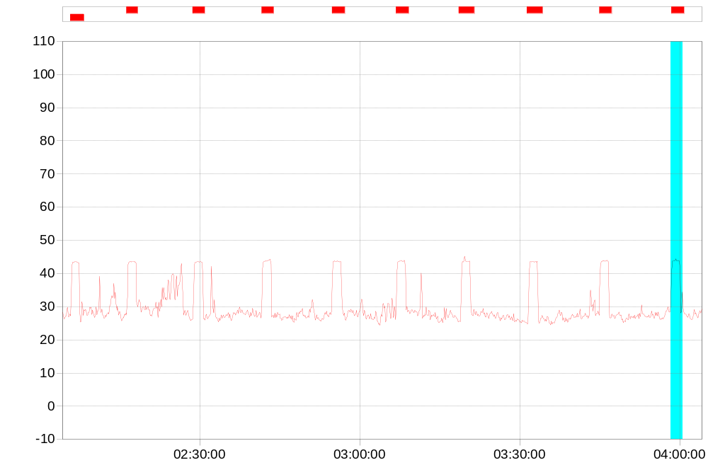
The above is a take off of the hours between 0200-0400hrs and each red section is when the chiller unit was in operation.

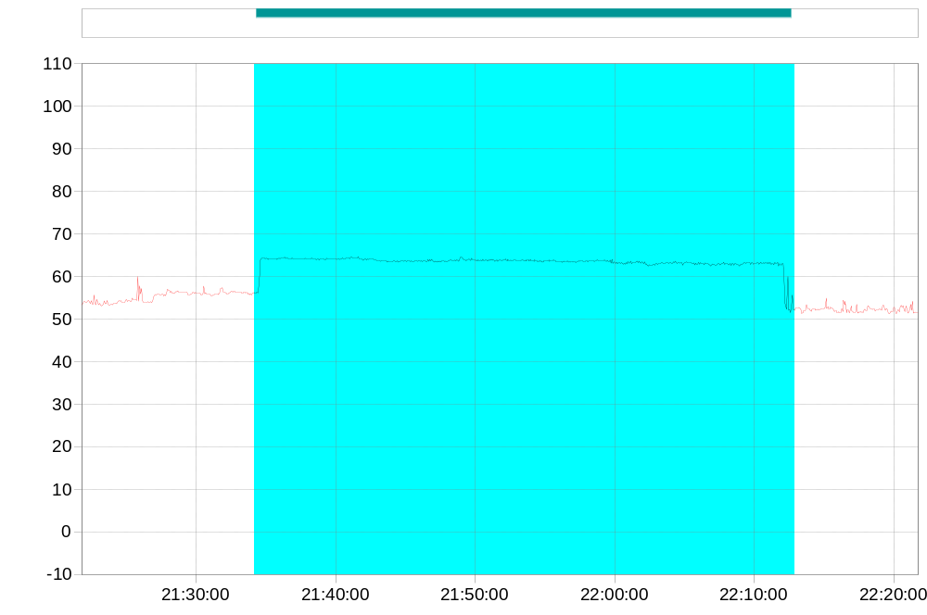
The above graph shows the time period between 2135-2215hrs and it shows the increase in noise levels due to the neighbouring plant being turned up. It can bee seen that the levels increase to beyond 60dBA during this period, further illustrating that the replacement plant for No 45 High Street will not have an adverse impact on the residential dwellings located at 1st floor level.

