Aerial photograph of existing property. For reference only
23 Shaftesbury Ave,
Waterlooville,
Hampshire.
PO7 5HW.

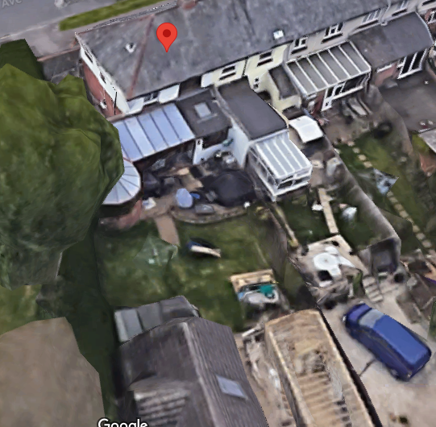

C.H Planning & Sales
112 Stubbington Lane,
Fareham,
Hants. PO14 2PE
Tel: 01329-661877
OS Licence: 100050691

