PP/21/00114 - 2 Elderfield Close

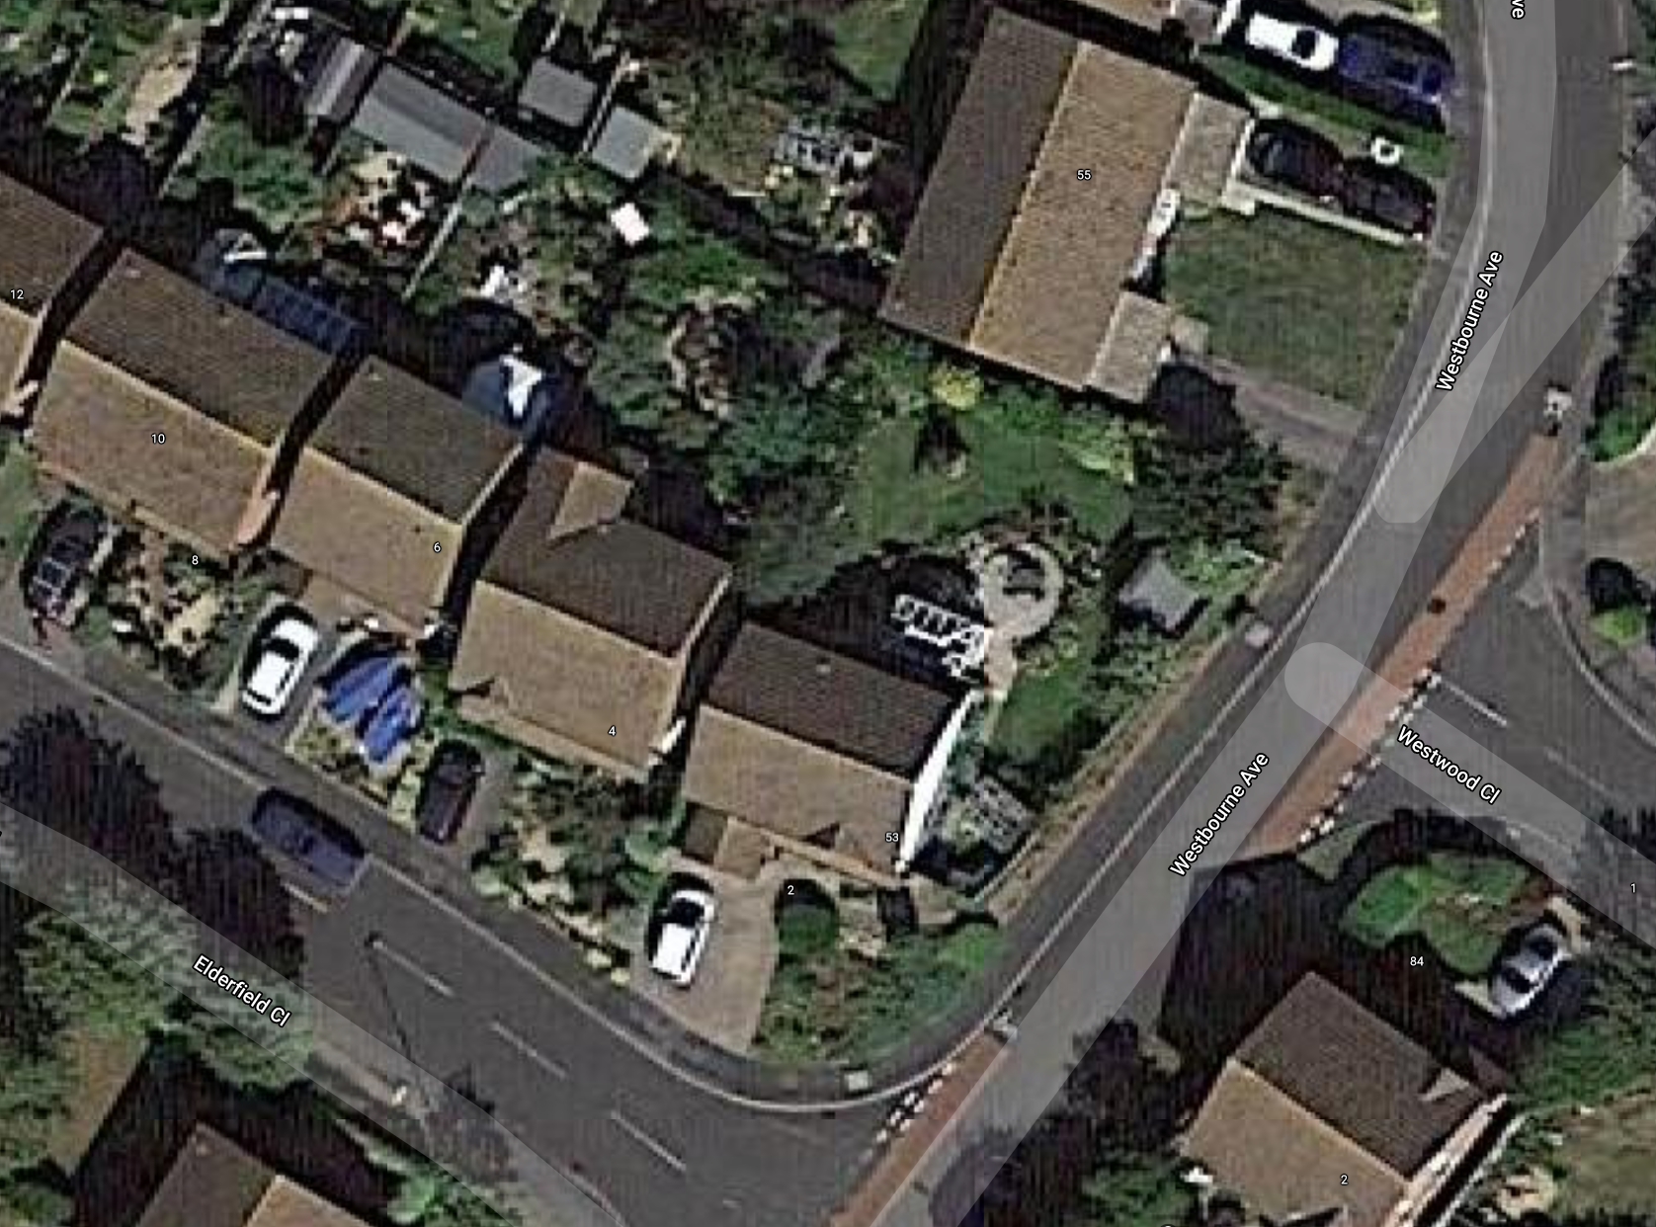

No.4 No.2
Image 1 - Google earth image. No.2 set forward of number 4

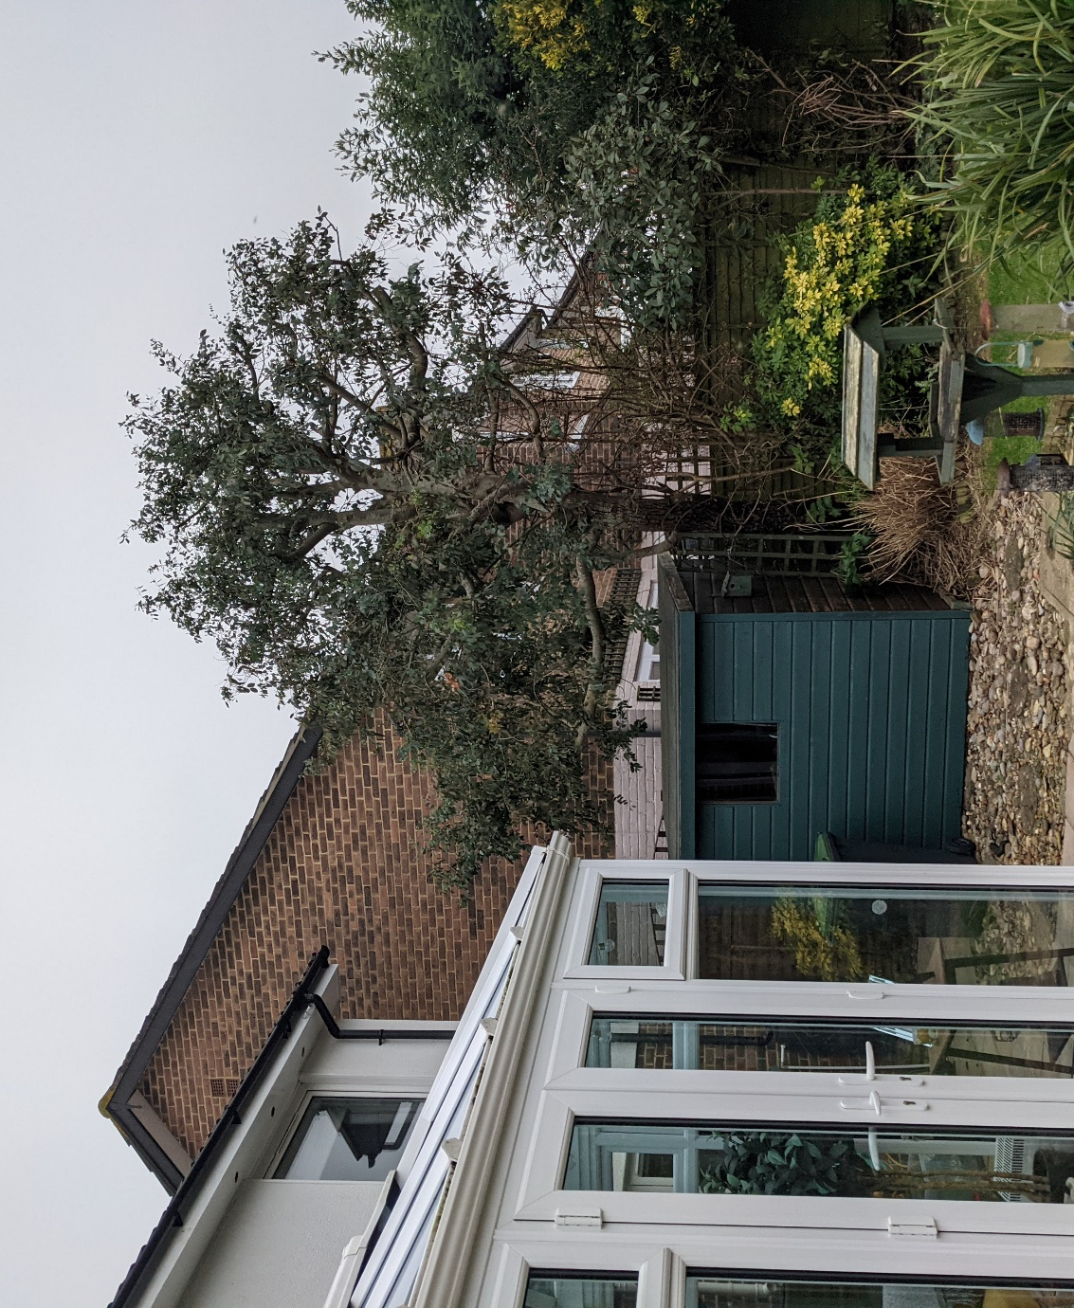

Image 2 – N0. 4 set back from number 2

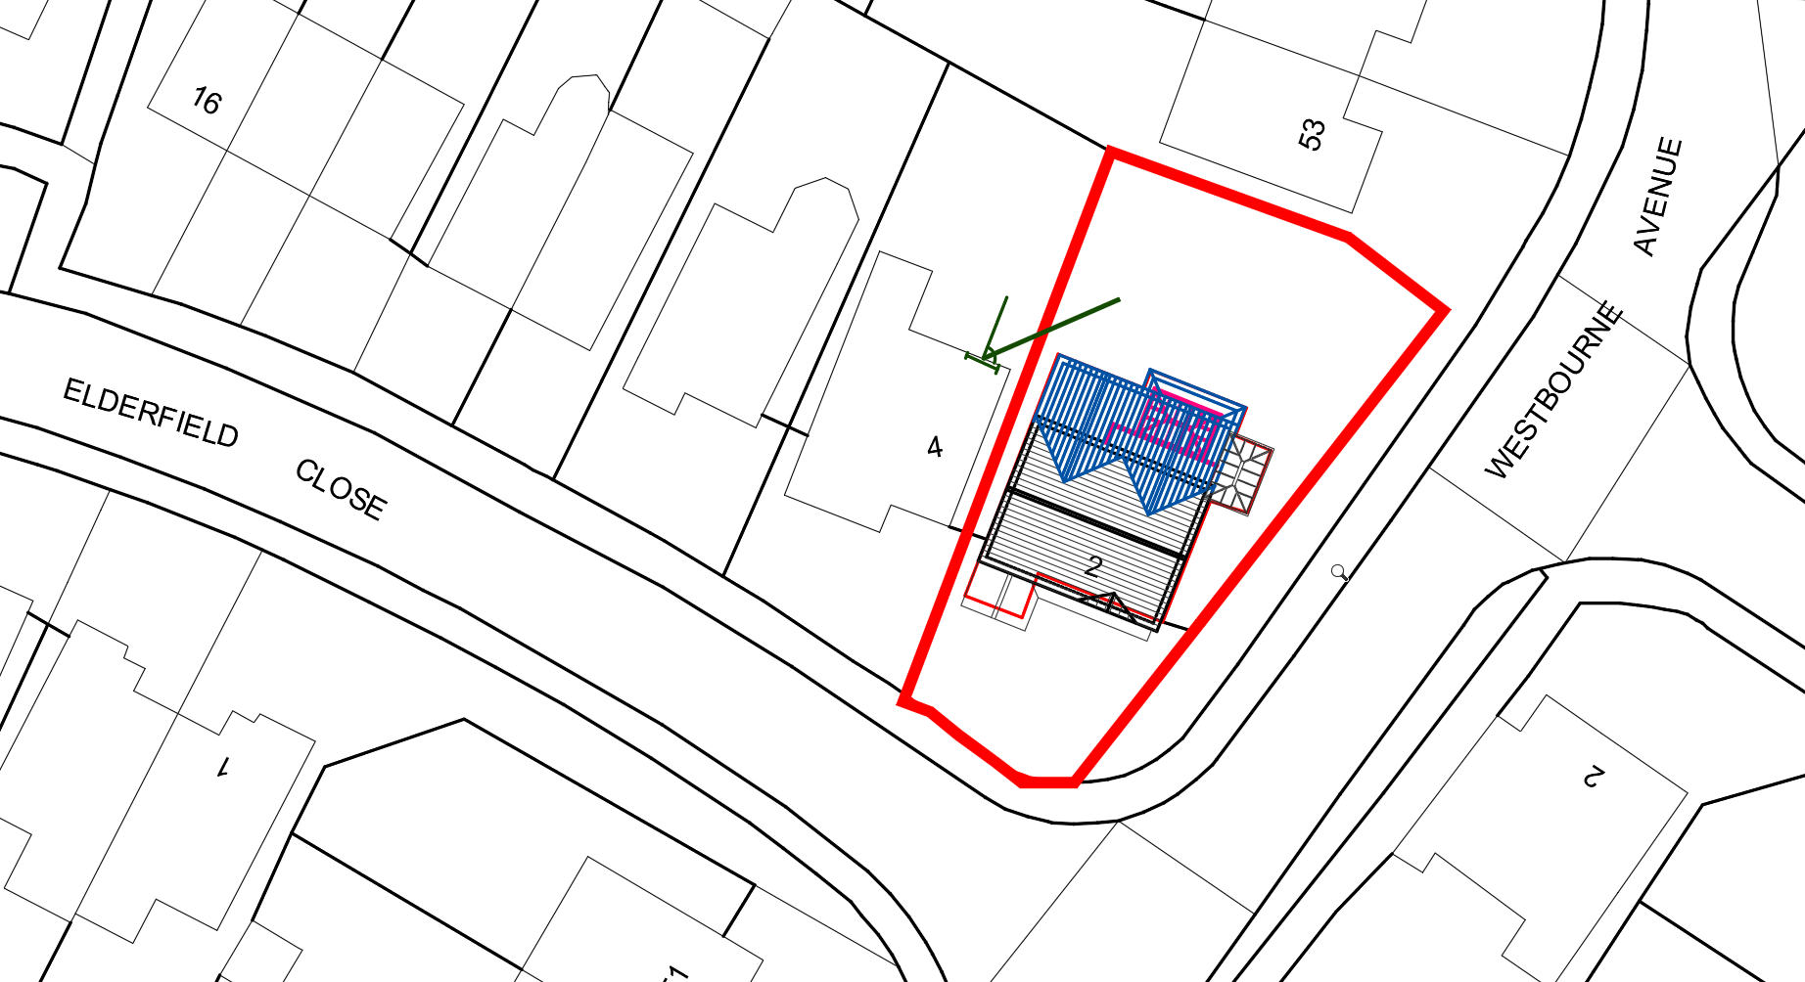
Image 3 – 45 degree line from no.4 and effect of extension.

