CONSTRUCTION ENVIRONMENTAL MANAGEMENT PLAN
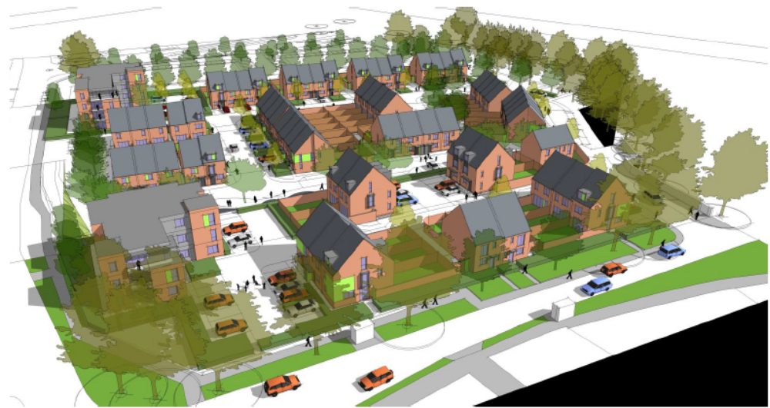

Former Colt Site, Havant
Drew Smith
Former Colt International Site
Havant
PO9 5TE

DATE |  | 20-06-25
AUTHOR |  | Richard Couchman
REVISION |  | A

Construction Environmental Management Plan Revision Sheet
Issue Number | Date of Issue | Reason for Revision and Comments
1 | 25/6/20 | Issued for submission and review
Author: | Richard Couchman |  | Checked by: | Paul White
Date: | 25/6/20 |  | Date: | 26/6/20

Contents
Executive Summary
- Project Background
  - Framework of this CEMP
  - Summary of the Requirements of Planning condition 18 – APP/18/00244
- Site Information and Consented Development
  - Site and Surrounding Area
  - Scheme Description
  - Sensitive Receptors
  - Environmental Impacts and Mitigation

3 Control of the Construction Process
3.1 Roles and Responsibilities
3.2 Training and Raising Awareness
3.3 Reporting
3.4 Complaints and Incidents
3.5 Public Relations and Community Relations

4 Construction Management
4.1 Description of Construction Works
4.2 Phasing of Construction Works
4.3 Construction Equipment
4.4 Hours of Working (Hours of Site Operation)
4.5 Construction Traffic Management Plan
4.6 Storage of Plant and Materials
4.7 Handling of Plant and Materials
4.8 Health and Safety Management
4.9 Security On-Site
4.10 Considerate Constructors

5 Environmental Control Measures
5.1 Public Access and Traffic Management
5.2 Waste and Materials Management and Storage
5.3 Noise and Vibration
5.4 Dust and Air Quality
5.5 Ecology & Diversity
5.6 Tree Protection
5.7 Contaminated Land Procedures
5.8 Hydrology & Water Quality
5.9 Visual Impacts
5.10 Artificial Lighting
5.11 Emergency Procedures

6 Conclusions

Appendix A - Existing Services
Appendix B -Traffic Route Plan
Appendix C- Site Set Up Plan
Appendix D- Construction programme
Appendix E- Emergency Contact Details

Executive Summary

Drew Smith shall be responsible for safeguarding the environment and for mitigating the effects of the proposed construction works at Colt, Havant. To do this, Drew Smith and all its subcontractors and suppliers will comply with the environmental requirements outlined in the contract documentation and the specific content of this Construction Environmental Management Plan (CEMP).

This CEMP details the construction operation in accordance with relevant legislative requirements and construction industry best practice. This document will form part of Drew Smith’s Construction Phase Plan which will be developed and agreed with the client, the specialist consultant team and the Local Authority prior to commencement of any construction activity.

Appended Documents:

- Existing Services Drawing
- Traffic Route plan
- Site Set Up Plan
- Construction Programme
- Emergency Contact Details

1 Project Background

1.1 Framework of this CEMP

This CEMP has been prepared to provide the details required by the Local Planning Authority relating to Condition 18 - Prior to the commencement of any specific phase of development hereby approved
(or such other date or stage in development as may be agreed in writing with the
Local Planning Authority) a Construction Environmental Management Plan (CEMP)
for that phase shall be submitted to and approved in writing by the Local Planning
Authority to demonstrate how spills, incidents and site drainage will be managed
during the proposed site development. The development shall thereafter be carried
out in accordance with the approved details.

LPA Ref: APP/18/00244

1.2 Summary of the Requirements of Planning condition 18

The planning Condition is worded as follows:

Prior to the commencement of any specific phase of development hereby approved
(or such other date or stage in development as may be agreed in writing with the
Local Planning Authority) a Construction Environmental Management Plan (CEMP)
for that phase shall be submitted to and approved in writing by the Local Planning
Authority to demonstrate how spills, incidents and site drainage will be managed
during the proposed site development. The development shall thereafter be carried
out in accordance with the approved
details.

2 Site Information and Consented Development

2.1 Site and Surrounding Area

2.1.1 DESCRIPTION:

The site is located at Martin Road, Havant. The site is approximately 1 ha in size and is currently unused open space following the demolition of the factory previously located there.

Please refer to Appendix B for Traffic Route Management Plan for location details.

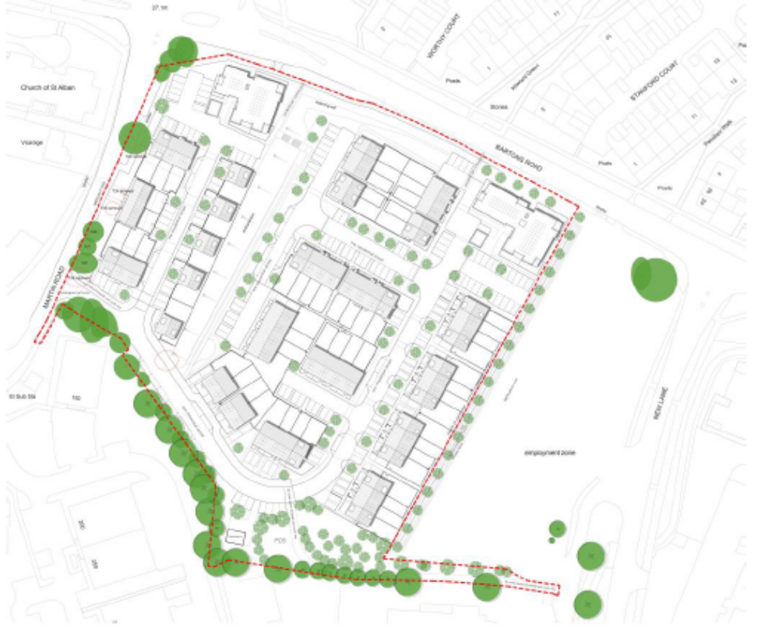
2.2 Scheme Description / Scope of works

2.2.1 The scheme consists of 94 flats and houses made up of,
- 2no 1 bed flats,
- 30no 2 bed flats
- 21no 2 bed houses
- 37no 3 bed houses
- 5no 4 bed houses

The key construction stages are as follows:

- Construction of new site entrance from Valley road
- Construction of roads and drainage
- Groundworks including retaining walls and piling to houses
- Erection of timber frame houses
- Final service connections and completion of houses
- Landscaping and Tarmac wearing course to road

2.3 Sensitive Receptors

2.3.1 Table 2.1 below lists a number of receptors which have been identified as being potentially sensitive to the works to be undertaken during the construction of the Development due to their proximity to the Site and nearby access road.

Table 2.1 Receptor in the Vicinity of the Proposed Development that are Potentially Sensitive to Construction Works

Receptor | Location and / or impact
Neighbours | Noise  Dust  Fumes  Litter  Vibration  Vehicle movements
Air quality | Dust  Fumes
Ground and groundwater | Site clearance  On site earth moving operations  Pollution spills  Vibration  Dust
Watercourses | Pollution spills  Litter  Dust / silt  Monsoon drain on site to be protected to prevent contamination of water course
Protected Species | Badgers  Badger survey has been completed and confirmed no badgers present on site
Existing utilities | Water- has been cut off on site boundary as part of the enabling works  Gas main/service- has been cut off on site boundary as part of the enabling works  Electric- Existing Substation to be removed and relocated

2.4 Environmental Impact and Mitigation / Control Measures

    - The table below lists a Environmental Impacts and Mitigations which have been identified as being potentially sensitive to the works to be undertaken during the construction of the Development.

Environmental Impact | Mitigation / Control Measures
Ecology | Reptiles to be relocated as stipulated in Ecology report.
Transport | The Traffic Management Plan can be found within Appendix 2 and details the following:  - Vehicle routes  - Parking  - Vehicular/pedestrian access/egress from site  - Segregation of vehicles/plant and pedestrians/operatives  - Material unloading areas  - Crane hard standings  Signage will be displayed at junctions on the routes to the site from the main road to help drivers navigate and reduce the likelihood of large vehicles having to attempt to turn around causing obstructions and hazards associated with reversing vehicles on carriageways.
Noise and Vibration | No construction operations and deliveries are permitted to take place outside 8am – 6pm  All contractors will be required to control and limit noise and vibration levels so that current legislative standards are not exceeded, i.e. the noise limits referenced in Table E.1 Annex E of BS5228:2009 and A1:2014 Part 1
Air quality | Areas of hardstanding and permanent road surfaces will be constructed as soon as possible on site. Until this time and in areas of unsurfaced roads and where significant dust creation is identified, ground conditions will be compacted using static sprinklers, bowsers, where necessary.  All processing plant and vehicles carrying loose aggregate and workings will be covered or shielded to reduce/avoid dust emissions.

3 Control of the Construction Process

3.1 Roles and Responsibilities

3.1.1 The anticipated roles and responsibilities of the key parties involved in the construction works are set out below. However, it should be noted that all members of staff are responsible for ensuring the requirements of the CEMP are followed.

Main Contractor

3.1.2 Drew Smith will appoint contractors to develop specific phases on their behalf. They will appoint a Site Manager, full details of which will be included within the CMS.

Architect

3.1.2 Drew Smith have appointed MH Architects to carry out the working drawings for this scheme. Contact details below:-
Contact: MH Architects
Address: Ground Floor, Bicentennial Building, Southern gate, Chichester, PO19 8EZ
Telephone: 01243 774748
Engineers

3.1.2 Drew Smith have appointed AKS Ward to carry out the civil engineering drawings for this scheme (Civil). Contact details below:-
Contact: AKS Ward
Address: 116 High Street, Southampton, SO14 2AA
Telephone: 02380 235340
3.1.3 Drew Smith have appointed AKS Ward to carry out the structural engineering drawings for this scheme (Structural). Contact details below:-
Contact: AKS Ward
Address: 116 High Street, Southampton, SO14 2AA
Telephone: 02380 235340
Site Manager
3.1.4 The Site Manager will be responsible for the day to day management of Health and Safety, Environmental and Quality Performance during the construction of the Proposed Development. The Site Manager will also be responsible for implementing the CEMP, including the development of a detailed Environmental Action Plan for delivering the CEMP, monitoring the performance of sub-contractors and maintaining records to demonstrate compliance with and implementation of CMS.

3.1.5 In addition, the Site Manager will be responsible for ensuring that all staff and operatives receive a site specific health, safety and environmental induction prior to starting work on-site and are provided with relevant information concerning environmental sensitivities and protection measures.

3.1.6 The Site Manager will be responsible for reviewing all risk assessment method statements and ensuring an appropriate programme of tool box talks are developed and effectively communicated.

3.1.7 All queries and complaints from the public and local community will be directed to the Site Manager who will be responsible for responding to these and maintaining a register of complaints.

Internal Team
3.1.8

Description | Person(s) Responsible
Contracts Manager | Richard Couchman
Site Manager | TBC
Health and Safety Advisor | Adrian Shipley
Contracts Surveyor | Callum Doswell
Technical Manager | Paul White
Produce CEMP | Richard Couchman
Site Inspections | Regular site inspections to be carried out to check all site operations, identify environmental risks and implement controls

All Staff and Subcontractors
3.1.9 All staff and subcontractors have the responsibility to:
- Work to agreed plans, methods and procedures to eliminate and minimise environmental impacts (including the CEMP);
- Understand the importance of avoiding pollution on-site, including noise and dust, and how to respond in the event of an incident to avoid or limit environmental impact;
- Report all incidents immediately to their line manager;
- Monitor the work place for potential environmental risks and alert the immediate line manager if any are observed; and
- Co-operate as required, with site inspections and audits.

Table 3.1 Key Contacts

Contracts Manager |  | Site Manager
 | Richard Couchman  Drew Smith  01489 861400 |  | TBC  Drew Smith  01489 861400
Ecologist |  | Arboriculturalist
 | Ecosupport  K4 Keppel  Daedalus Park  Daedalus Drive  Lee-on-Solent PO13 9FX  Tel no. 01329 832841 |  | CBA Trees  East Lodge  Leylands Business Park  Colden Common  Winchester SO21 1TH  Tel no. 02380 986229
3.2 Training and Raising Awareness

3.2.1 The raising of environmental and health and safety awareness is viewed as a crucial element in the appreciation and implementation of the CEMP. This CEMP will be distributed to members of the project team, including suppliers and subcontractors as necessary to ensure that environmental and health and safety requirements are adequately communicated.

3.2.2 The Site Manager is responsible for ensuring that all people on-site are provided with relevant information concerning environmental protection. A system should be operated on-site whereby all staff and operatives receive a site specific safety and environmental induction prior to commencing any work on-site.

3.2.3 All information is relayed to personnel by the nominated person during Site Induction and continued through by Toolbox Talks. The Site Manager is the nominated person.

3.3 Reporting

3.3.1 Any problems are reported to the Site Manager, and the Contracts Manager for his comments.

3.4 Complaints and Incidents

3.4.1 The Site Manager will develop and implement an appropriate queries / complaints procedure and details of whom to contact in the event of a complaint will be displayed on signage on the perimeter hoarding.

3.4.2 Logging a complaint / incident will be done by Site Manager.

Table 3.2 Incident and Complaints Log

Date | Recorded by | Concerning | Incident

3.4.3 The formal procedure for handling project complaints/concerns will be developed and agreed by the principal contractor / site manager but may include a procedure similar to that detailed below:
- Stakeholders (i.e. the general public, local authority etc.) will be able to report any concerns complaints or other comments to site manager in writing, by email or in person at the site offices. Site contact details should be provided at site entrances, on perimeter hoardings and possibly at appropriate community locations;
- The site manager will take full details of the concerns expressed and ensure that a formal assessment is commenced of the reported concern. They will also issue an initial response to the person who has submitted the complaint / concern. They will also issue an initial response to the person who has submitted the complaint / concern confirming its receipt;
- The site manager will undertake an investigation to assess what corrective and preventative action, or further investigation is necessary;
- Any corrective measures / actions will be implemented with associated implementation dates being recorded;
- Following implementation of the corrective action and agreement with the relevant stakeholder that the complaint has been adequately addressed the case will be closed and date recorded.

3.5 Public Relations and Community Relations

Meeting the locals
3.5.1 General information regarding the development will be provided to neighbours affected by the work and the form and format for regular communication will be organised in liaison with established community groups to ensure effective and regular communication is maintained throughout the development period regarding programming and construction activities.

4 Construction Management

4.1 Description of Construction Works

4.1.1 The main elements of construction works associated with the different components of the Proposed Development are summarised in Table 4.1 below

Table 4.1 Overview of Construction Works

Works | Description
Site Clearance and Site Set-up | Delivery of site Welfare, enabling works to create pedestrian and vehicle routes
Site Infrastructure | New services connections to plots for water, gas, electricity & BT.
Construction of New Buildings and Associated Facilities | Construction of timber framed houses and traditional built flats.

4.2 Description of Construction Works

4.2.1 Works due to commence on 20th July 2020 for 114 weeks

4.2.2 The above timescales are estimates based upon current market conditions and likely build rates.

4.3 Construction Equipment

4.3.1 Plant typically to be used for this site are listed below:-

- Excavators
- Dumpers
- Telescopic Forklift
- Piling rig

Site vehicles;

- Staff and sub-contractors cars and vans
- 32t 8 wheeler lorries for aggregate deliveries and spoil removal
- Street class 1 delivery vehicles
- Road class 2 articulated lorries for larger brick and block deliveries

4.3.2 The impacts associated with the use of this equipment/activities on noise and air quality and the environmental control measures which are recommended are discussed in Section 5.

4.4 Hours of Working (Hours of Operation)

4.4.1 The standard working hours for all construction activities will be from:

0800 – 1800 Monday to Friday and 0830 – 1300 on Saturdays. Sunday working is not permitted.

4.5 Construction Traffic Management Plan

Vehicles:
4.5.1 Traffic and Traffic operatives will follow the information set out below:
- All vehicles to switch off engines – no idling vehicles (noise and emission prevention)
- All loads of loose material entering and leaving site to be covered
- No site runoff of water or mud onto the adjacent public highway will be permitted
- The site manager will be responsible for ensuring that suitable measures are in place to ensure roads are kept clean
- Consolidate / hard surfacing and effective cleaning of haul routes and appropriate speed limit around site
- Ensure plant is regularly maintained, any plant showing signs of black smoke should be taken out of use. Well maintained modern plant helps reduce noise levels
- Use low Sulphur diesel
- Delivery times and routes will be issued to our subcontractors and suppliers
- Suppliers / subcontractors will be sent away by site management should they ignore these requirements at their cost

Pedestrians/Personnel:
4.5.2 The pedestrian route will be clearly defined to ensure that there is no crossing of pedestrians through the vehicular route.
4.5.3 The general public will be excluded from the works area using appropriate fencing and signage.
4.5.4 Health and Safety signage will be displayed at appropriate locations throughout the works.
4.5.5 All visitors will be required to sign in and out of the site on a daily basis

4.6 Storage of Plant and Materials

    - The Site Manager will inspect daily the site area for spillage, an incident form will be completed should any be found, and forwarded to HQ so we can avoid reoccurrences
    - The Site Manager will inspect bunds and drip trays, more frequently during periods of bad weather
    - Rainwater should be kept from entering bunds and drip trays. The Site Manager will be responsible for overseeing the emptying of drip trays bunds adhering to control procedures
    - Information will be displayed on spill kits and within the site office covering emergency actions and contact details. The EA and Southern Water contacts will be prominently displayed and used should any incident occur which could impact upon ground water
    - Hazardous chemicals, which may harm staff and the environment, should be stored in an appropriate container within a ventilated store
    - COSHH assessments covering all substances on site will be kept within the site office and operatives will be appropriately trained in emergency procedures
    - The Site Manager will be responsible for updating the register
    - Plant should be regularly maintained, and removed from site immediately if found to be leaking
Dealing with Spillages
    - Use bunded areas for refuelling as indicated on the Compound Plan
    - Drip trays will be used when refuelling and care should be taken with hoses running between mobile plant and tank to avoid spillages and contain any leakage
    - Spill kits will be provided adjacent to refiling sites
    - Operators will be spill kit trained and kits will be inspected at regular intervals by the Site Manager to ensure supplies are maintained
    - Refuelling procedures will be covered in the site induction, though only trained operatives will be permitted to carry out the procedure
    - Small plant should be refilled within the designated area
    - Small/mobile/static plant such as generators, compressors, pumps etc. will have drip trays
    - Clean spillages using agreed wet handling methods

4.7 Handling of Plant and Materials

    - The handling of plant materials will be managed by the appointed Contractor.

4.8 Health and Safety Management

4.8.1 Drew Smith are committed to promoting a positive safety culture. The enforcing authority for health and safety on construction sites is the Health and Safety Executive (HSE) who will be notified of all construction works prior to their commencement on site.
4.8.2 The Site Manager will maintain a register of accidents, incidents, near misses and complaints. Contractors failing to maintain the required safety standards may be excluded from the approved tender list of future work.
4.8.3 All works will be carried out in accordance with all legal compliance and all other acts, regulations and Codes of Practice and site rules relating to the works will be observed.
4.8.4 No bonfires are to be permitted in any case

4.8.5 When laying and using Bitumen, do not overheat bitumen and cover pots

4.8.6 Use great care in all processes to prevent spillages and extinguish any accidental fires immediately

4.9 Security On-Site

4.9.1 Only authorised persons will be allowed on Site. A Site Risk Assessment will be produced which will detail how security will be managed on the Site. Any person identifying unauthorised personnel on-site should contact the Site Manager who will take appropriate action and ensure the unauthorised person leaves the Site safely.

4.10 Considerate Constructors

4.10.1 In order to maintain a high standard of good practise at this development, all staff and contractors will be advised of the below values:
- Consideration: All work to be carried out with positive consideration to the needs of all potentially affected parties and the environment in general;
- Environment: Minimising noise and dust from construction, attention of waste management and avoidance of pollution;
- Cleanliness: The working site is to be kept clean in good order at all times;
- Good Neighbours: Full and regular consultation with neighbours regarding programming and site activities;
- Respectful: Respectful and safe standards of dress shall be maintained. Lewd or derogatory behaviour will not be tolerated;
- Safe: Construction operatives and site vehicle movements are to be carried out with great care and consideration for the safety and security of the general public and site personnel;
- Responsible: Considerate Constructors will ensure that all site personnel and any other persons working on the site understand and implement these values;
- Accountable: Posters relating to the scheme will be displayed around the site giving names and telephone numbers of staff who can be contacted in response to issues raised by the general public or other persons affected by the site operation.

5 Environmental Control Measures

5.1 Public Access and Traffic Management

5.1.1 Construction traffic associated with the proposed development will access the site from the direction of Martin Rood. Please refer to traffic route plan enclosed for full details.

5.1.2 Where possible, measures will be adopted to ensure that construction traffic travels minimal distances along sensitive routes (residential or congested roads) and those vehicles are kept clean and sheeted when on public highways.

5.1.3 Action will be taken to minimise and control any nuisance arising from construction traffic by using measures such as controlling vehicle speed, use of sweepers, wheel washing and keeping all site entrances clean.

5.2 Waste and Materials Management and Storage

5.2.1 Waste and materials management will be the responsibility of the Site Manager. Please refer to enclosed Site Set Up plan for full storage details.

5.3 Noise and Vibration

5.3.1 The construction works are likely to follow the generic mitigation measures as listed below:
- Plant and equipment will be regularly maintained to ensure optimum performance of any fitted sound reducing devices, e.g. exhausts.
- Toolbox talks will be held with site operatives to promote being a “Good neighbour”.
- A site induction will take place and will cover appropriate use of radios and being considerate to neighbours.
- Equipment and vehicles to be shut down when not in use
- Where necessary, any permanent noise barriers would be constructed as early as possible in the construction programme.
- Hours of operation will be restricted as indicated in Section 4.4

5.4 Dust & Air Quality

5.4.1 During the construction phase, there will be various site clearance works and activities undertaken, which all have the potential to generate particle emissions arising from dust and smoke. Outlined below are typical generic measures that will be implemented to minimise the effect of air pollution:
- Minimise dust generating activities. Machinery and dust causing activities are to be located away from sensitive receptors;
- Use water as dust suppressant where applicable, dust suppression should consist of “mist spraying” only;
- Whenever possible keep stockpiles or mounds away from the site boundary, sensitive receptors, water courses and surface drains;
- Whenever possible securely cover skips with polythene or tarpaulin;
- Use mechanical road sweepers on all adjacent roads during periods of dry weather. Site Manager to arrange regular inspections of site and local network.

5.4.2 The table below demonstrates the main sources of particle emissions during construction activities and the controls required to minimise pollution.

Table 5.1

Activity | Remedy
Dust blown up from Road Ways | Roads to be kept clean as best as possible. Dampen down with water from a fine water spray
Materials / dust being blown from skips | Cover skips with tarpaulins or similar
Dust blown from areas around site | Erect Fencing (permanent) where possible or hoardings to cut down on airborne dust
Smoke, ash | No burning on site
Exhaust from mechanical plant | Ensure plant is regularly maintained, any plant showing signs of black smoke should be taken out of use. Use low sulphur diesel.
Dust arising from materials / storage | Cover materials with polythene or tarpaulin.

5.5 Ecology & Biodiversity

5.5.1 Prior to any works commencing (and at any time during construction for advice) please contact our Ecologist.

5.5.2 To minimise the risk of killing and, or injuring reptiles, any ecology fencing must be kept clear and intact during construction.

5.5.3 The ecologist must be in supervision for vegetation clearance and tree felling

5.5.4 No tree felling or lopping works to be undertaken during bird nesting season (March – August inclusive) to reduce the risk of disturbing, damaging, and destroying active nests and their occupants.

5.5.5 Erect Ecology and Tree protection fencing in accordance with the Ecology and Arboricultural reports

5.5.6 Ecology related constraints on this site are as follows:

- Existing fox setts, which will be removed prior to works starting on site.

5.6 Tree Protection

5.6.1 Some trees and hedgerows will need to be either wholly removed or partially removed to enable the proposed development to take place.

5.6.2 Prior to any works commencing please contact our Arboriculturalist to arrange a pre-start meeting. A further meeting to inspect installed tree / ground protection measures will also be required.

5.6.3 Outlined below are typical measures that will be implemented to minimise the effect on protected trees:
- Tree protection fencing to be erected prior to any on site activities in accordance with the Aboricultural Impact Assessment
- No materials to be stored within the tree protection area
- No plant or site personnel to enter tree protection area
- No reduction or raising of soil levels within tree protection area
- No tree felling or lopping works to be undertaken during bird nesting season (March – August).
- Works within tree root zones to be undertaken under supervision of appointed Aboriculturalist
- Penalties for contravention of a TPO can result in a fine at Magistrates or Crown Court depending upon extent of damage

5.7 Contaminated Land Procedures

5.7.1 Should any areas of contamination be encountered, the LPA will be notified immediately and these will be dealt with in an appropriate manner.

5.7.2 All workers on-site will be made aware of potential contamination issues on the Site and will use best practice techniques during the construction phase.

5.8 Hydrology & Water Quality

5.8.1 The following generic mitigation measures are proposed to protect the water environment:
- All site works will be undertaken with suitable temporary drainage measures in place.
- Strict control of the site boundaries will be enforced by the Site Manager, including minimal land clearance and restrictions on the use of machinery near water bodies.
- The design of the SUDS and the use of pollution prevention control measures will ensure that the development does not affect groundwater,
- Cleared land should be replanted or vegetated as soon as practicable to minimise the extent of exposed land and the volume of surface water run-off.

5.9 Visual Impacts

5.9.1. Retention of boundary vegetation / sensitive boundaries / screening / footpaths / etc.

5.10 Artificial Lighting

5.10.1 Light spill and glare during construction will be minimised by the controlled and sympathetic use of lighting taking into account the location of sensitive receptors both on and surrounding the site.

5.10.2 The following best practice measures will be implemented during the construction works:
- Lighting to be switched off when not required for construction activities or for security / health and safety.
- Light spill will be minimised by avoiding poorly sited lights on the Site boundary.
- The programme of works will take into account the location of sensitive receptors, in particular the residential properties, ecological species sensitive to changes in ambient lighting levels, pedestrians and road users, through the careful selection of the compound locations, restricting hours of operation and through control and careful direction of lighting used.

5.11 Emergency Procedures

5.11.1 Pathways for pollution to escape should be removed and/or easily intercepted. This can be achieved through isolating polluting materials from drainage infrastructure and ensuring that there are appropriate methods for intervention and containment. More information on dealing with spillages and storage of chemicals, fuels etc. is found within Section 4.6.

5.11.2 A set of standardised emergency response procedures will govern the management of environmental incidents. Construction contractors will be required to adhere to and implement these procedures and ensure that site operatives are familiar with the emergency arrangements.

6 Conclusion

6.6.1 All this information is relayed to personnel by the nominated person during Site Induction and continued through by Toolbox Talks. The Site Manager is the nominated person.
6.6.2 Any problems are also reported to the Site Manager for his comments.
6.6.3 The following information sheet will be discussed at each person’s site induction and continued through tool box talk by the Site Manager.
6.6.4 Each sub-contractor will be informed how and when he can help to cut down on air pollution at the pre-start meeting.
6.6.5 Any breaches will be notified to the site contractor in writing.

Appendix A – Existing Services

Appendix B – Traffic Route Plan

Appendix C – Site Set Up Plan

Appendix D – Construction Programme

Appendix E – Emergency Contact Details

Name | Company | Contact Name | Contact Number | Contact Address
Client | Vivid Homes | TBC | 0800 652 0898 | Peninsular House, Wharf Rd, Landport, Portsmouth PO2 8HB
Contractor | Drew Smith ltd | R Couchman | 07974 454 275 | Drew Smith, The Sawmills, Durley
Site Manager
Environment Manager

Environment Agency

Natural England
Ecologist
Planning Consultant

Waste Management Contractor
Emergency Services
Water Company
Gas Supplier
Electricity Supplier
Telephone/Internet Provider

