10 Blackthorn Road Photos
Photo 1: Rear of the Property
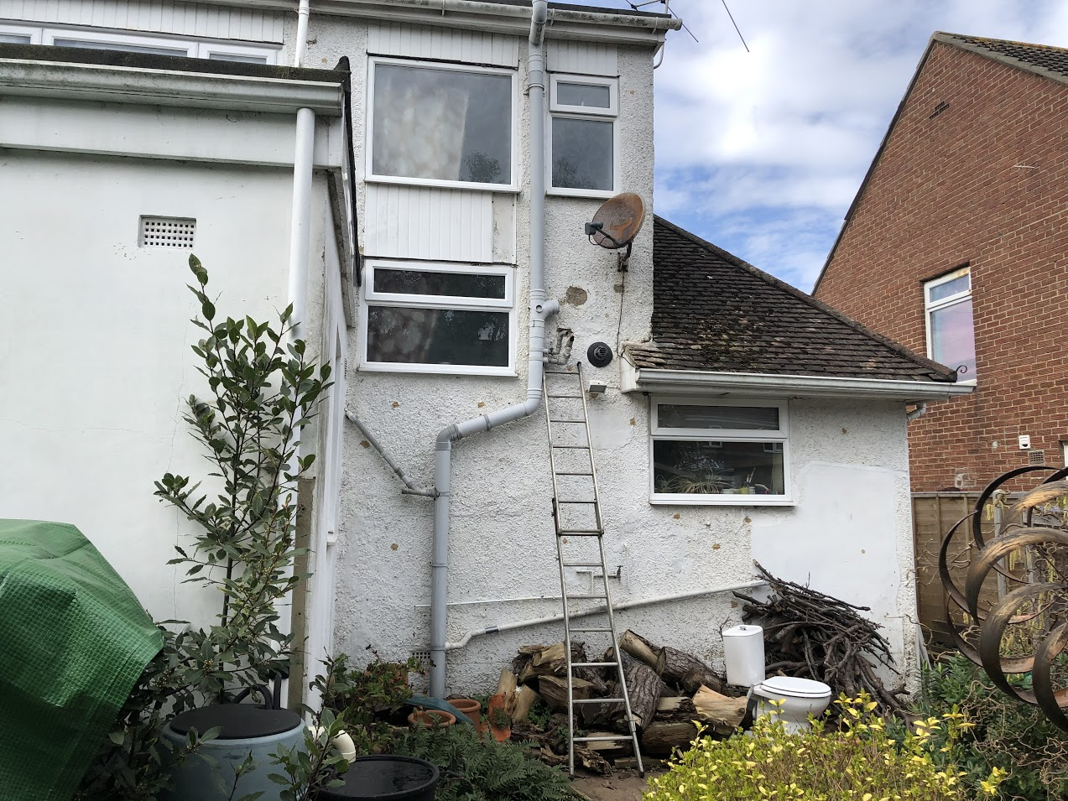

Photo 2: Rear of the Property
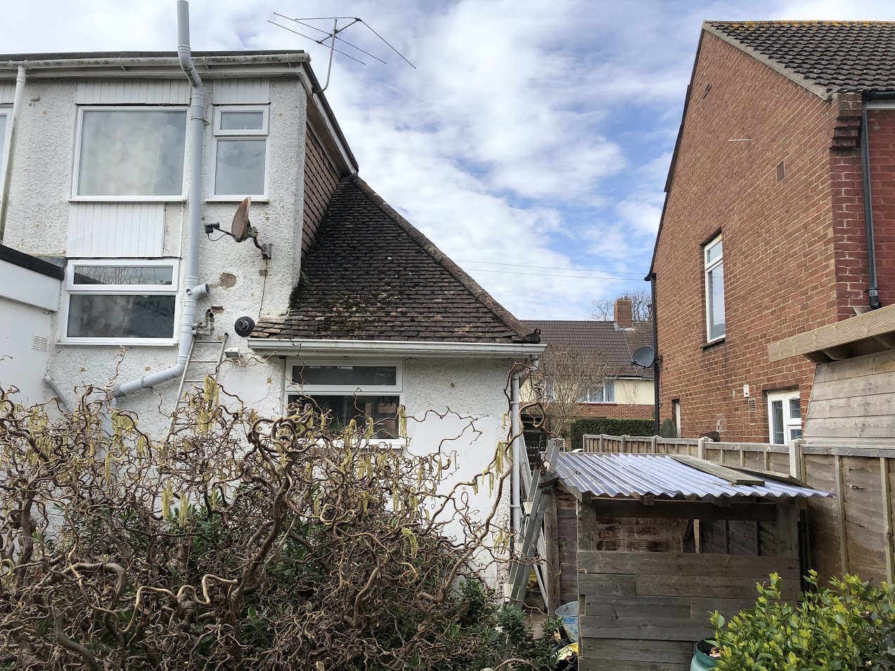

Photo 3: Rear of the Property
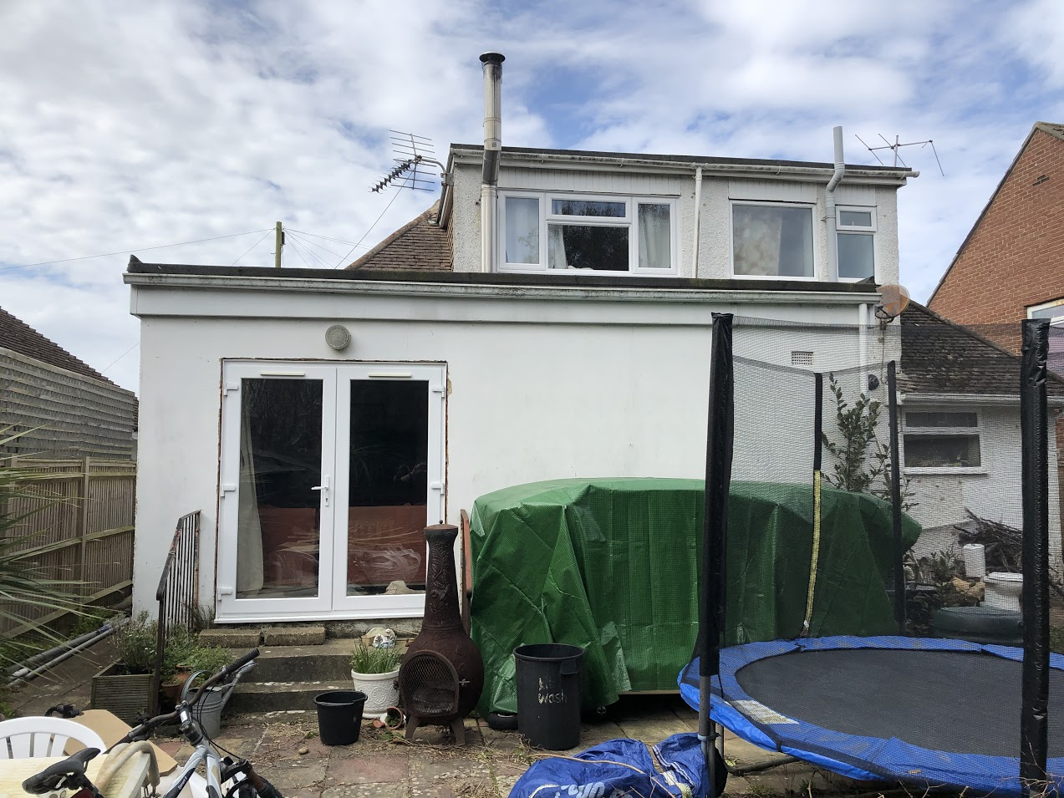

Photo 4: Side of the Property next to No. 8
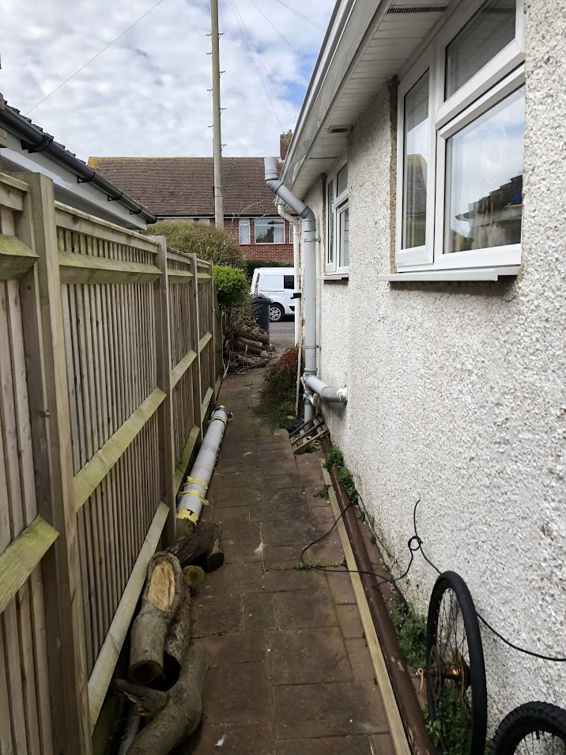

Photo 5: Front of property
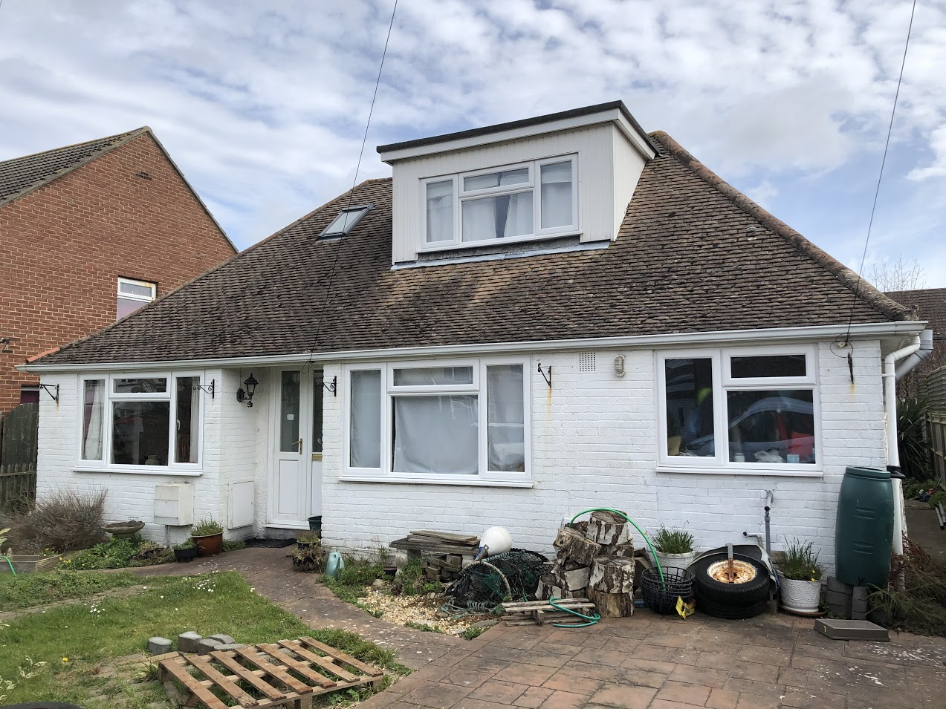

Photo 6: Front of the Property
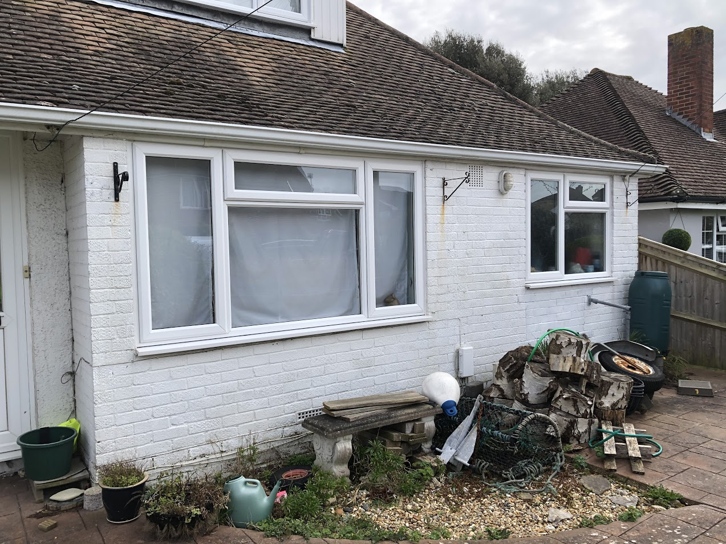

Photo 8: Side of property next to No. 12
