38c Bedhampton Hill, Havant, PO9 3JW
T1 – ASH  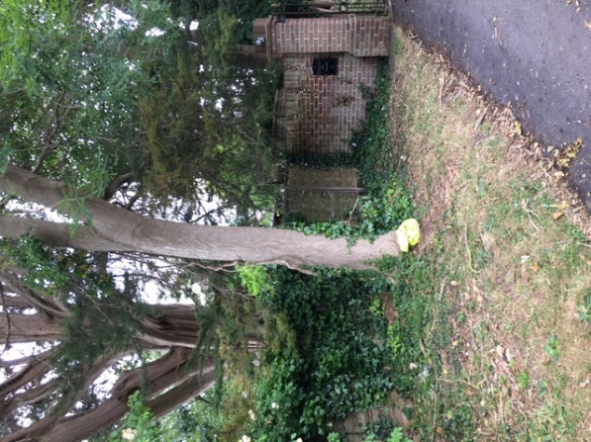 | T2 - ASH  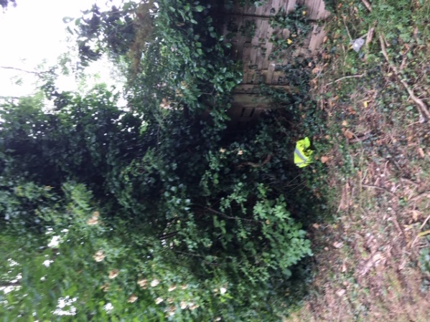
T1&T2 Evidence of Ash Dieback  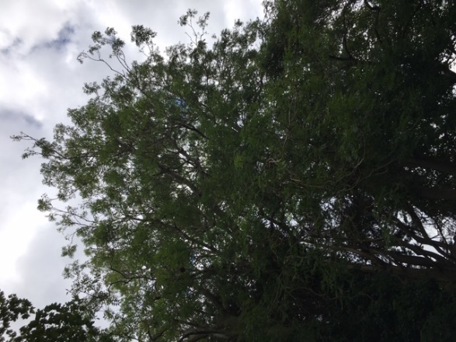 | 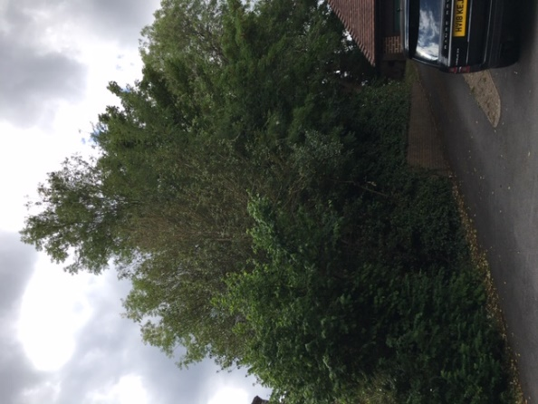  T3-T10 SYCAMORE
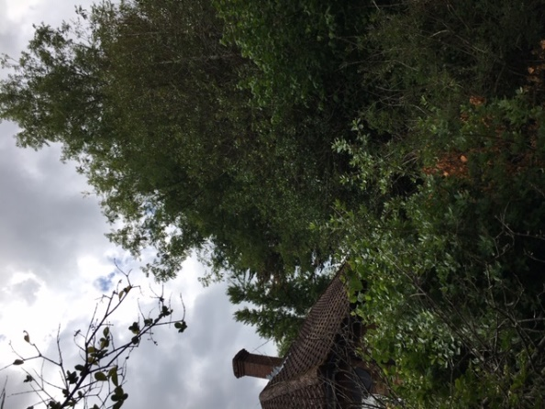
T12-14 ASH

