 | Your ref  APP/20/00324  Our ref  PLAN-032994  Date  17/07/2020  Contact  Tel 0330 303 0119
  Department of Planning and Development
  Havant Borough Council
  Public Service Plaza
  Civic Centre Road
  Havant
  Hampshire
  PO9 2AX

Dear Sir/Madam,

Proposal: Single storey front extension.
Site: APP/20/00324: - 9, Stansted Crescent, Havant, PO9 5NL.

Further to our previous correspondence dated 14/05/2020 regarding the above planning application and further information submitted by the applicant stating that a build over agreement will be applied for as part of the building regulation application procedure which is satisfactory to Southern Water.

All other comments in our response dated on 14/05/2020 remain unchanged and valid.

Yours faithfully,
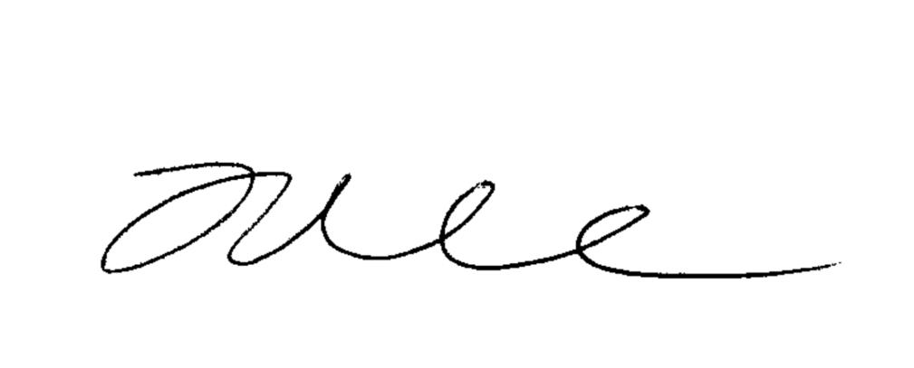
Joff Edevane
Growth Planning Lead
Business Channels

