Condition 7 Sign off for 1A Haven Road Hayling Island ref APP/19/00067

‘No development hereby permitted shall commence until plans and particulars
specifying the layout, depth and capacity of all foul and surface water drains and
sewers proposed to serve the same, and details of any other proposed ancillary
drainage works/plant (e.g. pumping stations) have been submitted to and approved
in writing by the Local Planning Authority. Unless agreed otherwise in writing by the
Local Planning Authority, the development hereby permitted shall not be brought
into use prior to the completion of the implementation of all such drainage provision
in full accordance with such plans and particulars as are thus approved by the
Authority.’

The development will aim to use the existing foul sewer system which is already in place and has been utilized for a number of years by the two-bedroom residential Caravan on the site (see below)

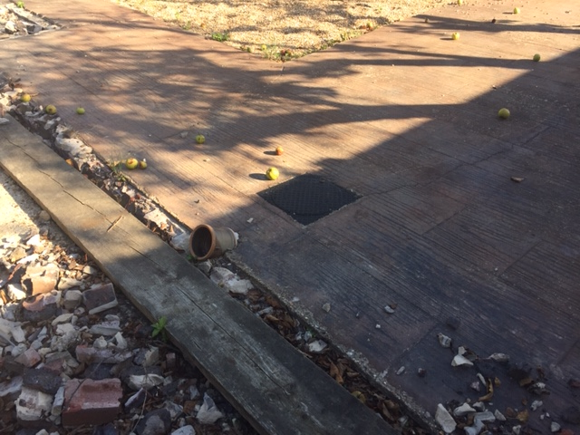

The manhole will be re-sited / replaced with a full sized inspection chamber to the front of the proposed development and will be attached to the existing foul sewer system which runs directly into the existing public sewer system, all work will be undertaken as per the submitted and approved building regulations plans submitted to Havant Borough Council The layout of this is shown on drawing A102 (attached).
The rainwater drainage will be taken to a new soakaway, the location of which is shown on drawing A102 (attached)

