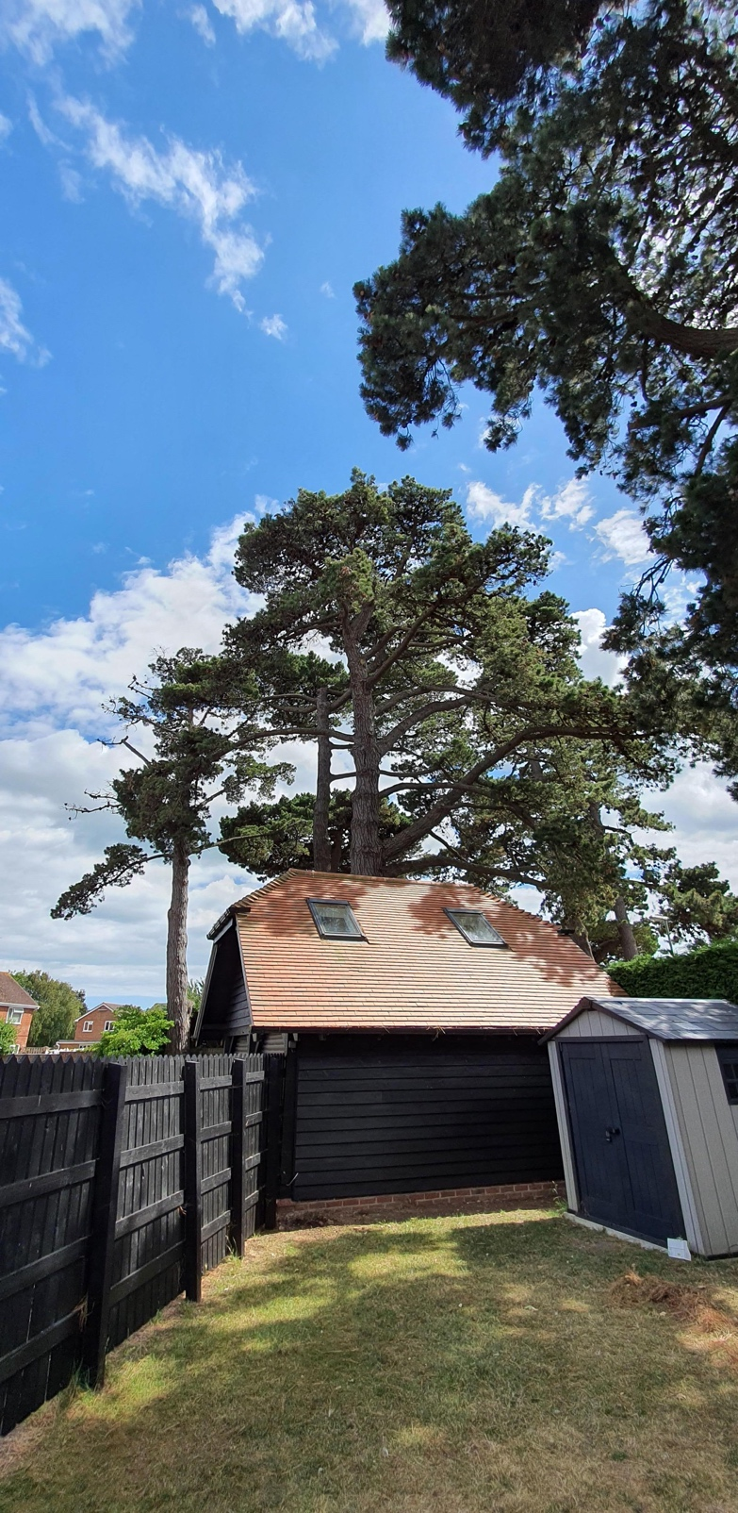

View on Monterey Pine tree (3 on sketch) showing bowing of branches on both sides due to the weight of pine cones. One side hangs over Goldring Close.
Propose crown reduction to a number of branches on both sides to balance of approximately 3 feet, and removal of excess cone weight reducing the risk of branches coming down in Goldring close, and reducing stress on the tree due to excess weight.

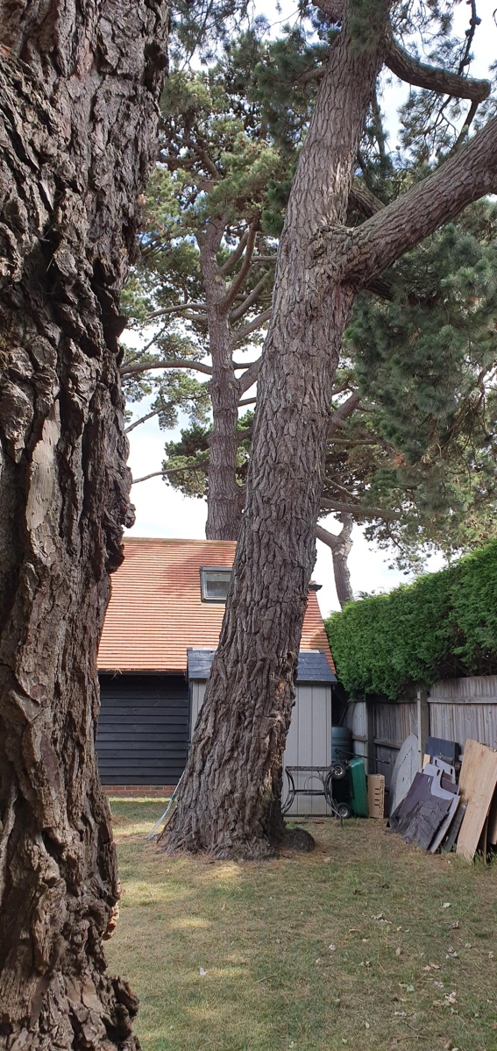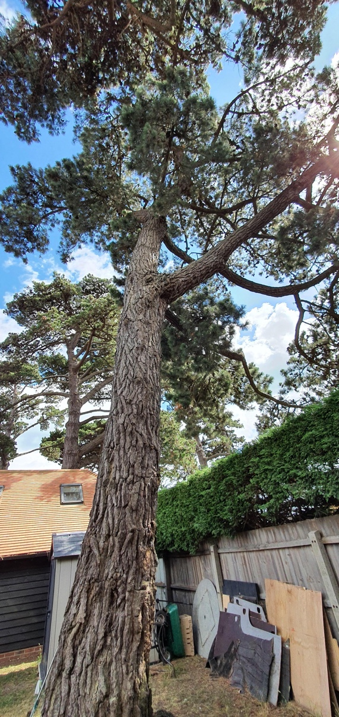

View of Monterey Pine tree (4 on sketch) showing the lean angle, and bowing from pine cone weight.
All branches on this tree are on the side of the lean hanging over Goldring Close.
Propose crown reduction to a number of branches of approximately 3 feet and removal of excessive cone weight, reducing the risk of branches coming down in Goldring close, and reducing stress on the tree due to excess weight.

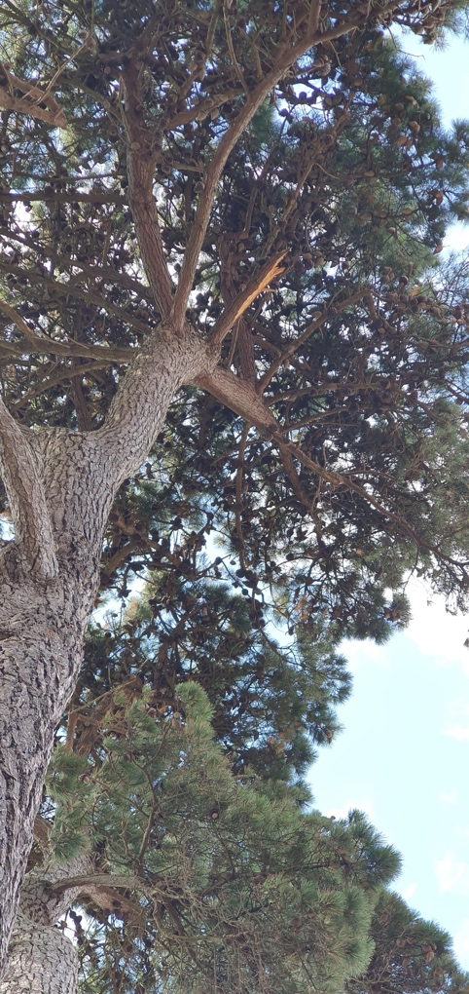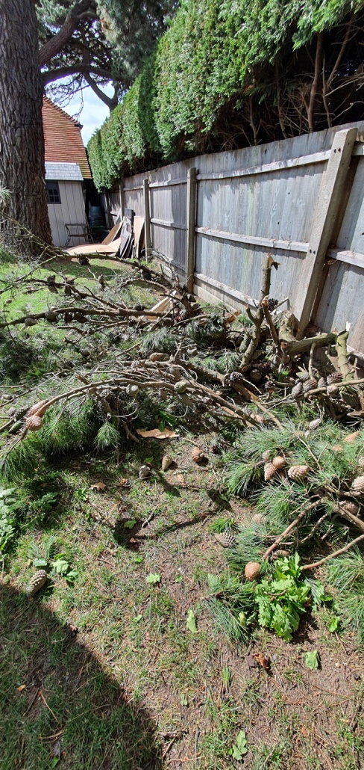

View of Monterey Pine tree (5 on sketch) showing the remains on a large branch that came down in the wind. You can see from what remains that this healthy branch was ripped (on 11/05/2020) from the tree due to the excess cone weight.
Email to inform of this branch fall was sent on 14/05/2020, and a copy is attached.

This was the second branch that had come down for this reason, the first had not completely come down, and was professionally removed on the 20/03/2020 (picture below)

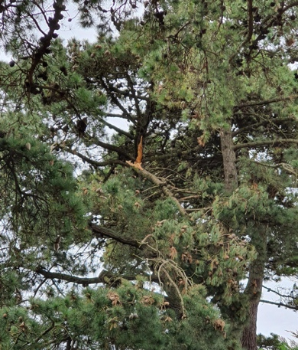
Email chain from 20/03/2020 to 23/03/2020 is attached.

Propose crown reduction (pine 5 in sketch) to a number of branches of approximately 3 feet, tidy where the branch was torn away, and removal of excessive cone weight, reducing the risk of further branches coming down, potentially in Goldring close, and reducing stress on the tree due to excess weight.
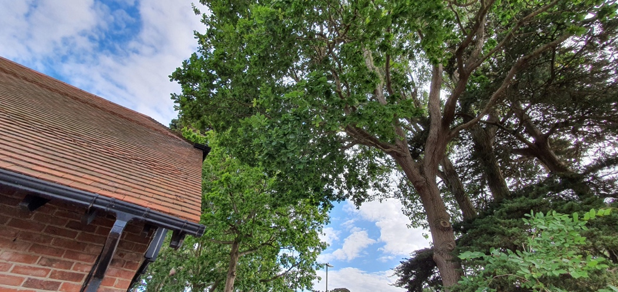

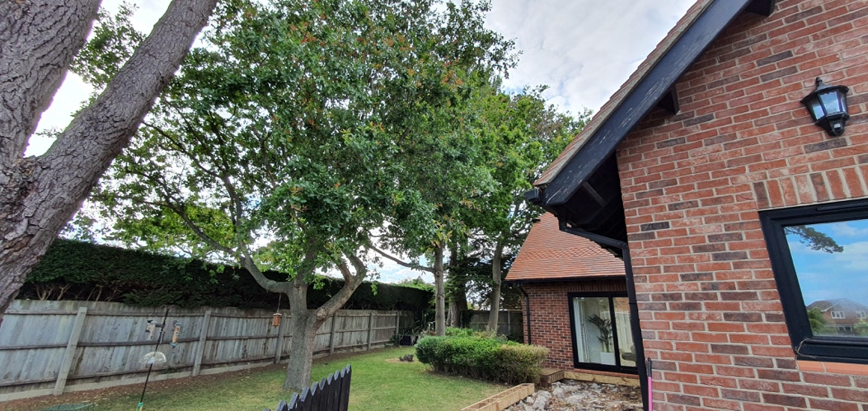

View of three Oak trees (7, 8, 9 on sketch) showing the density of foliage intertwining between them.

Propose crown thinning to each of the three oak trees by between 15% and 20% to increase light to lower branches and preserve tree health.

