Application for sign off of conditions 3,4,5,6,7,8,9 and 10 for APP/18/00407 at Eastview Manor Road Hayling Island PO11 0QH approved on 30th July 2018

- Condition 3 reads.
No development shall commence until details of the measures to be taken to ensure that the development does not cause harm to the public infrastructure and drainage apparatus surrounding the site have been submitted to and approved in writing by the Local Planning Authority. The development shall be carried out in accordance with the approved details.
Reason: The application site lies within close proximity to a public surface water sewer and as such it should be demonstrated that any proposed development will not result in harm to the public drainage apparatus. The condition is imposed having due regard to Havant Borough Local Plan (Core Strategy) 2011 policy CS19 and the National Planning Policy Framework 2018.
Condition 3 sign off proposal for effects on public infrastructure & drainage...
The attached southern water wastewater drainage map (appendix 6) shows the direction and depth of the public surface water sewer. The closest drain cover for the public surface water drain (number 5051) is directly outside to the east of the southern boundary of East view and is shown on Photo 3.
The foul drainage for the proposal will connect to the existing foul surface drainage for east view which is shown on photo 2 the connection side of this inspection chamber is 4 meters from the boundary and in the centre of the drive. As shown in drawing A101 V6.11 (appendix 5) The path of the new sewer does not cross or come close to the existing surface water drain. Thus, there will be no impact on the public surface water sewer caused by the installation of the new foul drain.
In terms of water gas electric and cabling utilities, The invert level of the surface water drain outside the property in manor road is 1m thus allowing enough depth for utilities to be installed, warning of the location and depth of the sewer will be giving to the utility companies installing the water, gas, electric and cabling to ensure any required excavations are performed by the advised methods and with the required care and attention to ensure no damage is caused to the public sewers,

- Condition 4 reads
No development shall take place until finished floor levels for the proposed buildings relative to agreed off-site datum points have been submitted to and approved in writing by the Local Planning Authority. The development shall be undertaken in accordance with the approved details
Reason: In the interests of the amenities of the area and having due regard to policy CS16 of the Havant Borough Local Plan (Core Strategy) 2011 and the National Planning Policy Framework

Condition 4 sign off proposal for Floor levels
There is an existing foul drain cover 3.7m from the drive entrance boundary with Manor Road which is set in the driveway (see red arrow photo 2), it is 710mm below an OS bench mark marked on the existing Eastview property (see photo 1 & 2 below) There is an offsite pavement drain cover in Manor road (see Photo 3) this is also 710mm below the OS bench mark, the drain cover is marked number 5051 on the attached southern water drainage plan appendix 6
The ground height at the proposed new dwelling construction area of the site is 95mm above the top of the drain cover on the drive. The finished floor level will be 175mm above this height and hence the finished floor level of the new dwelling above the driveway drain cover will be 270mm and thus 440 below the OS benchmark datum point

Photo 1 
Photo 2
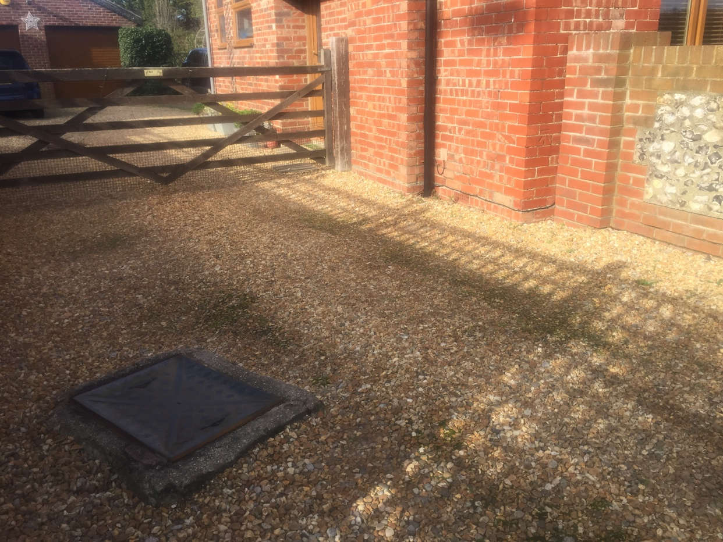
Photo 3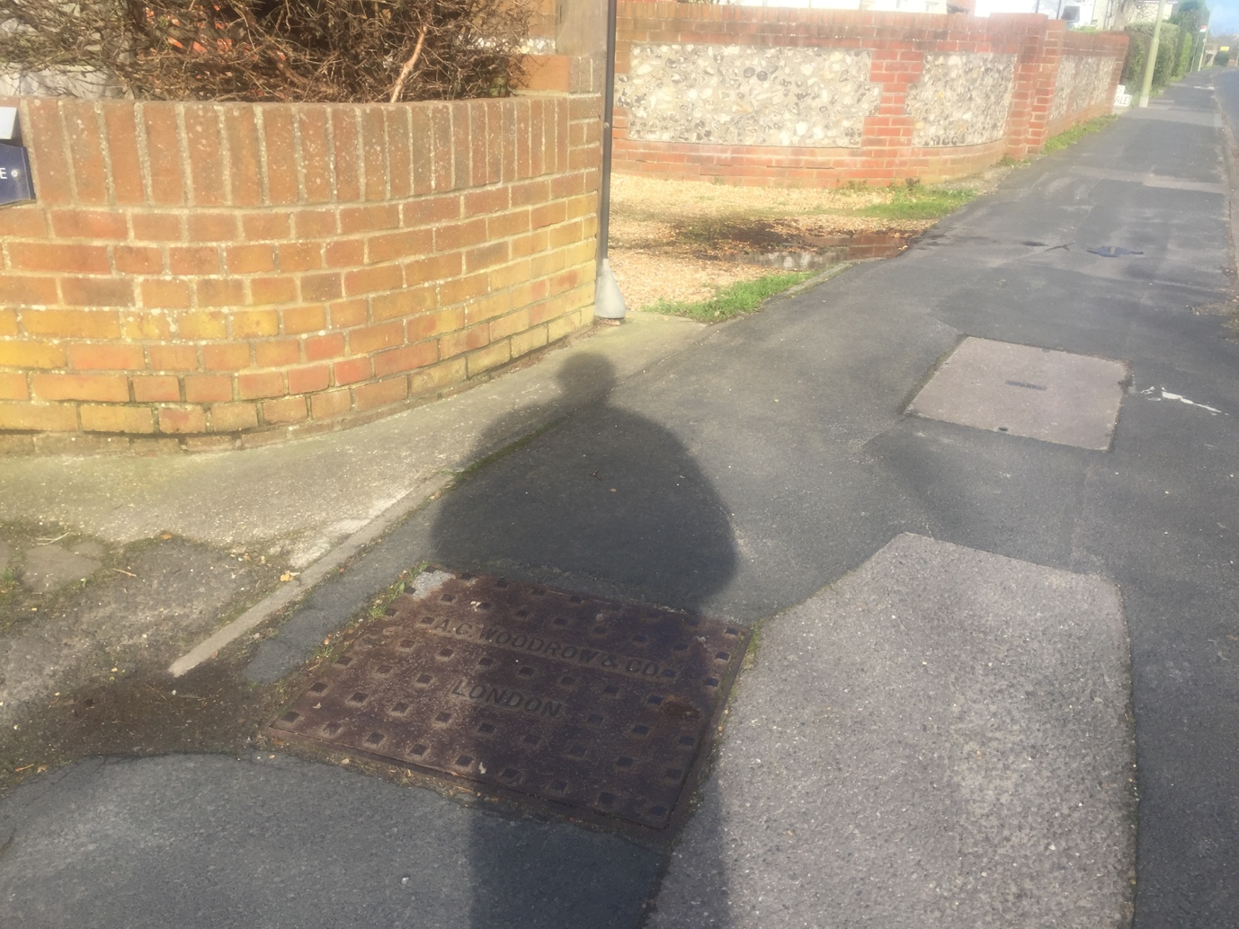

- Condition 5 reads
No development hereby permitted shall commence until a specification of the acoustic fence to be erected to the south of the application site has been submitted to and approved in writing by the Local Planning Authority. The development hereby permitted shall not be brought into use until the implementation of the fence has been completed in full accordance with that specification.
Reason: In the interests of the amenities of the locality and having due regard to policies CS11, CS16, and DM8 of the Havant Borough Local Plan (Core Strategy) 2011 and the National Planning Policy Framework 2012.
Condition 5 sign off proposal for Acoustic fence
It is proposed that the acoustic fence required on part of the south boundary as shown on drawing A101v6.1 will be Concrete posts with 6ft acoustic fence panels on concrete gravel boards. The specification of which will be as per appendix 1 (or see the link below)
https://www.forestgarden.co.uk/product/6ft-1-83m-x-1-8m-decibel-noise-reduction-fence-panel/

- Condition 6 reads
No development work shall commence until a Tree Protection Plan has been submitted to and approved in writing by the Local Planning Authority outlining the position of the mature tree line between Eastview, Shiralee and 3 Atherley Road along the south boundary and the mitigation measures proposed to ensure it's protection prior and during development works. All such approved measures shall be carried out throughout the period of construction activity on the site. This mature screening between Eastview, Shiralee and 3 Atherley Road shall be retained and reinforced where necessary to the existing height position. Any trees or shrubs planted or retained in accordance with this condition which are removed, uprooted, destroyed, die or become severely damaged or become seriously diseased within 5 years of the completion of the development shall be replaced within the next planting season by trees or shrubs of similar size and species to those originally required to be planted.
Reason: To ensure the maintenance of screening to the site and to protect the appearance and character of the area and neighbouring amenity and having due regard to policies CS11.4 and CS16 of the Havant Borough Local Plan (Core Strategy) 2011 and the National Planning Policy Framework 2018.
Condition 6 sign off proposal for Tree Protection Plan

The area bordering the mature screening should be protected by fencing of the type shown below this will be placed in the positions indicated buy the blue lines on drawing A101 V6.11 (appendix 5). Note that these plans are to scale and can be scaled off. The fencing will be permanently fixed to the ground as shown in the plans or fixed to a permanent feature. Weatherproof signs will be attached to the fencing, stating their purpose and that they should not be moved. The protective fencing will delimit a construction exclusion zone and will be considered immovable.
Prior to commencing work on site, all contractors will be given an induction on the protection measures employed during the development project and on the potential consequences of disregarding them (pre-commencement meeting). The fencing comprising the construction exclusion zone will not be moved. All staff on site will understand the need for protective fencing, and to keep strictly within the designated access routes, when moving in/out the site. Protective fencing will be maintained & inspected on a weekly basis by the site manager. Inspections will be recorded on an inspection form.
The following screening protection measures will be adopted throughout the life of the development.
All damage to protective fencing or accidental damage to screening will be reported to the site manager immediately. Works occurring within the incident vicinity will cease immediately until adequate screening protection measures are re-established. A record of the damage will be made by the site manager and, remediation measures carried out.
No materials and/or plant will be stored within 2.5 meters (Root protection area RPA) of the fencing and/or within the delimited construction exclusion areas. Any liquid materials to be stored on site, will be located where, in any event of spillage, will allow for natural run-off to be away from the designated areas and buffer zones and/or stored within a pre- constructed spillage containment area.
The mixing of concrete and mortar will be performed outside any root protection areas, in such an area where in the event of any spills, any liquid will drain away from the root protection areas and any buffer zones and/or within a pre-constructed spillage containment area.
The use and movement of any cranes/heavy lifting arms/digger arms and booms of delivery vehicles will be carried out without damage to any part of the retained screening
No dry construction materials will be stored within the RPAs of the retained screening, unless adequate ground protection has been installed within the storage area.
No soil, demolition debris, or any other arisings will be stored within the RPAs or under canopies of the screening, whichever is the greater.
No ground level changes will occur (no grading/levelling/raising), within any RPAs of the retained screening, unless consented to by the LPA & supervised by an appointed arboriculturist.
The positions of all site welfare & storage areas will also be located outside any canopy areas & RPAs of any retained screening.
No fires will be lit within 20m of any RPAs or canopies of retained screening, whichever is the greater
Screening protection measures will have been installed prior to any commencement of demolition site preparation.
No plant machinery will encroach on the RPA of the retained screening, unless the ground is adequately protected & the machinery is incapable of striking the canopy or screening stems.
The protective fencing in the site will be retained in situ until landscaping operations are to be undertaken. This will provide additional protection for the Root Protection Areas.
Debris from any preparation work will not be stored within any RPAs of retained screening at any time.
Landscaping operations will commence only when all main construction work has ceased. The protective fencing will be removed immediately prior to commencing these. No soil lowering will occur within the RPA. The existing soil levels will not be raised by more than 150mm within RPA of retained screening without seeking advice.
On completion a detailed visual inspection of the retained screening on the site & RPA, will be carried out, to check for signs of development damage to both the screening and its rooting environment. any damaged branches will be removed or pruned cleanly in line with current good l practice (BS3998:2010). Any other remedial work will also be carried out as & when recommended. An annual screening inspection regime will be implemented to monitor the health of the retained & replaced screening for a five year period after the development project is complete.

- Condition 7 Reads
No development shall take place unless and until a new boundary fence has been erected to the front of the Walnut Tree in position along the north boundary of the application site and shall be subsequently retained. No activity prohibited by BS:5837:2012 shall take place within such fencing during the construction period unless otherwise agreed in writing by the Local Planning Authority.
Reason: To secure the conservation and enhancement of existing natural features and having due regard to Policy DM8 of the Havant Borough Local Plan (Core Strategy) 2011 and the National Planning Policy Framework
Condition 7 sign off proposal for the Walnut Tree
No TPO was issued for this tree which is predominantly within the boundary of 1 Manor Road. On the 6th July 2019, the neighbour at 1 Manor Road employed a tree surgeon to cut down the tree and removed it from the boundary. Thus, there is no need for a condition to create a protected area around the tree before construction commences.

- Condition 8 reads
Notwithstanding any description of materials in the application no above ground construction works shall take place until samples and a further specification of the materials to be used externally on the building(s) have been submitted to and approved in writing by the Local Planning Authority. Such details shall include the type, colour and texture of the materials. Only the materials so approved shall be used, in accordance with any terms of such approval.
Reason: To ensure the appearance of the development is satisfactory and having due regard to policies CS11 and CS16 of the Havant Borough Local Plan (Core Strategy) 2011 and the National Planning Policy Framework.
Condition 8 Sign off proposal for External materials
The external walls will be Parexdirect Acrylic Render System – white as shown below
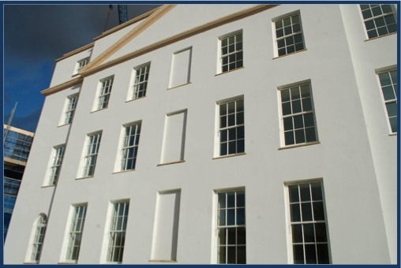

The roof will be Eternit Thrutone fibre cement slates (blue-black) as per the brochure attached in appendix 2
Aluminium door / window frames - RAL colour 7022 as below. Supplier to be idealcombi or velfac.


Aluminium box gutters and matching aluminium soffit / fascia - RAL colour 7022. (as above)

Garage for Eastview – will be bricks to match Eastview , Grey torch-on high performance bitumen felt roof / brown roller shutter door from as per the original east view garage
Garage for new development - externally rendered white as per the main house walls / grey EDPM single ply roof roof / Hormann steel sectional garage door RAL colour 7016 as below.
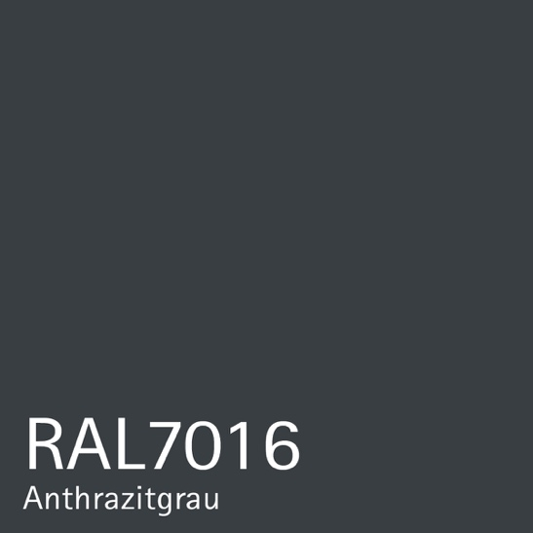

- Condition 9 reads
No part of the development shall be first occupied until details of the type, siting, design and materials to be used in the construction of all means of enclosure including boundaries, screens or retaining walls, have been submitted to and approved in writing by the Local Planning Authority and the approved structures have been erected in accordance with the approved details. The structures shall thereafter be retained.
Reason: To safeguard the amenities of the locality and occupiers of neighbouring property and having due regard to policy CS16 of the Havant Borough Local Plan (Core Strategy) 2011 and the National Planning Policy Framework.
Condition 9 sign off proposal Enclosure / boundary
The only new boundary proposed other than the acoustic fence covered in condition 5 is that surrounding the revised rear garden of Eastview this will be Concrete posts with 6ft close board fence panels on concrete gravel boards. As shown in appendix 3 or follow the link below
https://www.forestgarden.co.uk/product/6ft-x-6ft-1-83m-x-1-83m-closeboard-fence-panel/

- Condition 10 reads
Notwithstanding the details submitted the materials used for the surfacing of all open parts of the site proposed including the driveway between Shiralee and Eastview shall be laid with a bound or concrete material in accordance Drawing No A101 V6.1. The development hereby permitted shall not be brought into use until the implementation of all such hardsurfacing has been completed in full accordance with that specification.
Reason: In the interests of the amenities of the locality and having due regard to policies CS11, CS16, and DM8 of the Havant Borough Local Plan (Core Strategy) 2011 and the National Planning Policy Framework 2018.
Condition 10 sign off proposal Driveway
The driveway will be a bound gravel within the Core Commercial product range. The product ensures there is no loose gravel as the product is only filled level with the plastic sides; this gives a gravel look with thin black plastic edges visible. The strength of the plastic sides takes the weight of vehicles and is rated to include a fire engine. The system ensures vehicles are effectively driving over a level surface. Please refer to appendix 4 or the link below. It is also notable that the HBC environmental health consultation submitted late for this application helped identify that noise from the drive is unlikely to be an issue for this application.
https://www.corelp.co.uk/core-commercial/

Appendix
- Decibel Noise reduction fence pdf (attached)
- Eternit fibre cement slate pdf (attached)
- Close board Fence panel pdf (attached)
- Core commercial Drive binding pdf (attached)
- Site Plan A101 v6.11 (attached)
- Southern water waste water drainage map

