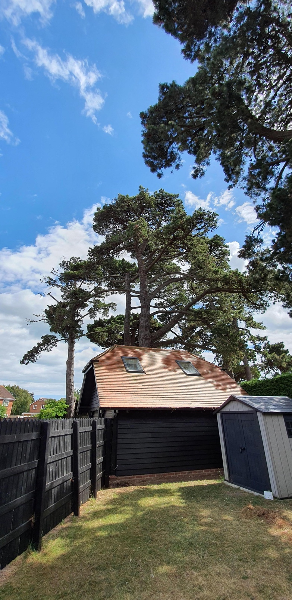

View on Monterey Pine tree (T3 on sketch) showing bowing of branches on both sides due to the weight of pine cones. One side hangs over Goldring Close.
Propose crown reduction to a number of branches on both sides to balance, removing of excess cone weight reducing the risk of branches coming down in Goldring close, and reducing stress on the tree due to excess weight.
Crown height is approximately 30 meters, and crown spread approximately 15 meters.
No change to crown height, reduction of crown spread by 1 metre on some branches to balance, leaving crown height of 30 metres and crown spread of 14 metres.

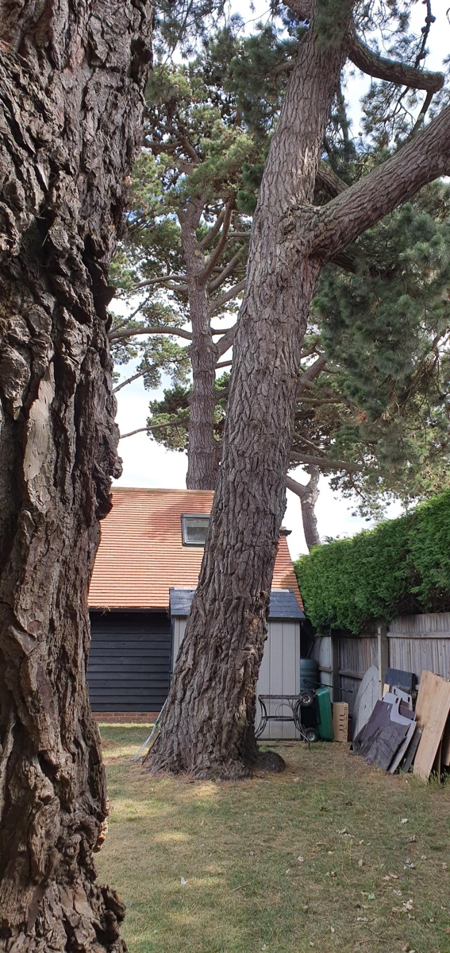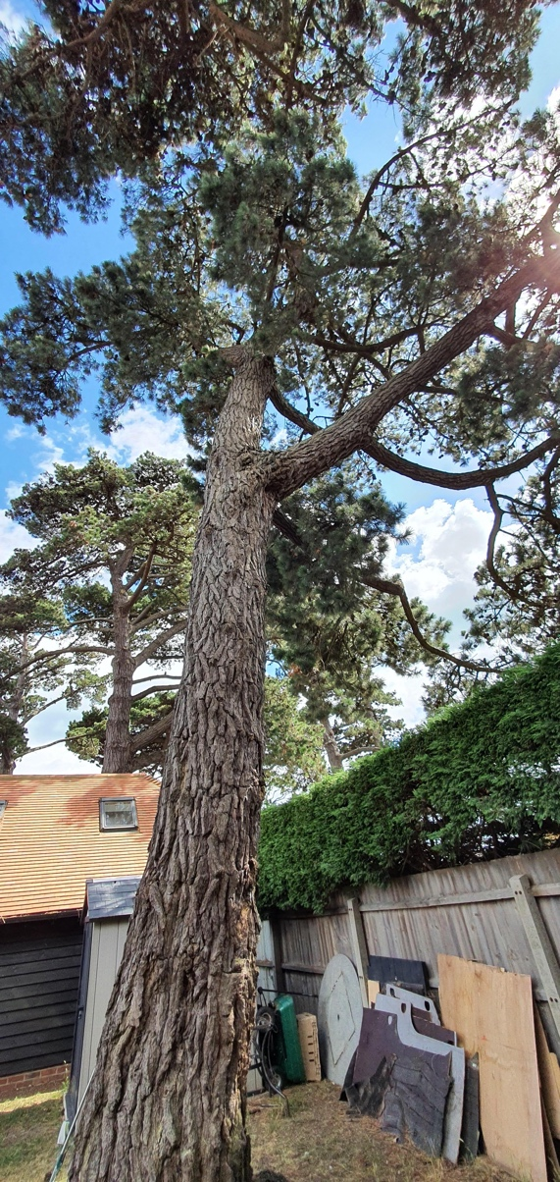

View of Monterey Pine tree (T4 on sketch) showing the lean angle, and bowing from pine cone weight.
All branches on this tree are on the side of the lean hanging over Goldring Close.
Propose crown reduction to a number of branches, removing excessive cone weight, reducing the risk of branches coming down in Goldring close, and reducing stress on the tree due to excess weight.
Crown height is approximately 30 meters, and crown spread (although all branches are on one side, as previously stated) approximately 10 meters.
No change to crown height, reduction of crown spread by 1 metre on some branches, leaving crown height of 30 metres and crown spread of 9 metres.

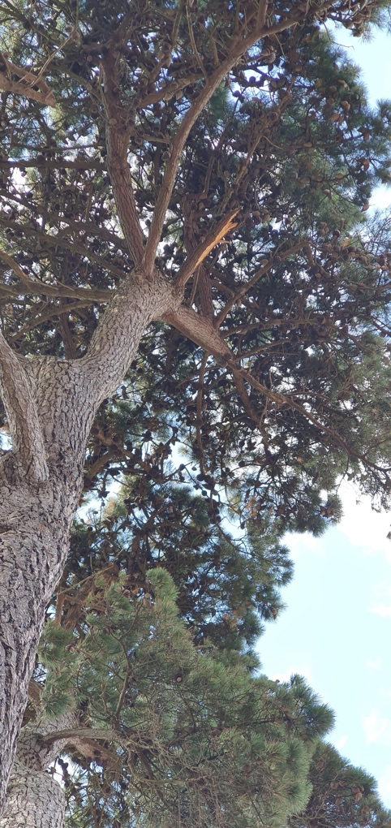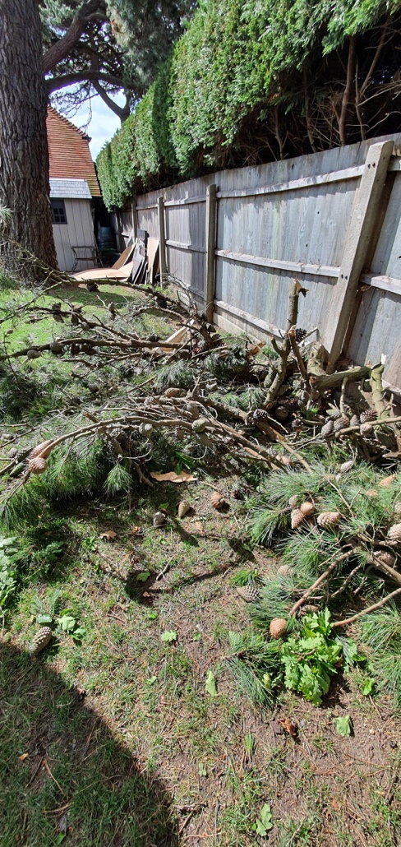

View of Monterey Pine tree (5 on sketch) showing the remains on a large branch that came down in the wind. You can see from what remains that this healthy branch was ripped (on 11/05/2020) from the tree due to the excess cone weight.
Email to inform of this branch fall was sent on 14/05/2020, and a copy is attached to application.
This was the second branch that had come down for this reason, the first had not completely come down, and was professionally removed on the 20/03/2020 (picture below)

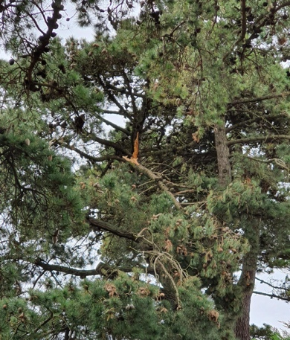
Email chain from 20/03/2020 to 23/03/2020 is attached to application.

Propose crown reduction (T5 in sketch) to a number of branches to tidy where the branch was torn away, and removal of excessive cone weight, reducing the risk of further branches coming down, potentially in Goldring close, and reducing stress on the tree due to excess weight.
Crown height is approximately 30 meters, and crown spread approximately 15 meters.
No change to crown height, reduction of crown spread by 1.5 metres on some branches, leaving crown height of 30 metres and crown spread of 13.5 metres.

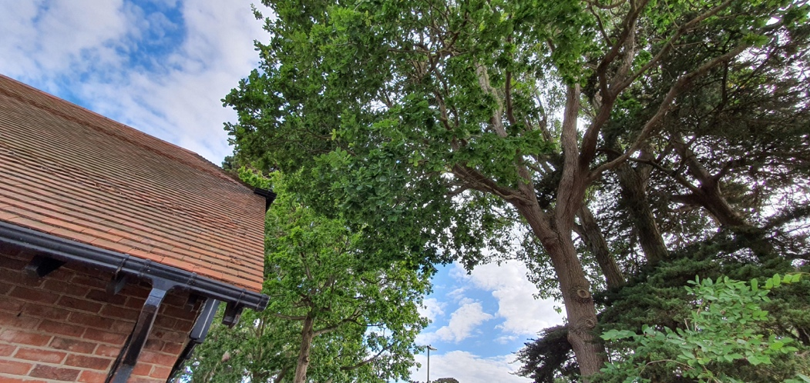

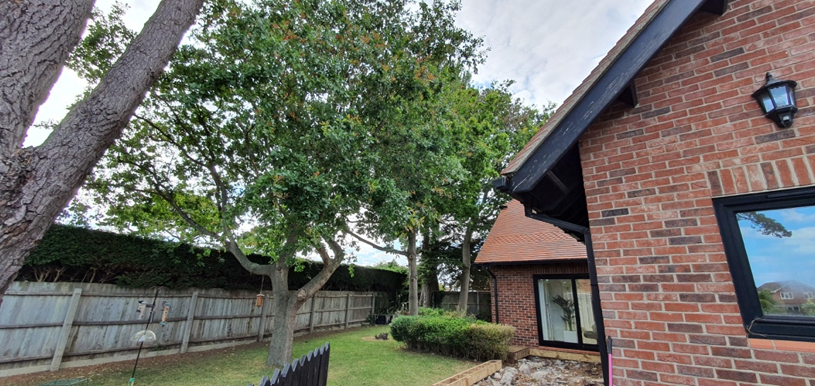

View of three Oak trees (T7, 8, 9 on sketch) showing the density of foliage intertwining between them.
Crown height approximately 12 meters, and crown spread approximately 10 meters on each of the 3 trees.
Propose crown thinning to each of the three oak trees by between 15% and 20% to increase light to lower branches and give space between for overlapping branches between the crowns.

