Condition 6 Sign off for 1A Haven Road Hayling Island ref APP/19/00067

‘No development shall take place until finished floor levels for the proposed
building(s) relative to agreed off-site datum point(s) have been submitted to and
approved in writing by the Local Planning Authority. The development shall be
undertaken in accordance with the approved details.’

The datum point chosen is the Southern Water manhole cover number 9401 (labelled 1) at the junction of Haven Road and Creek Road and within visible view of the site (see Photo below)

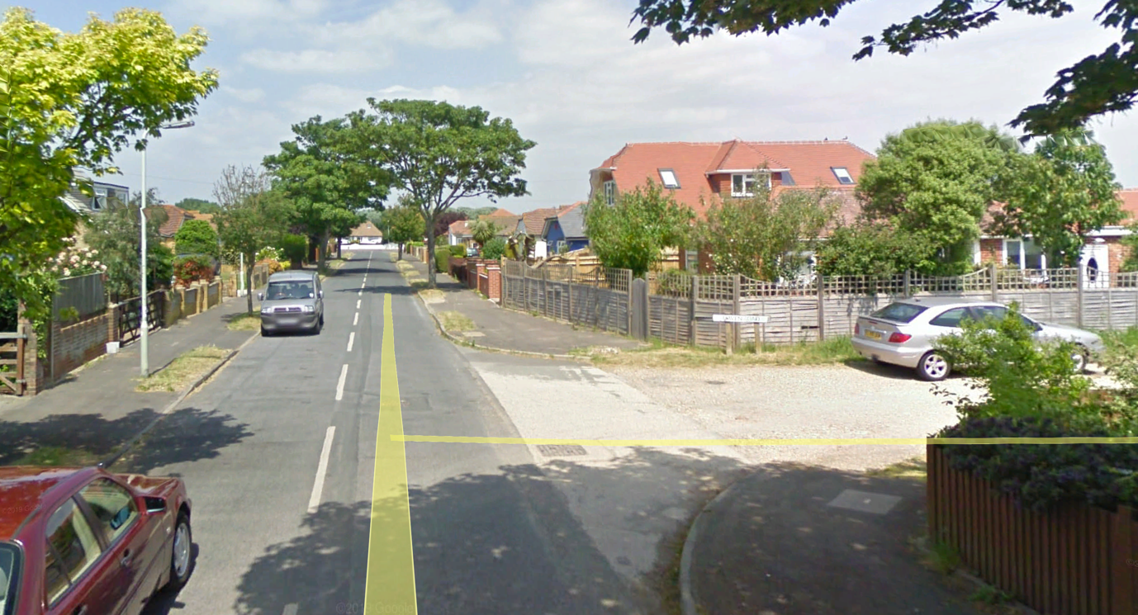

In addition a second datum has been taken form the second cover close by (labelled 2) to provide a second check
The ground level of the existing and finished development is 175mm above manhole 1 and 150mm above manhole 2.
Thus the DPC and finished floor level will be 150mm above these levels
Thus finished floor level will 325mm above manhole 1 and 300mm above manhole 2

