Condition 9 Sign off for 1A Haven Road Hayling Island ref APP/19/00067

‘No development hereby permitted shall commence until a specification of the
materials to be used for the surfacing of all open parts of the site proposed to be
hardsurfaced has been submitted to and approved in writing by the Local Planning
Authority. The development hereby permitted shall not be brought into use until the
implementation of all such hardsurfacing has been completed in full accordance with
that specification.’

The driveway and paths will be laid in Formpave permeable paving blocks as below

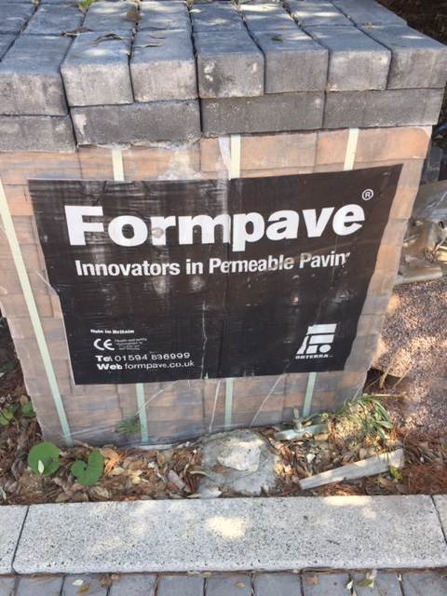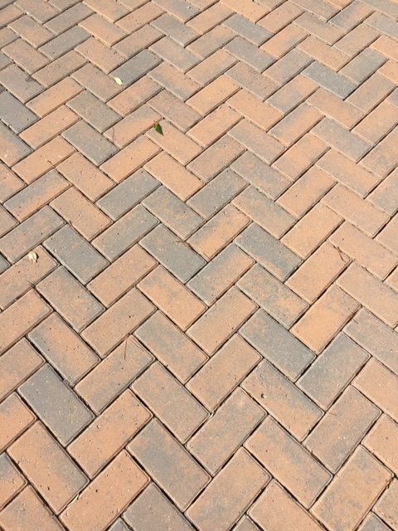

All additional area will be laid to lawn
These blocks have been used and approved in other developments in the area.

