Material samples submitted to HBC in support of the discharge of condition APP/19/00074 23 Langstone High Street, Havant

Kitchen/Family room roof- Cwt-y-Bugail dark blue/grey natural Welsh slate:
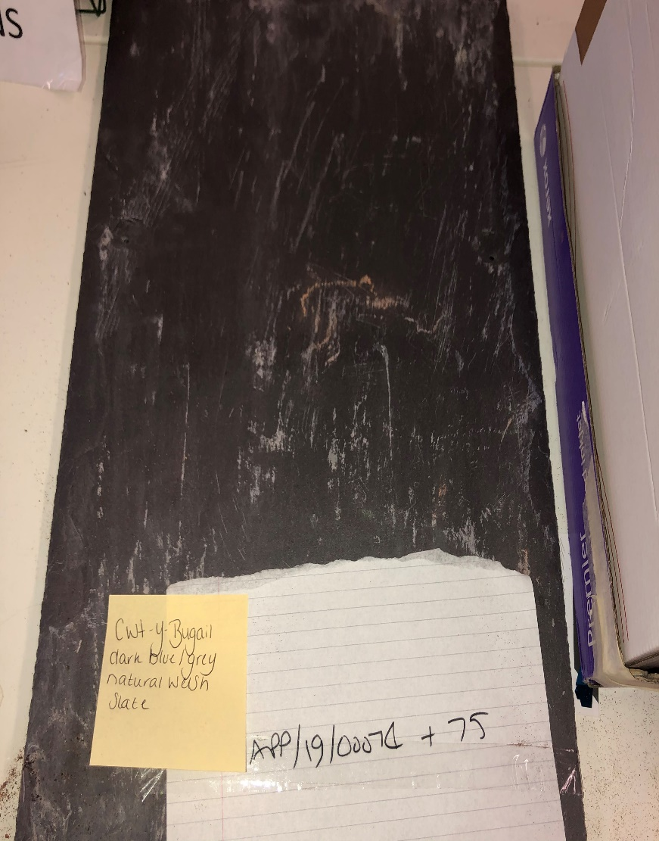
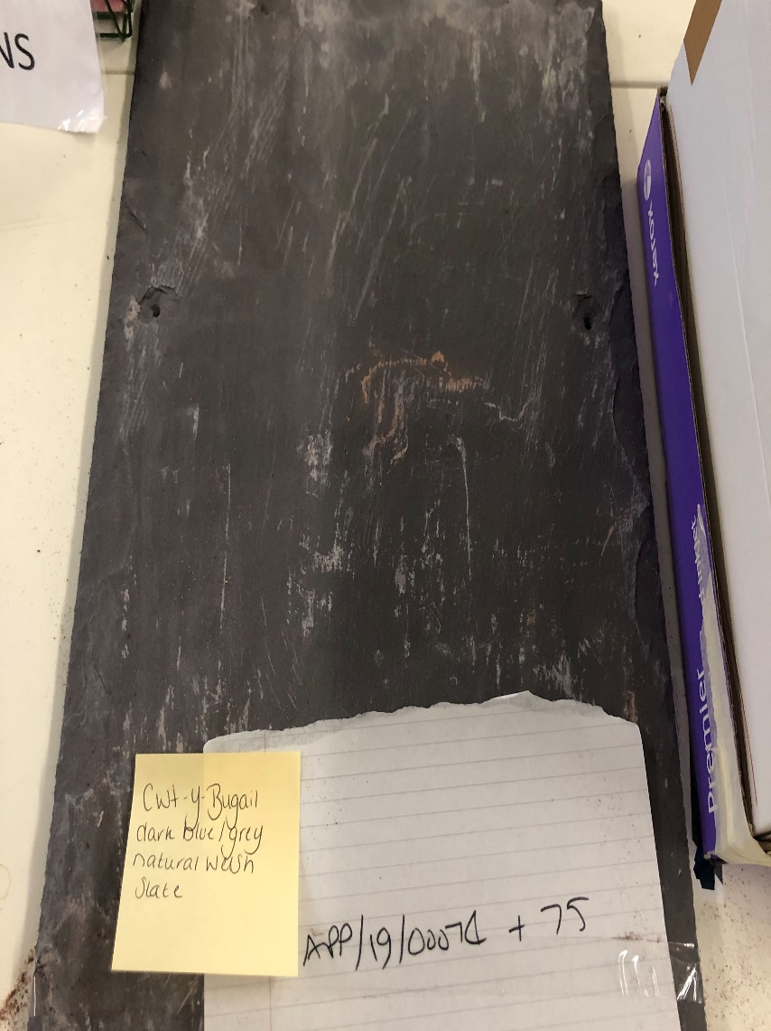

Bedroom 1 and 4 roofs- second hand clay peg tiles
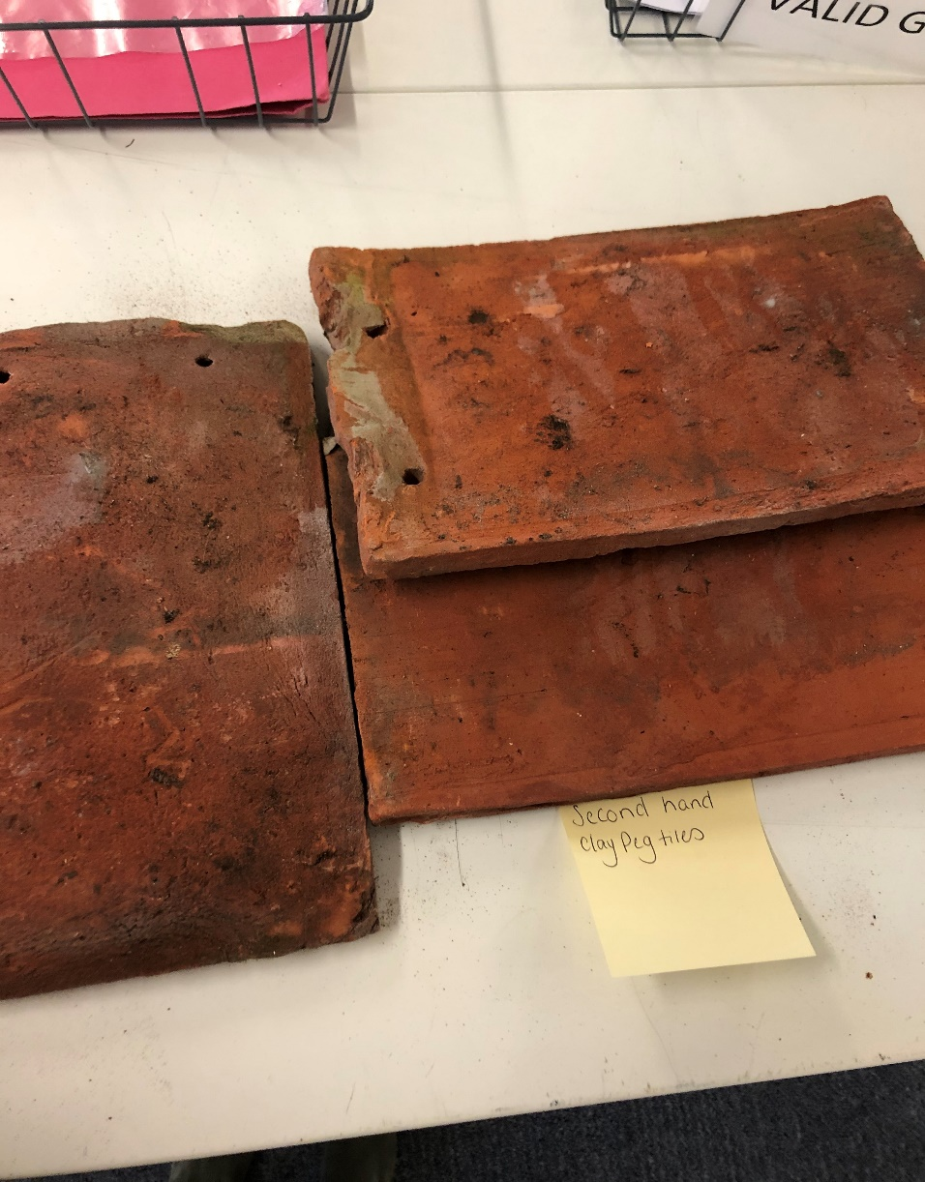
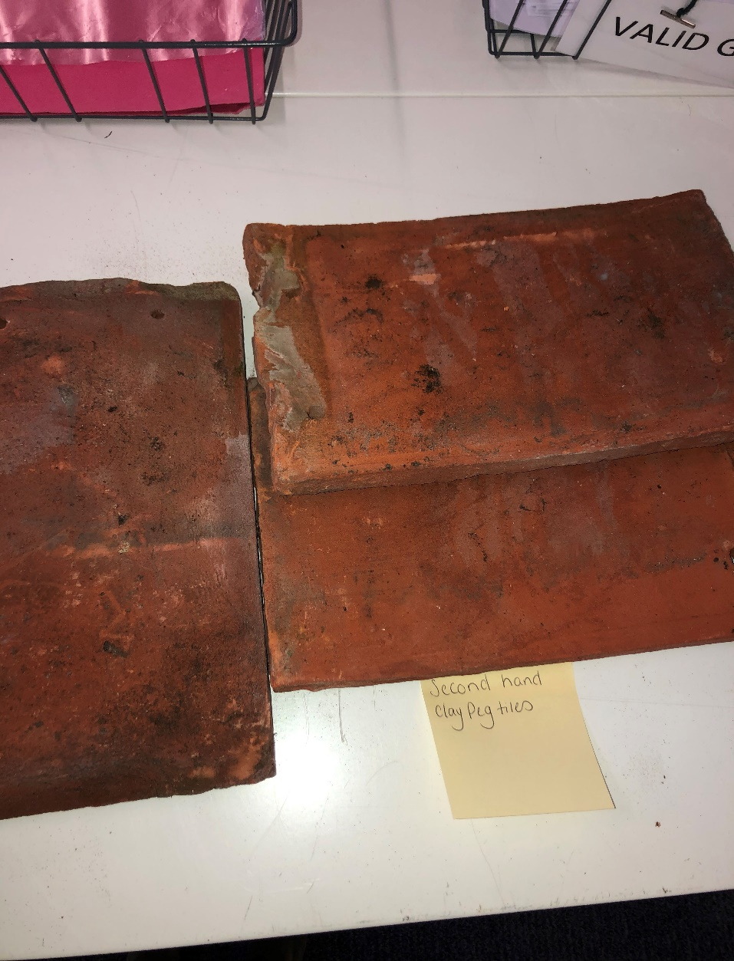

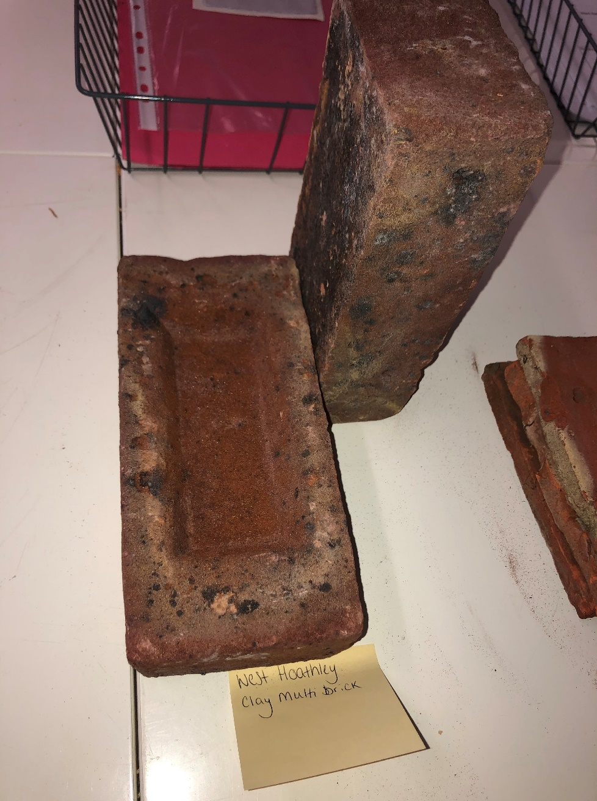
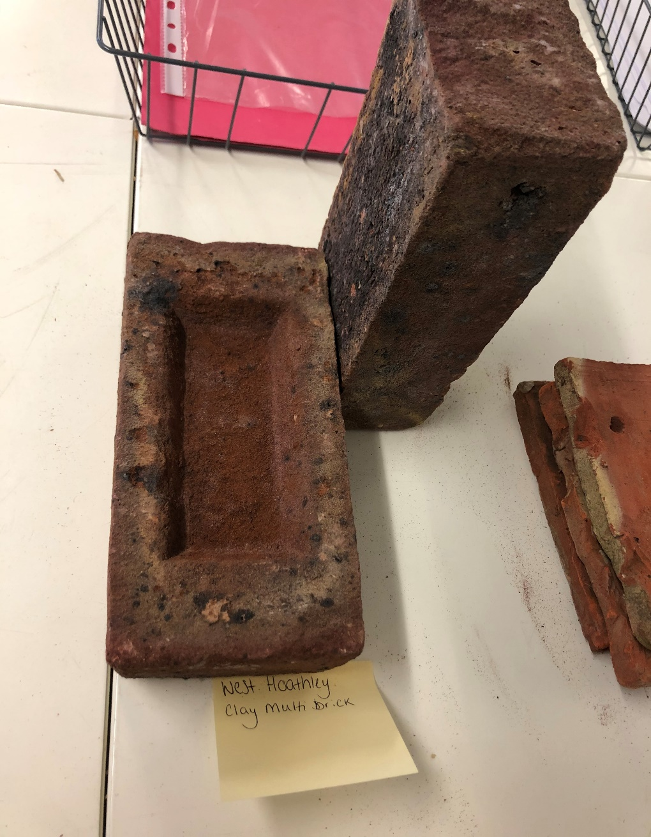
West Hoathly clay multi stock brick

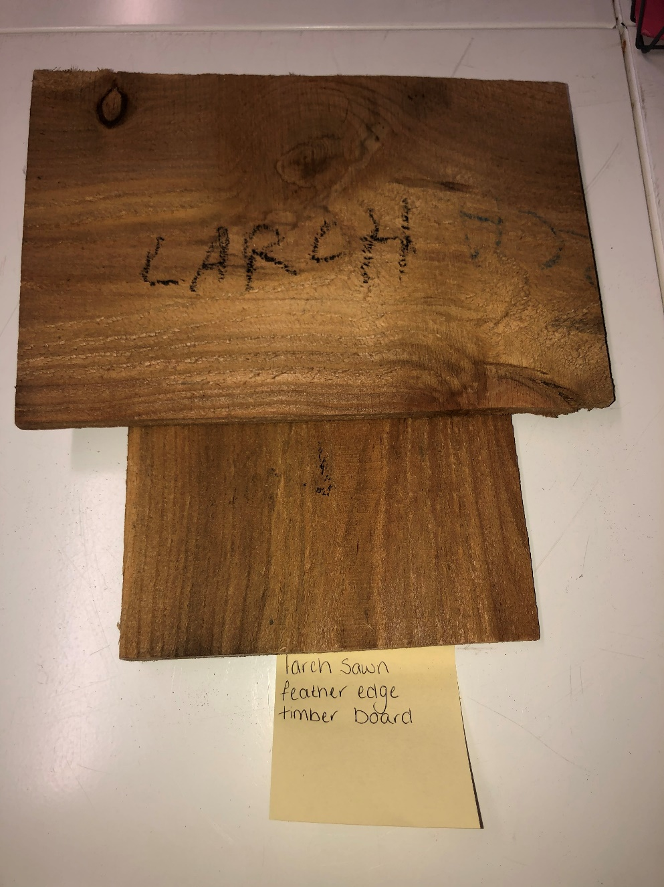
Larch sawn feather edge timber board
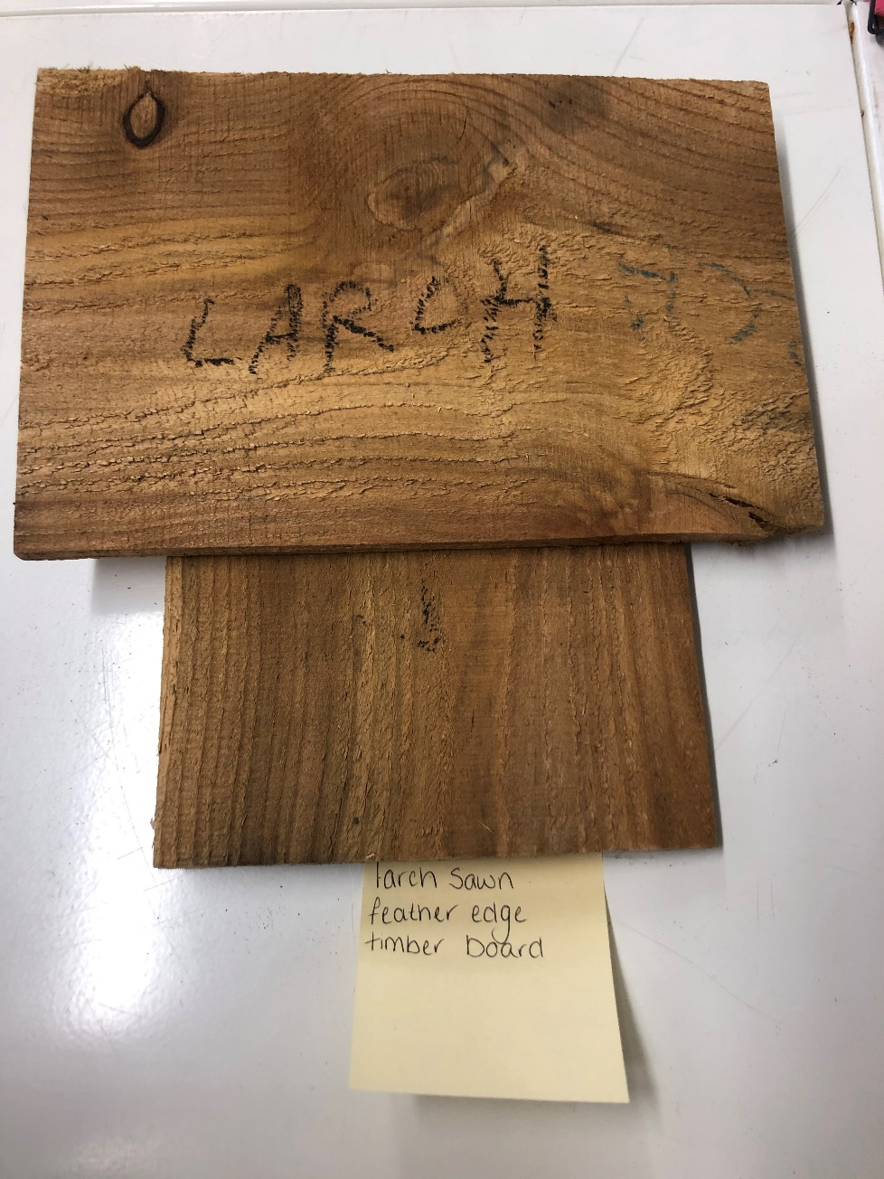

Old Essex hand moulded red multi brick
