Condition 8 Sign off for 1A Haven Road Hayling Island ref APP/19/00067

‘Notwithstanding any description of materials in the application no above ground
construction works shall take place until samples and a further specification of the
materials to be used externally on the building(s) have been submitted to and
approved in writing by the Local Planning Authority. Such details shall include the
type, colour and texture of the materials. Only the materials so approved shall be
used, in accordance with any terms of such approval.’

The materials chosen for the construction are as below, they have been chosen to reflect the materials used in other building in Haven road to ensure the property matches well

Bricks
We propose to use Forterra Atherstone Red and example of which is shown below together with a recent extension build on Hayling Island using these brick
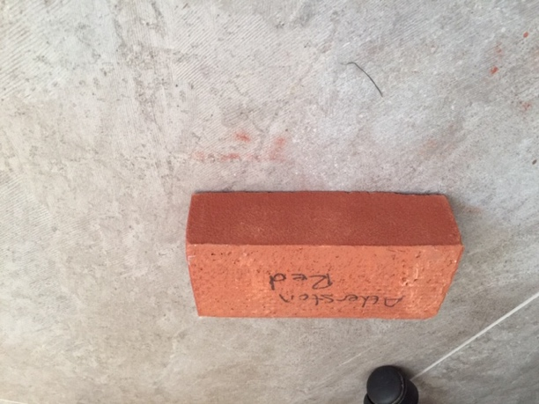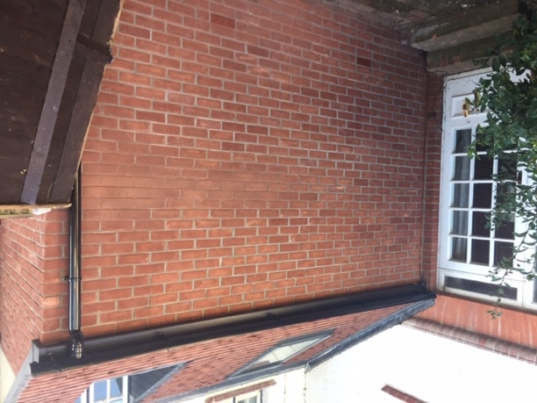

Roof Tiles
We propose to use Marley double roman antique brown as per the image below
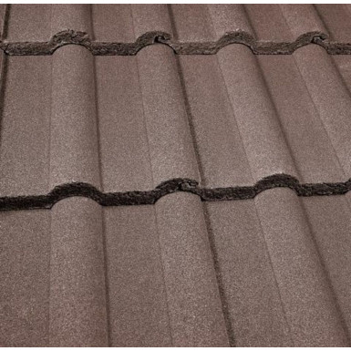

Windows
We proposed to use white UPVC windows as below
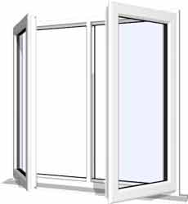

The front door, facias and guttering will be white upvc to match

