Condition 5 Sign off for 1A Haven Road Hayling Island ref APP/19/00067

‘No part of the development shall be first occupied until details of the type, siting,
design and materials to be used in the construction of all means of enclosure
including boundaries, screens or retaining walls, have been submitted to and
approved in writing by the Local Planning Authority and the approved structures
have been erected in accordance with the approved details. The structures shall
thereafter be retained.’

The existing site has 1.8m timber panel fencing to both side boundaries and the rear boundary
(see image below) These will be retained as existing.
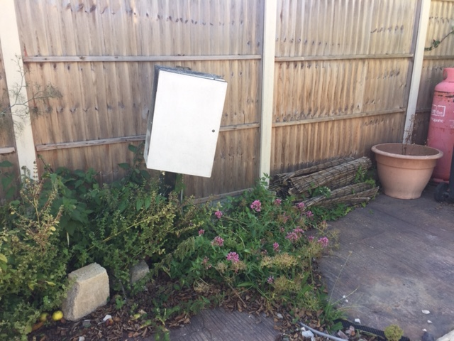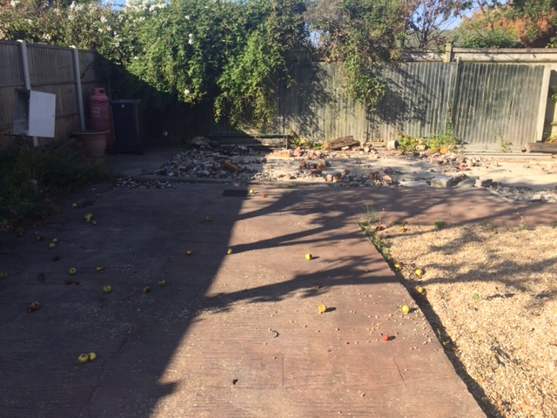

The front boundary has a metal security fence, (see Image below) this will be retained throughout construction to ensure the site is secure. On completion and during landscaping, it will be removed and replaced with the drive entrance and laurel hedging to the front boundary and as a screen between the front and rear gardens as per drawing A102 (attached)

