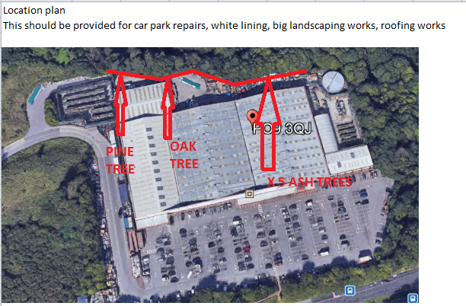

• To access a cherry picker to access high encroaching vegetation.
• To cut back any intruding vegetation.
. To cut back x 5 ash trees by 2m
. To remove encroaching x 4 branchs from the Pine tree situated by the rear gate.
. To remove over hanging dead wood from x 1 mature OakTree
• All waste generated will be chipped and removed from site.
• Works will be carried out by certified operatives.
See Below Photographs of effected areas.

