FAO: Havant Borough Council Planning Services Department
Ref: APP/18/01309

Please see below our comments on the above planning application.

As the extension is already nearly built, we fully appreciate the impact and implications of the building which the applicant has said is at its final height and shape.
We accept the development has taken place but based on the above and the submitted application, we wish to object to the height and design of the structure for the following reasons.
The designs as submitted, and explained to us by the applicant, do not seem to be achievable given that we have been told the constraints of the design are floor height, ceiling height and roof depth regulations and so do not seem to represent the final appearance of the development as built.
As illustrated below and considering the above constraints, the submitted plan shows the existing bungalow roof being bigger and the new flat roof smaller than reality therefore misrepresenting its final appearance.
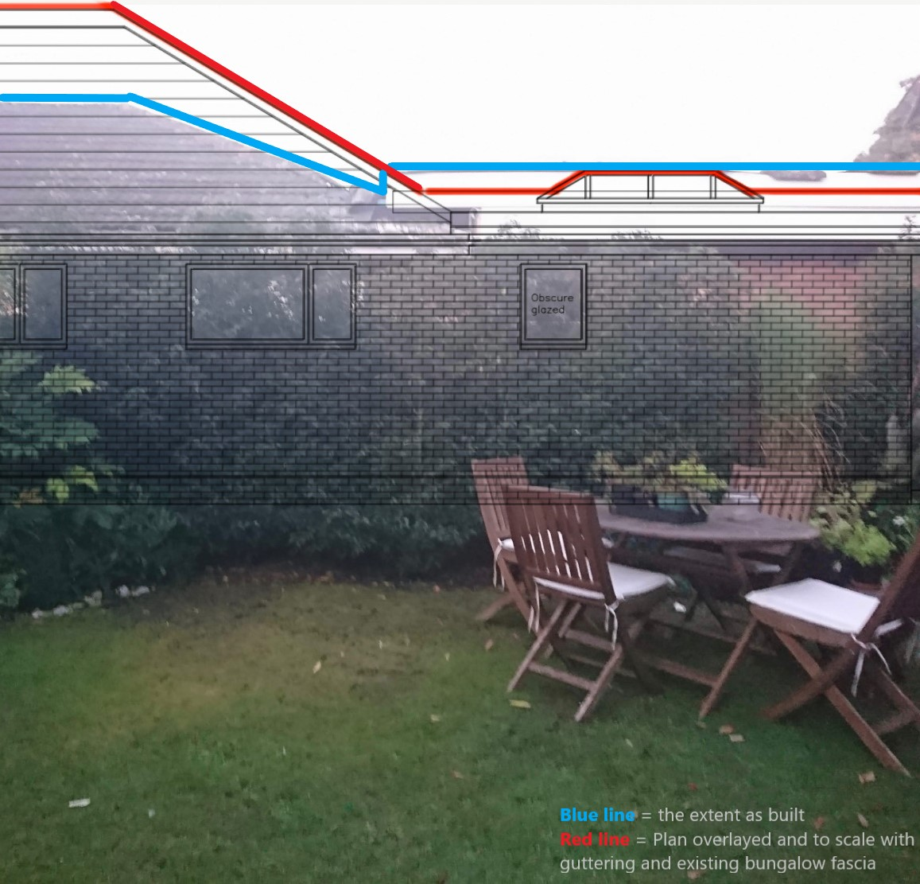
The overall height of the extension is greater than is shown on the application and what was previously permitted. We were led to believe from all involved parties that this extension roof would match the existing bungalow eaves height and scale. This affects us particularly because the extension roof now dominates our living room and garden, blocking a considerable amount of sky and daylight in a south-facing garden. Its scale overbears our living room and small garden more than it would a larger garden and this effect is greater as our bungalow is only approximately 7 metres from the new extension and it squarely faces the only window we have in our only living space.
The rear and side elevations show differing wall heights and a shallower roof pitch with fewer fascia boards than would actually be needed to bring the eaves in line with the existing roof while maintaining the current height of the extension. The aerial roof plan shows the extension joining the eaves under the lowest tiles whereas the side elevation plan shows a fully flat roof abutting the existing bungalow roof.
Visually the new roof is not subservient or sympathetic to the location and surroundings in appearance and scale, it being wider and taller where it joins the existing shallow pitched roof. The plastic fascia boards are much deeper than anything used on the existing bungalow or any other buildings in eyesight that they appear much closer to us and so are out of context. The small size of our garden and height of the roof would make screening very difficult.
This original shallow roof angle does not lend itself to being joined to a tall overhanging square-box roof putting it out of context with the neighbourhood of shallow pitched roofs of gentle appearance.
The height of the brickwork of the new extension was greater than the original bungalow wall, raising the height of the soffits by two courses of bricks. Today we notice the applicant has removed some bricks and fascia so currently work is still in progress and we cannot tell what the finished roof's appearance will be.

Thank you for giving us the opportunity to comment.

Regards,

