DHP Comments 20/09/2018
Comments on the specification of works, please note this is not an exhaustive list.
- As a general rule of thumb any works that remove fabric from a listed building or introduce new material into a listed building would require Listed Building Consent (LBC). Having looked through the specification of works there are a number of work items that would require LBC as well as a number of proposals that are cause for concern. These items of work would all require Listed Building Consent, however they can be divided into two categories: those that are likely to receive support for listed building consent and those that are unlikely to receive Listed Building Consent.
  - Noted

- There are also some general rules that we would apply to and major works; amongst which are that repair should be sought in the first instance where ever possible and that this repair should be of a like for like nature i.e. using the same materials and finishes. Like for like repairs would not normally be subject to Listed Building Consent as they are classed as a repair however repairs not using like for like materials would require listed building consent as will replacements.
  - Noted.

- Some of those works unlikely to be supported as an LBC application are due to in-appropriate materials rather than the works themselves.
  - Noted.

Works that unlikely to be given Listed Building Consent are:
Roof:
- The loss of any traditional roofing and roofing features in lead would not be supported.
  - Noted, Ubiflex lead replacement flashings were specified due to client cost constraints. If the existing lead flashings can be retained we will do so. I will need to liaise with my client, but envisage going forward if this is a stumbling block any replacement can be carried out on a like for like basis in lead (therefore becoming a repair as opposed to a replacement).

- The use of a Bauder roofing system has not been justified and its use on both the single storey and main roof is questionable.
  - Please refer to the below images of the single storey flat roof taken in May 2017. As the images demonstrate there is significant blistering, slumping and splitting of the existing bituminous felt roof. If the roof hasn’t already failed, it is highly likely it will fail in the immediate future and therefore to safeguard the building fabric have specified a replacement roof covering. The Bauder built up felt roofing system was selected due to its robust nature, similarity with the existing system and guarantee offered on the product. As we are proposing to replace in excess of 25% of this roof area, we/ Bauder have specified for the roof to be thermally upgraded to comply with the requirements under Part L of the Building Regulations. Furthermore, I attach an email you sent to my client suggesting that the replacement felt roof would be accepted as a repair.
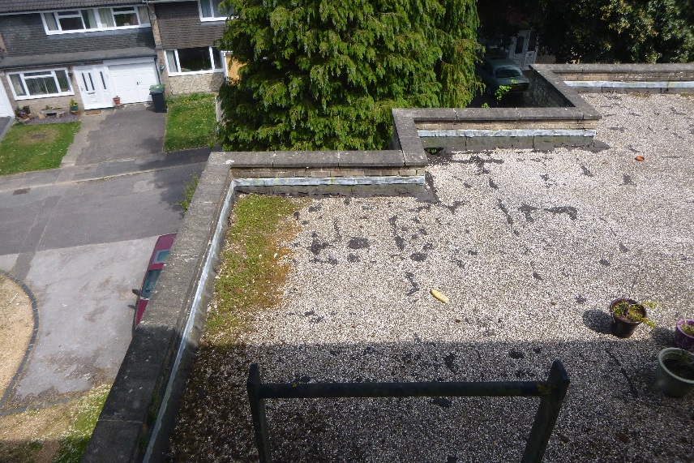
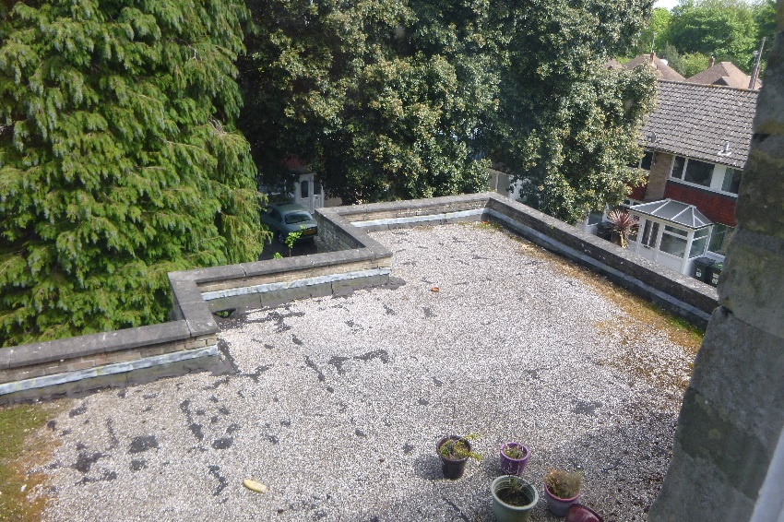


Image 1 – Single Storey Flat Roof Image 2 – Single Storey Flat Roof
  - With regard to the main roof, as no safe access can be provided before a scaffold is erected, for the purposes of the specification we have had to make assumption on a ‘worst case scenario’ to ensure the correct funds are allocated to these portions of work. Our assumptions are somewhat based on the current condition of the single storey flat roof and the appearance of the roof from internet satellite tools (please refer to image 3). Much like the single storey flat roof we have selected the Bauder built up felt system because of its robust nature, similarity with the existing system and guarantee offered on the product. I am of the understanding that there is a butterfly roof beneath the flat roof overlay shown in the below image. I am unsure on the history of why the flat roof overlay was installed, but strongly believe it was due there being issues with the butterfly roof and it was a more economically viable option. Given the commercial reality of these works, the landlord simply cannot fund the reinstatement of the butterfly roof, so as a next best option we have specified re-covering the flat roof overlay on a ‘like for like’ basis as existing. This has been specified on a worst case scenario and once safe access can be erected we will carry out a full survey of the roof overlay to determine if any works are required. The replacement of the roof covering is a last resort.

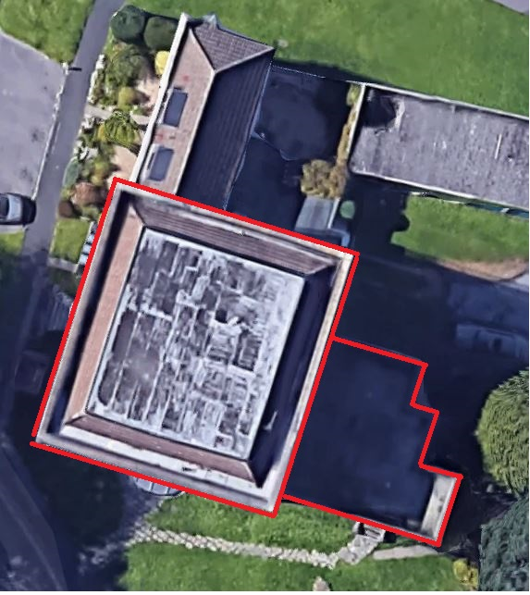
  - With regard to the gutter area of the main roof again this has also been specified on a worst case scenario and largely based on presumptions and the below image. Again here it has been assumed that the gutter is lined with a built up felt system which could be in a similar condition to the single storey flat roof. Subsequently the same specification has been utilised. It is very difficult to tell from the below image if the roof is a felt system that has been over coated with a liquid plastic waterproofing or if the gutter is lined with lead. If the gutter has been lined with lead then the specification will need to be reviewed accordingly – though in this instance there will only likely be repairs required. But again for cost purposes to ensure sufficient funds were allocated to this portion of works a replacement specification was drafted.

Image 3 – Satellite Image Roof Plan

- Removal of all lead detailing to both the flat roof and the main roof including gutters and removal of lead flashing replace with Uiflex (3/37, 3/41, 3/43)
  - As suggested if there is any lead detailing to the main flat roof this will be retained where possible. If replacement is required this will be carried out in lead as opposed to the specified Ubiflex.

- Removal of lead flashing replace with Uiflex garage new roof covering (3/47)
  - I don’t remember seeing any lead flashings to the garage block, please refer to the below image. Equally we didn’t feel the roof and detailing to the garage block had any historic value therefore specified the Ubiflex flashings? Are the garages subject to the listing because they fall within the curtilage of the main building? There is no specific reference within the Listing itself - https://historicengland.org.uk/listing/the-list/list-entry/1154983

  - If, when the debris/ vegetation is cleared to the rear of the box gutter a lead lining is identified can we review accordingly with the Conservation Dept at the time?

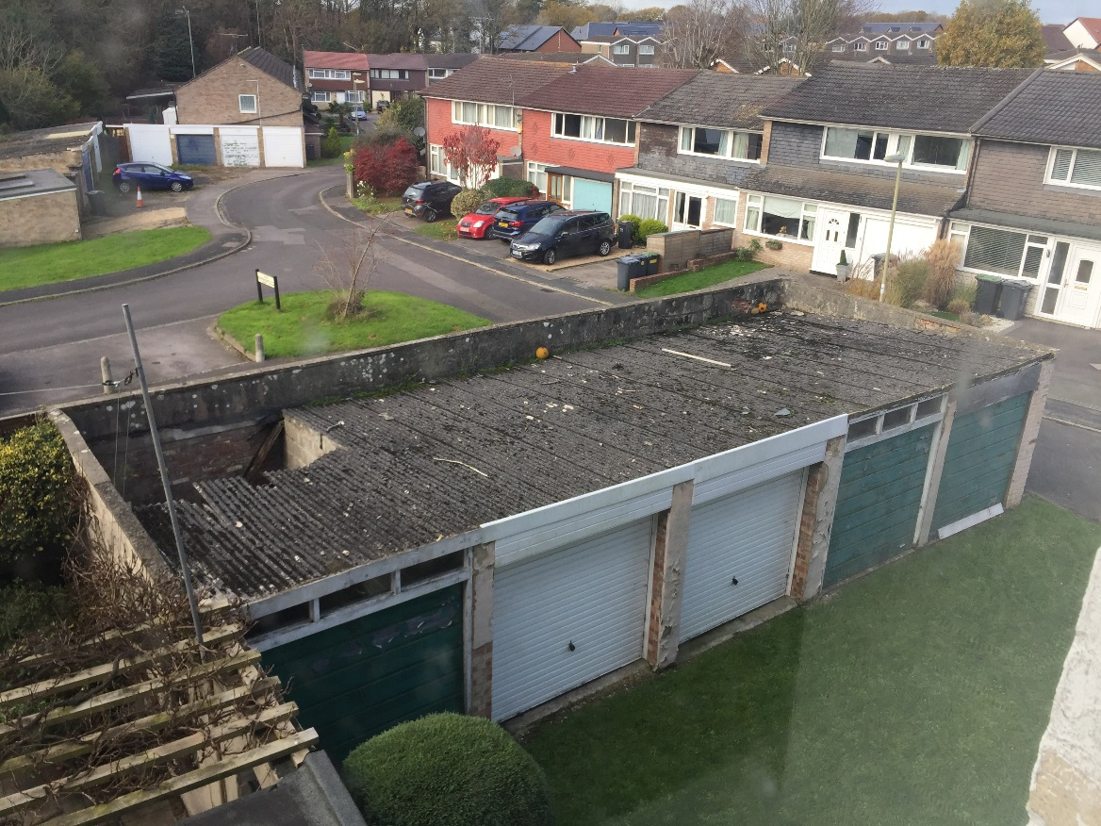

Image 4 – Asbestos Cement Sheet Garage Roofs

- Removal and replacement of box gutters main roof loss of traditional fabric (3/35) (3/48
  - Please refer to item 5c.

- Replacement of the main roof with Bauder system
  - Please refer to 5b.

- Use of UPVc guttering south west corner (3/40) (3/48). UPVc wholly unsuitable, any existing cast iron should be repaired and replacements should be cast iron. At lower level we may accept a good quality aluminium casting. UPVC gutters are considered wholly inappropriate on a grade II listed building and the use of cast iron would be sought. No justification for the change to an inferior product that is out of keeping with the property has been given to support such a request.
  - Noted and agree with your comments in principle. However we are only replacing the asbestos cement downpipe on the North West corner of the property to match the already existing uPVC hopper and downpipe on the South West corner of the property. Please refer to image 5 below. You will note from the image that the hopper and downpipe to the South West corner (far corner of image) is uPVC and the base of the asbestos cement downpipe on the North East corner of the property is also uPVC. The main reason we specified a replacement here was due to friable nature of the asbestos cement downpipes and the rationale behind uPVC was to match all adjacent rainwater goods. If this is unacceptable I can discuss an alteration of specification for cast iron with my client, but due to budgetary implications this item may have to be omitted all together.
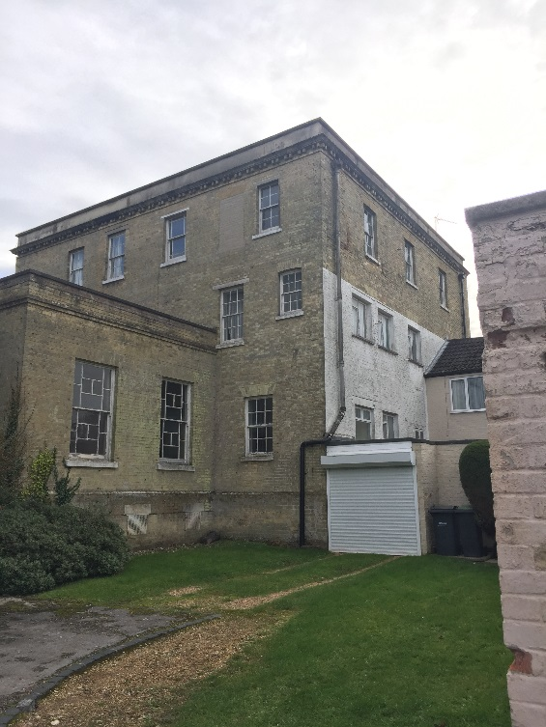
Image 5 – Downpipes
Walls:
- Use of cement in render repairs including; to parapets, East porch – Columns render repair; east elevation repairs to quoins; window sill; window reveal; garage render repairs and quoins. Consent is unlikely given the use of cement a non-traditional material that will be harder than the existing render and the issues of spalling arises with time.
  - Noted and agreed. Item 3/8a of the specification states ‘Include to provide access ahead of scaffold erection to carefully remove a provisional 5nr samples of the pointing and render in locations to be agreed with the CA (at ground floor and high level). The contractor is to send these samples to an SPAB approved test facility for analysis. The following repointing and rendering specifications have been made based on assumptions given the age of the property. The test results will determine the exact mix specification for any remedial pointing/ rendering works.’ As this item suggests we will be testing both the render and pointing prior to agreeing the final mixes – the mixes will be agreed on a ‘like for like’ basis.

- The use of cement in render mix or for repointing work will not be permitted as it is not an appropriate material for use on a historic building and will cause damage in the long term. Use of stainless steel mesh should be a last resort as it can cause metal jacking later down the line and more substantial damage to the render. Appropriate use of fibre in a lime render mix will allow for flexibility and strength.
  - As per item 11a above.

Windows and door features:
- Flat 4 entrance door to be replaced – repair should be considered in the first instance 3/18
  - Noted. Again the specification is based on a ‘worst case scenario’ for cost purposes. At the time of our last inspection the door was in a very poor state, though if repairing the door is achievable we will certainly investigate this route first. However we simply will not know until works commence.

- Aluminium letter boxes (3/50)
  - This relates to the replacement internal flat doors. Please refer to images 6 & 7 below. As I am sure you will agree these doors are not original to the property (I presume these were installed when the property was converted) and therefore would suggest they have minimal historic value. We specified aluminium letter boxes for the replacement doors to match the ironmongery fitted to flat door 6. Furthermore the rationale behind the upgrade of the doors is for fire performance purposes. The existing flat doors are not fire certified.
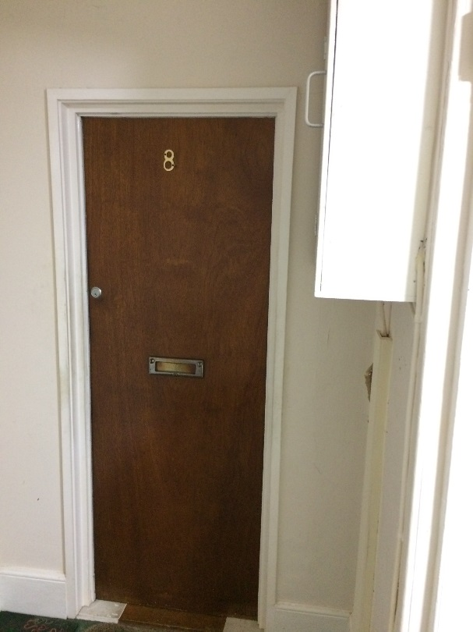
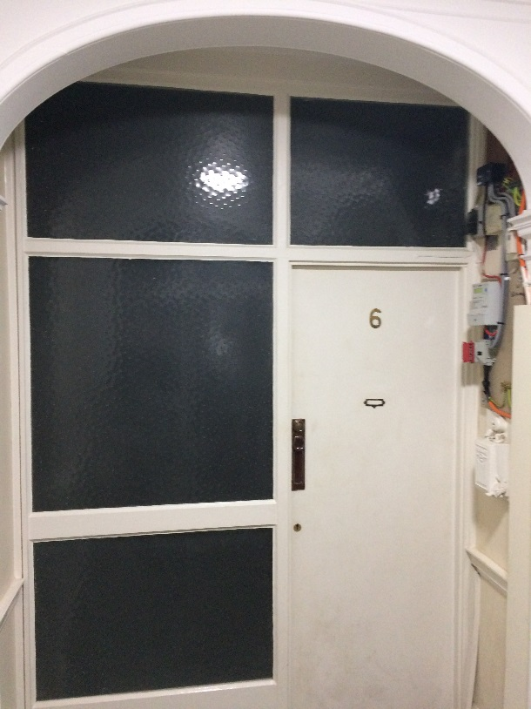

Image 6 – Existing Flat 6 Entrance Door Image 7 – Existing Flat 6 Entrance Door

- It should be noted that test is to ‘preserve and enhance’ the building therefore the replacement of historic doors and windows should be considered a last option and it should understood that repair should always be considered in the first instance. Evidence that repairs are not feasible will be required to justify any Listed Building Consent application for replacement windows and doors. The loss of historic glass will not be permitted from the windows which ever option is allowed.
  - Noted, thank you for the clarification.

- It is noted that safety glass has been mentioned a number of times in the specification bearing in mind the above the desire to retain historic glass I would suggest consideration of whether additional glazing alongside the historic could achieve the requirements that have led to the specification for safety glass. Secondary glazing, so long as it is reversible does not require Listed Building Consent.
  - Noted. Safety glazing has only be specified where glazing to external windows is missing, damaged or the window themselves are in such a poor condition there is no alternative but to replace them. The replacement glass is to be of the same thickness and appearance as the existing albeit with a safety rating to prevent injury if broken.

- Replacement of Flat 4 door east elevation, repair should be considered in the first instance as this will preserve historic fabric including the glass.
  - As per item 13a.

- Removal of a Georgian Wire work window (3/50) internally and replacement with an un specified design Pilkington Pyroudur window would not be acceptable as it would constitute the loss of an original feature. I feel that there must be a better solution than loosing this fabric of the building and would ask that consideration is given to finding a better solution.
  - Noted. I will discuss this with my client. We were instructed to specify a replacement for fire performance purposes. As we previously discussed over the telephone there may be a protective film that is both reversible and offers an enhanced fire rating.

- The replacement of doors with fire doors whilst accepted as requirement further details would be sought on the suitability of the style of doors and door furniture. Aluminium letter boxes would not necessarily be considered appropriate and whether possible any original doors should be retained or re-used within the building.
  - Noted. The specified doors are 44mm FD30 timber flush faced paint grade doors (paint colour TBC). Where possible all locks and general ironmongery will be retained from the existing doors, but replacement hinges, closers (perko style) and letter boxes will be required to achieve a 30 minute fire rating.
The following external items will require Listed Building Consent:
- Any major repointing would require LBC as this can dramatically alter the aesthetic of a building if done badly and therefore a sample panel may be required.
  - Noted. Samples in inconspicuous areas have been requested within the specification.

- Replacement of historic glass with safety glass would be resisted with some exceptions. Fitting of reversible secondary glazing should be considered as a possibility if there is a concern about the integrity of the glazing
  - Noted.

- South elevation panelled door and side panel to be replaced
South elevation porch column – replace
East elevation window replacement – repair in first instance
Replace column south porch elevation
South elevation window replacement repair in first instance loss of glass
West elevation window replacement repair in first instance to prevent loss of glass
North elevation - replacement window lintel & flashing redress LBC
Possibly North elevation window replacement repair in first instance loss of glass
  - Noted

- Tapered PIR not breathable, single storey flat roof (3/41)
  - The current thermal performance of the roof is substandard and given the construction detail (parapet upstands) suggests the current roof is not ventilated. Moreover the existing felt roof covering is not breathable meaning there is likely a high risk of interstitial condensation within the roof structure. By thermally upgrading the roof this removes the likelihood of interstitial condensation therefore improving the current situation.

The following internal item will require a Listed Building Consent application before works can be carried out:
- Electrical works need to be clear of method of fixing cables and trays (4/8) refers to recessed in wall not surface mounted
  - Noted, apologies for confusion. 4/5 states the following ‘Ideally cabling will be surface mounted and installed on the building fabric where practical with due care to minimise disruption to the existing building fabric.’ We expect all cables to be surface mounted and fully reversible.

- Replacement of concrete lintel would require LBC
Replacement doors to flats 5 & 6 (3/49)
Supply and install new softwood architrave (3/50) type of wood should match the original
New plaster (3/50) what type of plaster is proposed and on what substrate?
The nature of materials for the making good of work is not entirely clear and should be included in any application
  - Noted. Plaster works will only be a British Gypsum skim coat on newly formed flat entrance fire rated timber partitions. Partitions proposed to form fire break between stairwell and flats. Timber partitions specified to have minimal impact and be fully reversible in the future. Partitions to be covered with 2no layers of 12.5mm Fireline Plasterboard.
Other matters:
- Section 2 mentions the use of code 5 lead for Lead sheet coverings/flashing however the specification is for the replacement of all lead work with non-traditional materials. Where ever possible lead finishes should be kept or replaced in lead to an appropriate detailed specification.
  - The code 5 lead refers to the lead cappings to the entrance porch/ canopy roofs. Though as suggested I shall liaise with my client and suggest where possible we retain the existing lead and sought ‘like for like’ replacement where absolutely required.

- Is it safe to torch on Bauder system? Particularly where there is insulation (PIR) beneath?
  - Bauder have introduced a ‘torch free’ and ‘safe to torch’ zone system whereby there are designated zones in which open flames can and can’t be used. All contractors are specifically trained and certified by Bauder to install their roofing systems. Moreover the contractor will operate a ‘Hot Works Permit’ which is a permit to work system and all hot works must cease a number of hours prior to the end of the working day for fire watch purposes. Where possible self-adhesive layers will be used.

- None of the Bauder system appears to be breathable. Whilst the existing felt roof may not have any breathability the main roof (if lead will have breathability to the boards that form the substrate of the roof. Putting a non-breathable roofing system in place will remove this breathability and alter the buildings performance in away that may result in damage to the substrate of the roof through causing the building to sweat and trapping moisture around the timber substrate.
  - Agreed. As previously suggested the existing felt coverings are not breathable. We have presumed that the existing main roof box gutter is felt lined though if it is lead covered we will have to review the specification accordingly at this point. If it is lead covered however it is likely that only repairs will be required.

- Use of weathershield paints – breathable paints appropriate to the surface of application should be used, Confirmation of breathability is required where the use is on a porous material. This principal should be applied to the painting of any surface within the building as this will help prevent blistering of paint surface due to moisture being trapped behind an non permeable coating.
  - Noted. Dulux state ‘Weathershield products are micro-porous and breathable, allowing moisture and air to be released.’ I do note that it is recommended Weathershield isn’t used on lime based renders so we will alter the specification to Keim (or equivalent) product specific for lime renders.

