Design and Access Statement

This Design and Access Statement has been produced to accompany and support a Householder Planning Application for the addition of a single storey Glass Canopy to the rear elevation of the Property.

The existing residential property is located at 50 West Lane, Hayling Island, Hampshire, PO11 0JL. The semi-detached, two storey Property comprises both red brick and white painted brick with white doors and window frames. The property has been granted planning permission previously for 06/71823/000 ‘Two storey side extension and single storey rear extension’.

Access to the site is via West Lane. The driveway allows access for parking and routes around the site. The main point of access into the property is via the front elevation, the site of the proposal is on the rear elevation, situated on the patio in the rear garden. There is a gate at the side of the property with direct access to the rear garden.

The purpose of the design is to provide a sheltered area within the garden. The Glass Canopy will provide the applicant with a space, which can be used throughout the year. The non-insulated Glass Canopy is an enhancement of the garden area; as opposed to an extension of the house as it is an open structure, accessible via the existing external doors of the property and the garden.

The design of the Glass Canopy has a gutter system built into the supporting posts. This is an elegant design, which does not detract from the existing building and is both functional and sleek. The 5° pitch of the roof enables rainwater to roll down and into the gutter, rather than lying flat on the roof and therefore is essential to the design.

The floor space of the Glass Canopy will be 9.6m², which comprises WT029/60740 ‘Chestnut Metallic’ brackets, posts and profiles, and a clear glazed roof.

The character of the existing dwelling is preserved, through the addition of the clear glass. The original building is unharmed as the construction of the proposal is demountable, with unobtrusive fixings, unlike a conservatory or extension. The proposal is aesthetically pleasing with the colour choice. The ‘openness’ of the Glass Canopy allows the garden area to be utilised in all weather conditions.

The proposed Glass Canopy is an elegant solution to the client’s requirements, providing a sheltered area within the rear garden with minimal disturbance of the building both visually and materially. This discreet design is both elegant and fitting for the function and site.

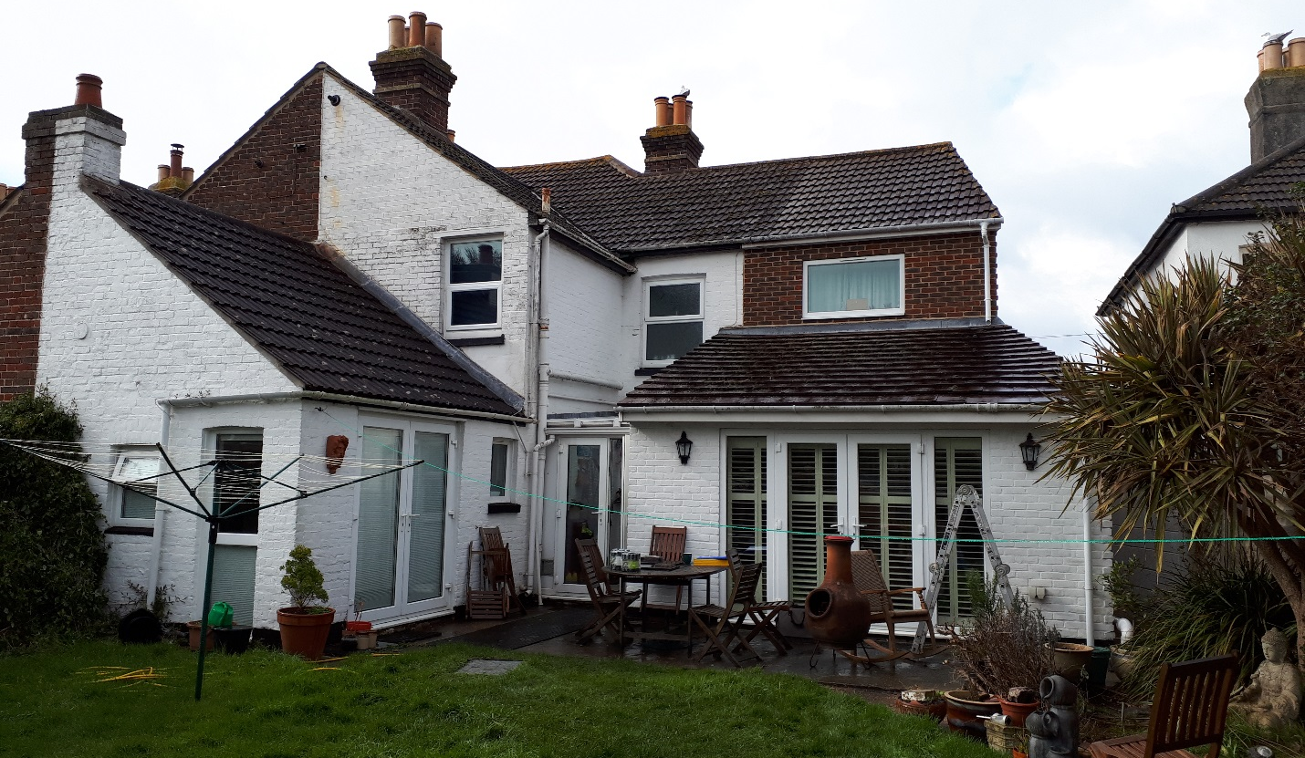Photograph of the rear of the Property.

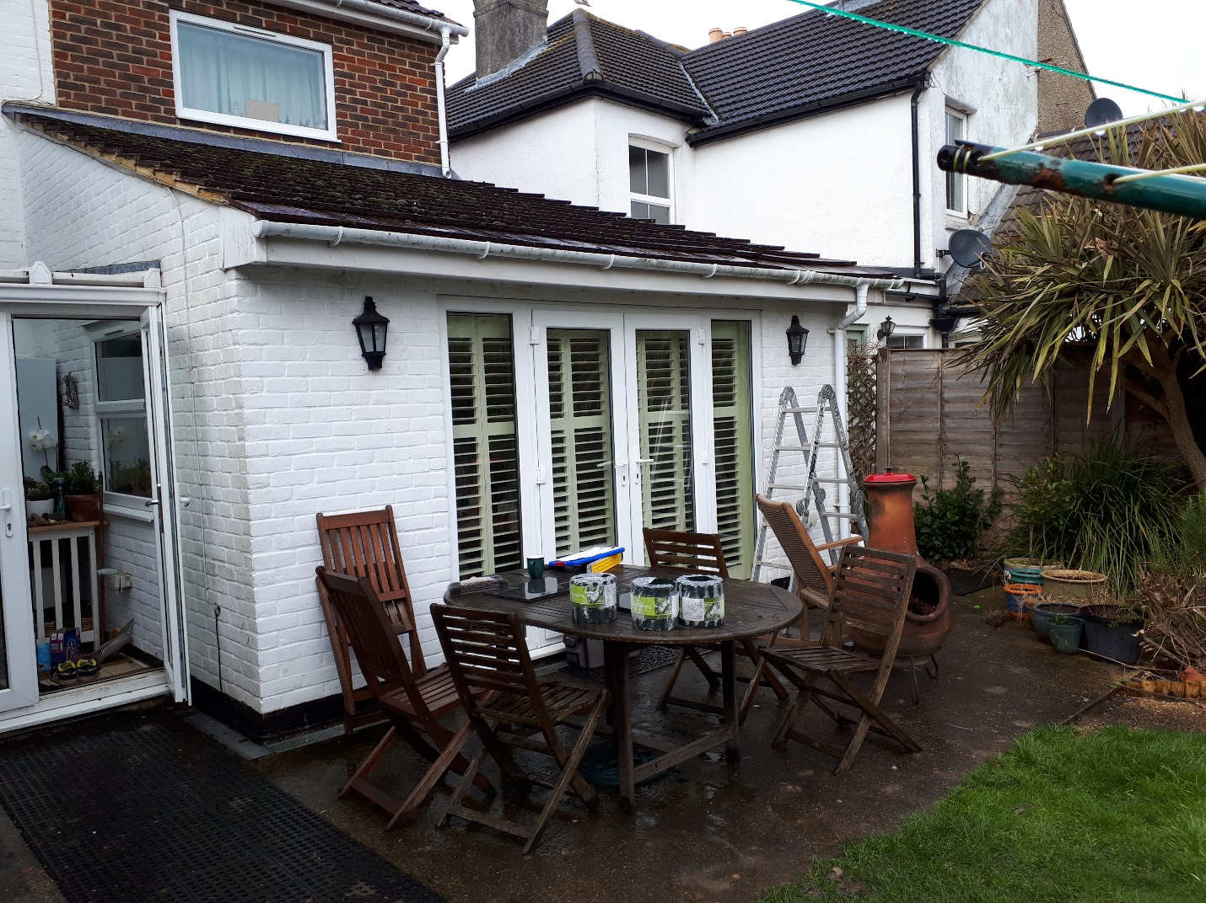Photograph of site of the proposal at the rear of the Property.

